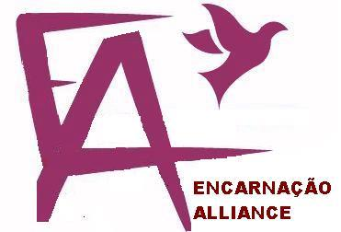

The Encarnação Alliance Training Commission
Training Leaders to Catalyze Redemptive & Transformative Movements Among the Global Urban Poor

Slum Leaders’ Curriculum
(Vers. 10.2, April 12, 2019)

Grassroots Certificates:
Transformational Urban Leadership
Urban Theology
Theology & Practice of Social Entrepreneurship
Urban Spirituality & Pastoral Care
Urban Ministry Trainer

Executive Summary

Within the global Encarnação Alliance Training Commission, after 30 years of experimentation with grassroots training of urban poor leaders, we now need to move to formalized certificates that can both enable slum leaders to (1) become highly effective in spiritual, social, economic transformation of their people, and (2) to move from the lower circuit economy to the upper circuit formalized educational system when needed.

This requires systematizing the content being used into (1) web-based information delivery as (2) the basis for action- reflection delivery of training in knowledge, skills and values by (3) mentored local facilitators globally who can also impart spiritually in areas of character formation, leadership and spiritual giftedness.

This needs to be developed using a VET competency-based approach for group-based oral-learning cultures. Topics have now been refined into five certificates. The modelling of TEAR Fund materials identifies the style and quality of content delivery and some content. Some other content is evaluated, and included or rejected. Around these, the process and patterns for course and topic outlines and trainers’ manuals are defined (instructional learning design), with initial cost estimates.

Index
1. The Need: Upskilling Slum Church Leaders 3
2. Nature of the Learner Population 5
3. A History of Responses 5
4. Learning Outcomes 7
5. Delivery Mechanisms 7
6. Certificate Design 10
7. Grassroots Churchplanters’ Training Topics (3 Years) 10
8. Each Course Rooted in Theology 12
9. Trainers’ Training 13
10. Comparison with/Input from Other Programs 13
11. Educational Philosophy/ Pedagogical Principles 14
12. Competency-Based Evaluation Processes 16
13. Trainer of Trainers Modules 16
14. Potential Partnership Expansion 17
15. Current Development Team 18
16. Development Budget 19

The Need: Upskilling Slum Church Leaders into Holistic Training of their People
The 1.4 billion people (over 35% of the world’s total urban population) that currently reside in informal settlements (slums) throughout the world are to be a “priority concern” of the Church, especially as their number continues to increase. The overflowing cities of the Majority World will absorb another four billion people before the world population peaks at around 10 billion in 2050. Within them are rapidly growing grassroots movements of churches. Slum cultural factors mean they are mostly Pentecostal in style and theology.
This is primarily a program in Urban Poor Movement Leadership, a field we have been developing within missiology, integrating the fields of urban theology, church growth, community development, and social entrepreneurship practices with leadership studies. It aims to train leaders who evidence potential to catalyze or strengthen redemptive movements, through church-planting, transformational development, economic discipleship, coalition-building, and creative problem-solving.
This may also be viewed as a program in a relatively new field of Social Entrepreneurship/ Community Development with courses in which learners develop an understanding of the community economics, microfinance, capitalization of land issues, organizational management, and NGO business processes
This is at its core a program in Urban Poor Theology (Theologia de Base) utilising a Transformational Conversations approach to contextual theology, with theology constituting a third of most modules.
This is an action-reflection program in NGO or Social Movement Leadership built around learning as the beginning of learning.
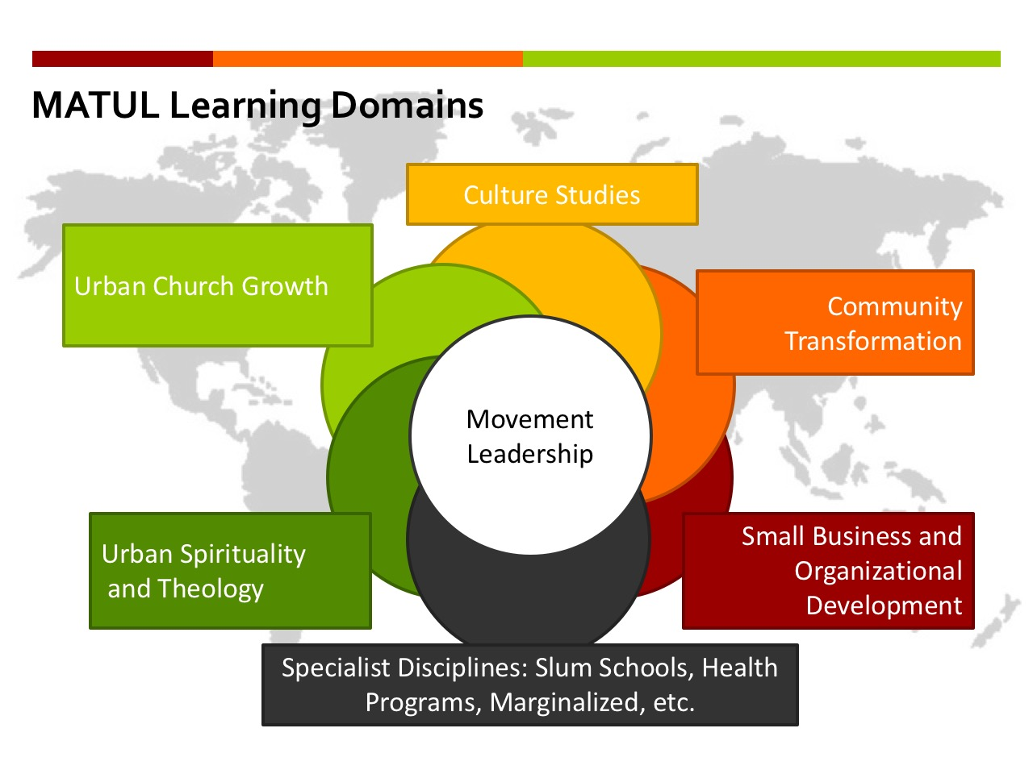
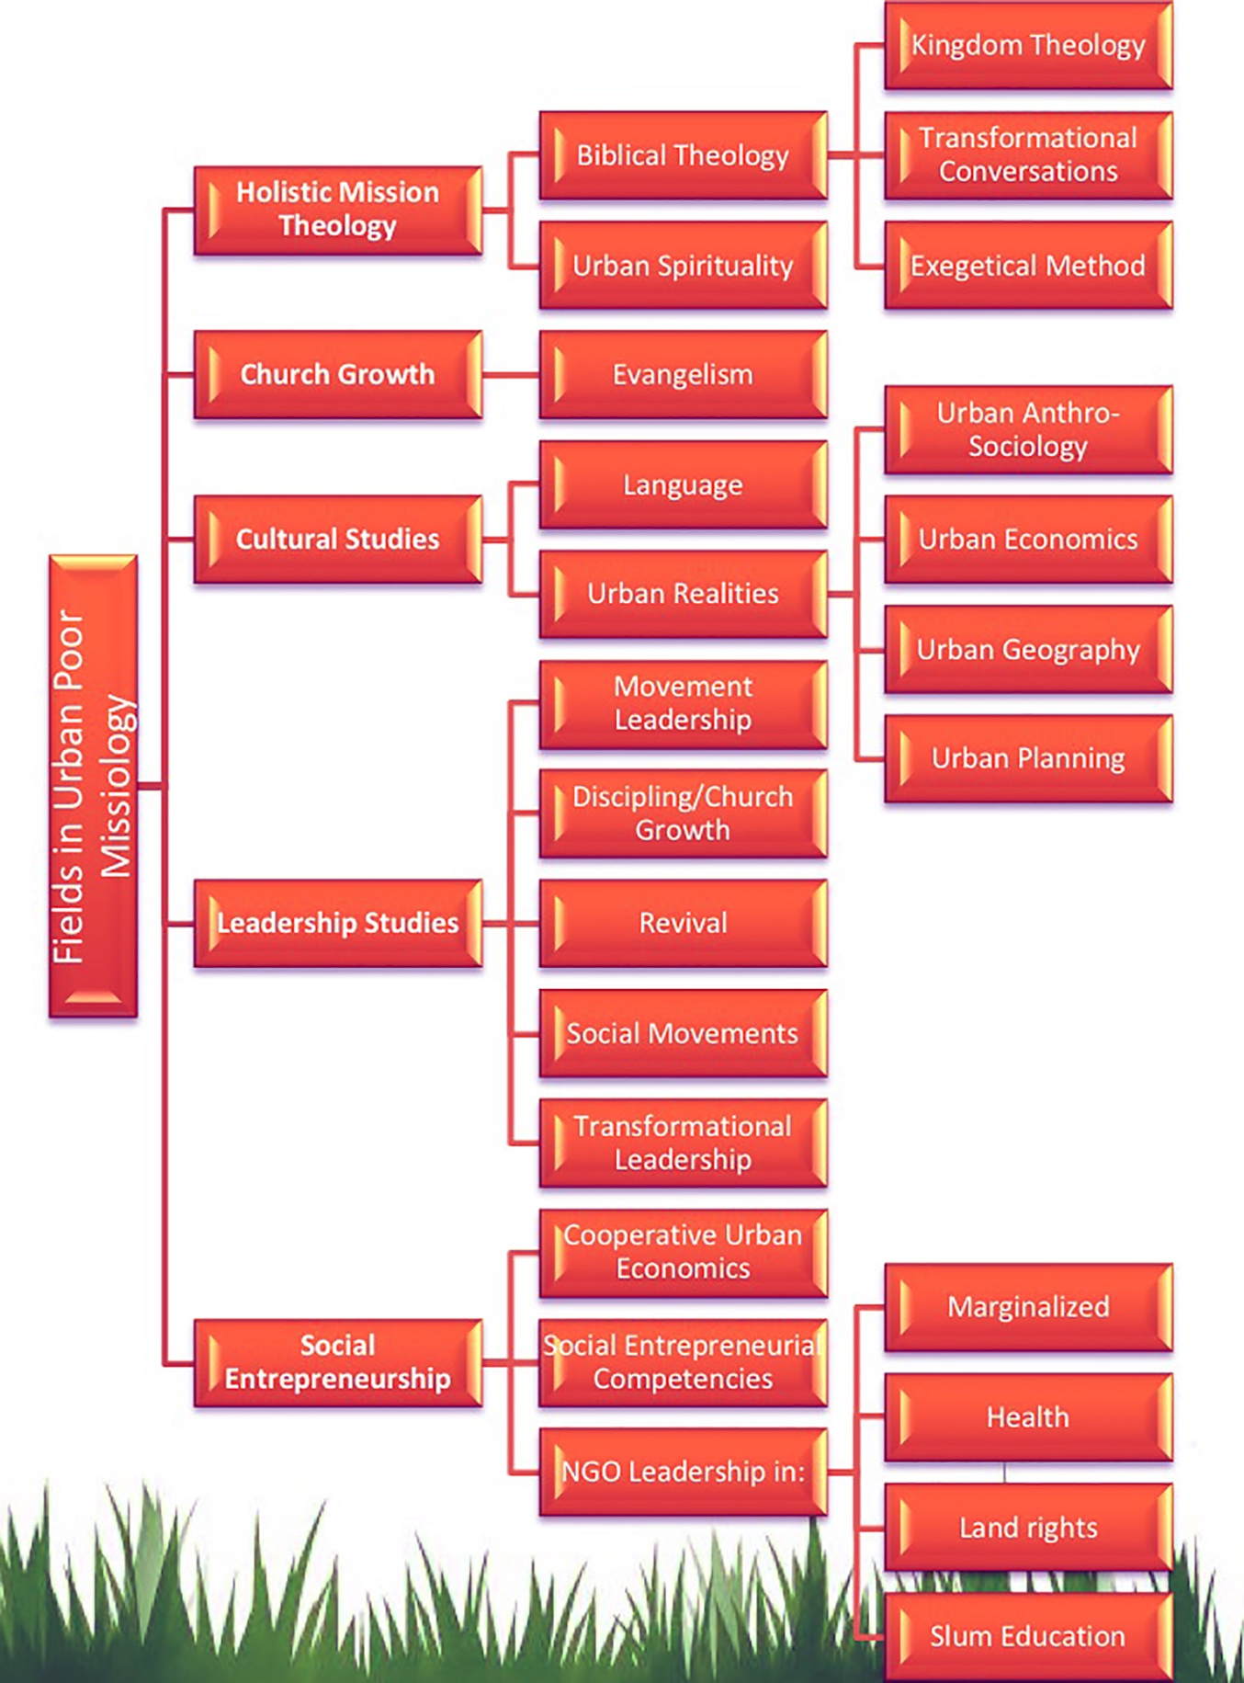

Nature of the Learner Population

Educational Level
In most countries, the average educational level in the slums is about Grade 6 or Standard 6 or Primary level. i.e. they are essentially oral learners, but can read simple documents in English or their own language

Ministry Experience
Most are effective evangelists, pastors having gathered 40-150 people and built a church building. Others are elders, deacons, or women leaders in the teams of these leaders.

Pentecostal Belief System
Pentecostalism is a global grassroots phenomenon. It depends on the Holy Spirit and has a dispersed authority and financial flows. It responds to grassroots folk religious contexts, including deliverance from demons, and healings. Its culture is deeply emotional as there is a constant dealing with trauma. (See Grigg, Cry of the Urban Poor, Ch. 15, 16 for an analysis of cultural factors that determine Pentecostal practice and theology). It is highly pietistic and spiritually other-worldly with an emphasis on the Holy Spirit.

Some Critical Paradigm Shifts in Slum Pastor Thinking
- This training begins with those Pentecostal emphases but expands the pneumatology into the Old Testament understanding of the Holy Spirit as the Spirit of creation.
- It also expands the understanding of the gospel of salvation to the holistic Gospel of the Kingdom of God.
- ¼ of Jesus’ teaching was on economics, so a paradigm shift into ten biblical principles of economics underlies mobilization of members into economic uplift.
- The development of deacon/esses takes an existing and understandable Biblical category into the 21st Century roles of community development workers and business catalysts.
- The training fosters the building of leadership teams, moving the pastor from the center of processes to being a servant facilitator of development for others, thus changing the understanding of the pastoral role and authority.
- Each course results in engagement and in many context the form

A History of Responses
Following story-telling consultations of urban poor leaders in Mumbai (93) and Hongkong (96), the Encarnação Alliance Consultation of urban poor mission leaders in Sao Paulo in 2002 concluded that collectively we should develop our own training processes for urban poor workers.

The Encarnação Alliance Consultation in Bangkok in July, 2004, sensed that the Lord was in process of mobilizing 50,000 to the slums of Asia, Africa, and South America of indigenous and cross-cultural new workers to meet the need of deepening poverty, growing migrant populations from rural contexts, and the responsiveness of the urban poor.

New urban poor holistic church planting movements that are deeply involved in holistic ministry and implementing income-generating projects that would result in viable communities of believers are desperately needed. These movements are catalyzed by those who live an incarnation lifestyle among the urban poor. The fastest growing of these movements flourish where healing and deliverance are normal aspects of church life.

The delegates at the July, 2004 Consultation in Bangkok identified three levels of training and equipping needed in urban poor ministry:

- Grass Roots Training: Existing workers are to be trained in a storytelling model of training teams of new workers to minister among the urban poor.
This was iniitally delivered to 3000+ leaders in 27 cities and been developed around 12 course modules available on CD, covering 40 topic areas. The modules include: Introduction for Trainers; Spiritual Formation; Theological Framework for Slum Ministry; Slum Context; Slum Evangelism; Discipleship of the Urban Poor; Church Growth in the Slums; Leadership Among the Urban Poor; Kingdom and Transformational Development; Urban Poor Mission Structures; Kingdom and Land Rights Conflicts; and an integration module.

- Undergraduate Degree (BA) in Theology of Urban Ministry
The Encarnação Alliance members saw this as an expansion of the grassroots courses with diplomas into a formal degree structure for equipping existing workers who have had no formal education but several years of ministry experience, or business people who have been assisting urban poor ministry teams on a part-time basis and are now considering full-time service. It has not previously been confirmed as a seriously felt need, but persecution of Pentecostal movements by State churches in Africa mean it is now a necessary progression from certificates to diplomas.

- Graduate Degree in Urban Leadership. Potential learners were identified as either:
- Existing workers with a number years’ experience and proven leadership ability to be prepared for future apostolic roles to give leadership to multiplying urban church planting movements in the slums across a city.
- This degree could also apply to those with pastoral ministry experience who sense the call of God to the urban poor and desire to multiply urban poor ministries through team building.
- This training could also apply to those with the call of God to the poor having a strong sense of injustice and wanting to use business training and experience to economically and spiritual liberate the poor.
- Movement pioneers who would catalyze new movements among the urban poor in targeted slums in the poorest countries of the world.

Implementation of Process
From 2002 , we visited 13 seminaries with these ideas, constantly refining a list of 433 outcomes (see Access database in website) indicated by church-planters and development workers from 22 consultations in cities, and from this an initial program design of 23 courses. Bryan Johnson worked in putting the initial grassroots ourse descriptions together.

While most training in the program is deeply theological, we determined that this should be called a leadership program as against a theological program (which would immediately invoke the addition of 7-9 core systematic courses). This defused opposition from the traditional theological faculty, and minimize friction as the new style of theologizing took root. We use the Transformational Conversations model of doing theology (See Transformational Conversations document) doing theology from action to reflection, with cluster so leaders among the urban poor.

God-Centered Design
The attached document has been incrementally developed from these processes and the experiences of initial implementations. Each context brings variations to the core documents, but we avoid drift from the core of multiplying leaders of multiplying movements among the urban poor engaged in holistic transformation of their context.

This has involved a humble posture of learning and discovery, involves stakeholders in multiple steps in the process; agility and dynamics in the design. These build onfive principles in business innovation theory of Human Centered Design, which is helpful.
- Iterative
- Empathetic
- Creative ideation over possible solutions
- Prototype feedback loop
- New properties
- Fresh Expressions

Learning Outcomes
Prerequisites (can be done in parallel with the training for some)
Adult education in English and mathematics that leads to a School Certificate.

Certificates in Holistic Churchplanting: For Slum Pastors/ Elders:
Evangelism, and Church Growth: Successfully expand church-planting and church growth, through training elders and deacons/esses, enabling them to be self-sufficient financially and extending skills and values to lead congregation engagement in community transformation.

Socio-Economic Discipleship: Expand a spiritual theology of gifts to working with the Spirit of creation in transforming the whole person and their context (spiritual, social, economic, political, environmental).

Certificates in Transformational Urban Leadership/Social Entrepreneurship/Community Development: For Deacons/esses/Development Workers
Paradigm shifts: Can teach others about the Kingdom, Kingdom economic principles, and other paradigms required to set people free economically.
Skills: able to lead the congregation engagement in community transformation, self-help savings, vocational training, entrepreneurship etc.
Character: Develop character qualities in each course, including those needed for successful entrepreneurship. These include becoming self-sufficient financially.

For those needing access to a Bachelor’s Degree
- Get School certificate or a high school leaving certificate.
- Complete each certificate plus 20 hours of reading (= 120 hours per certificate, or one course at a Bachelors level in a University).
- Demonstrate English proficiency in essays for each certificate.
- Demonstrate educational ability in summarized readings each week.
- Fulfil other requirements of the University.

Delivery Mechanisms

Content Development Parameters
Follow the principles modelled by Tear Fund in their Footsteps series:
Accessibility is priority
  - Content will be accessible online and via smartphone.
  - Content will be freely available off the website.
  - Content of the complete certificate program also available on a flash drive
  - Ultimately in the main trade languages English, French, Portuguese, Spanish, Hindi, Bangla.
- It will be developed in color graphically-formatted, compressed pdf format, utilizing InDesign templates that compress info into smaller space.
  - Content must be bite sized and graphically oriented
  - The pdfs to be available in letter, A4 and easily printed in black and white.
- Oral Learning Culture: It will be developed at a reading level less than Grade 8, second year high school. This can largely be done in Word, but then a readability checker is needed (Some are discussed at http://www.readabilityformulas.com/free-readability-formula-tests.php ).

Course Development Parameters
- Content should be freely accessible on the web
- But modules to be developed in Moodle as the only freely accessible LMS, or to be compatible with Tear Fund, if we had the money in a Learning Pool LMS.
- Each Moodle course to contain minimal numbers of files as learners can only visit internet cafes occasionally: the main pdf, a description of the course, a set of practical activities, a final exam that is computer graded and weekly evaluations of practical engagements.
- The cohort training program will include the attached courses (below).
- 16 modules of 4-7 lessons each.
- The initial introductory modules will be a 5 day training where possible.
- delivered 3 hours per week.
- over 2 years.
- 2-4 hours practical work weekly, monitored by a reporting process.
- Four modules will make up one Certificate = 100-120 hours of supervised learning.
- Access to Moodle or the LMS will be made when a registration fee has been paid.
- The registration fee FOR CERTIFICATES (viz a viz the freely accessible web content), will be set by the local trainers in consultation with the global program dean at a level affordable in the culture, that covers costs of materials printing, equipment and ideally the time the trainer takes out of ministry or work. No funds will be recoverable back to the West, except from 40% of fees for trainees from First World countries.
- We use Jane Vella’s 8 Steps of Design

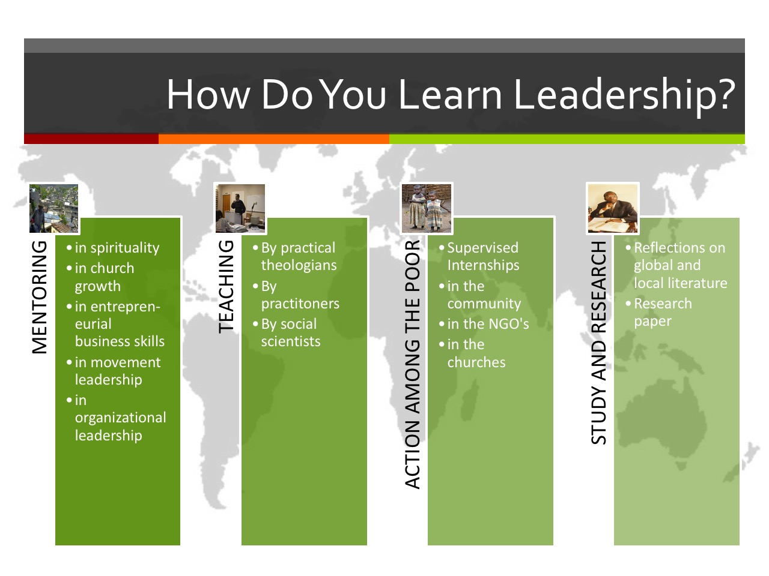

Delivery Processes
- The courses are being set up in Moodle (or a ntoher LMS), so that those who have registered in each place (and paid the local fee), can always access them by computer in an internet café, and particularly must sit the exam at the end of each course on a computer. However regular computer access is not needed, as the courses are designed around an oral learning group process. The course trainer needs to have access regularly to a computer.
- Weekly meetings, 7-10 pm in a church or ideally in an internet café. A screen connected to a laptop is needed with a sound system.
- The introductory grassroots module introduces a number of these topics. After the introductory week, the pastoral groups gather weekly. They tell stories or do a drama of what they have done since the last training. Then they receive one of the modules taught by expert slum leaders who have successfully developed that area of expertise in that or another city. In between these modules, they all review the material on the CD-ROMs, or flash drive. All receive face-to-face mentoring and all extend their existing ministries using the new ideas.
- Teaching and discussion using PowerPoint and Video (PowerPoints may be found on Authorstream, Videos may be found on Vimeo – search for Viv Grigg or MATUL)
- Practical assignments weekly
- Each module is 4-6 sessions
- Evaluation and exam after each module in Moodle, is automatically graded.
- The trainer has to also evaluate the practical assignment submission.
- A certificate is given at the end of each 4 modules.
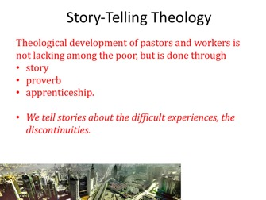

Certificate Design

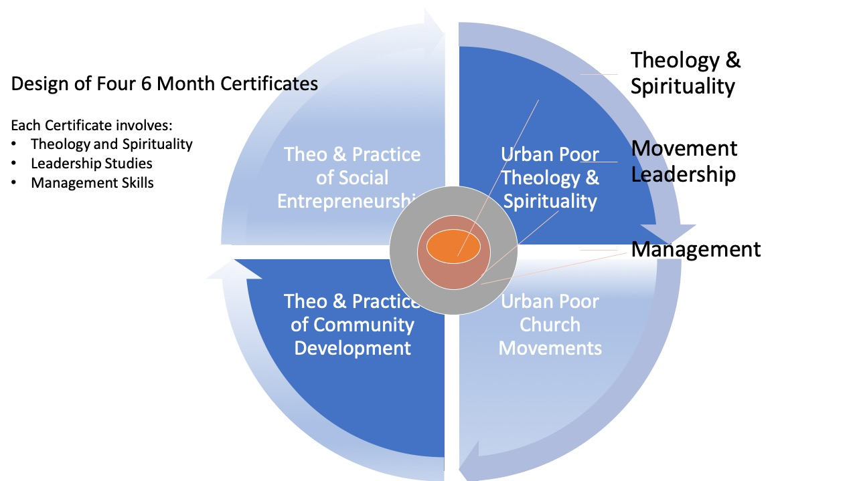

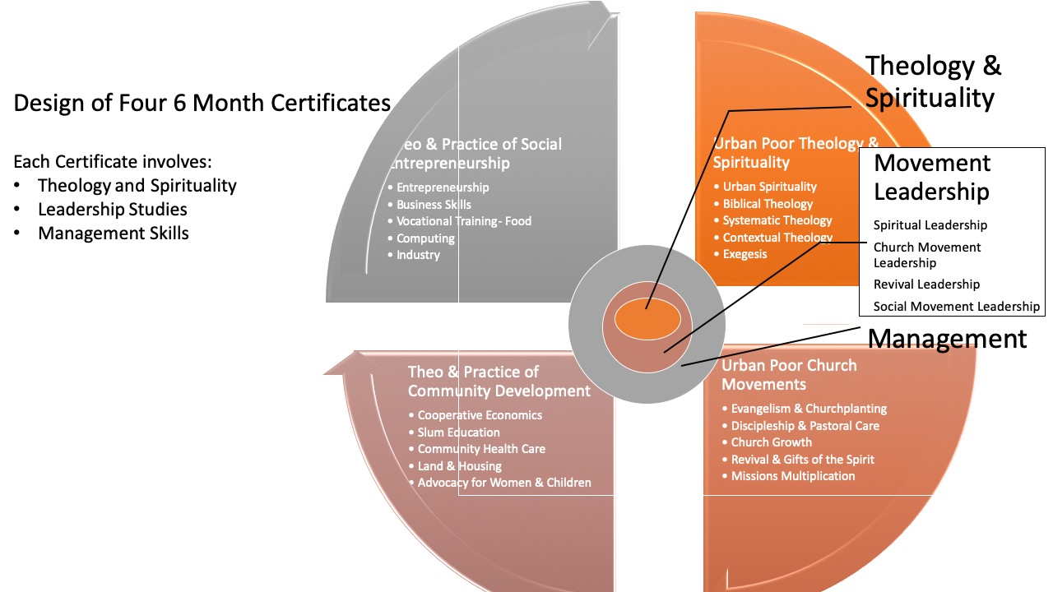

Grassroots Churchplanters’ Training Topics (3 Years)
Mar 2019 version, 16 topics. Each topic is 3-6 sessions

Each certificate contains 20 x 3 hour topics from below plus practical application. At least one topic from each of the four quadrants above should be in each certificate.

Prerequisites (Can be done in parallel)
English Skills for Adult Learners
Basic Mathematics Skills for Adult Learners

Introduction
Developing a Poor Peoples' Church
Introductions
Who are the poor of ...?
Personal evaluation

Trainers Introduction
Adult Learning
Story-telling as a style of Learning
Setting up a Learning Network
Using the Materials on the CD-ROM

Theological Framework
Pentecostal Distinctives
The Kingdom of God
The Kingdom and the Poor
Contextual Theology & Story-telling Theologies
Transformational Conversations
Kingdom Economics in OT & NT

Spiritual Formation
Spirituality for Survival in the Slums
Pentecostal Spirituality
Spiritual Gifts
Healing and Deliverance
Suffering, Coping with Sickness
Prayer and fasting for spiritual breakthrough

The Slum Context
Global movements in slums of mega-cities
Why are the Slums, Slums?
Social Analysis and the Pastoral Cycle
Causes of Slum Poverty
Squatter Culture and the Pentecostal Church
Squatter Economics

Entrance & Evangelism
Incarnation
Styles of Evangelism in the Slums
Finding the Needs: Entrance Points
The Spirit, Evangelism, and Justice
Public Preaching
Power Encounters
Reaching Gangs & Prostitutes

Discipleship & Pastoring
Discipling Movements
Training the Illiterate through Story-telling and Drama
Children’s Ministry
Discipling Street Children
Ministering to HIV/Aids victims
Developing a Work Plan
Approach to Pastoral Counselling

Church Growth
Four Seasons of Growth
Pastoral Care
Cash Flows of Urban Poor Churches
Pentecostal Church Worship
Preaching Styles
Church Management
Church Ordinances

Leadership
Developing Leadership Gifts (Eph 4:11,12)
Training of Urban Poor Pastors
Team Building
Family Survival in the Slums
Leadership for Multiplying Community Transformation
Diaconal Development
Preventive Health Evangelism
Creating Slum education: Preschool, Primary, Vocational, Computer Literacy
Adult Education – Literacy
HIV Aids Program

Community Economics
Diaconal Development
Economic Discipleship
Cooperative Savings
Bookkeeping skills
Savings Groups

Entrepreneurship and Management
Intro to Micro- Enterprise
Project Design & Management
Budgeting, fund raising
Income generating projects
Small business management

Vocational Skills
Theology of Skills Development
Food: Catering, Poultry, etc.
Housing: Construction Skills
Clothing: Sewing, Tie and Die etc.
Small Industry: Welding, Electronics, etc.
Recycling??

Advocacy
Community Organization
Street Kids
Caring for Orphans & Widows
Caring for the Elderly
Theology and Practice of Obtaining Land Rights
Connecting Rich and Poor Churches
Project Proposals
Kingdom & Justice

Mission Strategy
Pentecostal Multiplication
Apostolic Urban Poor Mission Structures
Revival Movements Among the Poor
Recruitment of Workers

Systematic Theology and Biblical Exegesis
Biblical Interpretation
OT Survey
NT Survey
Systematic Theology
Biblical Theology of Urban Mission

Final Integration
Integration of Lessons learned
Time of Intercession
A Vision for the Future – the Poor Wise Man
Final Exam
Giving of Certificates

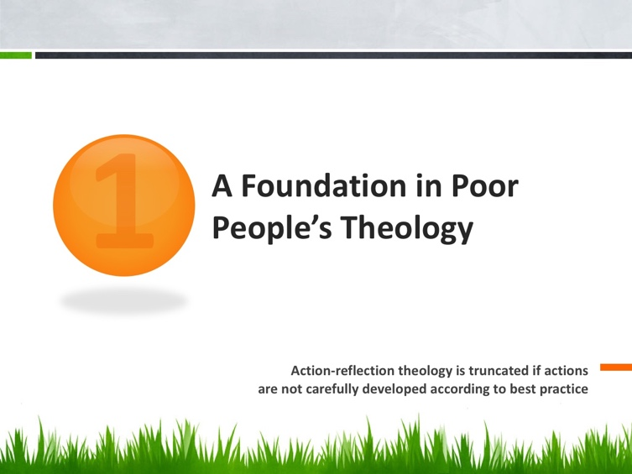

Each Course Rooted in Theology
- Conversational Theology: Drawing on Jesus, Freire, Vela and other action-reflection and adult education approaches to learning, learners build theology from the stories of the poor, as these engage the stories of the scriptures, and academic literature, resulting in transformational conversations. Local theologies from among the poor result. The locus of the power of knowledge is sustained as the knowledge of those among the poor, but from this vantage they also critically engage the literature of the academe, a reading of the scriptures from the underside of history, and the elites who reflect on how to change the poor and poverty aided by social analysis.
- This is in contrast with classic systematic theology, which begins with Philosophical categories. But that approach also needs to be understood, though better developed at the Bachelors or Masters level. There is a balance

Some major themes from Paulo Freire:

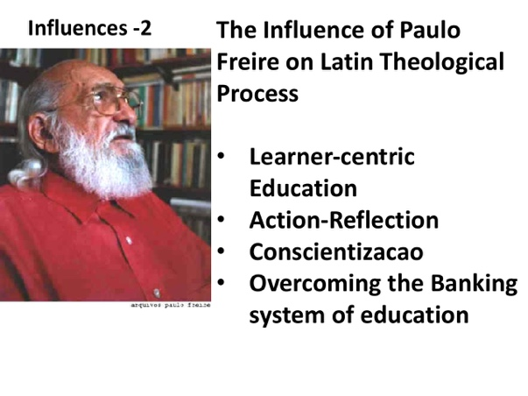
The development of an urban missions approach begins with an action entrance story, usually of shock at some discontinuity within the poverty that forces one to examine their Biblical understanding, and pushes us into social analysis. The Biblical conversation usually needs a wider input from theology. The dialogue between these results in a the Transformational Conversation which results in collective action in a new action story.
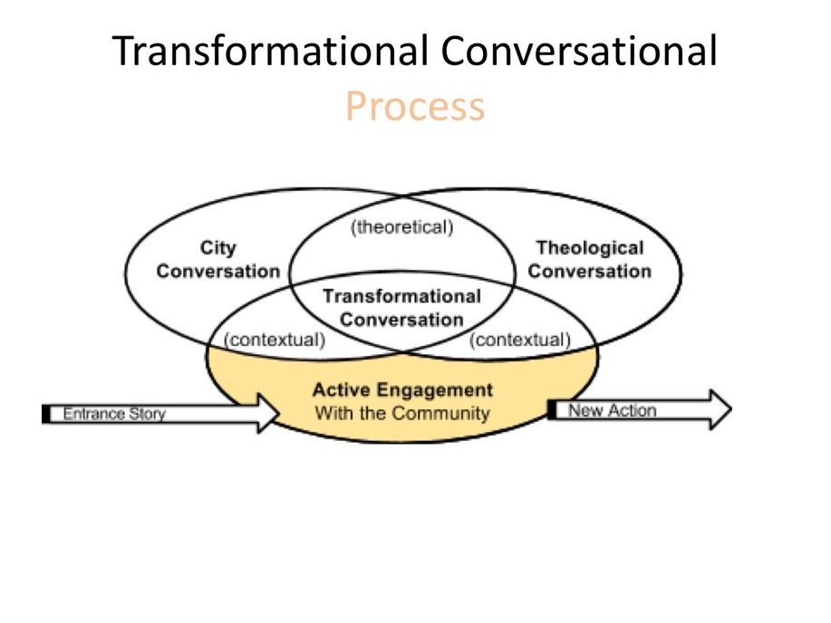

Trainers’ Training
A Group of Trainers Committing for 2-3 years

Qualifications
- Finished a certificate of the training
- Show interest in training others
- Have skills

- Trainers will meet monthly initially then at least every two months to review educational processes, and maintain accurate record keeping.
- Along with these, if they complete 2 readings for these courses weekly, they will obtain an additional Certificate as a Grassroots Educator.
- Distance-­‐learning lectures will be available on the www.urbanleaders.org website. Integration groups of 3–4 participants will be organized by interest or region for online interaction periodically.
- Mentors will assist each integration group in meeting the learning objectives.

Trainer of Trainers Training Module
Topics
  - Philosophy & History of the Training
  - Pedagogy of the Slums
  - Accountability Reports
  - Developing Teaching Plans and Presentations
  - Recruitment & Mentoring

Comparison with/Input from Other Programs
The grassroots programs have evolved through an iterative process of delivery in 22 cities and long-term in 5 cities, in parallel with the evolution of the domain of urban poor missiology at the MA in Transformational Urban Leadership (MATUL) level (www.matul.org) The design process is at www.urbanleaders.org/ma). Dr Hruda Lahora has taken the MA level and adapted it for the grassroots, delivering it in an Anglican church weekly.

In addition to the research at the grassroots we are comparing with TUMI and Tear Fund materials, adding some of the best from these. TUMI has not been derived from the grassroots but has some components that are useful and structured it beautifully in reproducible models. Tear Fund have used an iterative search of global practitioners each 3 months on a different development topic, and have designed at a level of accessibility and simplicity. Their website delivery process is excellent.

Some of this discussion is ongoing and may be found at: https://docs.google.com/spreadsheets/d/1kU5nLhnU-BZe1jQ-5YoY4T8IfWKJBARxwm4cvcXGbiQ/edit?usp=sharing

I have discounted the aibi harvesttime material as it does not follow our principles of action-reflection , competency-based learning, derived from issues identified by the base. Nor is it in a simple graphical format that I require for all my people. But there are a few modules that might be converted of standard Pentecostal docrtrine.

Educational Philosophy/ Pedagogical Principles
    - The educational philosophy is described in Slum-Dwellers Theology. The following are some principles:

- Holistic: This is a program meshing theology, urban spirituality, church growth, community development and a relatively new field of social entrepreneurship. It aims to train leaders who evidence potential to catalyze or strengthen redemptive movements, through church-planting, transformational development, economic discipleship, coalition-building, and creative problem-solving.

- Urban poor locus: Learning is located among the urban poor and serves emergent leaders. Learning involves the holistic empowerment of the urban poor rather than merely providing professional credentials.

- Leadership development: Following Jesus model, leadership, character and managerial capacities are developed through mentoring under educators and experienced church leaders, business people, spiritual mentors, and mentors in specialist areas.

- Action and practice-oriented: theoretical study is integrated with experience-based learning so that learners don’t merely learn about urban poor realities, but are directly engaged with urban communities through each of their courses. Action-reflection pedagogy (style of education) begins in action. Collective reflection on actions leads to the embedding of ideas in unique memories. But to sustain this assessment is needed to press learners to complete practical experiences. Generally, there should be one assignment per teaching, and they must fill in an assessment before the next week. The session starts with stories from the week. The facilitator then integrates the lessons learned with the theoretical content being studied. On the flip side these are learning experiences not full-fledged application of what is being learned, so the facilitator has to limit the practical work to what is feasible within the time from of the course content.

- Learners see the expansion of the Reign of God over all of life as primary, with solutions to issues of poverty as some of the holistic and derivative effects of the power of the preached word, the work of the Holy Spirit and the formation of faith communities among the poor. They also grasp the dynamics of his reign through common grace exercised by the Holy Spirit in societal structures.

- Conversational Theology: Drawing on Jesus, Freire, Vela and other action-reflection and adult education approaches to learning, learners build theology from the stories of the poor, as these engage the stories of the scriptures, and academic literature, resulting in transformational conversations. Local theologies from among the poor result. The locus of the power of knowledge is sustained as the knowledge of those among the poor, but from this vantage they also critically engage the literature of the academe, a reading of the scriptures from the underside of history, and the elites who reflect on how to change the poor and poverty aided by social analysis.

- Incarnational lifestyle: Rather than being sequestered in an academic compound, learners learn to enter the pain and problems of the urban poor, in identification with them in their experiences of suffering and oppression, bringing the hope of Christ.

- Character outcomes are critical across the degree, along with skills or knowledge. These come from mastery of an urban spirituality, a depth of walking with the Holy Spirit. This canot be done by web delivery of content, but requires engagement by trainers. Training of trainers can accelerate this.

- Dual Level Linguistic Delivery: Local language usage is important. Ideally, courses will be delivered in the language of the literature, but be interfaced with local language needs of urban poor workers. Equivalent written work in either language will be valued equally.

- Topic Design: Each topic is evaluated on its ability to engage head, heart, hands and habitat in its outcomes. Learning is in bite sizes. Bite size learning outcomes can be measured simply. The LMS should enable a progression of bites.

- Field-based: Learners should not be dislocated from their means of production to learn. That means incarnational living is essential among the urban poor and content is taken to learning centers within a short ride or walk of their locations.

- Camaraderie/ company of brothers and sisters: Learning is a communal process of supportive relationships. The creation of a cadre of workers who share a set of paradigms against the traditions around them cannot be underestimated.

- Pastoral care: Living and learning in slum environments is unlike any other kind of educational activity in the intensity of emotional stress. For this reason, trainers need to be sensitive to the provisions of pastoral care structures and be positioned to monitor any necessary emotional, spiritual and psychological support at least every fortnight.

- Revival Power of the Holy Spirit: Impartation of the Holy Spirit is a more powerful multiplier than transferal of knowledge. Put another way, there is a hierarchy of paradigm shifts that lead to changed action and engagement. The last item in the following list is perhaps a hundred times as productive as the first.
          - Transfer of knowledge can change perceptions; can be transmitted via e-learning
        - Action-based experiential learning changes long-term capacities to act; requires mentoring
      - Multiplying groups of leaders: group-affirmed action-based reflection cements changes in philosophy and paradigms enabling continued action; requires leadership, mentoring and content.
  - Impartation of Power: The Holy Spirit touches deep into our inner soul and changes character and capacities to lead; requires people touched by revival and skilled in spiritual gifts in leadership. The healing of trauma, release form sin, bondages, sicknesses and impartation of spiritual gifts releases people into a freedom of character growth, and leadership capacities. But this must be correlated with a solid understanding of the holism of the Kingdom.

Competency-Based Evaluation Processes
This program is based on developing competencies in each field of knowledge. It has been developed from research on the competencies that urban poor pastors and community workers within the Encarnacao Alliance of Urban Poor Leaders have identified, rather than what academics have identified. We have then gone to academic institutions to assist in the structuring of the program. The importance of starting with the voices of the marginalized cannot be over-emphasized.

- Each module requires an automatically graded multi-question evaluation of understanding of new content in Moodle or another LMS. This can be done with thousands at little cost.

- Evaluation of action-based learning activities requires a report to the class and mentor graded reviews of a written analysis of actions taken and reflections on the actions. This can be done with hundreds.

- Evaluation of character and leadership qualities and process for each certificate, involves the trainer and mentors in committee reflecting on both ministry engagements, written analysis by the trainee concerning outcomes, and written reflection by field mentors. This can be done with tens. It is time consuming.

Trainer of Trainers Modules
A Group of 5-12 Trainers Committing for 2-3 years, meeting monthly.

Qualifications to be invited to be a Trainer
- They have finished the training
- Show interest in training others
- Some teaching skills
- Character evidenced in ministry involvement
- Demonstrated ability to pull together small groups
- Not primarily a didactic teacher
- Catalyze leadership

Content of Training
- Philosophy & History of the Training
- Pedagogy of the Slums: Oral, story-telling, action-based, beginning form the issues people identify
- Conducting Weekly meetings: Video, sound, discussions, worship, sequence, getting commitments
- Monthly Accountability Reports
- Developing teaching Plans and Presentations
- How to evaluate the training
- Financial Processes
- Typical group discussion: Feedback, Teaching, discussion, prayer and worship before and after.
- Exams and certificates

Trainers’ Manual
- Cover
- Index
- Intro
- Pedagogical Principles
- a 2-page outline of each course
- suggested pedagogy for each course
- evaluation questions
- other administrative forms and instructions
- Word and pdf format using graphical stylesheet.

Potential Partnership Expansion
- Meeting in July of the Training Commission in Cameroons.
- Meeting August with the US Urban Poor Missions Trainers.
- Exploration of how to partner with TUMI materials,
- Review of Tear Fund’s educational development process. I have gone through 5 courses in detail.
  - The content of the Footsteps materials is brilliant:
    - Comprehensive on each topic
    - Easily accessible
    - Easily printable
    - Format is ideal for communication of information
    - Interesting and good balance of story and principle
    - Church based
    - Has been input form people around the world
    - Has links to readings
  - It is a communication of information so the following will be needed for each topic to be upgraded by them or us into a facilitated course:
    - Understanding that information transfer is not education, Freire;s difference between the banking system and conscientização.
    - Competency-based education: Review if content is compatible with course competencies we have identified – mostly it is.
    - Develop a one page topic outline for each educational section that includes 1. short description, 2. competencies expected, 3. a pathway through the material for (a) teaching, (b) action (c) reflection (d) evaluation.
    - Bible studies may need to be lower level
    - For those who wish to use the certificates for university entrance they will need to upgrade their courses by (a)adding readings (b) a process of evaluating readings (c) reports on action engagements (c) automated exam for each course.
    - A separate facilitators manual is needed that identifies:
      - Teaching tips
      - Action steps
      - Evaluative tools
      - Forms
      - Training of/supervising local mentors
  - I could help Tear Fund team in this by facilitating /teaching them in some of the pedagogical concepts underlying the MATUL and in which I have had to pioneer against the mainstream faculty inertia, but they likely are expert in these already. I need to pull together my own documentation of the following in expanding the trainers modules:
    - How to do bicultural online delivery to groups
    - Creating a workflow in course design
    - Action-reflection course design
    - Competency-based design
    - Group-based learning cultures and keys
    - Oral learning processes
    - Reflection-based evaluation
    - The difference between courses as information delivery and human mentoring processes and set up.
    - Training of facilitators
    - Training of mentors in the action phases of leaning, by facilitators; reporting
    - Screening potential mentors: family dynamics, evaluating past experience of multiplying groups, focus on knowledge or student learning
    - Pedagogical philosophy
    - What I have developed as expertise is all of the above linked to online delivery into multiple cultural contexts
    - Necessity of credibility in reporting processes.
    - Learning as a team process in an oral culture
    - Maslow and Bloom’s taxonomies
    - Freire, Vella, Vigotsky and pedagogy
    - Use of video within this type of educational framework in a bicultural manner.
    - Educational concepts of credibility
    - Not much in here for urban ministry. Possibly we could contribute to one or two

Current Development Team
Pr Luwago, Kampala, Ugandan input
Dr Hruda Lahora, Nagpur, Indian input
HBI Input, ??? Bobby, do you wish to have someone involved at this level?
Dr Viv Grigg, Conceptualizer, catalyst
Pr P. K. Moses, Hyderabad grassroots
Rev John Edmiston, AIBI, hosting
Rev David Omana, Uganda Christian University, and others in the MATUL Training Commission
Brazil: Ulisses
Camerouns: Dr Moussa, who do you recommend?
Graphics Designer:
Web Designer:
Grant Writer:
Tear Fund: ?
TUMI:?
Accra: Helena Mananu-Hooper
If you are reading this and wish to be included please email me.

Draft Development Budget
(send me suggestions of what are likely progressions and costs that need considering)
Income
Individual Donors | $1000
Grant (to be raised) | $5,000
Other | ???
Total Income | 6,000
Expenses
Program design | $2000
Course conversion & development from existing materials(One per month) | $9000
Integration into publishable manuals and websites | $2000
Graphical Design | $2000
Computer programs: Adobe Suite for 5 sites | $2000
Initial Translation into Portuguese and French | $2000
Partnership with other organizations (Calls, communications etc.) | $1000
Total Expenses | $20,000
To be raised | $14,000

Delivery budget for each site is not listed here, but includes computer equipment, a computer center, video projection and screen, printer etc.

References & Further Reading (Others to be added)
Freire, P. (1986). Pedagogy of the Oppressed (M. B. Ramos, Trans.). New York: Continuum.
Gardner, H. (1993). Creating Minds: An Anatomy of Creativity. New York: Basic Books.
Grigg, V. (2004). Cry of the Urban Poor. London: Authentic Press.
Grigg, V. (2012). Companion to the Poor. Auckland: Urban Leadership Foundation(revised), formerly with Authentic Media (revised and updated 2004), originally Albatross: Sydney (1984), revised MARC: Monrovia (1990)).
Grigg, V. (2009). Transformational Conversations: Hermeneutic for a Postmodern City The Spirit of Christ and the Postmodern City: Transformative Revival Among Auckland's Evangelicals and Pentecostals. Lexington, KY: Asbury: Emeth Press and Auckland: Urban Leadership Foundation.
Grigg, V. (2016). Kiwinomics: Conversations with New Zealand's Economic Soul. Auckland: Urban Leadership Foundation.
Grigg, V. (2018). Slum Dwellers’ Theology: Pedagogy in the Slums: Urban Leadership Foundation.
Vela, Jane. About Dialogue Education : The 8 Steps of Design http://www.globallearningpartners.com/about/about-dialogue-education/the-8-steps-of-design
Tear Fund. Footsteps series. https://learn.tearfund.org/en/footsteps/

There are many discussions on the www.urbanleaders.org/ma site.

The MATUL program PR site is at www.matul.org

