**TUL555 Educational Center Debelopment**

**Pics By Topic**

**Required Text**

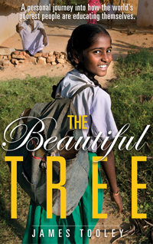

**TOPIC 1. Third World Schooling**

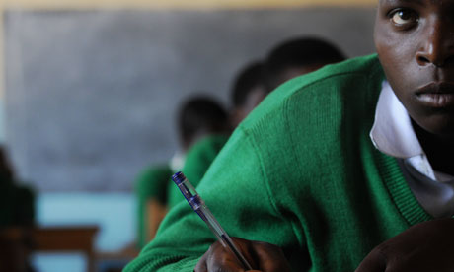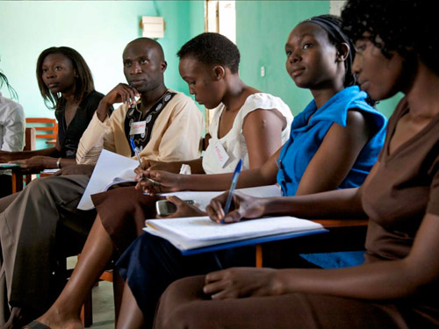

<http://www.guardian.co.uk/global-development/poverty-matters/2011/oct/25/developing-countries-secondary-education-challenge>

<http://www.macfound.org/press/from-field/slideshow-girls-education-developing-countries/>

**TOPIC 2. Educational Center Internship**

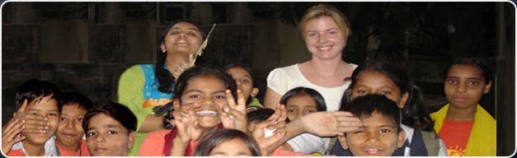

<http://www.volunteeringwithindia.org/our-programs/teaching-volunteer-program-india>

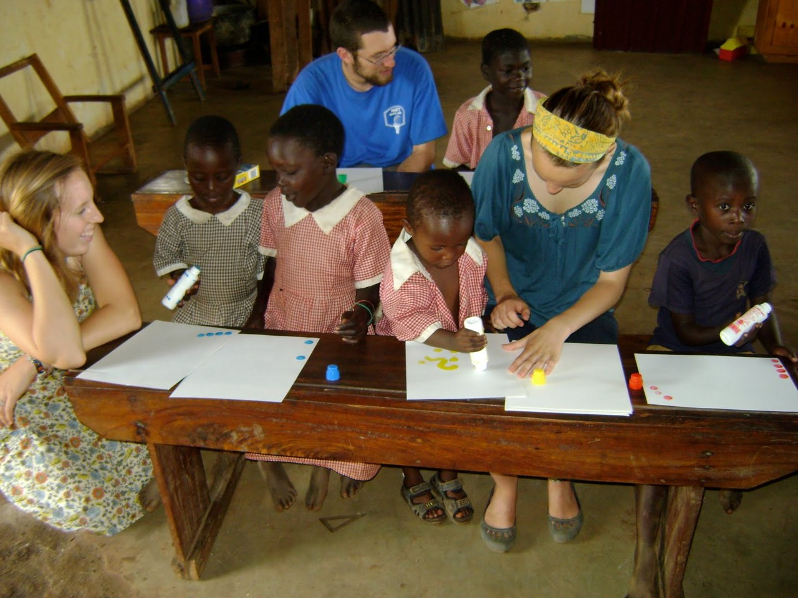

<http://showmefellows.tumblr.com/post/8152810215/achieving-universal-primary-education-earlier>

**TOPIC 3. Slum Schools**

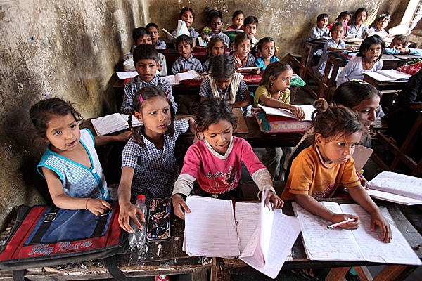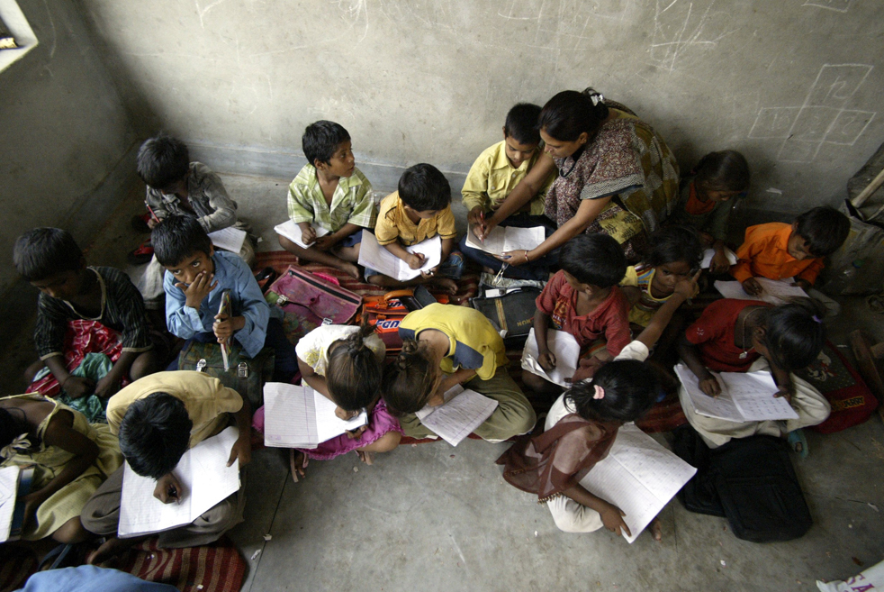

<http://www.volunteeringwithindia.org/our-programs/teaching-volunteer-program-india> <http://blogs.sacbee.com/photos/2009/09/international-literacy-day.html>

**TOPIC 4. Private or Public Schools for the Poor?**

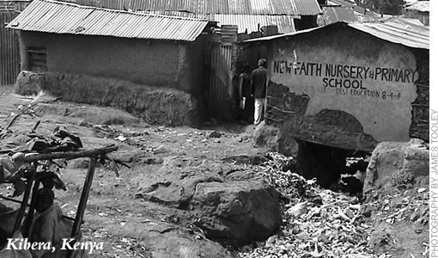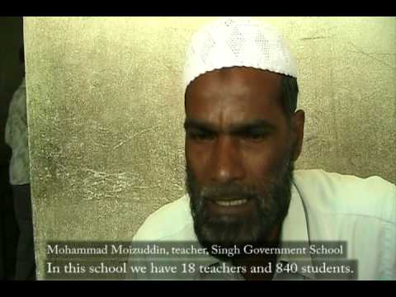

**TOPIC 5. Inside Slum Schools**

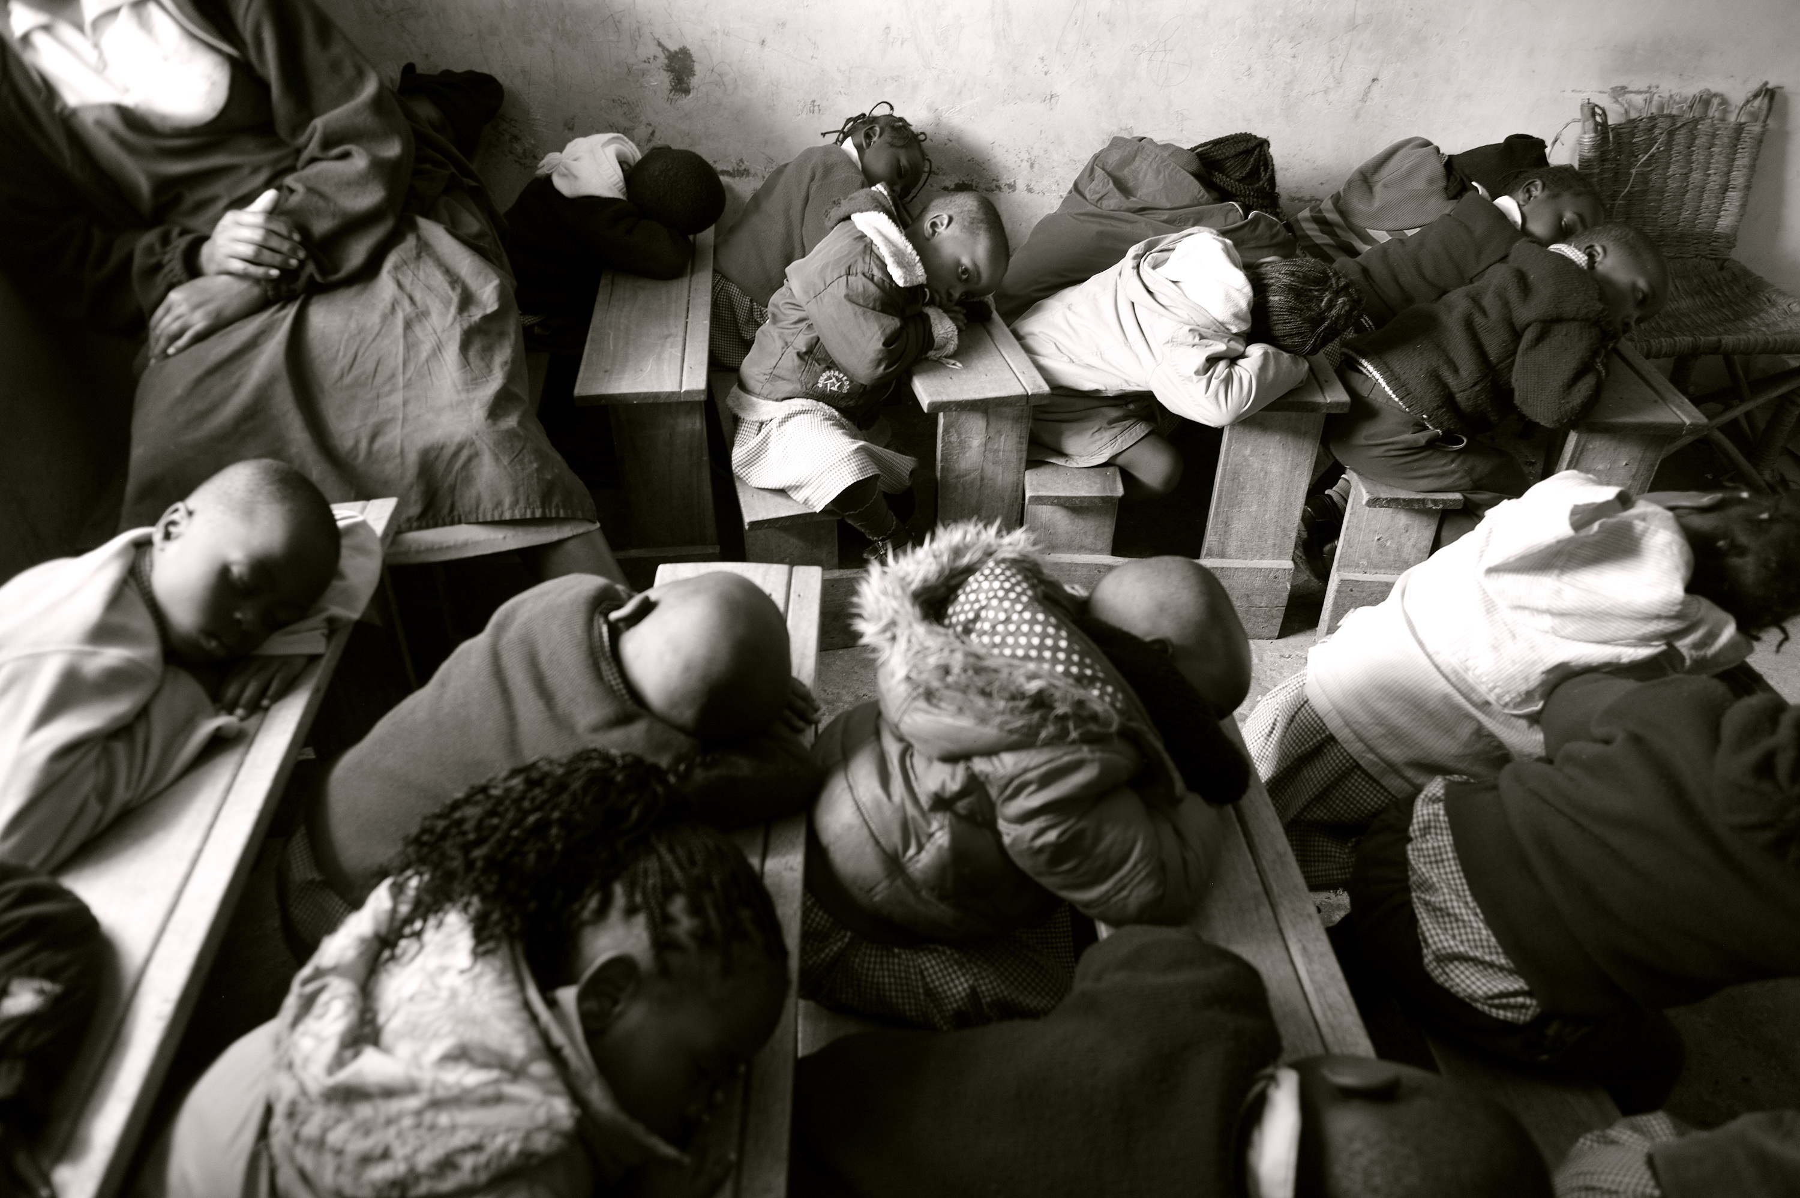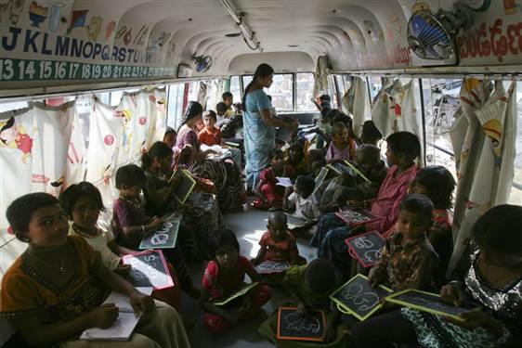

Children write letters from the Telugu alphabet as a teacher conducts lessons inside a bus converted into a school at a slum in the southern Indian city of Hyderabad. Photo - Krishnendu Halder  /  Reuters

**TOPIC 6. Improving Female School Participation**

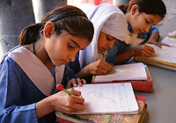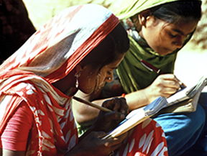

<http://www.unicef.org/infobycountry/bege_35996.html>

<http://www.girlup.org/learn/education.html>

**TOPIC 7. Educational Innovation in the Slums**

