**Project 2 Agency Assessment**

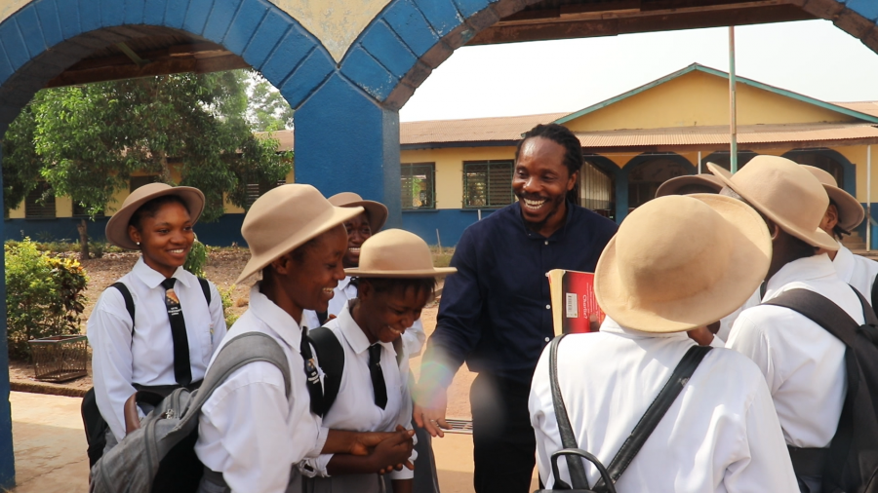Topic: Agency Assessment and Potential Internship Setup for Research on “Political Parties, Education in Sierra Leones’s Development

Photo Courtesy: (*Info, n.d.*). (Former Minister of Basic and Senior Secondary Education, 2019 - 2023, Dr. David Moinina Sengeh, who is now the Chief Minister and Chief Innovation Officer of the Government of Sierra Leone, is speaking to some secondary girls in Freetown, Sierra Leone)

Patrick Freeman

Doctor of Philosophy in Global Development,

William Carey International University

GD 750: Research Methods II: Qualitative Research Methods

Dr. Viv Grigg

November 12, 2024

Table of Contents

Table of Content 2

Introduction 3

Comparative Overview of Potential Agencies 3

1. Ministry of Basic and Secondary Education, Sierra Leone (MBSSE) 3

2. UNICEF Sierra Leone 3

3. UNESCO Sierra Leone 4

4. The World Bank in Sierra Leone 4

Approach to Setting Up a Potential Internship 4

1. Initial Contact and Interest Alignment 4

2. Exploration of Agency Needs and Priorities 4

3. Service Learning Agreement (Exploratory) 5

4. Research Topic and Methodology Refinement 5

Steps to Solidify Existing Relationships and Refine Research Topics 5

1. Formal Introduction to Key MBSSE Officials 5

2. Proposal Development 5

3. Formalizing Agreements 5

4. Continuous Engagement 5

Conclusion 6

BIBLIOGRAPHY 7

**AGENCY ASSESSMENT AND POTENTIAL INTERNSHIP SETUP FOR RESEARCH ON “POLITICAL PARTIES, EDUCATION IN SIERRA LEONE’S DEVELOPMENT”**

# Introduction

*Education is the most important weapon which you can use to change the world-*

*Nelson Mandela (A-Z quotes*. (n.d.).

In pursuit of my research on "Political Parties, Education in Sierra Leone's Development," I have identified four key agencies that closely align with my interests and offer potential fieldwork and collaboration opportunities. Each agency contributes uniquely to Sierra Leone’s educational and policy landscape, providing insights into the intersection of political influence and educational development. These organizations are:

1. Ministry of Basic and Secondary Education, Sierra Leone (MBSSE)

2. UNICEF Sierra Leone

3. UNESCO Sierra Leone

4. The World Bank in Sierra Leone

# Comparative Overview of Potential Agencies

# 1. Ministry of Basic and Secondary Education, Sierra Leone (MBSSE)

The MBSSE is Sierra Leone's principal government body overseeing primary and secondary educational policies. It offers valuable insight into how political influences shape educational priorities, including curriculum standards, resource allocation, and policy implementation. Partnering with the MBSSE would provide access to policymakers and direct data on educational outcomes, enabling a closer examination of how political agendas impact the national educational framework. The main challenge may involve navigating bureaucratic processes; however, by building relationships with MBSSE officials, I could facilitate timely access to necessary information (*MBSSE – Ministry of Basic and Senior Secondary Education*, n.d.).

# 2. UNICEF Sierra Leone

UNICEF Sierra Leone plays a critical role in promoting the rights of children and ensuring access to quality education, particularly in underserved communities. Their programs focus on improving educational outcomes, supporting child-friendly schools, and advocating for policies that enhance education equity. Collaborating with UNICEF would provide a platform to analyze how political dynamics influence the implementation of education initiatives and the responsiveness of policies to the needs of vulnerable populations. However, due to the high demand for partnerships, a compelling proposal that highlights mutual benefits and aligns with their advocacy goals would be essential to secure collaboration (*UNICEF Sierra Leone, 2022*).

# 3. UNESCO Sierra Leone

Focusing on building capacity in education, particularly around inclusive quality education and lifelong learning, UNESCO’s office in Sierra Leone works on initiatives to improve teacher training, student outcomes, and policy integration within the national context. Their support for education reform includes a focus on gender equality and curriculum development, which can provide comparative insights on the role of political parties in shaping educational goals and standards. Collaborating with UNESCO could allow for valuable access to international frameworks and the expertise needed to evaluate Sierra Leone’s education policies within a broader context, while also situating findings within the national development goals and priorities (UNESCO *Sierra Leone*, n.d.)

# 4. The World Bank in Sierra Leone

The World Bank is a significant partner in educational development in Sierra Leone, focusing on enhancing the quality and accessibility of education. Their initiatives aim to improve the management of education systems, increase teacher effectiveness, and address barriers to education for marginalized groups. Through funding and strategic support for educational reforms, the World Bank is instrumental in shaping policies that influence educational outcomes. An internship with the World Bank would provide access to data on project implementation and policy impacts, as well as insights into best practices in education governance and development strategies (*Sierra Leone*, n.d.)

# Approach to Setting Up a Potential Internship

To establish a meaningful internship with these agencies, I would take the following steps:

# 1. Initial Contact and Interest Alignment

I will initiate contact with each organization, presenting my research proposal to highlight areas where my work aligns with their mission. This outreach will include a clear outline of how my research could contribute to their goals, particularly in exploring the connections between political decision-making and educational outcomes.

# 2. Exploration of Agency Needs and Priorities

Upon initial contact, I would arrange follow-up meetings with relevant departments to better understand each agency’s current projects and data needs. This step will help identify areas where my research can provide actionable insights. For instance, the MBSSE may benefit from an analysis of how political agendas influence resource allocation, while UNICEF might be interested in understanding the policy impact on education access in underserved areas.

# 3. Service Learning Agreement (Exploratory)

To formalize expectations, I would draft a preliminary service learning agreement detailing the scope, objectives, and potential timelines for the internship. This agreement would establish clear terms around data access, confidentiality, and intellectual property rights, along with the logistical support needed from the agency, such as access to internal data or permission to conduct interviews.

# 4. Research Topic and Methodology Refinement

Once an agency partnership is confirmed, I would refine my research focus based on the agency’s specific needs and resources. A collaboration with UNESCO, for instance, could prompt a regional policy comparison, while a partnership with the World Bank might emphasize data-driven insights into policy effectiveness and funding impacts on educational quality.

# Steps to Solidify Existing Relationships and Refine Research Topics

Building on existing connections, particularly with the Ministry of Education, I would undertake these steps to strengthen potential partnerships:

# 1. Formal Introduction to Key MBSSE Officials

I would schedule a formal meeting to discuss my research goals, presenting the alignment between my work and MBSSE current initiatives. This step would foster trust and could open opportunities for mentorship from policymakers.

# 2. Proposal Development

I would develop a detailed research proposal tailored to each agency, highlighting the potential contributions of my research to their programs and goals. The proposal would clearly outline expected outcomes and emphasize how my findings could inform policy decisions or support program implementations.

# 3. Formalizing Agreements

Upon securing interest, I would work toward a formal agreement outlining the responsibilities, timelines, and outputs expected from the collaboration. This document would also clarify data access permissions and the support structure needed to facilitate the internship.

# 4. Continuous Engagement

Throughout the internship process, I would maintain regular communication with agency contacts to ensure my research aligns with their objectives, allowing for adjustments to the research focus based on their feedback and evolving needs.

# Conclusion

Building partnerships with these agencies could provide a multifaceted view of how political parties shape education in Sierra Leone. Collaborating with the Ministry of Education would offer policy-level insights, while organizations like UNICEF, UNESCO, and the World Bank would contribute perspectives on community impact, implementation challenges, and regional standards. These collaborations would ground my PhD research in both policy analysis and practical challenges within the education sector.

Through this agency assessment, I aim to establish a partnership that not only supports my research objectives but also contributes positively to Sierra Leone’s educational landscape. By carefully evaluating each organization’s alignment with my goals, I intend to lay the groundwork for an internship that fosters meaningful change in educational policy and practice.

# 

# BIBLIOGRAPHY

*Info*. (n.d.). Bing. <https://www.bing.com/>

*MBSSE – Ministry of Basic and Senior Secondary Education*. (n.d.). <https://www.mbsse.gov.sl/>

*TOP 25 IMPORTANCE OF EDUCATION QUOTES (of 54) | A-Z quotes*. (n.d.). A-Z Quotes. <https://www.azquotes.com/quotes/topics/importance-of-education.html>

*Sierra Leone*. (n.d.). World Bank. <https://www.worldbank.org/en/country/sierraleone>

*UNICEF Sierra Leone* (2022). UNICEF. <https://www.unicef.org/sierraleone/education>

*UNESCO Sierra Leone*. (n.d.). UNESCO. <https://www.unesco.org/en>