8/19/24, 2:24 PM Doing Action Research in Your Own Organization: Coghlan, David: 9781526458827: Amazon.com: Books

[**A**](https://www.amazon.com/Doing-Action-Research-Your-Organization/dp/1526458829/?_encoding=UTF8&pd_rd_w=57uf2&content-id=amzn1.sym.f76d456a-cb0d-44de-b7b0-670c26ce80ba&pf_rd_p=f76d456a-cb0d-44de-b7b0-670c26ce80ba&pf_rd_r=142-2852469-3801512&pd_rd_wg=dla5p&pd_rd_r=35ffd964-b006-47a1-8e93-8a02fc91925d&ref_=aufs_ap_sc_dsk&asin=1526458829&revisionId&format=4&depth=1)**vailable Samples:** [Kindle](https://read.amazon.com/sample/B07M962Q5J?f=2&l=en_US&rid=2VFHAHYBMNZZC1PV9J06&sid=142-2852469-3801512&cid=A2W7EEZ64VW6I0&ref_=litb_d&r=df175980)

[Close](https://www.amazon.com/gp/css/order-history?ref_=nav_orders_first)

[David Coghlan](https://www.amazon.com/David-Coghlan/e/B000APNB60/ref%3Dlitb_aut)

[Paperback](https://read.amazon.com/sample/1526458829?f=4&l=en_US&rid=2VFHAHYBMNZZC1PV9J06&sid=142-2852469-3801512&cid=A2W7EEZ64VW6I0&ref_=litb_d)

[**Doing Action**](https://health.amazon.com/prime?ref_=nav_cs_all_health_ingress_onem_h)[**Research in**](https://www.amazon.com/fmc/learn-more?ref_=nav_cs_groceries) **Y**[**our Own**](https://www.amazon.com/health-personal-care-nutrition-fitness/b/?ie=UTF8&node=3760901&ref_=nav_cs_hpc)[**Organization**](https://www.amazon.com/Advanced-Search-Books/b/?ie=UTF8&node=241582011&ref_=sv_b_3)

[87 ratings](https://www.amazon.com/product-reviews/1526458829)

[**Paperback:**](https://www.amazon.com/health-personal-care-nutrition-fitness/b/?ie=UTF8&node=3760901&ref_=nav_cs_hpc)

[$46](https://www.amazon.com/health-personal-care-nutrition-fitness/b/?ie=UTF8&node=3760901&ref_=nav_cs_hpc)[70](https://www.amazon.com/stores/node/20648519011?channel=discovbar%3Ffield-lbr_brands_browse-bin%3DAmazonBasics&ref_=nav_cs_amazonbasics)

[Add to Cart](https://www.amazon.com/amazonbookclubs/?_encoding=UTF8&ref_=sv_b_7)

[Sold by](https://www.amazon.com/stores/page/A9784236-8EDB-4131-8AA0-23930A929812/?_encoding=UTF8&pd_rd_w=f8wcM&content-id=amzn1.sym.c9278480-dd5c-4690-bc4f-87fdda0d1503&pf_rd_p=c9278480-dd5c-4690-bc4f-87fdda0d1503&pf_rd_r=2VFHAHYBMNZZC1PV9J06&pd_rd_wg=JPnA4&pd_rd_r=6440ea4e-29fd-4d09-b3a9-bb44d4a9ce9e) [Ample Books](https://www.amazon.com/sp?_encoding=UTF8&marketplaceID=ATVPDKIKX0DER&seller=A2P4HWVGU79BW0) [and Fulﬁlled by Amazon.](https://www.amazon.com/stores/page/A9784236-8EDB-4131-8AA0-23930A929812/?_encoding=UTF8&pd_rd_w=f8wcM&content-id=amzn1.sym.c9278480-dd5c-4690-bc4f-87fdda0d1503&pf_rd_p=c9278480-dd5c-4690-bc4f-87fdda0d1503&pf_rd_r=2VFHAHYBMNZZC1PV9J06&pd_rd_wg=JPnA4&pd_rd_r=6440ea4e-29fd-4d09-b3a9-bb44d4a9ce9e)

[Skip to main conte](https://www.amazon.com/ref%3Dnav_logo)[nt Deliver to Viv](https://www.amazon.com/Doing-Action-Research-Your-Organization/dp/1526458829/?_encoding=UTF8&pd_rd_w=57uf2&content-id=amzn1.sym.f76d456a-cb0d-44de-b7b0-670c26ce80ba&pf_rd_p=f76d456a-cb0d-44de-b7b0-670c26ce80ba&pf_rd_r=142-2852469-3801512&pd_rd_wg=dla5p&pd_rd_r=35ffd964-b006-47a1-8e93-8a02fc91925d&ref_=aufs_ap_sc_dsk&asin=1526458829&revisionId&format=4&depth=1) [Hello, Viv](https://www.amazon.com/gp/css/homepage.html?ref_=nav_youraccount_btn) [Returns](https://www.amazon.com/gp/css/order-history?ref_=nav_orders_first)

[**Pomona 91766**](https://www.amazon.com/Doing-Action-Research-Your-Organization/dp/1526458829/?_encoding=UTF8&pd_rd_w=57uf2&content-id=amzn1.sym.f76d456a-cb0d-44de-b7b0-670c26ce80ba&pf_rd_p=f76d456a-cb0d-44de-b7b0-670c26ce80ba&pf_rd_r=142-2852469-3801512&pd_rd_wg=dla5p&pd_rd_r=35ffd964-b006-47a1-8e93-8a02fc91925d&ref_=aufs_ap_sc_dsk&asin=1526458829&revisionId&format=4&depth=1)Books Searc[h Amazon](https://read.amazon.com/sample/B07M962Q5J?f=2&l=en_US&rid=2VFHAHYBMNZZC1PV9J06&sid=142-2852469-3801512&cid=A2W7EEZ64VW6I0&ref_=litb_d&r=df175980) [**EN**](https://www.amazon.com/customer-preferences/edit?ie=UTF8&preferencesReturnUrl=%2FDoing-Action-Research-Your-Organization%2Fdp%2F1526458829%2F%3F_encoding%3DUTF8%26pd_rd_w%3D57uf2%26content-id%3Damzn1.sym.f76d456a-cb0d-44de-b7b0-670c26ce80ba%26pf_rd_p%3Df76d456a-cb0d-44de-b7b0-670c26ce80ba%26pf_rd_r%3D142-2852469-3801512%26pd_rd_wg%3Ddla5p%26pd_rd_r%3D35ffd964-b006-47a1-8e93-8a02fc91925d%26ref_%3Daufs_ap_sc_dsk&ref_=topnav_lang)[**Account & Lists**](https://www.amazon.com/gp/css/homepage.html?ref_=nav_youraccount_btn)[**& Orders**](https://www.amazon.com/gp/css/order-history?ref_=nav_orders_first)

**All** [Same-Day Delivery](https://www.amazon.com/gp/browse.html?node=21382124011&ref_=nav_cs_SSD_nav_storefront) [Medical Care](https://health.amazon.com/prime?ref_=nav_cs_all_health_ingress_onem_h) [Groceries](https://www.amazon.com/fmc/learn-more?ref_=nav_cs_groceries) [Household, Health & Baby Care](https://www.amazon.com/health-personal-care-nutrition-fitness/b/?ie=UTF8&node=3760901&ref_=nav_cs_hpc) [Amazon Basics](https://www.amazon.com/stores/node/20648519011?channel=discovbar%3Ffield-lbr_brands_browse-bin%3DAmazonBasics&ref_=nav_cs_amazonbasics) [Buy Again](https://www.amazon.com/gp/buyagain?ie=UTF8&ref_=nav_cs_buy_again) [Livestreams](https://www.amazon.com/live?ref_=nav_cs_amazonlive)

[**Books**](https://www.amazon.com/books-used-books-textbooks/b/?ie=UTF8&node=283155&ref_=topnav_storetab_b)[Kindle Rewards](https://www.amazon.com/kindlerewards/?_encoding=UTF8&ref_=sv_b_2) [Advanced Search](https://www.amazon.com/Advanced-Search-Books/b/?ie=UTF8&node=241582011&ref_=sv_b_3) [New Releases](https://www.amazon.com/gp/new-releases/books/?ie=UTF8&ref_=sv_b_4) [Best Sellers & More](https://www.amazon.com/b/?ie=UTF8&node=16857165011&ref_=sv_b_5) [Categories](https://www.amazon.com/books-used-books-textbooks/b/?ie=UTF8&node=283155&ref_=sv_b_6) [Amazon Book Clubs](https://www.amazon.com/amazonbookclubs/?_encoding=UTF8&ref_=sv_b_7) [Children's Books](https://www.amazon.com/Childrens-Books/b/?ie=UTF8&node=4&ref_=sv_b_8) [You](https://www.amazon.com/your-books/?_encoding=UTF8&ref=yb_ip_bsf_d)

‹ [Back to results](https://www.amazon.com/stores/David-Coghlan/author/B000APNB60?ref=sr_ntt_srch_lnk_8&qid=1724102452&sr=1-8&isDramIntegrated=true&shoppingPortalEnabled=true)

g Action Research in Your [Kindle](https://www.amazon.com/Doing-Action-Research-Your-Organization-ebook/dp/B07M962Q5J/ref%3Dtmm_kin_swatch_0?_encoding=UTF8&qid&sr) [Hardcover](https://www.amazon.com/Doing-Action-Research-Your-Organization/dp/1526458810/ref%3Dtmm_hrd_swatch_0?_encoding=UTF8&qid&sr)

Organization Fifth Edition [**$39.99** after credits](https://www.amazon.com/Doing-Action-Research-Your-Organization-ebook/dp/B07M962Q5J/ref%3Dtmm_kin_swatch_0?_encoding=UTF8&qid&sr) [**$77.39 - $160.**](https://www.amazon.com/Doing-Action-Research-Your-Organization/dp/1526458810/ref%3Dtmm_hrd_swatch_0?_encoding=UTF8&qid&sr)

[$42.99 before credits](https://www.amazon.com/Doing-Action-Research-Your-Organization-ebook/dp/B07M962Q5J/ref%3Dtmm_kin_swatch_0?_encoding=UTF8&qid&sr)

[d Coghlan](https://www.amazon.com/David-Coghlan/e/B000APNB60/ref%3Ddp_byline_cont_book_1) (Author)

87 ratings See all formats **Paperback**

n Goodreads 110 ratings and editions **$35.94 - $46.70**

Concise and unintimidating, the ﬁfth edition of this Other Used and New from $35.94 bestselling book is the only pragmatic, quick-start guide to

the main theories, issues, and approaches to insider action **Delivery** Pickup research.

With an encouraging and approachable tone, David is the

perfect mentor for anyone conducting action research in **Buy new:**

their own organization. Calming nerves at the same time as -15% $4670

building conﬁdence, he helps readers devise an appropriate

research design that anticipates possible challenges and ﬁts List Price: $55.00 within the limits of their environments. One-Day A complete do-it-yourself toolkit for every step of the action FREE Returns

research process, this edition is outﬁtted with: FREE delivery **Tomorrow, August 20**. Or

- RReeaal-dwmoroldrestudent and professional case studies within 7 hrs 22 mins

Roll over image to zoom in

Report an issue with this product or seller Deliver to Viv - Pomona 91766

**Look inside**

ISBN-10 ISBN-13 **Only 1 left in stock - order soon.**

**Follow the author** Add to Cart

[David](https://www.amazon.com/David-Coghlan/e/B000APNB60/ref%3Daufs_dp_fta_an_dsk) **1526458829 978-1526458827** Buy Now

[Coghlan](https://www.amazon.com/David-Coghlan/e/B000APNB60/ref%3Daufs_dp_fta_an_dsk) Follow

Ships from Amazon

Sold by [Ample Books](https://www.amazon.com/gp/help/seller/at-a-glance.html/ref%3Ddp_merchant_link?ie=UTF8&seller=A2P4HWVGU79BW0&asin=1526458829&ref_=dp_merchant_link&isAmazonFulfilled=1)

Better Data Visualizations: A Guide Returns 30-day refund/replaceme

for Scholars, Researchers, and Wonks Gift options Available at checkout

by Jonathan Schwabish CusSteoemmerorseervice Amazon

359 | $26.67

| Paperback

Shop now › **Save with Used - Good**

Sponsored

$3594

Frequently bought together FREE delivery **August 29 - September 6**

Ships from: textbooks_source Sold by: textbooks_source

+ + Total price: $129.06

Add all 3 to Cart

**This item:** Doing [Action Research: An](https://www.amazon.com/Action-Research-Educational-Improvement-Christopher-Gordon/dp/1442223693/ref%3Dpd_bxgy_d_sccl_1/142-2852469-3801512?pd_rd_w=vsF5O&content-id=amzn1.sym.04064661-569a-4d64-8aef-6cc4eefc1253&pf_rd_p=04064661-569a-4d64-8aef-6cc4eefc1253&pf_rd_r=2VFHAHYBMNZZC1PV9J06&pd_rd_wg=1S0lH&pd_rd_r=802a0d4a-deb0-437f-b98c-7cef95ff5cde&pd_rd_i=1442223693&psc=1) [Learning to](https://www.amazon.com/Learning-Improve-Americas-Schools-Getting/dp/1612507913/ref%3Dpd_bxgy_d_sccl_2/142-2852469-3801512?pd_rd_w=vsF5O&content-id=amzn1.sym.04064661-569a-4d64-8aef-6cc4eefc1253&pf_rd_p=04064661-569a-4d64-8aef-6cc4eefc1253&pf_rd_r=2VFHAHYBMNZZC1PV9J06&pd_rd_wg=1S0lH&pd_rd_r=802a0d4a-deb0-437f-b98c-7cef95ff5cde&pd_rd_i=1612507913&psc=1) Add to List

Action Research in [Educational](https://www.amazon.com/Action-Research-Educational-Improvement-Christopher-Gordon/dp/1442223693/ref%3Dpd_bxgy_d_sccl_1/142-2852469-3801512?pd_rd_w=vsF5O&content-id=amzn1.sym.04064661-569a-4d64-8aef-6cc4eefc1253&pf_rd_p=04064661-569a-4d64-8aef-6cc4eefc1253&pf_rd_r=2VFHAHYBMNZZC1PV9J06&pd_rd_wg=1S0lH&pd_rd_r=802a0d4a-deb0-437f-b98c-7cef95ff5cde&pd_rd_i=1442223693&psc=1) [Improve: How](https://www.amazon.com/Learning-Improve-Americas-Schools-Getting/dp/1612507913/ref%3Dpd_bxgy_d_sccl_2/142-2852469-3801512?pd_rd_w=vsF5O&content-id=amzn1.sym.04064661-569a-4d64-8aef-6cc4eefc1253&pf_rd_p=04064661-569a-4d64-8aef-6cc4eefc1253&pf_rd_r=2VFHAHYBMNZZC1PV9J06&pd_rd_wg=1S0lH&pd_rd_r=802a0d4a-deb0-437f-b98c-7cef95ff5cde&pd_rd_i=1612507913&psc=1)

Your Own… [Leader's Guide to…](https://www.amazon.com/Action-Research-Educational-Improvement-Christopher-Gordon/dp/1442223693/ref%3Dpd_bxgy_d_sccl_1/142-2852469-3801512?pd_rd_w=vsF5O&content-id=amzn1.sym.04064661-569a-4d64-8aef-6cc4eefc1253&pf_rd_p=04064661-569a-4d64-8aef-6cc4eefc1253&pf_rd_r=2VFHAHYBMNZZC1PV9J06&pd_rd_wg=1S0lH&pd_rd_r=802a0d4a-deb0-437f-b98c-7cef95ff5cde&pd_rd_i=1442223693&psc=1) [America’s School…](https://www.amazon.com/Learning-Improve-Americas-Schools-Getting/dp/1612507913/ref%3Dpd_bxgy_d_sccl_2/142-2852469-3801512?pd_rd_w=vsF5O&content-id=amzn1.sym.04064661-569a-4d64-8aef-6cc4eefc1253&pf_rd_p=04064661-569a-4d64-8aef-6cc4eefc1253&pf_rd_r=2VFHAHYBMNZZC1PV9J06&pd_rd_wg=1S0lH&pd_rd_r=802a0d4a-deb0-437f-b98c-7cef95ff5cde&pd_rd_i=1612507913&psc=1) Some of these items

ship sooner than the

$4670 $5687 $2549 others.

Show details **Other sellers on Amazon**

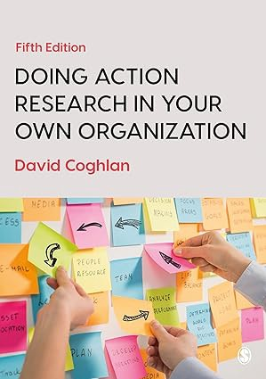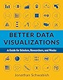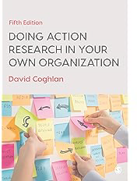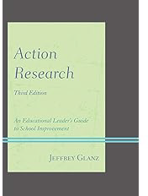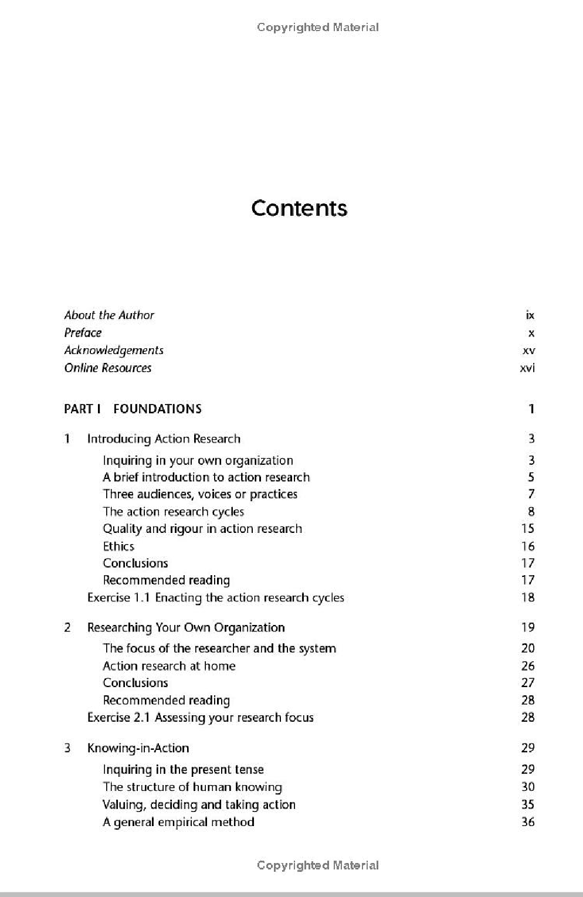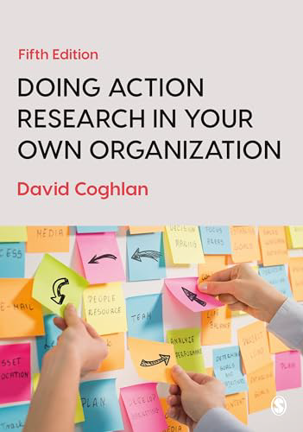

[See more buying options](https://www.amazon.com/Doing-Action-Research-Your-Organization/dp/1526458829/ref%3Dlitb_std_nodl)

Back to Store DOING ACTION RESEARCH IN YOUR OWN ORGANIZATION

Doin

Own

by [Davi](https://www.amazon.com/David-Coghlan/e/B000APNB60/ref%3Ddp_byline_cont_book_1) 4.5

3.6 o

**0**

https://[www.amazon.com/Doing-Action-Research-Your-Organization/dp/1526458829/?_encoding=UTF8&pd_rd_w=57uf2&content-id=amzn1.sym.f76d456a-cb0d-4](http://www.amazon.com/Doing-Action-Research-Your-Organization/dp/1526458829/?_encoding=UTF8&pd_rd_w=57uf2&content-id=amzn1.sym.f76d456a-cb0d-4)… 1/1