QUALITATIVE Research vs. QUANTITATIVE Research
Example 1
QUANTITATIVE Research (book of Daniel):
“⁸ But Daniel resolved not to defile himself with the royal food and wine, and he asked the chief official for permission not to defile himself this way. ⁹ Now God had caused the official to show favor and compassion to Daniel, ¹⁰ but the official told Daniel, “I am afraid of my lord the king, who has assigned your^{[c]} food and drink. Why should he see you looking worse than the other young men your age? The king would then have my head because of you.”
¹¹ Daniel then said to the guard whom the chief official had appointed over Daniel, Hananiah, Mishael and Azariah, ¹² “Please test your servants for ten days: Give us nothing but vegetables to eat and water to drink. ¹³ Then compare our appearance with that of the young men who eat the royal food, and treat your servants in accordance with what you see.” ¹⁴ So he agreed to this and tested them for ten days.
¹⁵ At the end of the ten days they looked healthier and better nourished than any of the young men who ate the royal food. ¹⁶ So the guard took away their choice food and the wine they were to drink and gave them vegetables instead.” (Daniel, 1: 8-15 NIV)

The Quantitative Research in Daniel’s story was used to prove Daniel’s “hypotheses”:
- Sample size – 4 young men (Daniel and his friends)
- Test length – 10 days
- Weight measured at the beginning of the new diet and after 10 days of the diet
- Conclusion about Daniel’s “hypothesis” was made based on the results of calculations

Quantitative Research:
- Begins with theory/hypotheses
- Tests hypothesis (Daniel’s assumption, an idea that was proposed for the sake of argument so that it can be tested to see if it might be true)
- Expressed in numbers
- Allows opportunity for measuring a larger sample size
- Uses Math/Statistical Analysis

QUALITATIVE Research (Gospel of Luke)
“Many have undertaken to draw up an account of the things that have been fulfilled^{[a]} among us, ² just as they were handed down to us by those who from the first were eyewitnesses and servants of the word. ³ With this in mind, since I myself have carefully investigated everything from the beginning, I too decided to write an orderly account for you, most excellent Theophilus, ⁴ so that you may know the certainty of the things you have been taught.” (Luke 1:1-4, NIV)
Luke
- was born between 1 AD and 16 AD
- died between 84 AD and 100 AD
Paul
- was born around 4 BC
- died around 62–64 AD

How did Luke (most likely) collect information:
- Lots of different ideas about Jesus were floating around during those times - contradicting descriptions about Jesus and his teaching
- Luke wanted to discover a factual information from “first eyewitnesses”
- Luke “have carefully investigated everything.” Most likely, he:
- Talked to disciples of Jesus
- Talked to healed people
- Talked to relatives of Jesus
- Talked to apostle Paul
- Talked to pharisees
- Observed places where Jesus lived/taught/travelled
- Observed objects that belonged to Jesus, his disciples, family, friends
- Investigated many other written sources about Jesus (“many have undertaken to draw up an account of the things that have been fulfilled among us”)
- Talked to other people who wrote about Jesus
- Investigated official state information

Qualitative Research
- Ends with theory/hypothesis (conclusion about who Jesus was and what he taught)
- Formulates hypothesis - theory/hypothesis emerges during the process of investigation (as Luke collects all different pieces of evidence from different sources)
- Expressed in words
- Usually uses smaller sample size
- Summarizes, categorizes, interprets (“I … decided to write an orderly account…. so that you may know the certainty of the things you have been taught”).
If, for example, 35 out of 40 people Luke interviewed said that Jesus turned water into wine, most likely this event did really take place, and Luke confidently added this event to his “account”

Example 2
QUANTITATIVE Research
Starts from the Hypotheses (Idea/Assumption): “The new method of teaching that was tested at 100 schools in district X during the last academic year has improved students’ performance.”
Research Process:
- Collects data on student grades
- Calculates how many A, B, C, D grades were received by students during the test at the beginning of the academic year.
- Calculates how many A, B, C, D grades were received by students during the test at the end of the academic year.
- Based on the collected quantitative data and statistical analysis, conclusions are made if the hypothesis is true or not.

QUALITATIVE Research
It starts with a question: “Why did the new method have improved the students’ performance?”
Research Process:
- Interviews with developers of new teaching method
- Interviews with teachers
- Interviews with students
- Observations of the lessons
- Student papers analysis
- Based on the collected data, we can answer the question, “Why did the new method improve the students’ performance?”

KEY CONCEPTS
Qualitative Research:
- Is interested in how meaning is constructed, how people make sense of their lives and their worlds. The primary goal of a basic qualitative study is to uncover and interpret these meanings.

- Is a relatively young approach, so new methods of qualitative research designs are emerging and existing methods have been improved and reimagined

- Still gets resistance especially from the fields that traditionally used Quantitative Research

- However, more and more fields are getting interested in Qualitative Research

- Qualitative research is inductive

- “The research process for qualitative researchers is emergent. This means that the initial plan for research cannot be tightly prescribed, and some or all phases of the process may change or shift after the researcher enters the field and begins to collect data. For example, the questions may change, the forms of data collection may shift, and the individuals studied and the sites visited may be modified. These shifts signal that the researchers are delving deeper and deeper into the topic or the phenomenon under study. The key idea behind qualitative research is to learn about the problem or issue from participants and to address the research to obtain that information”
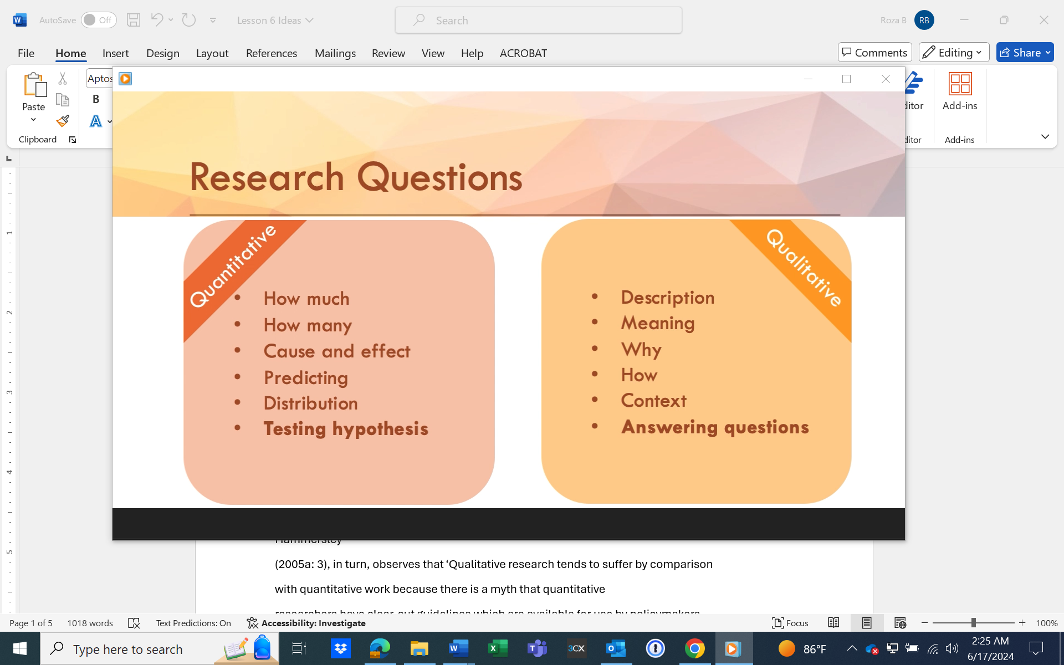

QUALITATIVE DATA ANALYSES
The goal of data analysis is the process of making sense out of the data.
And making sense out of data involves consolidating, reducing, and interpreting what people have said and what the researcher has seen and read—it is the process of making meaning.
Collection and analysis should be a simultaneous process in qualitative research.
The overall process of data analysis begins by identifying segments in your data set that are responsive to your research questions.

Coding
“Coding is nothing more than assigning some sort of shorthand designation to various aspects of your data so that you can easily retrieve specific pieces of the data. The designations can be single words, letters, numbers, phrases, colors, or combinations of these. Most often a code is “a word or short phrase that symbolically assigns a summative, salient, essence-capturing, and/or evocative attribute for a portion of language-based or visual data” (Saldaña, 2013, p. 3).

Example
Topic of the study
Online Education: Benefits and Challenges of Refugee Students

Data Collected (about 1000 pages)
- 14 interviews
- 3 observations of online courses
- Observation of the organizational online learning management System
- 33 documents

Research Questions
1) In what ways, if any, does the JWL's distance educational model support refugee population and facilitate its access to education?
2) What factors support or challenge the JWL's distance educational model in providing higher education opportunities to refugee students in Jordan, Iraq, Kenya, Malawi?
3) What are the implications of this study for educators, policy makers of countries hosting large refugee populations, and international and local NGOs operating in the region that are attempting to help a greater number of refugees?
Provisional Codes created (1st cycle of coding)
1) JWL’s online educational model
2) Challenges JWL faces in delivering online education to refugee students residing in Jordan, Iraq, Kenya, Malawi.
3) Barriers or challenges to Higher Education that JWL's distance educational model was able to eliminate for the refugee population.
4) How, in general, the JWL supports refugees and their access to higher education.
5) Advantages and implications of JWL's distance educational model in affecting access to higher education for refugees.
6) Disadvantages or limitations of JWL"s educational model.

Coding Process
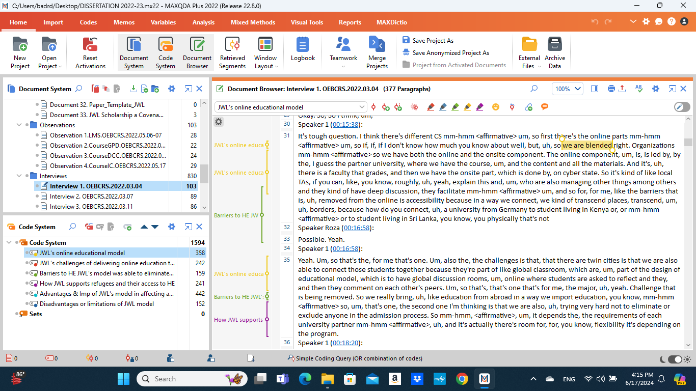

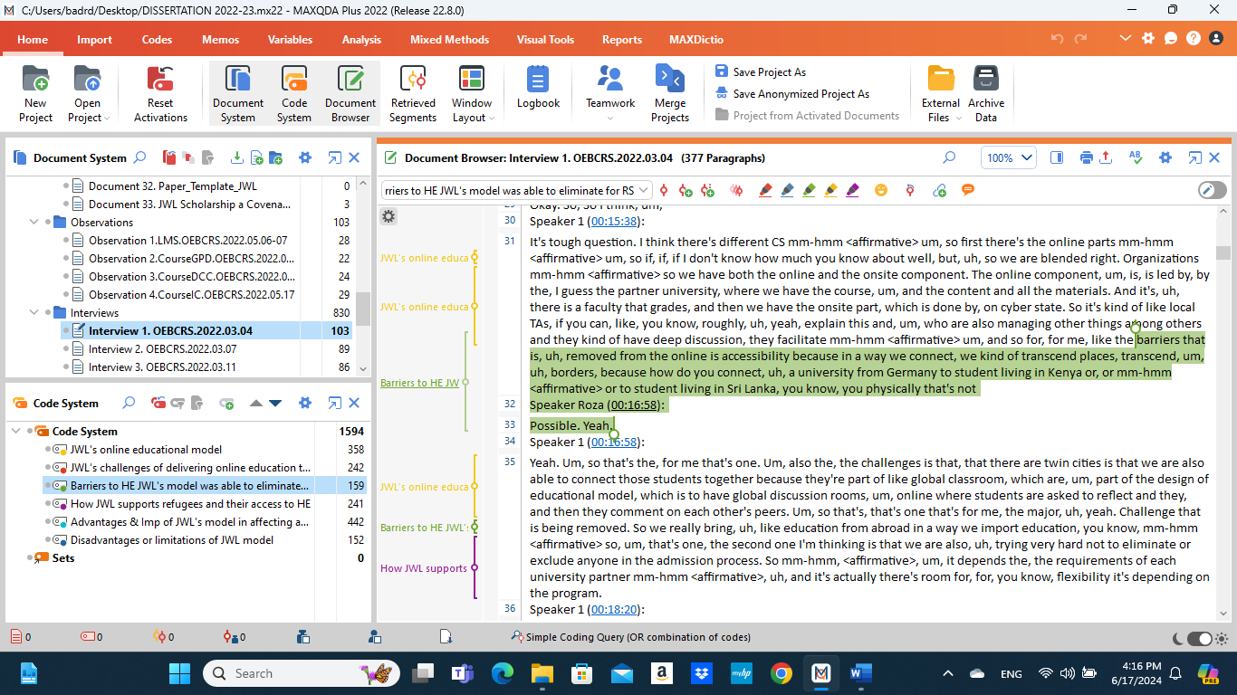

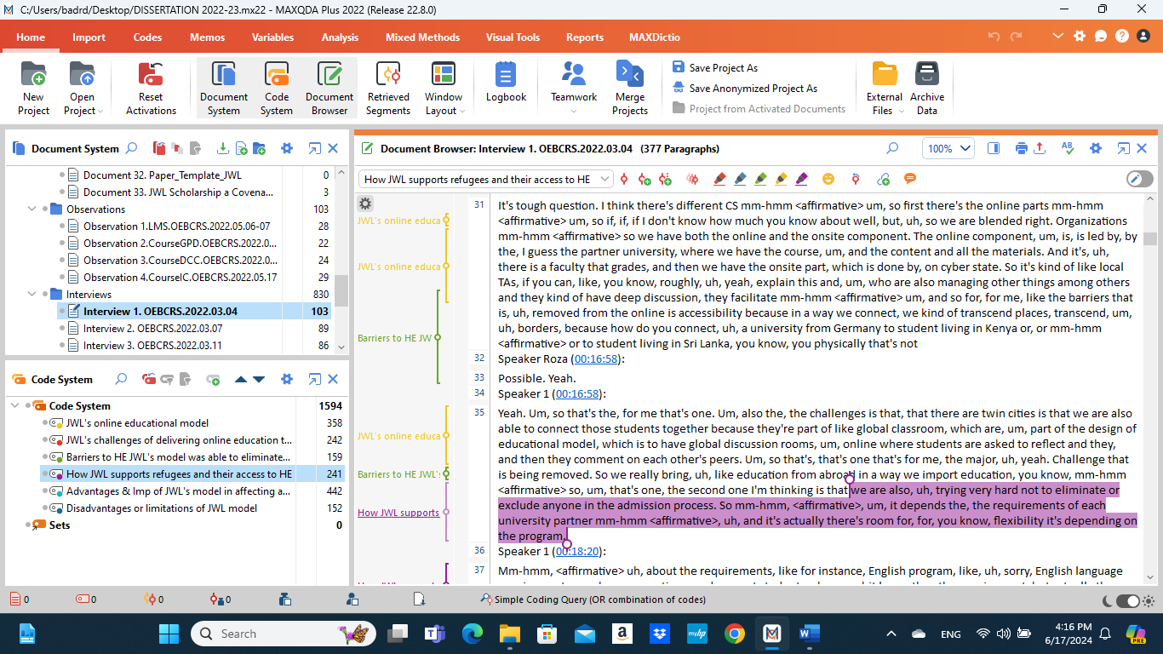

Figure of the Entire Coding Process (1st and 2nd cycles of coding, Roza’s research description is continued)
See doc “Figure Coding Process”

Different sequences of a coding process
- develop codes only on the basis of the emerging information collected from participants
- use predetermined codes and then fit the data to them
- use some combination of emerging and predetermined codes.
The traditional approach in the social sciences is to allow the codes to emerge during the data analysis.
In the health sciences, a popular approach is to use predetermined codes based on the theory being examined.

6 COMMON QUALITATIVE RESEARCH DESIGNS
Basic Qualitative Research
- the most common “type” of qualitative research is a basic interpretive study
- interested in (1) how people interpret their experiences, (2) how they construct their worlds, and (3) what meaning they attribute to their experiences. The overall purpose is to understand how people make sense of their lives and their experiences

Phenomenological Qualitative Research
- seeks understanding about the essence and the underlying structure of the phenomenon
- This type of research is based on the assumption that there is an essence or essences to shared experience. These essences are the core meanings mutually understood through a phenomenon commonly experienced. The experiences of different people are bracketed, analyzed, and compared to identify the essences of the phenomenon, for example, the essence of loneliness, the essence of being a mother
Ethnography Qualitative Research
- strives to understand the interaction of individuals not just with others, but also with the culture of the society in which they live.
- Of the various types of qualitative research, ethnography is likely to be the most familiar to researchers. Its history can be traced to late nineteenth-century anthropologists who engaged in participant observation in the “field” (for a brief and interesting history, see Tedlock, 2011). Anthropologists “do” ethnography, a research process, as well as write up their findings as an ethnography, a product. Thus ethnography is both a process and a product. Although ethnography originated in the field of anthropology, nowadays researchers from many fields and disciplines may engage in an ethnographic study.
- The factor that unites all forms of ethnography is its focus on human society and culture. Although culture has been variously defined, it essentially refers to the beliefs, values, and attitudes that structure the behavior patterns of a specific group of people.

Grounded Theory Qualitative Research
- What differentiates grounded theory from other types of qualitative research is its focus on building theory
- Grounded theory is particularly useful for addressing questions about process; that is, how something changes over time.
- Used to analyses social processes and relationships.
- The constant comparative method used to compare new data to previously collected data
- Once the data analysis cannot continue to refine the new theories down, a final theory (theme) is confirmed.

Narrative Qualitative Research
- Uses the stories people tell, analyzing them in various ways, to understand the meaning of the experiences as revealed in the story
- “The oldest and most natural form of sense making” is that of stories or narratives
- Examples of these stories of experience are biography, life history, oral history, autoethnography, and autobiography.

Qualitative Case Studies
- Case studies are a qualitative design in which the researcher explores in depth a program, event, activity, process, or one or more individuals. The case(s) are bound by time and activity, and researchers collect detailed information using a variety of data collection procedures over a sustained period of time.
(from Merriam &Tisdell (2016) Qualitative Research: A Guide to Design and Implementation. Wiley. Kindle Edition)

Additional resources I found very helpful in my qualitative research work:
- Merriam, Sharan B.; Tisdell, Elizabeth J.. Qualitative Research. Wiley. Kindle Edition
- Saldana, Johnny. The Coding Manual for Qualitative Researchers. SAGE Publications. Kindle Edition

Resources requested by students during the class:
MAXQDA Resources:
https://www.maxqda.com/
Check the resources section of the website.
Free for 2 weeks only! Students can get a discount

MAXQDA Online Manual:
https://www.maxqda.com/help-mx24/welcome

Getting Started with MAXQDA
https://www.youtube.com/watch?v=1HLD4xRuMe4

How to code with MAXQDA
https://www.youtube.com/watch?v=al7llMtVCWE

MENDELEY (free application for referencing)

MENDELAY guides:
https://www.mendeley.com/guides

Download:
https://www.mendeley.com/download-reference-manager/linux

Other Qualitative Research Data Analysis Software
(I have not tried them, so don’t know if they are effective. The list is probably longer, but I tried to find either cheap or free once)
QDA Miner Lite
https://provalisresearch.com/products/qualitative-data-analysis-software/freeware/
Free
RQDA
https://www.measureevaluation.org/resources/tools/data-quality/routine-data-quality-assessment-rdqa-curriculum-materials
https://rqda.r-forge.r-project.org/
Free

Taguette
https://www.taguette.org/
Free
Our free ATLAS.ti trial offers complete access to all features of ATLAS.ti across Mac, Windows, and Web versions without any significant limitations – for up to five days within an 20-day period. This period allows you to fully explore ATLAS.ti's capabilities and ease of use in your research projects.

LiGRE
https://ligresoftware.com/?trk=article-ssr-frontend-pulse_little-text-block
Free version (limit on amount of data to analyze, 250 Mb, 10 documents)
Student version $12.95 (monthly, 1 Gb, 25 documents)

