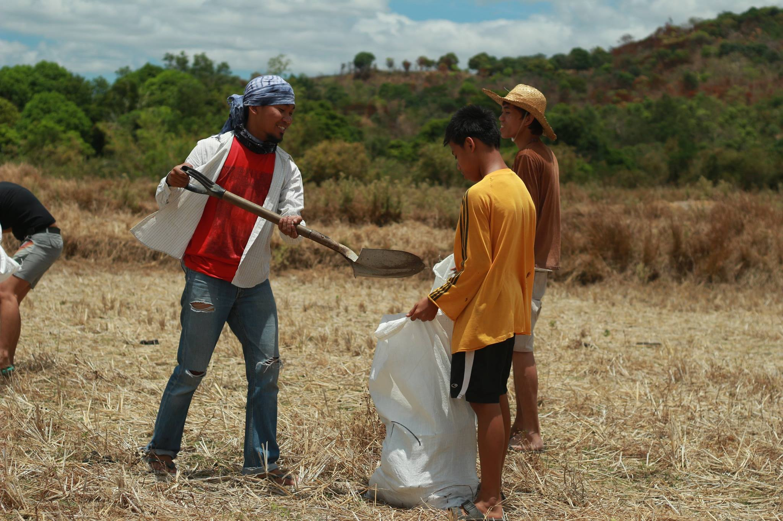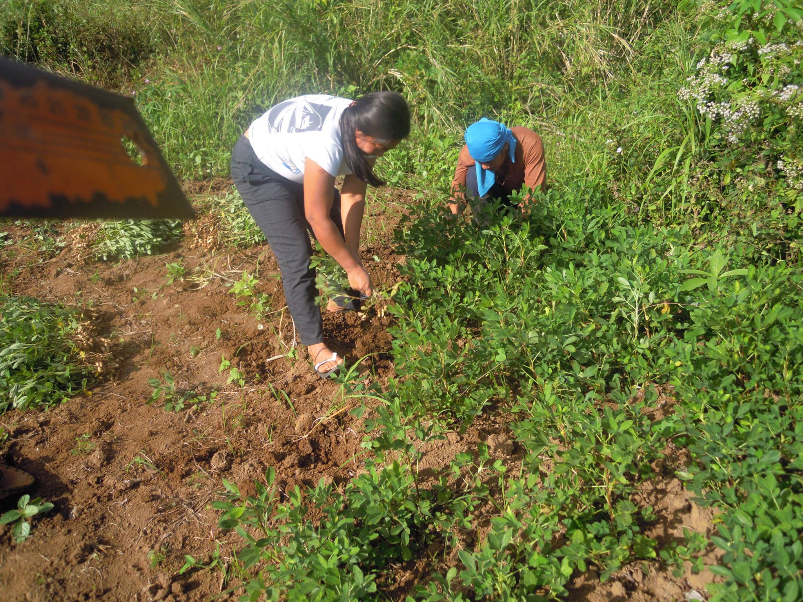

Project 5: Final Project Proposal

**An Exploratory Study on the Impacts of *Sakahang Lilok* on Environmental Stewardship Among Urban Poor Filipinos**

Amanda Tam

TUL670A

Dr. Viv Grigg

Spring 2015

ABSTRACT

*Sakahang Lilok*, is a farm in Rizal, Philippines run by Lilok Foundation and is a retreat site for urban poor churches and ministries from Metro Manila, Philippines. Sakahang Lilok aims to demonstrate how to better care for the land and creation. The focus of this research project is to assess the impacts of Sakahang Lilok and its effects upon urban poor individuals’ perspectives and practices on environmental stewardship.

The project will involve interviews of approximately 20-25 individuals from different communities who previously spent time at the farm. The findings of this research will assist Lilok Foundation and other similar organizations to better understand how to teach urban poor communities about the significance and value of environmental stewardship.

CHAPTER 1 INTRODUCTION

"These are important aspects, but not enough. We need to see, with the eyes of faith, the beauty of God's saving plan, the link between the natural environment and the dignity of the human person."

-Pope Francis, Manila, Philippines, January 2015

**TOPIC**

The need to care for the environment has become more of a mainstream issue across the globe due to emerging awareness of the effects of climate change. Even in the Philippines, plastic bags are banned in cities like Quezon City, Metro Manila, and the mega malls publicize their use of solar energy and concern for Mother Earth. I am aware that issues such as air pollution and waste management are key issues in Metro Manila and affect the urban poor at large, but know little about these issues from a personal level. I see mucky, trash-filled rivers and smoggy, grey skies on a daily basis in Metro Manila, and am aware that this negatively affects the quality of life for informal settlers.

I am passionate about seeing God’s creation cared for well, and even received my undergraduate course in Environmental Studies. In the Bible, God calls us to care for His creation and to steward what we’ve been given well. God intended for His creation to glorify Him, and it wounds Him to see it destroyed and abused; the land has more value than for mere human utility. For this research project, I am interested in exploring how urban poor Filipinos view and practice environmental stewardship. Is it a luxury for urban poor individuals to personally care for the environment when they are primarily focused on surviving in the present? Do the urban poor think about sustainability and the long-term effects of current environmental concerns? If so, how do environmental issues affect them personally?

**RESEARCH QUESTION**

*How do the experiences of urban poor individuals at Sakahang Lilok affect their perspectives and practices of environmental stewardship?*

This research question may seem rather small in focus, but I believe that using urban poor experiences from Sakahang Lilok is a concrete way to measure and analyze the practices and values of urban poor individuals in caring for the environment. I am curious to see if their experiences at Sakahang Lilok affected these practices and values, and to explore why or why not there were changes. The length of time available to conduct and analyze the research is limited, but I believe that it will be possible to achieve within the time frame. Accessing the communities of the informants to interview them may be somewhat challenging if they are difficult to find, but I will seek the assistance of my translator, a long-time resident of Metro Manila. Lilok Foundation will provide me with the contact information of communities, churches, and individuals who have attended Sakahang Lilok.

**VARIABLES**

The independent variable in this research study is Sakahang Lilok, the Lilok farm in Rizal where the research participants have spent time. Sakahang Lilok’s educational programs, activities, and staff have shaped the experiences of the dependent variable. The dependent variable is the group of urban poor individuals who stayed at Sakahang Lilok.

**POPULATION**

The population in question are urban poor individuals who have previously attended Sakahang Lilok for a retreat. I will make contact with the individuals through Lilok Foundation’s connections and provision of contact information. I will meet with informants at a location that is convenient for them, but is also private and secure to ensure that their information is kept confidential.

**COMMUNITY RELEVANCE**

Environmental concerns have been a pressing issue since the rise of urbanization, and more people continue to move to the city, causing increased demand for limited resources. We are deeply connected with our physical and natural environment and it is also important that we care for the things that God loves. Lilok Foundation has said that they have not yet had research conducted specifically about their Sakahang Lilok program and would be interested in learning more about how sustainability can be taught and encouraged among urban poor individuals. Lilok strongly values caring for the land because the land cares for us.

**COMMUNITY BENEFITS**

This research will contribute to a greater body of knowledge about the subject matter- urban poor values and practices regarding environmental stewardship. The Sakahang Lilok’s outreach and educational programs can also be structured and designed to better serve and educate the urban poor population. The research seeks to deepen understandings about how environmental stewardship benefits urban poor stewards. Hasan et al (2005) argue that local poor populations should be in tandem with local governments in order to manage urban environments in a pro-poor manner; there should be greater inclusion of poor groups in environmental governance. This research hopes to encourage further discussion as to how the poor can be more involved in environmental issues in their local communities.

**BIASES & ASSUMPTIONS**

I do have some presumptions at the beginning of this study as I have lived in an urban poor area in Metro Manila for more than a year and have made opinions based on my personal observations and experiences. One presumption I have is that environmental consciousness is not a priority or concern for most urban poor individuals because they are so focused on day-to-day survival instead of longer-term sustainability.

As a middle class individual who grew up in the United States, I may have a limited perception of what environmental stewardship looks like due to being raised in a different cultural and socioeconomic context. In addition, my religious background as a Christian and personal belief that it is really important and biblical to steward God’s creation is a bias.

I have structured some of the interview questions to be more open ended so as not to allow my bias to affect the responses of the research participants.

**ETHICAL ISSUES**

Environmental stewardship is not a very sensitive discussion topic in my opinion, but it still is associated with the personal values of urban poor individuals. As a privileged Westerner, it is important that I treat the interviews with care and respect. I will ensure that I value each informant as a human being, and not just a source of information for a research project.

Each interviewee will be informed about my thesis topic and will be read their rights as a research participant. My translator will assist me with this process and will help explain the IRB consent forms that they are required to sign before the interview process can begin. The interviewee will receive my contact information for future reference, and their confidentiality will be maintained after the interview. No research participant will be required to answer an interview question they are uncomfortable answering.

CHAPTER 2 LITERATURE

**The land for which Israel yearns and which it remembers is never unclaimed space but is always a place with Yahweh, a place well filled with memories of life with him and promise from him and vows to him**… **Land is a central, if not the central theme of biblical faith. Biblical faith is a pursuit of historical belonging that includes a sense of destiny derived from such** **belonging.**

-Walter Brueggemann

**ENVIRONMENTAL STEWARDSHIP FOR THE POOR**

Caring for the environment and other social justice issues have become recently become more popular, yet it has been a Biblical mandate since the start of creation to care for the earth. It is well known that the Bible calls Christians to care for their neighbor, but environmental stewardship is often seen to be separate and of lesser importance. Environmental issues are serious though, as Mastaler (2011) addresses the gravity of global climate change because the effects upon the poor are the greatest. Mastaler quotes, “It will be the global poor who will face the most devastating effects of global climate change induced largely by the global affluent and it will be the poorest regions of the world with the least amount of resources to mitigate those effects” (2011, p.66). Mastaler’s statement poses the argument that the global poor are the ones who suffer the most due to environmental damage, yet the ones responsible for the damage are the affluent.

According to Mastaler (2011) and Hart (2008), it is necessary to develop a theology that gives a preferential option for the poor and socially marginalized, as we seek to link economics with ecology and equalize the realities of the poor and affluent. It is unjust that both the poor and the earth are suffering due to current economic and ecological realities. Local environments are deteriorating due to the conditions of poverty, and will continue to degrade alongside the standard of human living (Mastaler, 2011, p.76). Although most environmental issues outside of Metro Manila are related to the degradation of natural resources such as forests and fishing grounds (start of the production chain), the environmental concerns in the urbanizing cities are related to disposal of waste (end of the production chain) (Broad and Cavanaugh, 1993, p.24). Urbanization continues at a rapid rate as more people are moving from rural to urban areas, in hopes of better lives, yet this has resulted in some detrimental effects upon the Lord’s creation.

In recent decades, the rate of individuals living in urban areas has increased to over 50 percent and continues to grow alongside the mega-cities of today (Jeppesen et al, 2006). A number of environmental injustices occur from this process- polluted air, trash-filled rivers, and cramped, squalid living situations for informal settlers. Living areas are becoming congested and cities are overcrowding as masses of people continue to migrate to the hubs of their respective countries. As urbanization continues, poor populations are also increasing in urban areas. Hasan (2005) states that the development of urban areas has led to greater inequality in society between rich and poor. These inequalities have resulted in a number of social problems such as issues in waste management, sanitation, and health that affect the poorest of the poor in urbanized areas.

Viv Grigg (1988) reasons that Christians must seek economic and social justice because godliness involves bringing righteousness into urbanization. Urbanization is a process that is rapidly continuing with no signs of stopping in the future, meaning that more people will be forced to live in crowded, inhumane conditions if they are not in the minority who are able to secure a decent job. Boff and Elizondo state that the poor are the victims of the rich who consume much less, but are forced to live in unhealthy conditions, pollute land and water, and do other such activities in order to survive (1995). Social injustice causes the poor to contribute to environmental injustice because of the hand that they are dealt by the wealthier. The poor are trapped in a world where they are both cause and effect of environmental injustice (Mastaler, 2011).

**SIGNIFICANCE OF LAND & CREATION**

Mastaler (2011) argues that faith communities need to be accountable for the environmental injustice that is hurting both the poor and the land. Brueggemann (2002) states that land is a central theme of the biblical faith and should be seen as interconnected with people’s lives. The land is much more than the physical dirt, as it is connected with security, joy, and prosperity (Brueggemann, 2002). God intended for us to view creation with a much bigger lens than mere utility. In the Old Testament, Israel is gifted with land and this is a sign of God fulfilling his promises (Brueggemann, 2002). Brueggemann (2002) adds that the gift of land comes with responsibility, as in Luke 12:48 it states, “Everyone to whom much is given, of him will much be required.” Land should be viewed with reverence and thus managed well because it is representative of a blessed gift from the Lord.

It is important that creation is stewarded well for the sake of sustainability and future generations. Brueggemann says that in biblical history, the land was not cared for effectively under the care of the judges, as they only appeared in times of crisis, and this was not effective because the land needed more disciplined care and attention (2002, Kindle Locations 1227-1232). The next form of management was kingship and Brueggemann asserts, “Israel reflected on the nature of kingship that was appropriate to the land, recognizing early that a legitimate form of management must be consistent with the character of the land as gift” (Kindle Locations 1242-1243). The concept of land as gift is significant to Brueggemann (2002) because of how the land is managed and perceived; he specifies that the land is to be like an entrusted gift, not one that is personally possessed. When a gift is entrusted to an individual, it is used in a resourceful manner, the recipient conscientious of how it is used and preserved. The land should not be seen as something just to be used for our personal security, but an entity that honors God as we wisely manage it.

Heath A. Thomas (2011) states that Isaiah called for people to appropriately use land for and in the Kingdom of God. According to Thomas (2011), Christians cannot view the kingdom of God merely as a place on earth where humans live under God’s reign, but it is significant to view the land as part of eternity. The earth is not just a place, but also an area of our lives in which we are called to be obedient to the Lord. As previously mentioned by Brueggemann, Thomas asserts that Israel knew that she was in relationship with God, his land, and his people (2011, p. 192); Israel knew that her purpose was to glorify God and demonstrate God’s grace. Isaiah 5:8-10 also describes Isaiah’s prophetic vision of land development and that the greedy rich will have luxurious estates that are built at the expense of the poor (Thomas, 2011, p. 195). This is evidence of how the land and creation can be exploited. Bookless (2008) adds that the biblical gospel is not just about individual salvation but healing and restoration of all relationships- between God, people, and creation, and thus there should be right relationships between all of created order. As we pursue the Kingdom of God, there should be healing between all of creation. Environmental stewardship honors the relationship between man and creation.

**MOBILIZING THE PEOPLE**

Hasan et al (2005) argue that the urban poor need to be included in managing the environment, as they are a valuable resource and are often not consulted, but there is great potential if local governments seek out their expertise. Hasan et al (2005) contend that the urban poor are valuable partners in caring for the land because they are motivated in securing their personal wellbeing, they have ground level knowledge about the issues at hand, and are valuable resources in the community due to their habituation in the area (p.8). Although the poor may be disregarded in concerns regarding environmental management because they may not have formal schooling, they are wise and knowledgeable of the matters that affect their loved ones and communities.

Broad and Cavanaugh (1993) claim that it is necessary to increase the capacities of Filipinos so that they can better manage their resources for lasting sustainability. They state that the Philippine sustainable-development movement includes NGOs, spontaneous citizens’ formations, environmental organizations, and mass-based people’s organizations (1993, p.133-136). Although Broad and Cavanaugh’s research is not very recent, their arguments still remain true today. They state that environmental issues in the Philippines require developmental responses that involve mobilizing citizens to pursue sustainability in the country (1993, p.18-19). Metro Manila, the urban area of the Philippines, is a congested and packed urban ecosystem where waste management is a key environmental issue. Trash clogs drains, is burned in places without regular waste collection, contributing to air pollution, and is dumped in improper places, which can contaminate water supplies (Tseng and Lin, 2009). Although it is important to address the role of larger forces, such as government, in environmental stewardship, it is important that individuals are involved in this movement too. A sense of responsibility among the Filipino people, who are so proud of their country and resiliency, can result in momentous positive effects upon the environment.

Mihaylov and Perkins (2015) explore how environmental psychology can be utilized to encourage individuals and communities to respond to environmental issues. Mihaylov and Perkins argue that the local level of activism is powerful because it involves a place of shared identity, the everyday lives and networks of community residents, and is conscious of state and corporate forces that may have opposing interests (2015, p.127). The authors state that within a spatial area, there is a strong sense of trust and community among institutions and people and so it is beneficial to do grassroots activism among communities. Environmental discourse emerges when community members are aware of the discrimination the community is facing, consciousness of power inequality, and/or the expectation of the participatory-democratic decision-making process as a form of change (Mihaylov and Perkins, 2015, p.135-136). Sparking discourse among a community is a complex phenomenon and requires strong relationships between members and local institutions.

Schlosberg (2004) states that there are three significant components in addressing environmental justice issues at the community level; these include: equality in the environmental risk of all people groups, acknowledging the diversity of all individuals and their respective experiences in marginalized communities, and involvement in the political process in attaining environmental justice. Schlosberg claims that achieving justice involves recognition and participation, as “justice includes a dimension of participation on environmental and other issues – participation by those at the short end of distributional inequity, and participation by those suffering” (2004, p.526). Participation is a significant aspect of the justice attainment process.

**METHODOLOGY**

Jeppesen et al (2006) state, “By addressing the household (social and cultural values), the industry (motivations for particular practices) and the management of the system (public and/or private) the potential technical and normative solutions can be assessed in their practical context” (p.29). Jeppesen et al suggest that by better understanding the household preferences, practices, and priorities of community members, potential conventional and ecological solutions that are culturally appropriate and economically viable can be explored (2006). Jeppesen et al’s recommendations to start at the ground level helped provide the basis of the methodology my research project in hoping to better understand the attitudes and customs of the urban poor when it comes to environmental stewardship and management. The practicality of Jeppesen et al’s suggestions seem more effective in the long run as the people who are the most affected can be empowered through education and take ownership of the condition of the places that they live in.

Our upbringing affects the way people view the world. Johnson (2014) says that since our worldviews are shaped by these factors, it is important to understand creation in light of how God views it because our other identities such as culture and spirituality can negatively skew our perspectives. Although in the secular world, it is common to view the world in a dualistic manner, the sustenance of creation is integrated with how God intended for humans to live under his governance (Johnson, 2014). Johnson emphasizes the importance of viewing the world through the lens of God, seeking to understand humanity and nature in God’s eyes and not our own biased ones. Members of urban poor churches and ministries typically frequent the Sakahang Lilok; thus, most research participants will be of the Christian faith. It is important to remember in this project analysis that culture and faith have greatly affected the participants’ perceptions and practices. These elements are important to consider when analyzing what hinders or promotes environmental stewardship and seeing if this parallels the biblical mandate to care for the earth.

CHAPTER 3 METHODOLOGY

The earth is the Lord’s and all that is in it, the world, and those who live in it.

-Psalm 24:1

I will be conducting individual interviews with approximately 20-25 individuals, male and female, ranging from ages 14-50 years old (the ages of the informants will be based on the contact information I receive from Lilok Foundation). These interviews are intended to gain insight into their personal values and practices on environmental care and how Sakahang Lilok affected them. The interviews will be somewhat structured, as I already have a list of questions I intend to ask. They are as follows—

1. Please provide a basic introduction of yourself – name, age, family, schooling, community, etc.
2. How do you think God views the environment/creation? Please explain.
3. Are there any environmental issues in your community? (e.g. polluted river, smoggy air)
4. How do you think Filipinos should take better care of the environment?
5. Why did you spend time at Sakahang Lilok? (e.g. church retreat)
6. What did you learn at Sakahang Lilok? Were there specific lessons or programs teaching you about creation care?
7. After your time at Sakahang Lilok, do you think differently about the environment? How did you view it before you went to Sakahang Lilok?
8. Do you try to be more intentional about caring for the environment? Why or why not? If so, can you provide examples? (e.g. not littering)

**RESEARCH GUIDE AND ASSISTANTS**

I will have Doris Risare, a bilingual MMP missionary and resident of my community, to assist me with the translation of my interviews. I intend to have her accompany me on my trips to the communities to interview the informants as I am unable to explain the IRB consent forms in full Tagalog. She will assist me in the translations of the recorded responses of the informants. I am conversationally proficient in Tagalog, but not when it comes to deeper topics such as the one for this research question.

**VALIDITY**

To ensure validity of this research, I will be detailed in the selection of the sample of research participants to certify that it is an accurate representative of the population of individuals who have spent time at Sakahang Lilok. I intend to interview a range of ages and both genders in order to get a diverse sample of individuals from urban poor communities. By leaving the interview questions not entirely open ended, the interview responses will be structured so that they can be analyzed accurately.

In addition to interviewing the individuals who have spent time at the farm, I will interview Sakahang Lilok staff in order to better understand the dynamics and details of what happens at the farm

**OUTCOMES**

This research will be submitted as part of the requirements for completing the MATUL program. The responses of the interviewees from the research project will be used to better understand the values and practices of urban poor individual regarding environmental stewardship. Lilok Foundation will be able to use this research to further develop Sakahang Lilok’s educational programs to teach others about how creation care fits into part of holistic discipleship.

**References**

Boff, L., Elizondo, V. (1995). “Ecology and Poverty: Cry of the Earth, Cry of the Poor.” *Ecology and Poverty*. Concilium. SCM Press. Longon.

Bookless, D. (2008). Christian Mission and Environmental Issues: An Evangelical Reflection. *Mission Studies*. 37-52.

Broad, R., Cavanaugh, J. (1993). Plundering Paradise: The Struggle for the Environment in the Philippines. London: University of California Press, Ltd.

Brueggemann, W. (2002). The Land: Place as Gift, Promise, and Challenge in Biblical Faith. Minneapolis: Augsburg Fortress.

Grigg, V. (1988). Biblical reflections on land and land rights: biblical frameworks for poor peoples' theologies. Auckland, N.Z: Urban Leadership Foundation.

Hart, J. (2008). The preferential option for the poor: The poor of the planet and the planet of the poor: Ecological ethics and economic liberation. University of St. Thomas Law Journal.

Hasan, H., Patel, S., Satterthwaite, D. (2005). How to meet the Millennium Development Goals (MDGs) in Urban Areas. Environment and Urbanisation, 17 (1), 3-19.

Jeppesen, S., Andersen, J., & Madsen, P. (2006). Urban Environmental Management in Developing Countries - Land Use, Environmental Health and Pollution Management - A Review. University of Copenhagen, Denmark. 1-47.

Johnson, T.K. (2014). Faith and reason active in love: The ethics of creation care. *Evangelical Review of Theology,* 38(4), 292-306.

Mastaler, J. S. (2011). “A case study on climate change and its effects on the global poor.” *Worldview*s. 65-87.

Mihaylov, N., & Perkins, D. (2015). Local Environmental Grassroots Activism: Contributions from Environmental Psychology, Sociology and Politics. *Behavioral Sciences,* *5*, 121-153.

Schlosberg, D. (2004). Reconceiving Environmental Justice: Global Movements and Political Theories. *Environ. Polit.*13, 517–540.

Thomas, H.A. (2011). Building house to house (Isaiah 5:8): Theological reflection on land development and creation care. *Bulletin for Biblical Research.* 21 (2), 189-212.

Tseng, M., Lin, Y.H. (2009). Application of fuzzy DEMATEL to develop a cause and effect model of municipal solid waste management in Metro Manila. *Environmental Monitoring and Assessment.* 158 (1-4). 519-533.