**Cailah Cox**

TUL670b Final Master’s Project

M.A. in Transformational Urban Leadership

Azusa Pacific University

July 2015

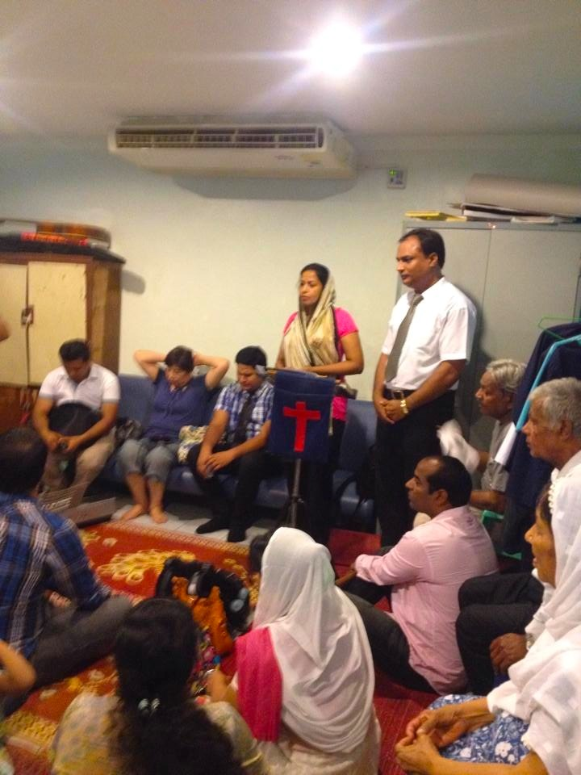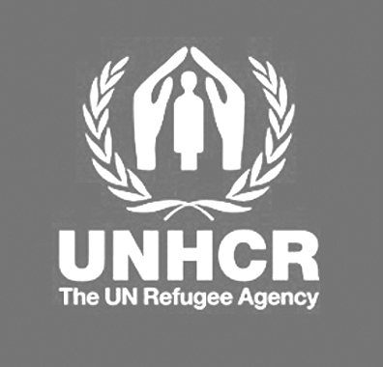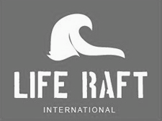

**Assessing Asylum Seeker Well-Being:**

**Pakistani Life in Bangkok**

ABSTRACT

TABLE OF CONTENTS

4

5

6

8

13

20

25

30

34

35

Chapter 1

**Introduction**

**Community Context**

Partner Organization

**Methodology**

Research question

Participatory approach

Data Collection Methods

Ethical Considerations

Chapter 2

**Literature Review**

Limitations of Research

Chapter 3

**Research Findings**

Survey Solutions

Key Themes

Chapter 4:

**Analysis of Data**

Implications of Findings

Variables that contribute to problem

Chapter 5:

**Recommendations to Partner Organization**

Short-term Action

Long Term Action

Chapter 6:

**Conclusion**

Research significance

Contributions to the field

**Academic References**

**Appendix**

INTRODUCTION

Word spread that the Thai military police were on their way to raid the building where John, his family and other Pakistani asylum seekers lived. They locked themselves inside their room so it would look as if nobody was home, closed the windows, and curled up in the corner being as quiet as possible. John’s wife and children grew more frightened as the sound of the police knocking on doors with their machine guns became closer and closer. Being the last room in the hallway, the police eventually got to John’s room and knocked. John having been clever decorated his door to look as if a Thai person lived there. The police knocked, but soon left after no answer. His brother on the other hand wasn’t so lucky. The police broke through the door to John’s brother’s room and without proper documentation he was hauled off to the police station and eventually to immigration detention. This is just one of the many stories the Pakistani asylum seekers have about their encounters with the Thai police.

An asylum seeker is someone who has fled their country because of persecution and is in the process of applying for refugee status in another country. “A refugee is someone who is unable or unwilling to return to their country of origin owing to a well-founded fear of being persecuted for reasons of race, religion, nationality, membership of a particular social group, or political opinion” (Convention & Protocal, p.3). In Thailand, people are declared to be a refugee or not by decision from the United Nations High Commissioner for Refugee (UNHCR).

The Office of the United Nations High Commissioner for Refugees (UNHCR) was founded on December 14, 1950 by the UN General Assembly to aid the European refugee situation. At the end of three years, the plan was to disband the UNHCR, but there continued to be demand after demand for their assistance so their work continued. Currently, the UNHCR has over 9,300 international staff working in 125 different locations (History of UNHCR, n.d.).

Of the asylum seekers residing in the urban center of Bangkok, the Pakistani people currently are the most populous people group. Most of the Pakistanis are of the religious minority in their home country being commonly Christian or Ahmadi. Having been persecuted in their home country they came to seek solace, but have instead even more hardships. The conditions that contribute to Pakistani asylum seeker well being are contingent upon how positively or negatively the surrounding environment effects them.



**1**

COMMUNITY CONTEXT

***BANGKOK, THAILAND***

With easily accessed borders, Thailand’s urban center of Bangkok has become a host for a plethora of nationalities. Tourist visas good for one or two months stay are easily attainable. Especially within the past few years, Thailand’s tourist visas have been capitalized on by persecuted people fleeing from their homelands. Persecuted in their home countries, multitudes of people come to Thailand seeking asylum. Of the countries in Southeast Asia, Thailand has the most easily accessed border.

The asylum seekers end up overstaying their visa because the application process for becoming a refugee takes years. Many of them are not prepared for the way of life they are forced to live in Thailand. The UNHCR provides little assistance to the asylum seekers. As a result, non-government organizations and churches have taken it upon themselves to serve these marginalized people.

***LIFE RAFT INTERNATIONAL***

One of the many non-governmental organizations assisting asylum seekers in Bangkok is Life Raft International. Founded in 2011 by Chris Woodruff, Life Raft International has been working with urban refugees in Bangkok. Their mission commits to serving asylum seekers who are being re-persecuted in Thailand by means of food, shelter, and protection.

***“Enabling Ordinary People to***

***Transform the Lives of Urban Refugees”***

Utilizing the power of relationships, Life Raft International connects those who need help with people who desire to help. The basis of their service is their advocacy program. Advocates are people living in Bangkok who are available to meet with the asylum seekers on a regular basis. Unlike other organizations who simply give handouts, Life Raft International recognizes the importance of having asylum seekers be working towards a goal during their time here. In return for their monthly stipend, the asylum seekers must show they have been actively working towards their goal agreed upon with their advocate. Providing services in this manner not only gives dignity to the asylum seekers, but it also gives them a sense of purpose.

METHODOLOGY

***POPULATION***

The target population for this research study consisted of Pakistani asylum seekers living in Bangkok. Men and women ages 18 and older were surveyed and interviewed. A third of the surveys came from asylum seekers associated with Life Raft International.

***RESEARCH QUESTION***

This research project addresses the question of, *what are the significant factors that effect the well-being of Pakistani asylum seekers in Bangkok?* The question applies to anyone who has left Pakistan because of persecution and has registered as an asylum seeker with the UNHCR in Bangkok. Since the situation in Bangkok is less than ideal, the purpose of the study is to better understand how they are handling it.

***DATA COLLECTION METHODS***

In order to answer the research question, a participatory approach was implemented, which contained surveys, focus groups, and individual interviews. The written surveys, interviews, and focus groups were conducted in one of the largest communities of Pakistani asylum seekers in the city. The online surveys came from families receiving assistance from Life Raft International; they came from a variety of areas within Bangkok.

**Interviews**

The individual interviews were semi-structured with both open-ended and closed questions. Attention was given to better understanding as to what their life was like in Pakistan, how they are surviving in Bangkok, and how they could improve their circumstance. The interviews were casual in setting, yet meaningful. The interviews were conducted in the homes of the asylum seekers because of safety reasons.

**Focus Groups**

Three focus groups were conducted in the safety of the homes of asylum seekers. For each group, around 10-15 people from the same building gathered in the house of one family. The discussion was guided by the survey question topics. As the discussion progressed, the participants began to open up more and more. Each focus group lasted between 1-2 hours. Both the interviews and the focus groups were conducted in English, with occasional translation from community members to get the point across better. Notes were taken during the discussions, which was welcomed by the participants.

**Survey**

A written survey consisting of 23 questions was distributed among Pakistani families, including those present at the focus groups. The same survey was also distributed online to Pakistani asylum seeker families connected with Life Raft International. There were a total of 34 completed surveys; 23 written surveys & 11 online surveys.

***ASSUMPTIONS & LIMITATIONS***

A variety of assumptions have had to be made in this study. The first assumption that was made is that the participant samples are representative of the entire Pakistani asylum seeker population. It is assumed that the participants understand the question being asked in English. Finally, it is assumed that the participants are answering truthfully about their actual situation.

The limitations of this study have to do with time and breadth. Time constraints limited the quantity of interviews and surveys gathered, as well as the depth of the information. Only one main community participated, plus the online survey. There are about five dominant clusters of Pakistani communities in Bangkok, of which only the largest was analyzed.

***ETHICAL CONSIDERATIONS***

Since the population of participants are viewed as vulnerable being asylum seekers, many ethical considerations had to be taken. The participants were briefed that I was an independent student researcher working in conjunction with Life Raft International. The terms of voluntary consent were given both verbally and written. No names were taken in order to protect the participant’s identity. Any names referred to in the project data have been changed for confidentiality.

LITERATURE REVIEW

This chapter examines in the international laws, local Thai government policies, and practices of the UNHCR in Thailand. By understanding the governing policies the asylum seekers’ situation can be better comprehended. This chapter also outlines the social determinants of well-being and how they came to effect asylum seekers.

***HUMAN RIGHTS***

Around the world many people are fearing for their lives in their home countries because of persecution based on: race, religion, political opinion, nationality, or membership in a particular social group (Government of Canada, 2012). Many of the countries who are able to provide adequate care for asylum seekers have strict visa requirements that do not allow them into their country unless they have obtained refugee status. Instead asylum seekers are forced to go to developing countries that have less strict immigration laws (Home Office Research, 2002). The downside to going to a developing country is that most of them do not have the resources to care for asylum seekers well.

***THE SITUATION IN THAILAND -***

Currently, Christians from Pakistan are fleeing by the masses to Thailand because of the persecution that is taking place in their home country. In South Asia, Thailand is the country with the most accessible boarders. As of January 2015, there were 7,600 Pakistani asylum seekers in Thailand. By December 2015 the UNHCR in Thailand has estimated for there to be 11,500 Pakistani asylum seekers (UNHCR Thailand, 2015).

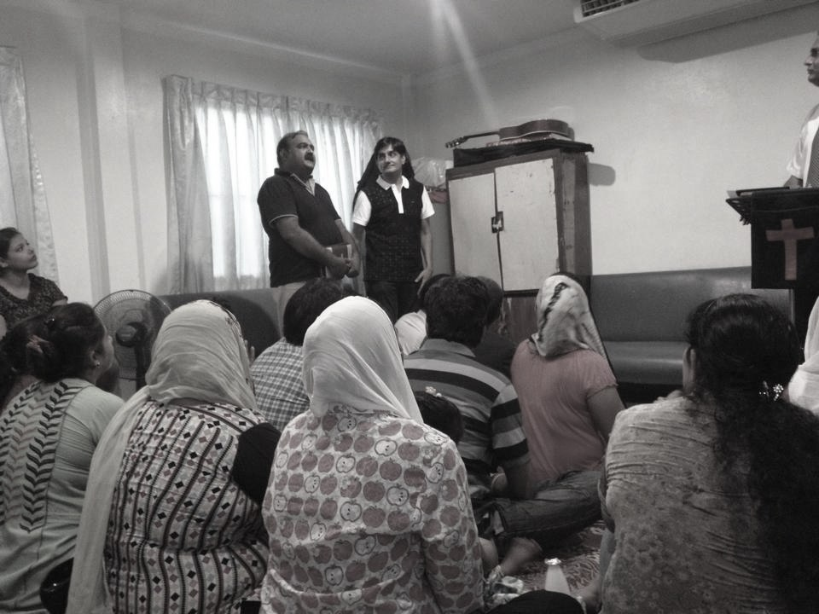

**2**

**2**

The persecution in Pakistan against Christians has continued to worsen. Violence against Christians has come in the form of church bombings, accusations of blasphemy, kidnappings, and forced conversions - to name a few (United States Commission on International Religious Freedom, 2014). Pakistan has blasphemy laws that decree it a crime punishable by imprisonment for defiling a place of worship, insulting religious beliefs, or disturbing a religious assembly.

The blasphemy laws were expanded in the 1980’s to include the willful desecration of the Koran as an act punishable by death for. Religious minorities have been wrongfully accused of blasphemy and ended up being killed, which spurred human rights movements to amend the laws, but with no avail (“What are Pakistani’s”, 2014). Seeking peace after being persecuted in Pakistan, the asylum seekers end up being re-persecuted in Thailand.

**Immigration Detention**

Thailand lacks national legislation regarding refugees. Instead, refugees fall under the Immigration Law of 1979, Section 17, which considers those who do not have valid documents as illegal immigrants who are subject to detention and deportation” (Singh, 2013, p. 79). All asylum seekers and refugees can be legally detained and deported under Thai law. Currently, a petition called ‘Treat them Like a Tourist’ is underway to amend the Immigration Act of 1979 to create a temporary refugee visa. If this petition gets passed it would decrease the illegal immigration issues and provide a safer place for asylum seekers in Thailand (Thai Committee for Refugees, 2015).

Since asylum seekers can and will be thrown in jail, going outside their home means the possibility of being caught by the police. If stopped by the police with no valid visa, asylum seekers and refugees will often end up going straight to jail. When the military government was cracking down on asylum seekers, the police raided many homes where Pakistanis lived (Pakistan Christian Post, 2015).

Living day by day knowing that you have no rights and could be arrested causes much stress in the lives of asylum seekers. “Scientific studies have consistently shown it leads to the build-up of clinical symptoms of anxiety, depression, post-traumatic stress disorder and even self-harm” (Jesuit Refugee Service, 2012). Being in constant fear of being arrested and taken to the immigration detention center is extremely high stress to live under.

**Thailand’s Domestic Law**

Without formal refugee law in Thailand, asylum seekers fall under the Immigration Act of 1979. The Immigration Act states that no persons are allowed to enter Thailand without proper means of living and if they overstay their visa they are subject to arrest, detention, and deportation.The UNHCR is at the mercy of the Thai government, they must compromise in certain areas. As of 2010, the UNHCR can no longer intervene in preventing detention of persons registered with the UNHCR (Singh, 2013).

Many freedoms are not given to asylum seekers living in Thailand. Asylum seekers do not have freedom from arbitrary detention. In refugee rights violations there is little access to justice. Thai law refuses asylum seekers the right to work on the grounds of desiring to keep the security of the national economy safe. The difficulties in Thailand arise from the discrepancies between Thai law and international law (Singh, 2013).

***INTERNATIONAL LAW***

Any persons seeking asylum are entitled to international protection under international law. In 1951 the UN held a Convention relating to the status of refugees, which laid the ground rules for the care, treatment, and processing of asylum seekers & refugees worldwide. Only one amendment has been made to the Convention. The 1967 Protocol was added, which removed the geographic and temporal limits of the 1951 Convention (McHugh, Rank, Peet, & Vasudevan, 2007).

In many cases, the countries that host a large number of asylum seekers are not signatories of the 1951 Convention (Asylum Access, 2014). The 1951 Convention is an instrument that defines the status and rights of a refugee. “Such rights include access to the courts, to primary education, to work, and the provision for documentation, including a refugee travel document in passport form”(UNHCR, 2010, p.3).

Oftentimes the countries with less strict immigration laws are the countries chosen to seek asylum in, but they usually are not the safest. Understanding that in seeking asylum, immigration rules may be violated, the 1951 Convention created a safeguard called the ‘principle of non-refoulment’ whereby no asylum seeker or refugee shall be forced to go against their will to a place where they fear for their life or freedom (UNHCR, 2010).

“Grounded in Article 14 of the Universal Declaration of human rights 1948, which recognizes the right of persons to seek asylum from persecution in other countries, the United Nations Convention relating to the Status of Refugees, adopted in 1951, is the centerpiece of international refugee protection today” (UNHCR, 2010).



For the countries that have signed the Convention, the UNHCR must impose the agreements of the contract and monitor their implementation. The countries, such as Thailand, who are non-signatories of the Convention legally do not have to bestow basic human rights to the asylum seekers. “Since Thailand does not accord any legal status to refugees, urban refugees do not enjoy the rights that derive from refugee status under international law, and under Thai law most are considered illegal immigrants”(“UNHCR protection challenges”, 2009, p.3). Not having access to these basic rights makes survival difficult.

**4**

***THAILAND’S UNHCR PROTOCOL: REFUGEE STATUS DETERMINATION***

One of the implications of Thailand not being a signatory of the 1951 Convention means that the government cannot determine refugee status. In these non-signatory countries the UNHCR steps in to provide protection for refugees and provides refugee status determination (RSD). “Refugee status determination is the linchpin of refugee protection because it is the means by which those who need protection are identified” (Alexander, 1999, p.285).

The process of refugee determination has yet to be thoroughly laid out by the UNHCR. They have a few documents available targeting government and NGO workers that describe the RSD process. These documents available are written in general terms in order to cover a multitude of types of people requesting refugee status (Alexander, 1999).

Upon arrival to the UNHCR, the asylum seekers must submit a written statement of their case in their own language. This written statement will be what the UNHCR compares their verbal statement with from the interview later on. The written statement is an important document that asylum seekers often forget to keep a copy of. Once it is submitted, the UNHCR will not provide them with a copy (Alexander, 1999). Without a copy, a person’s story could easily lose detail or forget events in the years waiting for the interview.

From the UNHCR in Bangkok asylum seekers are given a one page document written in legalistic English language. Most asylum seekers have little understanding of the RSD criteria or process in which they have entered. They are given an interview date that could be years in the future and told to come back then (Alexander, 1999).

At the interview, asylum seekers “are asked to provide evidence of persecution. Some break down in tears or can’t express themselves clearly,” said Medhapan Sundaradeja, the Thailand director for Asylum Access (Desk, 2015). Having already gone through immense amounts of stress, they now need to prove that their lives were indeed threatened in their home country.

When rejected, the UNHCR does not give the asylum seekers a reason for their decision. The UNHCR suggests that by doing this could spark a rise in fraudulent claims when asylum seekers know what gets rejected (Alexander, 1999). If rejected, asylum seekers have 30 days to appeal only if there is new information present. If the appeal is also rejected then the case is closed (Alexander, 2009). It has become ever more difficult to discern between refugees and other international migrants. “Due to the inherent difficulty in adjudicating on asylum claims, the capacity to make an incorrect ruling must be acknowledged” (UNHCR, 2005, p. 28).

The UNHCR office in Thailand does not allow for the presence of legal counsel during UNHCR RSD interviews. The APRRN has been advocating for a change in this policy and as a result of their effort the UNHCR in Thailand is working on expanding the accessibility of documents and transcripts as well as discussing specific cases with NGO legal aid providers (APRRN, 2014). Lacking proper guidelines, on both the part of the Thai government and the UNHCR, causes inconsistency in the approval and rejection of refugee status (Alexander, 1999).

***SOCIAL DETERMINANTS OF WELL-BEING***

Asylum seekers are a vulnerable population, which means they are easily affected by the social and environmental conditions around them that could either help or hinder their well-being. These social and environmental conditions that influence the health of people and communities are called the social determinants of health. The social determinants of health as laid out by the WHO (2015) show just how extensive the impacts of health can be.

* + - * + Income/Employment
        + Education
        + Physical environment
        + social support networks
        + Health & Nutrition
        + Transport
        + Food
        + Housing
        + Social Exclusion

One of the basic human rights is the right to health equity - being able to obtain their maximum health potential without being disadvantaged by a social circumstance (CDC, 2014). The above listed social determinants of health contribute to the health inequalities.

Health inequalities in the asylum seekers’ situation arose out of social exclusion. “Social exclusion is the failure of society to provide certain individuals and groups with those rights and benefits normally available to its members, such as employment, adequate housing, health care, education and training, etc” (Hadgkiss, E., Lethborg, C., Al-Mousa, A., & Marck, C. 2012, p.19). Though Thailand lacks refugee legislation, they still have the obligation under international law to protect the rights of refugees. Foreigners from an ethnically distinct culture are commonly viewed as a threat to the host society’s atmosphere (UNHCR, 2005). Desiring to preserve Thai culture, the government has decided to socially exclude those who do not legally belong in the country.

***CONCLUSION***

The situation in Thailand is unfavorable for asylum seekers as they have little freedom and rights in this country. The domestic law does little to protect these vulnerable people because Thailand is not a signatory of the 1951 Convention. Living in a place where basic human rights are not being abided, deeply effects a person. Being socially excluded from society limits asylum seekers’ ability to maintain their well-being.

RESEARCH FINDINGS

**Setting/Community Context:**

This section contains the data gathered from the interviews, focus groups, and surveys conducted among the Pakistani asylum seeker population in Bangkok. I was graciously welcomed into the homes of all of these people and treated with the utmost respect. I hope that in return these findings can raise awareness of the asylum seeker situation in Thailand. These findings seek to address the main question of “*what are the significant factors that effect the well-being of Pakistani asylum seekers in Bangkok?”* To answer this question, the experiences the asylum seekers have had in transitioning from Pakistan to Thailand were shared with me. Each person shared personally how the situation effects them and how they have responded to it.

KEY DEMOGRAPHICS -

From the collected surveys, 24 of the respondents were male (mainly the heads of the house) and 10 were female. A few participants were single males, but overall most of the households contained between 3 to 6 members. These members could include the spouse, children, grandparents, or other family members that live in the same room.

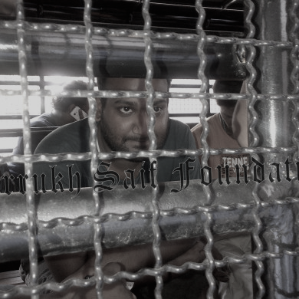

**3**

Most of the people surveyed were Christian (85%) with some of them indicating they are specifically Protestant or Pentecostal. The remaining people indicated that they were of the Catholic faith. Because of their faith, everyone declared that it was for the safety of their family that they left Pakistan.

The majority of the people participating in this study have lived in Thailand at least for one year, but many have been here for over 2 years. None of the people receiving help from Life Raft International have lived in Thailand less than a year.

A DAY IN THE LIFE…

Given that the Pakistani asylum seekers are all in similar situations, the way in which they spend their time is similar to one another. Though every family is unique, there are unique cases for certain families, the following description is of how a majority of the people spend their days.

In the room is where much of the day is spent, especially for the women. Responsible for the cooking, household chores, and the children, the women must ensure these are done and done well. Women leave the house less often than the men because of their duties. In the morning a small breakfast is made.

If the children go to school then the fathers take them to school. As seen in Figure 1 majority of the school attending children go to community learning centers. Community Learning Centers are schools that have been set up in specific communities to provide free education for the children of asylum seekers. Only a few children go to Thai school, International school, or are being homeschooled. Unfortunately, almost 1/4 of the children do not currently go to school.

Once the children are in school, the men have more freedom in Pakistani culture and can spend the day how they like. Some men have jobs or volunteer positions that they will go to.

The remaining day is spent in the room or in the rooms of friends or family that live nearby. After school, the children come home and usually play with other children who live in the same building. Many asylum seekers have a computer and internet in their rooms. They use this to watch videos, chat with family & friends, email, and keep up with world news.

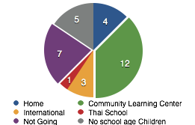

Figure 1: Types of Schools Attended

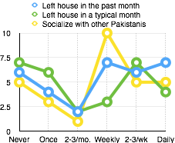

Figure 2: Frequency of Outside Interactions

*Leaving the Room*

Typically if the asylum seekers go out it is individually or with one or two others. Going out in groups is not safe because it raises the police awareness of their location. When asked about they type of clothes people wear when they go out, 70% of them wear casual clothes, 12% formal wear, 9% traditional Pakistani clothes, and 9% lounge wear. People began to realize that they type of clothes they wear influences the way that police view them. Most of the people have stopped wearing their traditional clothing out of the house because they feel they will be more of a target than if they wear casual clothing to fit in with what the rest of society is wearing.

Figure 2 above shows the frequency of outside interactions that asylum seekers have. The green line displays how often asylum seekers left their house in a typical month. This green line has the trend of a reverse bell curve, meaning that people marked that they either rarely left their house or they frequently left their house. Every month can be different from another depending on how intense the police crack down happens to be. This past month more people seem to have left their house on a more regular basis than usual. People must leave their house in order to replenish their food & water supplies and go to work, school, or church.

**Data Themes:**

PERSECUTION IN PAKISTAN

The story that is so afraid to be told, but yet so crucial to the plot is the story of persecution back in Pakistan. The country of Pakistan is predominately Muslim. The experience of the Christian minorities in the country has been harsh at times. Sharia law reigns in Pakistan, which means that anyone who talks against the Muslim law or religion will be put to death. The Christians living there have been exploited with untrue claims of blasphemy and been murdered. The reason that this type of conduct is allowed is because the government is run by Muslims. The Muslim clergy are in power and their goal is to make Pakistan a completely Islamic nation. The innocent Pakistani people being persecuted are simply trying to live in their homeland, but they are being discriminated against by their own people. Religion surpasses nationality. This can been seen even on the Pakistani passport as it is valid in every country except for Israel.

In Pakistan, from the very early years, children are brainwashed into what is good and what is bad. Everything Islamic is good and should be fought for even if it costs you your life. Anything not Islamic should be hated and people who believe in anything else should be killed. To comment on this, one man said:

*“When you put dirty water in the roots of the tree, it will produce bad fruit.”*

For the most part, the Muslims of Pakistan are sowing seeds of hatred in their children. If from day one, children are told who and what to hate, then they will grow up to hate because they won’t know any different.

*The story of James:*

James is one of the asylum seekers living in Bangkok who came out of Pakistan because of his experience with the persecution in his own country. Now in his late 40’s, James has been a lawyer for over 20 years in Pakistan. Soon after beginning his career as a lawyer he fell in love & married his beautiful wife and they made a family together.

The more experience James got as a lawyer the better he became. His name became known more and more in the surrounding region for his law abilities. One time he decided to take a Christian’s case of accused blasphemy against the Koran. In doing this he ended up having a hit-man point a gun at him, threatening his life and that of his family if he did not drop the case.

Since the courts in Pakistan are also under Sharia law they reign supreme. Everyone knew that James was a Christian and he was told that “because you are a Christian, I will kill you one day.” With that threat he knew that for his family’s safety they had to leave. They proceeded to get visas to come to Thailand where they would apply for refugee status.

LIVING IN THAILAND

(Social well-being)

Prior to arriving in Thailand, most people said they did not know about how bad the situation is here for asylum seekers. Many people thought that there would be freedom, peace, and protection here. After living here for a period of time, asylum seekers come to see that the better life they had dreamed of is still out of reach. Some people had hoped to get visas, but it turned out to be too expensive or not possible. The asylum seekers who came a few years ago have had their claims processed quickly with the whole process including resettlement taking about 2 years.

Many people heard about this quick resettlement and many Pakistani people began entering Thailand seeking asylum. This idea quickly backfired. Those asylum seekers who came during or after the Thai immigration crack down have a much prolonged stay as their refugee claims process could take 4-6 years. The asylum seekers were under the assumption that the UNHCR would provide more help than they actually do.

Community:

The Pakistani asylum seeker community tend to live together in pockets throughout the city. Most of the communities are not so big that they draw unneeded attention to themselves. The location of largest pocket of Pakistani asylum seekers is well known by the Thai police because their presence cannot go unnoticed. As a result, they have experienced more intense police presence. Living in close proximity to one another has both its advantages and disadvantages.

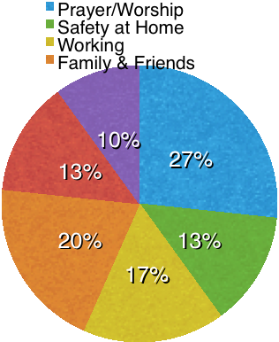

Figure 3: The types of things that bring happiness

The disadvantages of living in close proximity of each other is that the risk of arrest is increased. One of the advantages of living within close proximity to one another is the ability to have community. Most of the asylum seekers have a few families that live in the same building as them. If not in the same building, then they at least live within walking distance of one another. In Figure 2 previously referenced, 70% of the asylum seekers say they socialize with other Pakistanis on at least a weekly basis. Having other Pakistani asylum seekers close by gives room to have a more healthy social well-being.

Community for asylum seekers is very important because other people in their same situation are the only ones who truly understand what they are going through. Unfortunately, of the people surveyed, 30% said that their community does not support them and 2/3 said that they feel isolated from community.. The ways in which they support each other came mostly from highest form the sharing of problems and information with each other. Other types of support received from the asylum seeker community were prayer and giving food to one another.

Community does not just involve other asylum seekers, but it also includes the Thai community at large. Generally, the asylum seekers have not interacted much with the Thai community. If people do access the Thai community it primarily occurs through their church.

*Household Dynamics*

Pakistani culture is very male dominant where the man’s role is to provide for and lead the family. The woman’s role is to take care of the house and children. This relational dynamic was seen in one of the focus group discussions where all the men sat on one side of the room and the women on the other. In this discussion only one woman spoke up, the rest of the time the men dominated the discussion. During this discussion the men told me that they often spend time together on the roof of their building in the evenings. This is something they look forward to. When asked what the women do while they are there, they responded that they just stay in the rooms with the children.

The lives of the asylum seekers are often marked with much stress and little to be joyful about. When asked about the types of things that they do to bring happiness into their lives, they had a difficult time answering this question. Many said that there was nothing in their life to be happy about. When prompted more, most participants were able to think of something that they do that brings them happiness. Figure 3 shows the distribution of what types of things bring happiness to the asylum seekers. Prayer or worshipping God was the highest. One family has a hymn book in Urdu that they sing praises to God with daily. The second most common activity that brings happiness is talking with friends or family. This could be with friends and family who also live in Bangkok or via video chat with people living in another country. Working was the next most commonly expressed activity. Working gives people a way to productively spend their time and get out of the house.

*Discerning between truth and lie*

In conducting the research it was quite difficult to discern whether a person was speaking truth or not. Unsure of how long they will be in Thailand, it becomes easy for the asylum seekers to take anything that comes their way because the opportunity might not be there again. One man described it as “the Pakistani asylum seekers are like beggars - always wanting more handouts.” When you have very little to hold onto, afraid of losing even that little bit can be terrifying.

During the interviews and surveys it became clear that many people did not want to give away their secrets as to how they survive in Thailand. If others found out that they have money, they are afraid they will no longer receive support.

ABILITY TO SURVIVE

(Environmental well-being)

Survival in Thailand proves difficult for the asylum seekers because of their illegal status in the country. The result of the Thai law means that asylum seekers cannot legally work. If a person cannot work, then there is no income, which means paying rent and putting food on the table becomes a constant challenge.

Curious as to how the asylum seekers pay their room rent and feed their families, one of the survey questions was “how have you been able to support your family in Thailand.” As seen in Figure 4, most of the people said that they receive no support. The answering of this question was challenging for the asylum seekers to answer truthfully. Obviously, the families do pay their rent and they haven’t starved from lack of food, so they must support their families somehow. Most of the people (45%) receive some kind of support from either churches (29%) or from Life Raft International (16%).

From the surveys, 12 people reside under the help from Life Raft International. Three people were upfront about receiving money from family outside of Thailand. Two people use websites such as Facebook to ask for money. Knowing that they cannot survive on what they have, the asylum seekers must rely on the generosity of others.

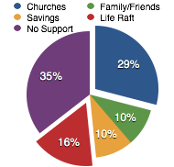

Figure 4: Income / Donation Distribution

*Stress*

Many things contribute to the overwhelming stress that asylum seekers face on a daily basis. The main areas of life that contribute to the stress of asylum seekers is money for food & room rent, inability to work, education for their children, fear of arrest, separation from family in Pakistan. They have reason to be stressed about all of these things, but the survey asked them to order them on degrees of stress and this was the outcome:

* + - 1. Fear of Arrest
      2. Money for Food
      3. Money for Room Rent
      4. Inability to Work
      5. Education for Children
      6. Separation from family in Pakistan

*Attitudes Towards Policies*

The months of March and April of 2015 were particularly difficult for Pakistani asylum seekers because that is when the Thai government began to strictly enforce the immigration laws. Anyone who was not Thai, particularly those who look as if they come from Middle Eastern decent, were targeted by the Thai police and asked for proof of a valid visa. The asylum seekers do not have a visa unless they are rich enough to afford one, but very few are. Most of them are living in Thailand with an expired 60-day tourist visa that they came in on. The UNHCR has given them documentation stating that they are indeed asylum seekers awaiting their refugee status determination. This document is not enough for the Thai police because it just states who they are, they are still living in the country illegally.

As a result of improper documentation, the police will escort the asylum seekers to the police station for further questioning. At this point, it is possible for the asylum seekers to bribe the police with money - could be 10,000 - 30,000 baht but if they can get this money they can prevent their loved ones from going to the Immigration Detention Center (IDC). Once a person gets to IDC the bail is set at 50,000 baht with an indefinite time of imprisonment.

*The Immigration Detention Center*

The IDC is not a fun place to be. With the city-wide police crack down, IDC quickly became overcrowded. This overcrowding has led to multiple unfortunate consequences. Over 100 people live in a very small one room cell. The cell is so small that the people cannot even lay flat to sleep, they must lay on their sides in order to fit everyone in the room. Staying in a place such as this is known to take a toll on the people’s mental health.

One of the things complained most about from the asylum seekers is the food given at the IDC. The food is of the Thai variety and rumored to be unappetizing and not nutritious. Many churches and individuals have been making Pakistani food and delivering it to the IDC when they visit for those inside to share with one another.

*Visiting Those Detained*

Every week day the IDC has visiting hours from 10:30-11:30 for those who have a valid visa to visit people in the detention center. I got the opportunity to visit someone in IDC and hear about the situation directly from one of the people living in it.

In order to get into the IDC I had to show my passport and valid visa, as well as have the inmate number of the person I wanted to see. Visitors are only allowed to see one person per visit. I had initially tried to get in to see my friend whom I did not know the inmate number of, but they could not find his name in their list. I knew that he was still in the IDC, but discrepancy occurs in the documentation of the inmates because their English names are translated into Thai, which could lead to misinterpretation.

Eventually, I got in, once I found out the number of another person. None of our belongings could come in with us, they were kept in a locker. Visitors are allowed to bring food and a few other personal care items to give to the inmates. Everyone visiting comes with something to give the person they are seeing. The items are searched through to ensure no illegal objects are being brought through. The inmates who have a visitor are then called out of their rooms.

Two wire fences with about about a meter between are all that separates the visitors from the inmates. To find the person that you are visiting you must walk up and down along the fence until you spot them. With so many people visiting, having a conversation is tricky. You must shout back and forth to one another in order to hear what the other person is saying. An hour goes by rather quickly. When the time is up the visitors must leave and the inmates can grab their delivered bags and go back to their room.

*The Story of Peter*

Most of the people when caught by the police end up going to the IDC, but since there were so many people needing detention some ended up in the real Thai jails where prisoners go. I got the privilege to talk with one man who had been to the jail, but is now thankfully set free.

Peter, his wife, and two children were all walking on the street one day and got stopped by the police. Without proper documentation they were taken to the police station and then to the Thai jail. When they arrived they were very confused as to why they were taken here - this place was for people who committed real crimes.

Peter was then separated from the rest of his family who were taken to another section of the jail. The guards stripped Peter of his clothes and gave him one set of traditional Thai garments to put on. He was without shoes and had to walk, sleep, and constantly live with a 5 kilogram ball and chain locked to his ankles. Similar to IDC the conditions in the jail are pretty bad. Peter ended up getting a skin disease on his feet that he has been treating, but no pharmacist seems to know how to remedy it. The disease has discolored his feet and has been bothersome. Peter and his family have since been released, but the effects of that experience still traumatize them.

*Feelings Towards the Underlying Policies*

In Thailand, asylum seekers have no freedom. Most of them understand Thailand’s reasoning behind their immigration laws. The asylum seekers are generally more disappointed and upset with the UNHCR for not providing more protection. The UNHCR has fallen short of many expectations and are not providing viable solutions to the problems at hand.

The Thai community for the most part has been quite welcoming of the Pakistani asylum seekers. Granted there are some Thai people that want nothing to do with the asylum seekers, but these people simply keep to themselves. Many of the Thai neighbors are friendly and genuinely concerned for the Pakistanis. In describing how he feels about his time here, one man said “we are thankful to Thailand.”

In coming to Thailand, the most unexpected condition was the length of time they would have to wait for the interview date. Even with a set interview date, they have no assurance that the interview will happen as scheduled. The UNHCR has been known to postpone interviews for an unknown amount of time.

One day at an Urdu church service, the pastor asked his congregation what they are thankful for. One man responded “I am thankful to have life.” This statement was given so sincerely that for a moment the room silenced. Many of these asylum seekers have caught glimpses of death either for themselves or of their family members. Simply being able to live another day is something to be thankful for.

HEALTH AND NUTRITION

(Physical well-being)

Health is something that people often take for granted until they no longer have it. The access to healthcare is something that the asylum seekers have no right to in Thailand. Their health is constantly on their minds as they try to manage it the best they can.

When asked to assess their health, 44% claim good health and 56% claim poor health. Of those who claim good health, 3/4 of them say their weight has decreased since coming to Thailand. Out of those who claim poor health, 63% say their weight has decrease, 21% have gained weight, and 16% say weight has stayed the same. The majority of the people have lost weight. The reasons people gave for as to why they have lost weight is due to the stress, lack of food, and overall atmosphere of their living conditions.

Many people said they have skin diseases, breathing problems, joint pain, diabetes, or the children are sick. The asylum seekers greatly need medications to help relieve these problems, but the medications are so expensive that many cannot afford them. The Bangkok Refugee Center (BRC) used to give out medications regularly, but now with so many asylum seekers needing help, they do not have the resources to aid all of them. Instead, they are saying only if you have a life or death situation will they step in to help pay for it. The asylum seekers said that the ways in which they need the most help is through getting food and medical supplies.

*Diet*

One thing that contributes to the health of the Pakistani asylum seekers is their diet. Pakistanis are partial to their own food and most do not enjoy eating Thai food. Thai food is cheaper than making their own food, but they would rather consume their traditional Pakistani cuisine. Many things are cooked in oil and most people said they use oil every day. Figure 5 shows how often different types of food are consumed. The items most often consumed daily are vegetables, bread, sugar, and milk. Most people consume these items daily with a fairly level amount for other frequencies. The two items that were rarely consumed daily, but most often consume between once a week to once a month was meat and fruit.

*Housing*

Every asylum seeker family visited for this research lived in a one room apartment with a small bathroom. Inside these rooms would often be a large bed upon which the whole family would sleep, eat meals, and entertain on. Other items in a room are things such as a refrigerator, side table, wardrobe cabinet, chairs, etc. The rooms lack a built in kitchen so most of the families, if they have a balcony, have made it into a makeshift kitchen. Typically families have a single burner propane stove upon which they cook all their meals.

This type of housing is vastly different from what they have been used to living in. In Pakistan the houses are usually large and have many rooms with a large one equipped for a kitchen. The one room house in Bangkok is quite confining for them, especially when that is where most of their time is spent.

KEEPING THE FAITH

(Spiritual well-being)

Every person knew about at least one church in the city of Bangkok, some people up to eight churches. 69% of asylum seekers have found a church to be involved in. The majority knew between 1-4 churches that help asylum seekers. Sadly, 18% of the people surveyed have never visited church in Bangkok, while 52% have visited a one church.

In the survey there were two separate questions one asking if they found a church to be involved in and the other asking if they receive help from any churches. People who go regularly to church and receive help from a church is 61%, people who haven’t found a church to go to but receive help is 18%, people who go to church but receive no help is 9%, and 12% do not go to church nor do they get help from a church.

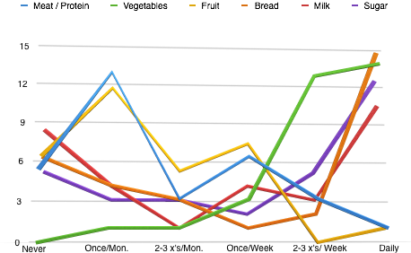

Figure 5: Frequency of Types of Food Consumed

# of people

Recently, some churches have had to rethink their way of handling the asylum seeker situation because they simply did not have enough resources to meet everyone’s needs. Many asylum seekers came to the churches asking for money. This spurred some churches to leave the physical needs up to the organizations and the asylum seekers themselves. This left the asylum seekers with something to think about - whether they are coming to church for God or for handouts.

All but one person remarked that since coming to Thailand their faith has increased. About 3/4 of the people say they meet regularly with other believers, which usually happens at church. Hard times will either show a person to have genuine faith or none at all.

Knowing that the Pakistanis do not want to travel far to go to church, a few pastors have established Urdu churches in areas where many Pakistanis reside. In commenting about this, one pastor said that when he first arrived he began to worry because the situation was different than what he had anticipated. In time, he began to see why God had put him here. He said that God spoke to him “I’m going to feed my people through you spiritually and physically. I am God. I do not need clouds to rain down.” This pastor routinely hands out food to the members of his church.

*The Two Types of People*

People fell into one of two categories; they either became overwhelmed with depression over their current situation or they chose to have hope for the future. The way they have decided to respond to their situation could be seen in how they answered my questions. Some people could only talk about how hard life is and what they needed. Other people gave the cold hard facts about the way life is, but their spin on it was hopeful. These hopeful people trust that the Lord has something great planned for their future.

Out of the desperation of survival, it has been noted by multiple sources that some asylum seekers have been known to create organizations or ministries that end up exploiting their own people. From the outside it looks as though they are using the outside funding to help other asylum seekers, but often the majority of this money is pocketed for themselves.

EDUCATION & SKILL TRAINING

(Mental well-being)

In order to live well in Thailand people recognize the importance of learning Thai language. Already 20% said that they knew some language simply from interacting with people on the street as they live their lives. The Pakistanis are eager to learn Thai as 75% of them say they want to, being able to devote an average of 2 hours a week to it.

*Employment*

Since the asylum seekers must be very careful not to get caught by the police, obtaining a job becomes difficult. As a result, many people end up not working, not because they do not need the money, but because they cannot find a suitable place. The survey asked if they had found temporary work and 11 people said they had: 5 people found official work at some type of organization and 6 people found unofficial work under the table. Asylum seekers have been able to find manual labor work such as car washing, handyman, house cleaning, dish washing, hair cutting, etc.

Figure 6A shows the types of skills that the asylum seekers currently possess. Many of them come from skilled, educated backgrounds. For the people who have been trained in the medical, engineering, or technical fields, it is even harder to find work in their field because of the language barrier in Thailand. A majority of the people have skills in some area of customer service, household crafts, and teaching.

It is important for the asylum seekers to continue to hone their skills. This not only gives them something to do, but can also stimulate hope. The skills that people would like to learn are the English language and Thai language. Language is utterly important because it is the way in which relationships are formed and business is conducted. Aside from that, people were interested in learning how to make something from home that they could then turn and sell for a profit. Many asylum seekers are gifted at teaching and they would like to further this skill and put it to use. One unexpected skill that was mentioned was the desire for biblical training in areas on how to share the gospel.

*Primary Schooling*

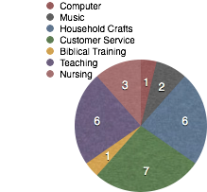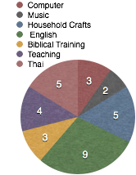

Figure 6:

A.) The skills people currently possess

B.) The skills people would like to improve on

A.)

B.)

Figure 1 on page 14 shows the distribution of the types of schools the children go to. The UNHCR works closely with the Bangkok Refugee Center, which has a school called Good Shephard. This primary school is aimed at the young children just entering schooling age because its goal is to teach the children Thai language and prepare them to move onto Thai school. This method is a good solution for the younger kids, but the older ones would be put way behind in order to learn enough Thai to catch up to the current grade level.

At the beginning of their time in Bangkok many children did not attend school because no suitable school was available. Later on a few people got the idea to start a school for the children in their own community. Running a school in Thailand has many laws that they would have to abide by, so instead of calling themselves a school they go under the pseudonym of community learning centers. Many children end up going to these community learning centers because they are in close proximity to their house and they are free. The downside to these centers is that there are too many kids at different stages of development. The teachers often cannot cater enough specifically to each child.

Not having a proper school for their children to attend is highly detrimental for their future. The community learning centers typically specialize in primary education, leaving out the older children. Many asylum seeker parents are concerned for their children’s future.

*Mental Illness*

When asked about their health, many asylum seekers stated that they have mental illnesses resulting from the situation in Thailand. Having to process this highly stressful situation with the only safe place being their room, has caused mental illness and depression to run rampant throughout the asylum seeker community. With no outside assistance available in this area, the asylum seekers are suffering alone. The effects of this are felt by both the parents and the children.

DATA ANALYSIS

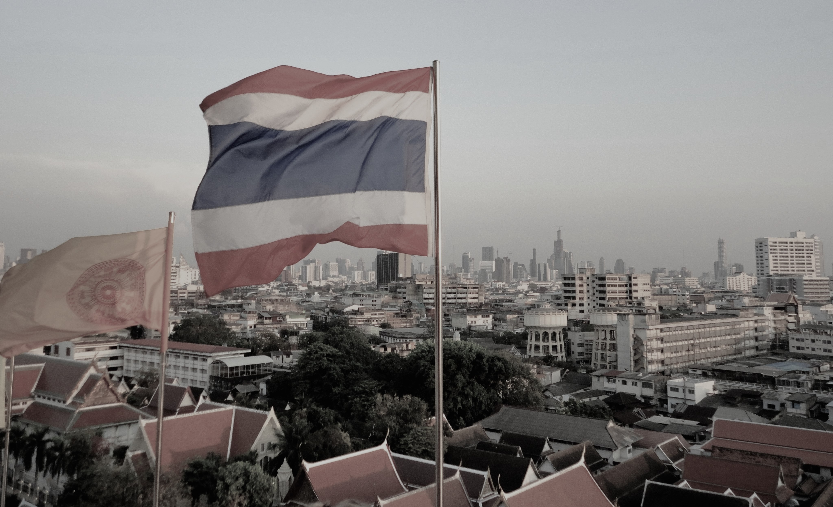

**4**

The purpose of this study was to identify the significant factors that effect the well-being of Pakistani asylum seekers living in Bangkok. The data displayed in the previous chapter came from interviews, focus group discussions, and surveys. From these methods, much information has been gathered about what Pakistani asylum seeker life is like in Bangkok.

IMPLICATIONS OF RESEARCH FINDINGS

The inalienable human right of being able to obtain the greatest health possible without being disadvantaged by a social circumstance is called health equity (CDC, 2014). The unfortunate truth is that many people around the world have less than adequate health because of circumstances beyond their control. A person’s health goes way beyond just the physical diagnosis; health determinants include the social, physical, spiritual, mental, & environmental as well. When any of these areas are not doing well, it affects the entire health of a person.

What was discovered was that for the asylum seekers, every area of health has been compromised in some way. When just one of these areas is not working properly a person can be stressed and not responding well. The asylum seekers have multiple areas of compromised health. People should not be forced to suffer when something could be done to change the outcome of the situation.

The asylum seeker situation in Thailand does not just have an affect here, but it also has a ripple effect throughout the world. The persecution in Pakistan brought the asylum seekers to Thailand and now they hope that Thailand will resettle them in a safe & free country. Eventually, these asylum seekers once they have refugee status will be resettled in developed nations around the world. For the future health of the communities that will be receiving these asylum seekers it is important that they come in as healthy as possible.

*Social -*

As a nation, Thailand has chosen to socially exclude refugees and asylum seekers. Thailand has denied this vulnerable population access to rights and benefits that are commonly available to the rest of society. This is the crux of all the stress because this one act of not signing the 1951 Convention means that asylum seekers have no right to employment, adequate housing, healthcare, education, etc. By not having the right to these basic needs, asylum seekers are at a enormous deficit in health from the start.

Social health has to do with how the Pakistanis are interacting within their own asylum seeker community as well as within the greater Thai community. Since the Pakistani asylum seekers all speak the same language and are in similar circumstances, it is easy for them to relate to one another. Despite the fact that most of them live around other Pakistanis, when 2/3rds of the respondents say that they feel isolated from community something is wrong. To be sustainable, community must go beyond the four walls of a building.

When most of the people say they feel isolated from community, the isolation seems to be coming not necessarily from other Pakistani people but from the rest of society. This could be the asylum seekers’ way of saying that they feel as if the world has forgotten about them. It seems that the way to remedy this would be to integrate the Pakistani more into Thai society.

Overall, the Thai people are generally welcoming and desiring to help in whatever way that they can. One obstacle in integrating these two cultures will be the language barrier. The common language of both groups of people is English, of which the majority of the populations know only a little. This is where learning Thai language would come in strategically useful.

The asylum seekers said that they support one another mostly through the sharing of problems. They need to share their problems especially with others who can understand. People who not only share their problems, but also their joy will bring much hope to communities. To have joy is a choice. Choosing joy in the midst of suffering displays to others what it means to have faith in God. When chaos surrounds, the Lord is the only unwavering thing that will provide life and love. These asylum seekers that have this kind of faith are the people who need to be leading their communities.

**5**

*Spiritual* -

People knew of churches in Bangkok, but not everyone has visited or become involved with one. This could be due to the fact that they do not want to leave the security of their room for fear of the police. Many churches have been turned off to asylum seekers because they have experienced many asylum seekers asking for handouts without having formed any sort of relationship with the church. The mentality of many asylum seekers is about what others can give them.

Almost every person said that their faith has increased as a result of coming to Thailand. Suffering becomes the real test of faith. The Israelites wandered in the desert for 40 years awaiting the promised land. The desert had no food, no water, no shelter, but the Lord is above all those things and ensured that not a single person lacked what they needed. Even when they lacked faith, the Lord still provided. In the same way the Lord has mercy upon these Pakistani asylum seekers, providing for their needs despite their attitude towards the Lord.

*Physical -*

Food and room rent are two items high on the list of the most stressful. This could be because they are confronted with them daily. The asylum seekers must feed their families and every day it becomes a challenge to know where they will get the money. Most of the participants’ weight has decreased. The reasons for this could be due to lack of food, stress, or lack of nutrients. The two important food groups that have been commonly left out of the diet of many asylum seekers is meat and fruit. It is important to get these integrated into their diet. This could be done by some community integration on where they could buy cheap items.

Many family members have some sort of health complications that require medication. If these illnesses don’t get treated, then it will just make for further complications later on. With the BRC no longer handing out these much needed medications, there is nowhere to go. Access to medical supplies could possibly be the most overlooked stressor by organizations and churches.

As for housing, the asylum seekers live in small rooms comparable to what the average Thai person would live in. In Pakistan many of these families had large houses where they could move about in and have space. Living in such a way is simply not possible given their situation. Instead of seeing this as the place where God has put them for the moment, many asylum seekers are upset at the conditions their family has to live in. The housing issue now turns into a heart issue. Pride has the opportunity to overrule what God may want to do in the lives of the asylum seekers.

**6**

*Mental* -

Having employment allows the asylum seekers to have more opportunities. Employment gives asylum seekers more than just a paycheck - it gives them a productive way to spend their time (WHO, 2008). People were naturally made to work. What has been discovered though is that the people who genuinely want to work will find a job. Some people who were given a job that they did not want, so they quit. This goes to show that some people’s situation may not be as desperate as they portray it to be.

Education is extremely valued by asylum seekers. With the community learning centers established, the children attending them receive an education, some learning centers more thorough than others. If more funds were available then better learning centers could be established. In establishing more learning centers, hopefully less children would be going without schooling. It would be ideal if these individual community learning centers could team together, learn from each others mistakes, and share resources with one another.

*Environmental*

The overall feeling the asylum seekers paint for the environment they live in is hostile. The Thai government has established the laws in place because they do not want asylum seekers to live in Thailand permanently. If Thailand was to fully integrate asylum seekers into society the government fears that Thai culture and customs could eventually be lost. In Southeast Asia, Thailand is one of the few countries that is moving upwards. Accepting immigrants could disrupt this.

The Thai government in conjunction with the UNHCR is re-persecuting the persecuted. The asylum seekers went from one evil to another evil. In Pakistan they had the ability to live how they would like to live, but were in fear for their life because they profess to be Christian. In Thailand there is little fear of professing your faith, but they live without freedom.

The UNHCR should be doing more than they are to protect asylum seekers from wrongful imprisonment. Granted the asylum seekers have overstayed their visa which gives them ground to be taken to IDC, but with few other options what are they suppose to do? Obtaining a visa is quite expensive, especially when it has to be done for every individual in the family. The act of obtaining a visa must be done under the table which can lead to exploitation. It will be interesting to see where the *‘*Treat the like a Tourist’ petition goes because this could be a step in the right direction of remedying this visa problem.

Where the asylum seekers were wounded the most is putting their trust in the world’s systems. Many of them said how disappointed they were about the lack of protection and direction from the UNHCR. The UNHCR will not solve the problems of this world, which is why we must trust and live according to the Kingdom of God.

The determinants of well-being do not act independently, but instead each influences the other. Each determinant of health was revealed to have multiple areas of weakness in the lives of Pakistani asylum seekers. Health equity is far from being achieved.

THE FUTURE POSSIBILITIES -

The nation of Thailand is significantly Buddhist in nature with only about 1% of the population being Christian. As of January 2015 there were 8,000 Pakistani refugees or asylum seekers living in Thailand. By December of 2015 it is estimated there will be over 12,000 asylum seekers coming from Pakistan to Thailand. Most of these asylum seekers will end up dwelling in Bangkok or the surrounding urban area (UNHCR-thailand GA 2015).

Though most of these Pakistani asylum seekers are Christian, some are other minority Muslim groups such as the Ahmadi. The exact number of Christian Pakistani asylum seekers currently is unknown. It would only take 10,000 Christian asylum seekers living in Bangkok to increase the total number of Christians living in this city by 10%. By happening approximately over a 2 year period, this has the possibility to dramatically shift the spiritual context of the city.

The Lord desires great things for Bangkok and the nation of Thailand. He is bringing His people into the city to live for an unknown period of time. What an incredible harvest field is present in Bangkok!

The Pakistanis know what it is like to live under persecution both in Pakistan and again in Thailand. The difference about being in Thailand is that it is unlikely that sharing their faith would cost them their life. Thai people are open to hearing about your religion.

*A Change of Mentality*

Oftentimes, the asylum seekers have the attitude of desiring what Thailand can do for them and not what they can do for Thailand. This attitude has come about as a result of their stressful situation, but it does not need to stay that way. Many asylum seekers carry a ‘beggar’s attitude’ in the sense that they feel the only thing they can do is take from others because they have nothing to give. Every person is valuable and no matter how poor they are, they do have something worthwhile to offer. “The greatest poverty of all is having nothing of value to offer the community” (Lupton, 2007, p.51). Nobody is that poor.

Ironically, the faith that the Pakistanis have to offer is the most valuable item anyone could give. It matters not that they have no money or resources to give the Thai people, but what they do have is their time and their faith. The Pakistanis have an incredible opportunity to make Thailand a better place because of their presence.

By cowering in fear they think that they are protecting themselves. This is not what the Lord desires for their lives.

**“**Have I not commanded you? Be strong and courageous. Do not be frightened, and do not be dismayed, for the Lord your God is with you wherever you go.” (Jos. 1:9)

At the time being, they have been placed in Thailand. For their well-being it is imperative for them to come out of their old mentality and begin walking with Kingdom mentality. By doing so will effect every aspect of their lives and the lives of those around them.

APPLICATION TO OTHER SETTINGS

This experience with the asylum seekers has parallels that can relate to other vulnerable populations such as the homeless and other sojourners. Many people go throughout life overwhelmed by their situation, thinking that there is no way out. This results in an endless cycle of falling deeper into helplessness. They become dependent on outside resources for their survival. Nothing in their life gives motivation enough to change their actions. Despite whether they change or not, as Christians we are called to love the poor. Love people where they are at by never ceasing to bring God’s presence into their lives.

RECOMMENDATIONS TO ORGANIZATIONS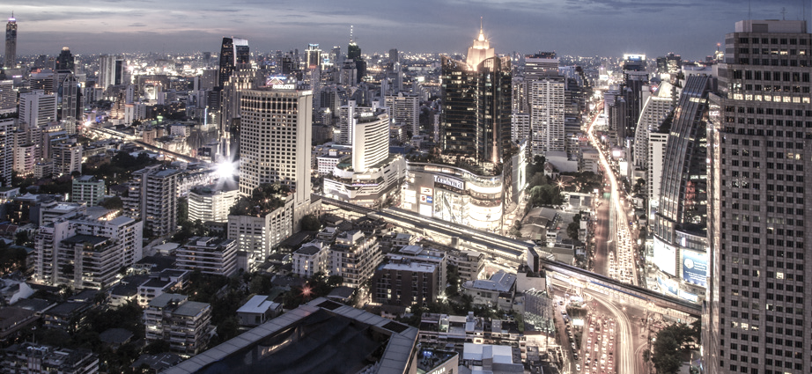

& CHURCHES IN BANGKOK

Short-term strategies:

Learning Thai language -

This was the most common skill that everyone mentioned would be beneficial to improve their life in Thailand. Learning Thai could create more access for job opportunities and overall improve their emotional state by allowing them to be more involved with the Thai community. This is one of the necessary steps that organizations and churches should take to help the asylum seekers.

Counseling -

Because of the stressful situation the asylum seekers are under, professional counseling should be provided to them. This would help them understand their feelings and be able to process the situation with someone who is able to coach them through it. This could help ease the burden of the depression and mentally sick that is taking over the asylum seeker population.

Networking churches-

One problem that Bangkok currently lives under is the disunity of its body of believers. One way to begin to break this chain is by coming together in unity to figure out a plan of action as to how to best care for the asylum seekers. The organizations working with asylum seekers have already created BASRAN, it is time for the churches to work together in this way.

Long-term strategies:

Prayer-

The Pakistani asylum seekers are asking for Christians around the world to be praying for those who are living under persecution. The only thing that has the power to break the oppressive chains of the world is the glory of God. Fasting and prayer is the way in which the Kingdom of God manifests itself on earth.

Raising Awareness-

Most of the world does not know how severe the plight of asylum seekers is. The Pakistani people are asking those who have influence to lobby people together in their cities to pressure governments and get the word out as to what is happening to so many people. Through petition might the government of Thailand change their policies and treatment of asylum seekers.

Mindset Change-

It is imperative that the asylum seekers begin a shift in their thinking about how they react to their situation. This will most likely come through solid teaching from dedicated pastors who lead the asylum seekers into the faithfulness of God to provide. The Lord already knows what they need and He will be sure to provide. If they no longer worry about how they will survive, then they can concentrate on giving back to the community what they have to give, the love of Jesus.

Life Raft International:

Being a Christian organization, Life Raft can work in conjunction with churches in Bangkok to work towards this goal of evangelizing the city. The asylum seekers must meet monthly goals in order to receive help from Life Raft; evangelism could be suggested as one of those goals they could work towards.

Another suggestion specifically asked of Life Raft was that there would be more work directly with the people. The advocates are fine, but some of the asylum seekers desire additional connection with the people directly working for Life Raft.

CONCLUSION

The story of the plight of Pakistani asylum seekers to Thailand is not an uncommon story to hear about as there are millions of people being displaced in the world today. The Pakistani asylum seekers have experienced a violation of human rights in Thailand. The protection measures that were suppose to be taken care of by the UNHCR never followed through. As a result, the Pakistani people have been left living in Thailand in an extremely vulnerable situation.

Every aspect of well-being for the Pakistani asylum seekers has been compromised in some way from their living situation in Thailand. While people must have their basic needs met, there are opportunities around Bangkok that if desperate enough the asylum seekers can access. The well-being of asylum seekers is most significantly influenced by the larger scale mentality of the situation.

When the mindset of the asylum seekers changes from what can I get from others to what can I give to others, then the gospel is shown to be alive and active in their life. The Christian Pakistani asylum seekers could become a huge asset for the churches in Thailand. They have the opportunity to not only redefine their purpose for being here, but to also redefine the spiritual landscape in Thailand.

Works Cited

(6 November 2014). What are Pakistan’s blasphemy laws? http://www.bbc.com/news/ world-south-asia-12621225

Alexander, M. (2009). *Refugee status determination conducted by UNHCR*. International Journal of Refugee Law, vol. 11, no. 2.

Asia Pacific Refugee Rights Network. (2014). *Annual Report 2013*. Bangkok, Thailand: Sukumaran, A., Mayerhofer, J., Darby, J., Jones, E.

Asylum Access. (2014). *Global refugee work rights report*. Oakland, CA.

Asylum Access, Boat People SOS and Conscience Foundation. (2009). *UNHCR protection challenges for urban refugees in Thailand: Report and recommendations.* Bangkok, Thailand.

Center for Disease Control and Prevention (CDC). (2014). Social determinants of health. http://www.cdc.gov/socialdeterminants/FAQ.html

Desk, W. (2015). ‘*They will kills us’: Pakistani family seeks asylum in Bangkok after escape.* The Express Tribune. http://tribune.com.pk/story/844567/they-will-kill-us- pakistani-christian-family-seeks-asylum-in-bangkok-after-escape/

Government of Canada. (2012). *Determine your eligibility: refugee status from inside Canada.* Retrieved from http://www.cic.gc.ca/english/refugees/inside/apply- who.asp

Hadgkiss, E., Lethborg, C., Al-Mousa, A., & Marck, C. (2012). *Asylum seeker health and wellbeing*. St. Vincent’s Health Australia.

History of UNHCR. <http://www.unhcr.org/pages/49c3646cbc.html>

Home Office Research, Development, and Statistics Directorate. (2002). *Understanding the decision-making of asylum seekers*. Swansea, Wales: Robinson, V. & Segrott, J.

Jesuit Refugee Service. (2012). *Annual Report 2012*. Rome, Italy: Balleis, P., Vella, D., Bonello, M.

McHugh, S. Rank, C., Peet, K., Vasudevan, R. (2007). I*mproving the Bangkok Refugee Learning Center: An Assessment of the Current Program and the Development of a Computer Literacy Course.* Worcester Polytechnic Institute.

Pakistan Christian Post. (2015). Thailand: New arrests of Pakistan Christian refugee seekers and communications with refugee groups. http://www.pakistanchristian post.com/headlinenewsd.php?hnewsid=5228

Singh, A.K. (2013). *Insecure legal status of refugee: Right to freedom from arbitrary detention and freedom of movement - a case study of Pakistani Ahmadi refugees in Thailand.* Mahidol University, Bangkok.

Thai Committee for Refugees. (2015). *Organize refugees: Fix the Immigration Act 2522 to have a visa, a refugee camp in Thailand for one year can be carried forward to the third countries.* [www.change.org](http://www.change.org).

United Nations High Commissioner for Refugees. (2005). New issues in refugee research. Edinburgh, United Kingdom: Kate, M.A.

United Nations High Commissioner for Refugees. (2010). *Convention and protocol relating to the status of refugees*. Geneva, Switzerland.

United States Commission on International Religious Freedom. (2014). *Annual report 2014,* 74-77.

UNHCR. (2015). Thailand. UNHCR country operations profile. <http://www.unhcr.org/> pages/49e489646.html

World Health Organization. (2015). Health Impact Assessment. <http://www.who.int/hia/> evidence/doh/en/

World Health Organization. (2008). Closing the gap in a generation: Health equity through action on the social determinants of health. Commission on Social Determinants of Health Final Report. Geneva, Switzerland.