**The Meaning of the City (Jacques Ellul Legacy) Paperback – 1970/2011**

by [Jacques Ellul](https://www.amazon.com/Jacques-Ellul/e/B001ILM8UU/ref=dp_byline_cont_book_1)

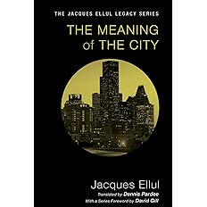

Jacques Ellul, a former member of a Law Faculty at the University of Bordeaux, was recognized as a brilliant and penetrating commentator on the relationship between theology and sociology. In the Meaning of the City he presents what he finds in the Bible--a sophisticated, coherent theology of the city fully applicable to today's urbanized society. Ellul believes that the city symbolizes the supreme work of man--and, as such, represents man's ultimate rejection of God. Therefore it is the city, where lies man's rebellious heart, that must be reformed. The author stresses the fact that the Bible does not find man's fulfillment in a return to an idyllic Eden, but points rather to a life of communion with the Savior in the city transfigured. The Meaning of the City, says John Wilkinson in his introductory essay to the book, is the "theological counterpoint" to Ellul's Technological Society, a work that analyzed the phenomenon of the autonomous and totally manipulative post-industrial world. Ellul takes issue with those who idealistically plan new urban environments for man, as though man alone can negate the inherent diabolism of the city. For Ellul, the history of the city from the times of Cain and Nimrod through to Babylon and Jerusalem reveals a tendency to destroy the human being for the sake of human works. Nevertheless, continuing the theme of the tension between two realities that characterizes all his works, Ellul sees God as electing the city as itself an instrument of grace for the believer. William Stringfellow describes The Meaning of the City as a book of "startling significance," which "should rank beside Reinhold Niebuhr's Moral Man and Immoral Society as a work of truly momentous potential." Douglass D. McFerran adds that it is "a book worth serious consideration by anyone interested in the relationship between religious commitment and secular involvement." And John Wilkinson sums it up: "There are very few convincingly religious analyses of the sociological phenomena of the present day. . . . Ellul's biblically based sociology is today furnishing the matter for a large and growing group of social protestants, particularly in the United States."

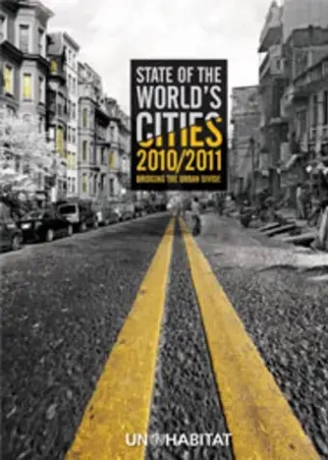**Publication date:** 2010

**Publisher:** UN-Habitat

**State of the World's Cities 2010/2011- Cities for All: Bridging the Urban Divide**

This report uses the framework of 'The Urban Divide' to analyse the complex social, political, economic and cultural dynamics of urban environments. It addresses poverty and deprivation, which expose low-income urban dwellers to higher risks and make them even more vulnerable. The overall book focuses on the concept of the 'right to the city' and the ways in which many urban dwellers are excluded from the advantages of city life, using the framework to explore links among poverty, inequality, slum formation and economic growth.

The volume is intended for all professionals and policymakers in the field and aims to be a valuable resource for researchers and students in all aspects of urban development.

**Contents include:**

Part 01: Urban Trends  
1.1 Cross-Currents in Global Urbanization  
1.2 The Wealth of Cities  
1.3 Slum Dwellers: Proportions are Declining, but Numbers are Growing

Part 02: The Urban Divide  
2.1 The Urban Divide: Overview and Perspectives  
2.2 The Economic Divide: Urban Income Inequalities  
2.3 The Spatial Divide: Marginalization and its Outcomes  
2.4 The Opportunity Divide: When the "Urban Advantage" Eludes the Poor  
2.5 The Social Divide: Impact on Bodies and Minds

Part 03: Bridging the Urban Divide  
3.1 Taking Forward the Right to the City  
3.2 The Regional Dynamics of Inclusion  
3.3 The Five Steps to an Inclusive City