Transformational Urban Leadership course

TUL520 Urban Spirituality

Facilitators: Dr Viv Grigg, B.E.E., M.A. (Missiology), PhD (Theology)
vivgrigg@yahoo.com

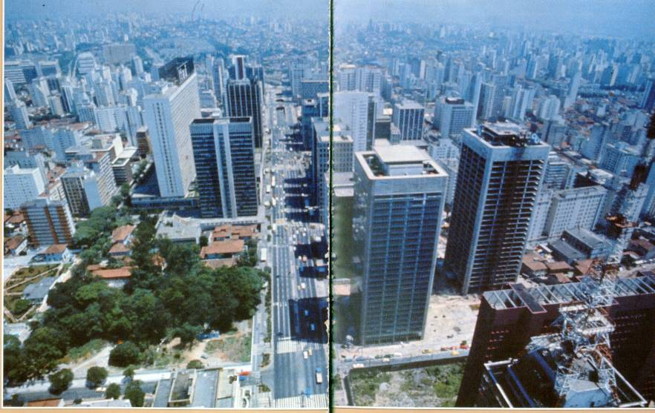



STUDY GUIDE



Auckland Urban Leadership Training Institute
Mar 2008
/tmp/in/input.doc

Index
Transformational Urban Leadership course 1
TUL520 Urban Spirituality 1
I. Course Description 3
II. Expanded Description 3
III. Course Rationale 3
IV. Student Outcomes 5
V. Course Materials 5
VI. Learning & Assessment Activities 7
VII. Expectations & Grading 8
VIII. Course Calendar 8
IX. Assignments and Weighting 11
Assignment 1: Pre-Course Slum Worship Styles 12
Assignment 2: Course Readings and Reflections 13
Assignment 3: Fivefold Ministries Questionnaire 14
Assignment 4: Kiwi Spirituality and Migrant Poor Spirituality Logs 18
Assignment 5 : Designing Your Own Rule of Life 18
Assignment 6a: Husband/Wife Evaluation 18
Assignment 6b: Single Person’s Self-Evaluation 18
Assignment 7: Motivational Evaluation and Ministry Values Quizes 20
Assignment 8: Dealing with Pain 25
Assignment 9: Spiritual Growth Plan for Duration of Degree 25
Assignment 10: Pakeha Spirituality and Urban Poor (Migrant) Spirituality Integration 25
Assignment 11: Weekly Examen Exercises 25
Assignment 12: Spiritual Growth Group 28
Assignment 13: Group and Individual Course & Facilitator Evaluation 30
X. Bibliography 35

Auckland Urban Leadership Institute
Auckland, New Zealand
Transformational Urban Leadership (TUL) Program

TUL520 : Urban Spirituality (3 units)

Dr. Viv Grigg, (Email: vivgrigg@yahoo.com)

I. Course Description
This course explores the development of a personal urban spirituality, as well as the skills of leading spiritual formation among the urban migrants, elites and poor. The course includes a personal inventory of character, calling, and giftedness and addresses human development and family life in the inner city context.

II. Expanded Description

Personal inventory of character, calling and gifteness. Critical application of the four seasons of Christian growth to ones own life and the lives of a selected group of people.

Issues of sustaining a healthy marriage partnership or singleness in the midst of the stresses of urban poor ministry.

Reflections on building an intimate relationship with God in the context of the migrant poverty, the city and indigenous culture, knowing the appropriate use and application of spiritual disciplines.

III. Course Rationale

- Well developed inner spirituality and knowledge of the work of the Holy Spirit is
prerequisite for sustained ministry among the needy. Candidates will be encouraged in disciplined habits that promote an urban spirituality through weekly reading, study, response and practice of the classical spiritual disciplines. They will develop an action plan (individually or with their spouse) for the next years of spiritual formation. The course outcomes involve a focus on both personal spirituality and the impartation of spirituality to others.

- Urban Poor Spirituality: This is also a course on urban poor (largely migrant) spiritualities in Auckland and Pacific cities (a largely uncharted academic area) not a traditional course on classic Western or Catholic spiritual exercises (though these are a significant section of the course). Because it is uncharted, the course participants themselves need to be encouraged through a story-telling approach to inject their knowledge of urban poor spirituality into the course processes. Urban poor spiritualities are very different from classical Western spiritualities or even much evangelical spirituality (See Cry of the Urban Poor chs 15,16 for anthropological reasons for this).

Such urban poor spirituality revolves around the Holy Spirit in the community of faith (vs the individualism and quietness of the leisured classes). It is noisy, emotional, involves frequent power encounters and healing of devastating emotional problems often taking many years, under authoritarian leadership. Engaging these issues of urban poor spirituality and relating these cultural characteristics to ancient Western or more middle class traditions is critical. On the other hand Pentecostal pastors from among the migrants, the poor and the working classes will be expanding their understanding to see the whole field of spirituality as a critical element for long-term wholeness. Classic spiritual disciplines are critical for their survival and also critical for middle class students who are entering urban poor ministry in the class to cope with the stresses of incarnational ministry (in this we draw from the emergent Protestant apostolic orders).

- Spirituality from the Holy Spirit: Christian spirituality can be taught centred around
doctrine, psychological approaches or the work of the Holy Spirit. Evangelical spirituality has always centred in movements of revival of the Holy Spirit vs more psychological approaches derived from Catholicism or psychotherapy. There are elements of each in this course. In this course, the class will seek to move into dimensions of the work of the Holy Spirit. Sensitive contrast of the diversity of doctrinal approaches to activity of the Spirit needs be done so that diverse traditions in the class are not offended. One of the goals of this class is that each student can freely move in the power of the Spirit, hear his voice, and exercise appropriately their spiritual gifts, in ways that maintain harmony of the Spirit across the body of Christ. (Lecturers and supporting faculty need to be aware that this may also provoke some degree of spiritual warfare during this training. It would be wise for this course to always be team taught by people both academically learned and practically experienced in these areas of releasing people from sin and bondages into the fullness of the work of the Spirit).

- Classical Spirituality: Reflections on the continuity of building an intimate
relationship with God in the context of the city, knowing the appropriate use and application of prayer and fasting, encountering and responding to spiritual conflict, exercising deliverance ministry, in-depth bible study, practising the presence of God, the exercise of spiritual gifts with an attitude of servanthood, and practising moral integrity and ethics.

- Self Awareness and Dealing with Pain: This is not a counseling course but it will
also further screen candidates in areas of family, psychological, emotional and spiritual wholeness and enable pastoral care for problem areas compulsive sin, demonic possession, areas of bondage (this may in relationship to leadership, narrow doctrinal bondage, work expectations within their mission, family bondages, paranoias etc), and enable evaluation of the candidate's spiritual maturity potential to fulfil the outcomes required for the whole program. Facilitators will sit at least twice with each person during the first week in a process of evaluation with them outside of the classroom time, based on some questionnaires they do and working with them on defining a program for spiritual growth. The introductory week will facilitate them into a relationship with a spiritual director for the remainder of the year.

- Spirituality and Marriage: Issues of sustaining and developing a healthy marriage
partnership in the midst of the stresses of urban ministry and poverty are briefly engaged in the light of contextual spirituality. For single people similarly issues of developing a godly singleness are touched on.

- A Framework for Growth: Critical application of the four seasons of Christian
growth to ones own life and the lives of a selected group of people, ascertaining which season each person is in and how that contributes to their spiritual development and function within a ministry team or faith community.

- Practicum: In the practical phase of the course above, students are invited, through
spiritual direction, personal journaling and group interaction:

- to explore the nature of one’s spiritual formation
- to experiment with a variety of spiritual practices that encourage a contemplative approach to life
- to share one’s experience of these practices in a community setting
- to integrate academic and professional foundations around a center of spiritual maturity in Christ
- to examine traditional Christian practice in the light of a commitment to social justice
- to identify core idols and life patterns needing repentance, spiritual healing, and transformation
- to nurture a “rule of life” that can sustain one’s witness within slum environments

Field Instructors will draw upon spiritual formation resources (see bibliography) and local retreat facilities to organize day-long retreats. Students come to these retreats prepared to share out of their spiritual journals. These journals record responses to various Self-Examination Questions, Notes they have developed on Filipino Spirituality or Slum Spirituality, and Reflections on Leadership of a small group in spiritual growth – personal life reflections that can contribute to the fashioning of a rich group life and enable students to appreciate how God is forming them through individual and interpersonal experience, nature, and the urban systems in which they live and work.

IV. Student Outcomes

Praxis
1. Has identified personal styles of hearing God, areas of blockage to the work of the Holy Spirit in their own lives,is experiencing his presence and power, has identified areas of primary gifting, calling and capacity.

2. Has developed a personal Lifestyle and Values and a plan for personal spiritual growth and exercise of spiritual disciplines in an ongoing relationship with a spiritual mentor.

- Exercises ministry gifts in a team, in a way that encourages a faith community to experience the direct presence of God.

4. Understands the seasons of growth each member of a small group has reached and can identify next steps in this season.

Reflection
5. Understands the Biblical framework of the work of the Holy Spirit and various styles of spirituality from a holistic and contextual perspective.

6. Has collaborated in the development of an analysis of urban spirituality and of the spirituality of the poor, the migrants.

V. Course Materials

Course CD and Reader: Each student will be given a CD with much of the course materials
on it, plus may buy a course handbook with many of the assignments, plus a reader. Many of
the article below can be found in this reader. They will also be on the CD.

Abeledo, Yago. (2002). The Slums: The Challenge of a Crucified People. In Franceso Pierli and Yago Abeledo (Ed.), The Slums:A Challenge to Evangelization (pp. 109-132). Daughters of St Paul, P.O. Box 49026, 00100 Nairobi GPO: Paulinas Publications Africa.
Bessenecker, Scott. (2006). Voluntary Poverty of God. The New Friars: The Emerging Movement Serving the World's Poor. Downers Grove, IL: IVP.Boa, Ken. (2001). Warfare with the Flesh. Conformed to his Image. Grand Rapids: Zondervan.
Boa, Ken. (2001). Walking in the Power of the Spirit Conformed to his Image. Grand Rapids: Zondervan.
Brother Lawrence of the Resurrection. (1977). The Practice of the Presence of God. Garden City: Image.
Cone, James H. (2005). God & Black Suffering. The Spirituals and the Blues. An Interpretation. New York: Orbis Press.
Chu, Reineer. A Theology of Change Unpublished paper.
Doolittle, Benjamin R. and Micheal Farrell. The Association Between Depression and Spirituality in an Urban Clinic. Journal of Clinical Psychiatry, 2004; 6(3).
Hanks, Thomas. (1984). Basic Old Testament Vocabulary of Oppression. God So Loved the Third World. Maryknoll, Orbis Books. pp3-25.
Breen, M. (2002). Fivefold Ministries. In The Apostle's Notebook. Eastbourne, England, pp. 161-171, 220
Cox, Harvey. (1995).Your Daughters Shall Prophesy. Fire from Heaven: The Rise of Pentecostal Spirituality and the Reshaping of Religion in the Twenty-First Century. Reading, MA: Addison-Wesley. 161-184.
Flavier, Juan M. (1974). Ka Berong, Albularyo. In My Friends in the Barrios. Manila: New Day Publishers.
Grigg, Viv. (2005). Works of the Spirit of God. In Cry of the Urban Poor. GA, USA: Authentic Media.
--- . (2005). Group Structures for Squatter Churches In Cry of the Urban Poor. GA, USA: Authentic Media. ch 13.
---. (2005). The Nature of Revival. In The Holy Spirit and the Postmodern City: Transformative Revival Among Auckland's Evangelicals and Pentecostals. PhD (Theology), University of Auckland, Auckland. ch 6. pp74-96.
---. (2005). An Insider's Perspective. In Cry of the Urban Poor. GA, USA: Authentic Media. ch 15.Capaque, George N. (c2000) PAGBUBUKAS-LOOB: A Filipino Evangelical Theology of Spirituality. Excerpt from PhD Thesis.
Jocano, F. Landa. (1980). The Coming of the Gods. In Outline of Philippine Mythology. Manila: Centro Escolar University Research and Development Center.
Koch, Kurt. (1994). Pastoral Cases from the Field of Occultism. Christian Counselling and Occultism (fr German, Trans.). Grand Rapids: Kregel.
Ligo, Arche. (1993). Liberation Themes in Philippine Popular Religiosity: A Case Study. Voices from the Third World, XVI (2), 117-142.
Murphy, Ed. (1996). Six Sin Areas and Possible Demonisation of Christians. The Handbook of Spiritual Warfare. Nashville: Thomas Nelson.
Rieblich, Ruthellen Josellson and Amia. The Psychology of Keeping a Diary. In The Narrative Study of Lives.
Sandford, John and Paula. (1985). The Forgotten Functions of Our Spirit. In Healing the Wounded Spirit (pp. 3-26). Tulsa, OK: Victory House, Inc.
Wimber, John & Springer, Kevin. (1986). An Unlikely Healer. Power Healing. London: Hodder & Stoughton.
Weekly Examen Exercises

Books used in course

Boa, Ken. (2001). Conformed to his Image. Grand Rapids: Zondervan.
Grigg Viv. (2004). Companion to the Poor. Monrovia, CA: Authentic Media (revised and updated).
---. (1985). The Lifestyle and Values of Servants. Auckland: Urban Leadership Foundation.
---. (2005). The Nature of Revival. The Holy Spirit and the Postmodern City: Transformative Revival Among Auckland's Evangelicals and Pentecostals. PhD (Theology), University of Auckland, Auckland.
Gutierrez, Gustavo. (1984). We Drink from our Own Wells: The Spiritual Journey of a People. New York: Orbis Books; London: SCM Press.
Hanks, Thomas. (1983). God So Loved the Third World: The Biblical Vocabulary of Oppression. Maryknoll: Orbis.
Koch, Kurt. (1994). Christian Counselling and Occultism (fr German, Trans.). Grand Rapids: Kregel.
Ligo, Arche. (1993). Liberation Themes in Philippine Popular Religiosity: A Case Study. Voices from the Third World, XVI (2), 117-142.
Murphy, Ed. (1996). The Handbook of Spiritual Warfare. Nashville: Thomas Nelson.
Sabatier, Paul & Sweney, Jon M. (2003 (1894)). The Road to Assisi: The Essential Biography of St Francis. MA: Paraclete Press.
Brother Lawrence of the Resurrection. (1977). The Practice of the Presence of God. Garden City: Image.
St. Ignatius of Loyola. (1999). Spiritual Exercises. Tan Books & Publishers.

VI. Learning & Assessment Activities

1. Classroom Teaching on Underlying Theoretical Considerations in Spirituality
Spirituality is based on understanding critical paradigms from both scriptures and the literature of spiritual experience.

2. Reflective Reading
The readings assigned each day or week are to be completed and carefully reflected upon before gathering. They analyze a range of spirituality perspectives which we will discuss during our class sessions. Typically only one or two articles or book chapters will be assigned each week. Nevertheless, they are very important! The concepts presented through the readings will correlate with the week’s topical presentation/discussion, providing us a theoretical “frame” for analyzing spiritualities.

3. Spiritual Journal
Students will keep a daily journal of insights into aspects of their spiritual journal. This will begin with students developing a personal timeline, reflecting on their spiritual journey to the present.

4. Guided Retreats
A guided, 2 day silent retreat may include group worship, personal counseling, private prayer, issue discussions, and academic reading and writing.

Students may also form smaller reflection groups (no more than eight peers) to help them reflect on how their personal and communal spiritual experience might find expression in loving action within migrant communities.

5. Analysis of City and Migrant Spiritualities
Based on the classroom analysis students will keep a notebook of daily/weekly observations of the nature of spirituality in the slums and in filipino society. These reflections will be integrated by the class during a retreat into a paper or papers on the nature of Filipiono slum spirituality.

6. Small Group Growth in Exercising the Ministry of the Holy Spirit
This class is structured to be a secure environment where students can grow in discernment and experience of the work of the Holy Spirit, and their exercise of gifts of the Holy Spirit based on Biblical understandings. The class will take time seeking the presence of God in prayer and worship.

7. Personal Examination
There are a number of self-assessment charts to enable greater self-understanding.

VII. Prerequisites

This course is based on an understanding that students
- have experienced conversion
- are growing in the work of the Spirit
- have been involved in forming and leading small discipleship groups.

VII. Expectations & Grading

The Meaning of the Grading System:

- Outstanding performance: virtually perfect attendance; always prepared for class with all assignments completed; shows intrinsic interest in the class and subject, asks penetrating questions or offers thoughtful reflections in class; demonstrates exceptional intelligence and insight with unusual creativity; earns high scores on course assignments—usually the highest in the class.
- Above average student in terms of attendance, preparation, attitude, initiative in asking questions, time management, and assignment quality.
- Average or typical student in terms of attendance, preparation, attitude, initiative in asking questions, time management, and assignment quality.
- Below average or atypical student in terms of attendance, preparation, attitude, initiative in asking questions, time management, and assignment quality — minimally passing in performance.
F. Repeat course. Inadequate/insufficient performance.

VIII. Course Calendar

Topics | RESOURCES & ASSIGNMENTS  (Due dates in extended asssignment descriptions following)
 | Assignment 1: Pre-Course Slum Worship Due on first day of class
Foundations  • Powhiri (Welcome)  • Worship  • Introductions  - Students introductions  - Lecturers stories  - Introduction to the Encarnacao Alliance  - Introduction to the MATUL (VG, LW)  - Course Outline(VG, RC)  - Objectives and Expectations  - Introduction to the Study Guide & CD (VG)  - Goals of Sanctification  - Biblical Basis for a Theology and Process of Sanctification (ppt)(VG)  - Prayer  - The Beatitudes – Nature of Sanctification (VG)  Primary frameworks for spiritual growth are developed in:  • Four Seasons of Spiritual Growth | Abeledo, Yago. (2002). The Slums: The Challenge of a Crucified People. In Franceso Pierli and Yago Abeledo (Ed.), The Slums:A Challenge to Evangelization (pp. 109-132). Daughters of St Paul, P.O. Box 49026, 00100 Nairobi GPO: Paulinas Publications Africa.  Boa, Ken. (2001). Warfare with the Flesh. Conformed to his Image. Grand Rapids: Zondervan.  Grigg, V. (2005). Group Structures for Squatter Churches In Cry of the Urban Poor. GA, USA: Authentic Media. ch 13.  Reading Assignment overnight:  1. Read Grigg, Viv. (2005). The Nature of Revival. In The Holy Spirit and the Postmodern City: Transformative Revival Among Auckland's Evangelicals and Pentecostals. PhD (Theology), University of Auckland, Auckland. ch 6. pp74-96.  2. Read Reineer Chu, A Theology of Change on course CD.  3. Read Hanks, Thomas. (1984). Basic Old Testament Vocabulary of Oppression. God So Loved the Third World. Maryknoll, Orbis Books. pp3-25.  Assignment 2: Complete the Fivefold Ministries Questionnaire overnight
Holy-Spirit Centred Spirituality Seeking the Holy Spirit in Worship  • The Nature of the Holy Spirit  o Release of the Spirit  - Leadership Giftings (power point)  - Discuss Fivefold Ministries Questionnaire  - The Nature of Revival | Nee, Watchman. (1965). The Release of the Spirit. Box 74 - Route 2, IN 46120, USA: Sure Foundation.  Breen, M. (2002). Fivefold Ministries. In The Apostle's Notebook. Eastbourne, England, pp. 161-171, 220  Cox, Harvey. (1995).Your Daughters Shall Prophesy. Fire from Heaven: The Rise of Pentecostal Spirituality and the Reshaping of Religion in the Twenty-First Century. Reading, MA: Addison-Wesley. 161-184.  Grigg, Viv. (2005). Works of the Spirit of God. In Cry of the Urban Poor. GA, USA: Authentic Media.
Indigenous Spiritualities
- The Kiwi Soul
- The Spirituality of the Pakeha
- Evening Prayer

Contextual Urban Spirituality  - Urban Spirituality  - (Post-Modern Spirituality) | Scharen, Christian. (2006). One Step Closer: Why U2 Matters to Those Seeking God. Grand Rapids, MI: Brazos Press, Baker Publishing.
Seeking the Presence of the Holy Spirit in Worship  Classical & Evangelical Spiritual Disciplines  - The Wheel Diagram & The Word Hand  - Prayer and Fasting (Students)  - Classical Spirituality  - Spiritual Direction  - Centring Down | Willard, D. (2002). Renovation of the Heart. Colorado Springs: Navpress.  Boa, Ken. (2001). Warfare with the Flesh. Conformed to his Image. Grand Rapids: Zondervan.  Foster, Richard. (1998). Celebration of Discipline. New York: HarperCollins.  Boa, Ken. (2001). Walking in the Power of the Spirit Conformed to his Image. Grand Rapids: Zondervan.
Slum Church Spiritual Disciplines(VG)  - Urban Poor Spirituality  - The Culture of Poverty and Spirituality  - Worship Styles  - Students report back from weekend worship  - Group accountability  - Encounters with the Miraculous  - Deliverance  - Healing  - Prayer: Seeking the Presence of the Holy Spirit | Grigg, Viv. (2005). Squatter Culture and the Church. In Cry of the Urban Poor. GA, USA: Authentic Media. ch. 16.  Grigg, Viv. (2005). An Insider's Perspective. In Cry of the Urban Poor. GA, USA: Authentic Media. ch 15.  Gutierrez, Gustavo. (1984). We Drink from our Own Wells: The Spiritual Journey of a People. New York: Orbis Books; London: SCM Press.  Cone, James H. (2005). God & Black Suffering. The Spirituals and the Blues. An Interpretation. New York: Orbis Press.  Koch, Kurt. (1994). Pastoral Cases from the Field of Occultism. Christian Counselling and Occultism (fr German, Trans.). Grand Rapids: Kregel.  Murphy, Ed. (1996). Six Sin Areas and Possible Demonisation of Christians. The Handbook of Spiritual Warfare. Nashville: Thomas Nelson.  Wagner, C. Peter. (1992). Warfare Prayer. Ventura: Regal.  Wimber, John & Springer, Kevin. (1986). An Unlikely Healer. Power Healing. London: Hodder & Stoughton.  Assignment for next morning:  1. Complete the Motivational Evaluation and Personality Quizes or Go online and take the enneagramme test at  http://similarminds.com/advtest.html  2. Husband/ Wife Analysis
Seeking the Presence of God in Worship  Spiritual Disciplines for Incarnational Workers  • The Lifestyle and Values (Power Point))  • Why a Third Order? | Bessenecker, Scott. (2006). Voluntary Poverty of God. The New Friars: The Emerging Movement Serving the World's Poor. Downers Grove, IL: IVP.  Assignment: Rewrite your own Lifestyle and Values with your wife and/or team
- Migrant Spirituality: Biblical Context of Oppression (Discussion based on Hanks)  - Spirituality of the Oppressed | Assignment for Weeks 1-6 Filipino Spirituality and Slum Spirituality journal
Seeking the God in Worship
Self-Awareness
- Motivational Evaluation
- Understanding our Personality, Mental and Spiritual Health
- The Enneagramme as a means of self-knowledge
Family Life in Urban Ministry  - Family Stresses in Urban Ministry  - Exercise on Roles of Pastors’ Wives  - Discussion on Couples Reflection on Readiness for Slum Leadership  - Discussion of Singles and Spirituality (Mens/Womens Groups)  Time of Intercession/Prayer for Healing | Families Surviving with Servants
Spirituality and Pain (VG)  - Grief Questionnaire  - Give Sorrow Words or  - Courage to Grieve  - Dealing with Bitterness or  - Dealing with Painful Past  Time of Prayer for Healing  Korokorake (farewell from place) | Sandford, John and Paula. (1985). The Forgotten Functions of Our Spirit. In Healing the Wounded Spirit (pp. 3-26). Tulsa, OK: Victory House, Inc.  Read the conclusions in Benjamin R Doolittle and Micheal Farrell. The Association Between Depression and Spirituality in an Urban Clinic. Journal of Clinical Psychiatry, 2004; 6(3).  Assignment: Dealing with People in Pain
PRACTICUM (10 weeks, 6hrs/week +6hrs/week reading/assignments)
Weeks 1-6: Filipino (or whatever culture) Spirituality and Urban Poor Spirituality  Week 1-10: Weekly Examen Exercises  Week 1-10 Small Group Spiritual Growth | Assignment: Each day in the back of your devotional journal keep a log of two things you notice  - elements of Spirituality that are defined by Filipino culture  - elements of Spirituality defined by Slums/Urban Poverty  Lieblich, Ruthellen Josellson and Amia. The Psychology of Keeping a Diary. In The Narrative Study of Lives.  Assignment: Weekly Examen Exercises  Assignment: Course Readings: Each week spend 5-6 hours reading course materials and reflecting into a reading log/journal  Assignment: Spiritual Growth Group: work with a small group in the development of their spiritual growth
1. Spiritual Direction | Assignment: Complete plan for working with a Spiritual Mentor and Growth for duration of Degree  Brother Lawrence of the Resurrection. (1977). The Practice of the Presence of God. Garden City: Image.
2. Facilitator/Student Consultation
3. | Nouwen, Henri. (2002). A cry for mercy: prayers from the Genesee. Garden City, New York: Image Books.  Or Nouwen. Henri. (1993). Gracias! A Latin American journal. Orbis.
4. | St. Ignatius of Loyola. (1999). Spiritual Exercises. Tan Books & Publishers.
5. Spiritual Mentoring | Peterson, Eugene H. (1993). The contemplative pastor: returning to the art of spiritual direction, Eerdmans Publishing.
6. Group Silent Retreat
7.
8. Facilitator. Student Consultation
9. Spiritual Mentoring
10. Final Retreat, seeking God together | Assignment: Students meet for retreat to integrate their assignments on Filipino Spirituality and Slum Spirituality into an integrated (set of) paper(s). Ideally (some) to be published.  Assignment: Group and Individual Course Evaluation

IX. Assignments and Weighting

Assignment | Points Possible | DUE DATE
1. Pre-Course Slum Worship |  | Day 1
2. Course Readings and Reflections | 25 | Week 4&9
3. Complete the Fivefold Ministries Questionnaire |  | Day 2
4. Migrant Poor Spirituality Logs | 5 | Week 9
5. Rewrite your own Lifestyle and Values with your wife and/or team | 20 | Week 4
6. Husband/ Wife Analysis or Singles Analysis |  | Day 5
7. Motivational Evaluation and Personality Quizes |  | Day 5
8. Dealing with People in Pain |  | Week 8
9. Spiritual Mentoring Plan/ TimeLine | 10 | Week 7
10. Silent Retreat | 10 | As Determined by Local Facilitator (Ideally Week 7)
11. Weekly Examen Exercises (in Journal | 15 | Week 9
12. Spiritual Growth Group | 10 | Week 9
13. Group and Individual Course Evaluation |  | Week 1,10
14. Course Participation and Attendance | 5
Total: | 100

Grading System
Grades are standardized and recorded using the following scale:
1.0  1.25  1.5  1.75  2.0  2.25  2.5  3.0 | A+  A  A-  B+  B  B-  C  C-  F | Outstanding Performance  Superior Performance  Satisfactory Performance  Minimum Acceptable Performance  Unsatisfactory Performance  Fail | 96-100  91-95  86-90  80-85  75-79  70-74  60-69  50-59  Below 50

All assignments need your name, class number and date in top right corner.

Assignment 1: Pre-Course Slum Worship Styles
SIMPLE ETHNOGRAPHIC ANALYSIS
Prior to the course attend a slum church. Write a less than one page analysis for discussion in class.
- What was the physical context of worship?
- What are the noticeable features of the participants?
- Describe ten characteristics of the worship
- Why do you think they worship in this style? What is contextually determined? What is imported?
Due: Day 1 of class

Assignment 2: Course Readings and Reflections
There are about 15 chapters on the CD that can be printed off to read. Other texts are in the library. Read each, identify the main theme and subpoints, perhaps by highlighting. Do a reading log (unless a longer response is requested), with the title in APA format, the number of pages read, and do either a one paragraph summary or one paragraph response, and jot down a quote with page number.

When reading a longer book, you should browse more than read each detail. Review the index, introduction and conclusion, then browse each chapter, and focus in on one or two of significance.

A total of 1000 pages reading. You have about 6 hours per week designated for this reading and reflection activity
Due: The early weeks of this log are to be passed in, in week 4, for review, and the whole log passed in again for grading in week 10.

Assignment 3: Fivefold Ministries Questionnaire
Breen, M. (2002). Fivefold Ministries. In The Apostle's Notebook. Eastbourne, England, pp. 161-171, 220.
Due: Day 2 of class

Read through the statements and decide as honestly as you can whether you strongly agree, agree, or disagree, and tick the appropriate box. Do not linger on each item, as your first thought is likely to represent the most accurate response.

Item No. |  | Often | Sometimes | Rarely
1 | I remember names or at least where I first met someone
2 | I have expressed my feelings about God as pictures or analogies
3 | My ability to present Scripture clearly and accurately has been commented on
4 | I can be counted on to contribute original ideas
5 | I find myself talking about my faith to the people I meet
6 | I get frustrated when I feel I'm not experiencing 'new' things as a Christian
7 | When I communicate biblical truths to others I see resulting changes in knowledge, attitudes, values or conduct
8 | I share what knowledge I have with others
9 | I have an urge to share thoughts with people that I felt when I prayed and I have been told they meant something or were relevant to the person's current situation
10 | I get upset at other people's difficulties and problems even if I haven't experienced them myself
11 | I have strong sense of what God wants to say to people in response to a particular situation
12 | I enjoy studying the Scriptures and find that I get fresh insights that people find interesting and helpful
13 | When reading the Bible I am more able to grasp the wider picture or message than the specific details
14 | I like to share what I believe
15 | I have been successful in developing Christian discipline in others
16 | I'll try things out if it will encourage others to do the same
17 | I am quick to help when help is needed and often do things which I see need to be done without even being asked
18 | I have been able to spot a 'person of peace' who is ready to receive a word from God and have seen a positive response
19 | I have a clear vision and others have said that they feel confident to go along with me
20 | I try explaining things in different ways if people are finding a concept difficult to grasp or understand
21 | I think before I speak
22 | I really fear that people I know will not be saved
23 | I like to be clear and decisive when speaking about what I believe God has said to me
24 | I am by no means an expert on Scripture, but I can grasp the point of a passage quite quickly
25 | I get frustrated and even depressed at the lack of faith or understanding of others around me
26 | People tell me that the things I say often help them to try new things for God
27 | I am interested in living and working overseas or among people from a different culture
28 | I am good at listening and taking in what people say
29 | I have contrived situations so that non-Christians are prompted to ask spiritual questions
30 | I have helped fellow believers by guiding them to relevant portions of the Bible
31 | I get excited when I discover new understanding, insights and applications of God's word
32 | I have reminded people of the foundations of their faith
33 | Despite not enjoying the nitty-gritty details of the leadership, I still often end up leading things
34 | People have told me that I have helped them be restored to the Christian community
35 | I feel that I know exactly what God wants to do in ministry at a specific point in time
36 | I dig out information and passages to explain a concept
37 | I mix easily with a wide variety of people without having to try to be one of them
38 | I have a deep concern to encourage people towards spiritual growth and achievement
39 | I try to think of different ways of expressing the truth to gospel
40 | Friends ask me to help clarify a situation or scripture
41 | I am quite persuasive when encouraging people to examine their spiritual motives
42 | I empathize with those who are hurting or broken and can support them through their pain to wholeness
43 | When in a group, I am the one others look to for vision and direction
44 | I enjoy being with non-believers because of my desire to win them to Christ
45 | I will see a job through to the end so that no one has to pick up the pieces after me
46 | My prayers surprise me with their clarity and unexpected direction
47 | People comment that they remember what I tell them about God
48 | I expect opportunities for witnessing to arise rather than react in surprise when they occur
49 | I desire the gift of healing in greater measure (that the Lord would heal others through me)
50 | The things I say in a spiritual contex make people feel uncomfortable
51 | I have enjoyed relating to a certain group of people over a period of time, sharing personally in their successes and their failures
52 | People have told me that I have helped them learn biblical truth in a meaningful way
53 | I have led someone to a decision for salvation through faith in Christ
54 | God has enabled me to reveal specific things which have happened or meant something at a later date
55 | There have been times when I felt sure I knew God's specific will for the future growth of his work, even when others have not been so sure
56 | People have told me that I have communicated timely words or pictures which must have come directly from the Lord
57 | People call on me to help those who are less fortunate
58 | I get great satisfaction from studying the Bible and sharing my insights with others
59 | Others have suggested that I am a person of unusual vision
60 | Non-Christians have noted that they feel comfortable when they are around me, and that I have a positive effect on them towards developing a faith in Christ
61 | I am willing to challenge or confront people in order to help them mature
62 | I regularly need to get space alone or long periods of time out to reflect, pray and think
63 | I have just suddenly known something about someone
64 | I enjoy taking notes when someone is speaking and pay close attention to the details of what they are saying
65 | I am faithful in providing support, care and nurture for others over long periods of time, even when others have stopped
66 | I enjoy mentoring individuals
67 | I enjoy relating stories and sharing my experiences
68 | I enjoy coming up with new and original ideas, dreaming big and thinking about visions for the future
69 | I find non-Christians ask me questions about my faith in Christ, and my church involvement
70 | I can accurately assess a person based on first impressions and know instinctively when something is not quite right
71 | I like to provide a safe and comfortable environment where people feel they are welcome, that they belong, are listened to and cared for
72 | I would like to start a church or a new ministry in an area which is not catered for at present
73 | I have a heart to share my faith and to pray for those in my work and neighborhood who do not attend church
74 | When I hear about situations of need I feel burdened to pray
75 | I like to help churches, organizations, groups and leaders become more efficient and often find myself thinking about how things function
76 | I enjoy spending time studying Scripture and prefer to do so systematically
77 | I look for opportunities to socialize and to build relationships with non-Christians
78 | People come to me to ask me my opinions on particular parts of the Bible or to answer their queries
79 | I find that people trust me and come to me regularly, wanting to char and looking for my advice, prayers and help
80 | I can clarify goals, develop strategies, and use resources effectively to accomplish tasks

Now transfer your answers to the score sheet on the next page and add up your totals.

Place a tick against each item number for which you answered 'often' or 'sometimes' (the 'rarely' answers are not counted, but you may wish to use the shaded column for 'rarely' to keep tabs on which answers you have transferred from the question sheet).
Note that some questions occur more than once in the columns on the score sheet.
Finally, add up the number of 'often' ticks, double the answer and add to the number of ticks for 'sometimes'.

Please refer to the appendix to discover which of the five ministries you are currently operating in.

Remember this is only a snapshot. If you want to use the questionnaire to provide a more accurate picture, you will have to use it on several occasions in the future and keep your results to compare. I think that if you answered the questions two or three times a year for two or three years, you would begin to get a clear picture of both of your base ministry and of the phases you were most regularly visiting.

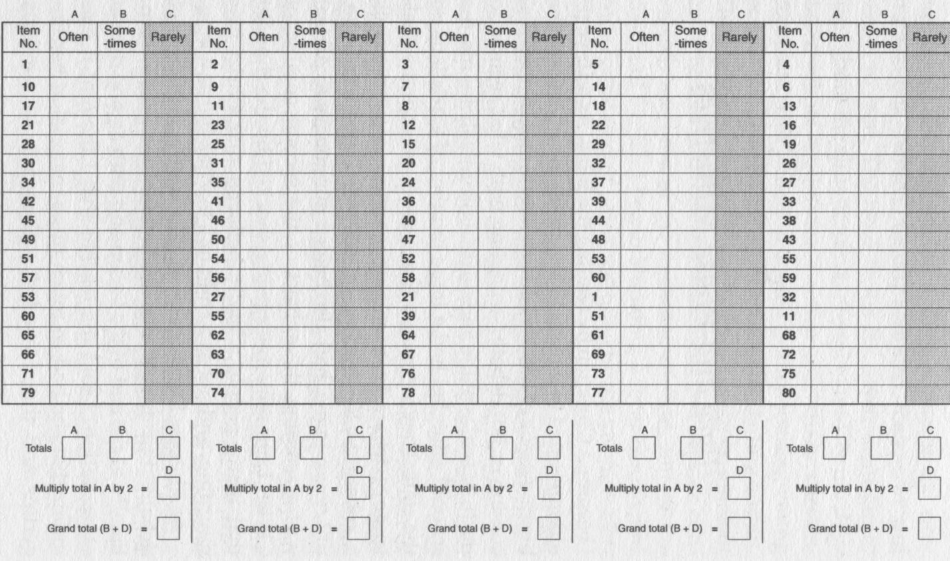

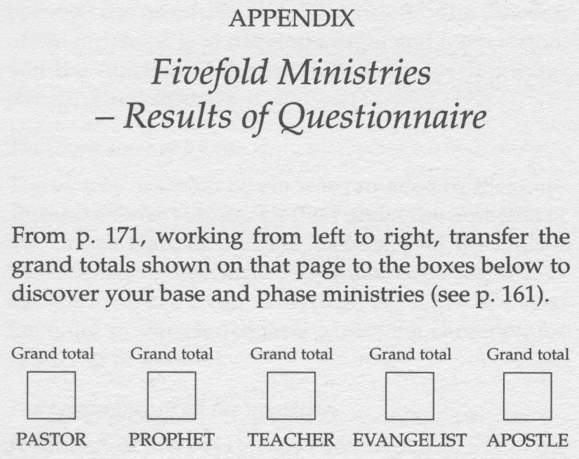

Assignment 4: Kiwi Spirituality and Migrant Poor Spirituality Logs
Each day in the back of your journal keep a log of two things you notice:
- elements of Spirituality that are defined by Pakeha culture
- elements of Spirituality defined by Migrant/Urban Poverty

Integrate these into three to five page papers each in preparation for the retreat. Pass in at this retreat for marking. Search in the library or at other schools for other material on Kiwi spirituality, (recognising that that term is not always used). Where possible integrate any references, so that your reflections are both from in the field and from the literature. During the retreat these will be integrated into collective papers and presentations by groups. Ideally, one of these integrated documents will be published.
Due: Submit one week before the retreat

Assignment 5 : Designing Your Own Rule of Life
Read the Lifestyle and Values of Servants, and Scott Bessenecker, The New Friars.

Write your own Lifestyle and Values with your wife and/or team. Keep it simple. Not too many topics. Think through on how you can be accountable to each other and a spiritual director for the values you identify. Discuss with your spiritual director.
Due: Submit in week 6.

Assignment 6a: Husband/Wife Evaluation
Coping with the demands of ministry among the poor puts high levels of stress on the husband and wife relationship. Take 1-2 hours and discuss and document the extra stresses you face and how they affect your marriage for good and for bad. Is your marriage at a place where you fulfill the Biblical requirements of an elder or overseer? Decide what steps you can take to manage these stresses and to turn them into positive factors for growth? Decide when you can get time together as a couple without kids or people just talking each week.
Due: Day 5 of the first week’s course.

Assignment 6b: Single Person’s Self-Evaluation
Rate yourself on a scale of 1 to 5. This is not a scientific psychological analysis but the basis for reflection and discussion with a core of friends or your spiritual director

 | Evaluation Item | First Date: | Need to grow(✓) | FinalDate: | Need to Grow(✓)
 |  | Score |  | Score
1 | I have a good relationship with my family
2 | I plan ahead to spend time/call my family regularly
3 | I have worked through tensions with my father/mother
4 | I maintain a real home environment for myself not just a place to sleep
5 | I am content to remain single
6 | I am at peace about looking for a husband/wife. I have trusted God to provide a godly partner for me and am careful not to make soul connections with non-believers of the other sex. Or I am committed to remain single for the sake of pioneering the Kingdom
7 | Apart from natural (God-given) loneliness, I consider myself a whole person
8 | I utilise my singleness to give greater energy into the Kingdom of God
9 | I utilize my lack of one love to more deeply care for many people
10 | I have a circle of friends who give me emotional support when I am in need
11 | I have group contexts where I can meet people from whom I meet reasonably expect to find a mate if that is the way the Lord leads
12 | I do not engage in counseling/ministry on my own at deep levels with singles of the other sex, and avoid soul ties that are inappropriate
13 | I have learned to treat the other sex not as objects but as real people
14 | I am making responsible plans for care of my elders, my future family and myself
15 | I can give and receive love
16 | I have memorized 20 passages from the word to use when desires overwhelm me
17 | I have an accountable relationship with a peer or mentor that I can call on when faced with temptations
18 | I know which situations to avoid and which to run from
19 | I am careful to not be in situations of being alone in compromising contexts with someone of the other sex
20 | I am often playing with children, so that if I have children in the future I will be a loving parent
 | Total

What are the three immediate steps you can take to grow?

  - _______________________________________________________________
  - _______________________________________________________________
  - _______________________________________________________________

These questions are derived from Viv Grigg, The Lifestyle and Values of Servants and from Paul J Meyers, Personal Goal Settings.

Assignment 7: Motivational Evaluation and Ministry Values Quizes
The following graphs and questionnaire, on the following pages, has been adopted from the book “Ministering Cross-Culturally” by Lingenfelter & Mayers. Please answer the questions and then plot the graphs.

QUESTIONNAIRE
Determine to what extent each of the following statements describes your thinking and approach to life. If the statement is not at all descriptive of you, write the number 1 in the blank space. If it is very descriptive to you, write the number 7. Write the number 4 if the statement describes you only somewhat. Use the numbers 2 or 3 for items that are less descriptive of you and the number 5 or 6 for those that are more descriptive. Respond to all statements with a number from 1 to 7.

Example:
1. Statement not descriptive of you score:1
2. Statement hardly at all partially true of you score:2
3. Statement less than partially true of you score:3
4. Statement is only partially true of you score:4
5. Statement is usually descriptive of you score:5
6. Statement is generally descriptive of you score:6
7. Statement is very descriptive of you score:7

An example of how to complete the first line “Time Orientation” would be:
Total Average
Time orientation__ __ __ __ __
1 2 3 4 5 =_____5= _____

The lower numbers are the question numbers – insert your score for that question on the line above the question number. For example presuming your answers for Questions 1, 2, 3, 4 and 5 were 7, 5, 3, 6, 7 respectively. The Time Orientation line would look like this: Total Average
Time orientation 7 5 3 6 7
1 2 3 4 5 = 28  5 = 5.6 .

The Average is the figure plotted onto the graph on the vertical axis. (Time Orientation)

PERSONAL PROFILE
Find on each axis your average score for that orientation. Then plot on each grid the point where the two average scores intersect. This point indicates your basic tendency.

The personal profile of basic traits is an approximate representation of the motivations behind the individual's actions within his or her culture. It will prove useful to compare the individual's profile with that of others. The matrix form presents the contrasting traits as concurrent forces pulling in different (but not necessarily opposite) directions. The scores on each matrix indicate the relative strength of each particular trait as one makes decisions and interacts with others.

A score of (2,6) on the first grid (i.e., event has a priority rating of 2, time a rating of 6) suggests that the constraints of time exert a far stronger pull on the decisions and actions of the individual than does commitment to completion of the events in which one participates. A score of (2,2) probably means that neither trait is exerting a strong influence.

The personal profile of basic values can be applied in several ways: (1) it can serve as the basis of a judgment against a person who does not behave as we would wish; (2) it can serve as a radar signal that we are headed for conflict with another person and thus should avoid confrontation; (3) it can serve as an insight which will help us achieve maximum intelligent interaction with another person. In the chapters that follow we will see that by carefully choosing our responses to people and cultures whose orientations differ from ours, we can reduce or even resolve tensions in interpersonal relations

- ____I would not feel comfortable working for a large company because I would never see the whole picture of what I was working on.

- ____I seek out friends and enjoy talking about any subject that happens to come up.

- ____I avoid setting goals for fear that I might not reach them.

- ____I am more concerned about what I have accomplished than I am with the position and title of my job.

- ____I seldom think much about the future; I just like to get involved in things as they turn up.

- ____I feel things are either right or wrong; discussion of "grey" areas makes me uncomfortable and seems to compromise the truth.

- ____When making a decision, I feel that more than one of the options can be a right choice.

- ____When I set a goal, I dedicate myself to reaching that goal, even if other areas of my life suffer as a result of it.

- ____I am always one of the first to try something new.

- ____I tend to associate only with people of the same social status.

- ____I feel strongly that time is a scarce commodity, and I value it highly.

- ____When my car needs tuning, I go to the dealer rather than let my neighbour who works out of his garage do the job. With professionals I know it will be done right.

- ____I like performing before an audience because it pushes me to perform better.

- ____My primary criteria for buying a car are low price and a record of quality and reliability; I do not let family or friends influence me to spend more for a "name brand."

- ____My desk or work area is very organized. There is a place for everything, and everything is in its place.

- ____I attend lectures and read books by experts to find solutions to issues of importance to me.

- ____If offered a promotion, which entailed moving to another city, I would not be held back by relationships to parents and friends.

- ____I find it difficult to relate to people who have a significantly higher occupational or social position than mine.

- ____I always wear a watch and refer to it regularly in order not to be late for anything.

- ____I feel very frustrated if someone treats me like a stereotype.

- ____I tend not to worry about potential problems; I wait until a problem develops before taking action.

- ____When waiting in line, I tend to start up conversations with people I do not know.

- ____I hate to arrive late; sometimes I stay away rather than walk in late.

- ____I get annoyed at people who want to stop discussion and push the group to make a decision, especially when everybody has not had a chance to express their opinions.

- ____I plan my daily and weekly activities. I am annoyed when my schedule or routine gets interrupted.

- ____I do not take sides in a discussion until I have heard all of the arguments.

- ____Completing a task is almost an obsession with me, and I cannot be content until I am finished.

- ____I enjoy breaking out of my routine and doing something totally different every now and then to keep life exciting.

- ____When involved in a project, I tend to work on it until completion, even if that means being late on other things.

- ____I only eat in a few select public places outside of my home, where I can be sure the food is the best quality and I can find the specific items I enjoy.

- ____Even though I know it might rain, I would attend a friend's barbecue rather than excuse myself to repair the damage a storm has done to my roof.

- ____I always submit to the authority of my boss, pastor, and teachers, even if I feel they may be wrong.

- ____I feel that there is a standard English grammar and that all Americans should use it.

- ____To make meals more interesting, I introduce changes into the recipes I find in cookbooks.

- ____I argue my point to the end, even if I know I am wrong.

- ____I do not feel that anything I have done in the past matters much; I have to keep proving myself every day.

- ____When starting a new job, I work especially hard to prove myself to m~ fellow workers.

- ____When introducing important people, I usually include their occupation and title.

- ____I talk with others about my problems and ask them for advice.

- ____I avoid participating in games at which I am not very good.

- ____Even if in a hurry while running errands, I will stop to talk with a friend.

- ____I have set specific goals for what I want to accomplish in the next year and the next five years.

- ____I like to be active with many things so that at any one time I have a choice of what to do.

- ____When shopping for a major item, I first get expert advice and then buy the recommended item at the nearest reasonable store.

- ____I enjoy looking at art and trying to figure out what the artist was thinking and trying to communicate.

- ____I feel uncomfortable and frustrated when a discussion ends without a clear resolution of the issue; nobody wins the argument.

- ____I resist a scheduled life, preferring to do things on the spur of the moment.

- ____When leading a meeting, I make sure that it begins and ends on time.

Analysis
To determine your personal profile, fill in below your responses to each of the corresponding statements in the questionnaire. (If, for example, your response to statement 1 was 5, enter 5 in the first space after "Holistic thinking.") Then add the five numbers in each line and divide the total by five to obtain your average score for each trait.
 |  |  |  |  |  |  |  |  |  |  | Total |  |  | Average
1. | Time orientation | 11 |  | 19 |  | 23 |  | 25 |  | 48
2. | Event orientation | 5 |  | 24 |  | 29 |  | 31 |  | 47
3. | Dichotomistic thinking | 6 |  | 10 |  | 15 |  | 33 |  | 46
4. | Holistic thinking | 1 |  | 7 |  | 20 |  | 26 |  | 45
5. | Crisis orientation | 6 |  | 12 |  | 16 |  | 30 |  | 44
6. | Non-crisis orientation | 7 |  | 9 |  | 21 |  | 34 |  | 43
7. | Task orientation | 8 |  | 12 |  | 17 |  | 27 |  | 42
8. | Person orientation | 2 |  | 39 |  | 22 |  | 31 |  | 41
9. | Status focus | 10 |  | 18 |  | 32 |  | 33 |  | 38
10. | Achievement focus | 4 |  | 14 |  | 20 |  | 36 |  | 37
11. | Concealment of vulnerability | 3 |  | 23 |  | 32 |  | 35 |  | 40
12. | Willingness to expose vulnerability | 9 |  | 13 |  | 28 |  | 34 |  | 39

The Matrix Form

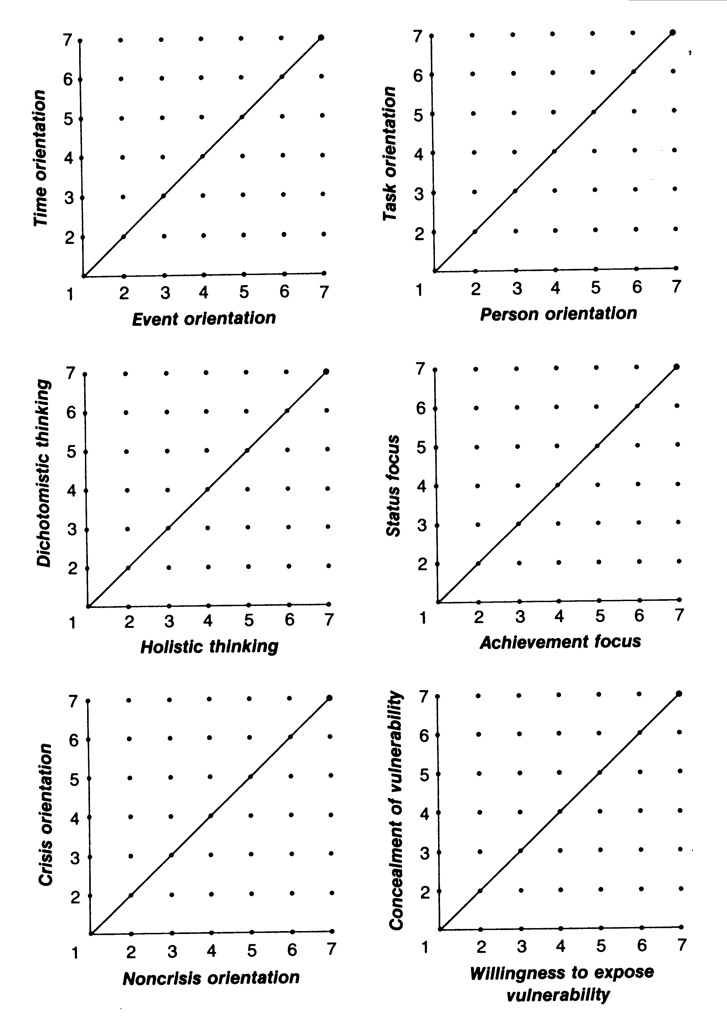

Assignment 8: Dealing with Pain
Identify any major area of grief, loss, bitterness, pain that you have experienced. Write out the experience in your journal, but thinking of the presence of Jesus with you at each step of the journey. Identify if there are things you need to release, let go, any actins you need to take to rectify relationships. Share this with another class member and pray for each other. Later in the course discuss these further with a spiritual director. Summarise these processes in less than a page and submit to the course facilitator.
Due: Week 8

Assignment 9: Spiritual Growth Plan for Duration of Degree
Identify who you would respect as a spiritual director. Discuss with the course facilitator. Evaluate with this person if this will work. Work together with this director and the course director on a plan for spiritual direction over the course of the program. Submit to Course facilitator
Due: by final retreat.

Assignment 10: Pakeha Spirituality and Urban Poor (Migrant) Spirituality Integration
Students meet to integrate their assignments on Pakeha Spirituality and Urban Migrant Spirituality into an integrated (set of) paper(s). Ideally (some) to be published.

Assignment 11: Weekly Examen Exercises
At least each week take time to work through one of the following processes of personal examination. Keep notes in your journal. These may be part of the discussions with your spiritual director.

The Ignatian Examen of Consciousness
The Examen is a prayer practice articulated by Ignatius of Loyola in the 16th century. It is, in short, a way of listening to our own lives and of discerning therein the presence and absence of God. It is rooted in the belief that God is constantly revealing himself to us in our experience-- the scripture of our life—and desires to speak to us through our deepest feelings and yearnings (what he called consolation and desolation). Consolation is whatever helps us to connect in love to ourselves, others, God and the universe; desolation is whatever blocks that connection. Ignatius urges us to take time at least once each day to pause and reflect on our experience.

Some Presuppositions in Doing the Examen
1. God’s creating is a continual sharing of Trinitarian life with all creation "that all may be one, as Thou, Father in me, and I in Thee, that they may be one in us." (John 17:21)

2. Thus present in creation and human history, God guides us toward the full attainment of this life with God and one another in unity and peace, justice and love.

3. We humans can discern the direction of God’s active guidance in our own daily history, and can collaborate with God to promote its realization in action.

4. The sign of God’s guidance is: what produces unity and peace among people and what instills feelings of peace, love, and integrity in us. By contrast, what produces dissension and hostility in society and selfishness and vengeance in us is a sign of the presence and activity of evil. (See Galatians 5:13-26)

Steps in Making the Examen
1. We begin by quieting ourselves. Become aware of God’s goodness, the gifts of life and love. Be thankful. Recall that without faith, the eye of love, the human world seems too evil for God to be good, for a good God to exist.

2. Pray for the grace to see clearly, to understand accurately, and to respond generously to the guidance God is giving us in our daily history.

3. Review in memory the history of the day (week, month, etc.) in order to be shown concrete instances of the presence and guidance of God and, perhaps, of the activity and influence of evil. These can be detected by paying attention to strong feelings we experienced that may have accompanied or arisen from situations and encounters.

4. Evaluate these instances in which we have either collaborated with God or yielded to the influence of evil in some way. Express gratitude and regret.

5. Plan and decide how to collaborate more effectively with God and how, with God’s assistance, to avoid or overcome the influence of evil in the future.

John Wesley’s Self-Examination Questions
John Wesley gave these nearly two dozen questions to members of his discipleship groups more than 200 years ago. The questions may have their origin in the spiritual accountability group started by Wesley when he was a student at Oxford -- a group that detractors called "The Holy Club."

- Am I consciously or unconsciously creating the impression that I am better than I really am? In other words, am I a hypocrite?
- Do I confidentially pass on to others what has been said to me in confidence?
- Can I be trusted?
- Am I a slave to dress, friends, work or habits?
- Am I self-conscious, self-pitying, or self-justifying?
- Did the Bible live in me today?
- Do I give the Bible time to speak to me every day?
- Am I enjoying prayer?
- When did I last speak to someone else of my faith?
- Do I pray about the money I spend?
- Do I get to bed on time and get up on time?
- Do I disobey God in anything?
- Do I insist upon doing something about which my conscience is uneasy?
- Am I defeated in any part of my life?
- Am I jealous, impure, critical, irritable, touchy or distrustful?
- How do I spend my spare time?
- Am I proud?
- Do I thank God that I am not as other people, especially as the Pharisees who despised the publican?
- Is there anyone whom I fear, dislike, disown, criticize, hold any resentment toward or disregard? If so, what am I doing about it?
- Do I grumble or complain constantly?
- Is Christ real to me?

Renovare Questions of Examen
RENOVARÉ Questions of Examen are designed for use within Spiritual Formation Groups. These are described by Renovare as “small fellowships that exist for mutual support, mutual encouragement, and mutual accountability as we participate in our transformation into Christlikeness. Drawing their format from small group models that span the centuries—from the Benedictines in the 4th Century to Methodism in the 17th Century to Alcoholics Anonymous in the 20th Century—participants in these gatherings of between two and seven people ask one another in various forms the old question, "How is it with your soul?" And this is how members of these groups help one another in their life for Christ.” Group members first covenant to Confidentiality. They then proceed to Questions of Examen based on six Christian traditions. At some point during each meeting individuals make plans for how they intend to partner with God in the growth of their souls before the next meeting. See http://www.renovare.org/journey_spiritual_formation_groups_order.htm

Contemplative: The Prayer-Filled Life
In what ways has God made his presence known to you since our last meeting? What experiences of prayer, meditation and spiritual reading has God given you? What difficulties or frustrations have you encountered? What joys and delights?

Holiness: The Virtuous Life
What temptations have you faced since our last meeting? How did you respond? Which spiritual disciplines has God used to lead you further into holiness of heart and life?

Charismatic: The Spirit-Empowered Life
Have you sensed any influence or work of the Holy Spirit since our last meeting? What spiritual gifts has the Spirited enabled you to exercise? What was the outcome? What fruit of the Spirit would you like to see increase in your life? What disciplines might be useful in this effort?

Social Justice: The Compassionate Life
What opportunities has God given you to serve others since our last meeting? How did you respond? Have you encountered any injustice to or oppression of others? Have you been able to work for justice and shalom?

Evangelical: The Word-Centered Life
Has God provided an opportunity for you to share your faith with someone since our last meeting? How did you respond? In what ways have you encountered Christ in your reading of the Scriptures? How has the Bible shaped the way you think and live?

Incarnational: The Sacramental Life
In what ways have you been able to manifest the presence of God through your daily work since our last meeting? How has God fed and strengthened you through the ministry of word and Sacrament?

Assignment 12: Spiritual Growth Group
In consultation with your mentor in churchplanting, work for 6-10 weeks with a small group training them in spiritual growth.
Report form for Churchplanting Supervisor to fill in and send to course facilitator
Due date: before final retreat of course.

 | Trainee Name: ………………………………………………………………………….
 | Trainee No:……………………………………. | Date: …………………………….
 | Details of Practical Service in a Small Group Ministry Project being offered for assessment
 | Describe the Practical Small Group Ministry Service responsibility:
 | Please report on the Trainees Small Group Ministry Service activities under the following headings:
 | Christ Like attitude; Give specific examples of godly attitudes that were demonstrated during the Small Group ministry practical service activity;
 | Punctuality and reliability and faithfulness in the small details and tasks:
 | Friendliness, servant qualities, cultural, gender and impaired persons sensitivity, contribution to the Small Group unity and reconciliation:
 | Pastoral qualities; such as caring, empathy, compassion, prayerfulness, assisting weaker members or persons, practical helps etc:
 | Respect, honour and shame issues, eagerness to learn new languages if appropriate, humility, incarnational considerations, advocacy:
Personal deportment, presentation, cleanliness and dress code:

Competency in the task and accountability for all equipment, finances etc:

Other general observations:

Practical Service confirmed by the spiritual supervisor/director or leader:
Name:……………………………………………………………………………………
Address:…………………………………………………………………………………
Position Held:…………………………………………………………………………………….
Telephone:………………………………………Fax:…………………………………
Email: … … ………………………… Website: ………………………………
Recommendation:
Would you recommend that this person continues to participate in Christian Pastoral
ministry ? YES/NO
What area of ministry do you think this person is most suited to? Please write your comments below. This form is confidential and should not be given to the trainee.
Please deliver it directly to the Course facilitator/Dean.

Assignment 13: Group and Individual Course & Facilitator Evaluation
Facilitator to develop both an individual analysis of the course and facilitators role and do a group exercise that enables students to freely express their insights and opens any areas of complaint in a cathartic way. Utilize existing school formats or the format below for facilitator.
Due: To be completed at final retreat.

Please also bring with you a copy of the assignments and weighting table on page 7 with the grades you have received to date, so that the facilitator can double check his records.

Course Evaluation
Individual (Choose 4 of the following)
- Redesign this programme
- Draw a life line with this course on it
- Predict how you will see this course next week, next month, next year, 10 years time.
- Draw a picture or diagram that represents your experiences on the course and what you think you will 'take away' from the course.
- Think of five very different people you will meet after this course, and what you will tell them about it.
- Assess your progress on each course/individual objective
Group
- Interview each other about the course and redesign the programme
- How did the staff help or hinder (or generally influence) you?
- How did being in this group help or hinder (or generally influence) you?
- On this course there should have been more opportunities for ..... because.....
- On this course there should have been less ..... because....
- Things that shouldn't be changed on this course (because they worked well for me).
- What experiences on this course do you think might have most affected your personal and social development?
- Can you think of three ideas (however big or small) that would help to make this a better and more valuable course.

PARTICIPANT EVALUATION OF COURSE FACILITATOR

Course Title:
Course Schedule:
Instructor:
Evaluation Date:

Introduction:
One of the most important sources of information for facilitator evaluation is the student. Facilitator evaluation has significant purposes: to provide feedback for the facilitator’s self-improvement, for personnel decisions and curriculum development, and for student’s own benefits in future learning experiences.

Before answering the questionnaire proper, please provide some personal information by checking which applies to you. (One answer for each item)

Gender: You are taking this course as:
___ Male ___ required (with credit)
___ Female ___ elective (with credit)
___ audit (without credit)

Age Group:
___ under 30 How many units are you taking this semester?
___ 30-39 ___ 3 units ___ 12 units
___ 40-49 ___ 6 units ___ 15 units
___ 50-59 ___ 9 units
___ 60 & above

Academic Year Level at ATS How many times have you taken a course with
___ Junior (30 units or less) this facilitator?
___ Middler (31-60 units) ___ first time ___ third time
___ Senior (61 units or more) ___ second time ___ more than 3 times

Instruction: Please take about 15 minutes to read the questionnaire carefully and answer each question in accordance with your personal knowledge of the facilitator. This questionnaire is asking for your evaluation of the facilitator on four aspects: course competence, pedagogical skills, student development, and professional conduct. Confidentiality will be strictly observed. Your answers will not affect your grade.

Put a check () to indicate to what extent you agree to the following statements:
SA = strongly agree; A = agree; U = undecided; D = disagree; SD = strongly disagree
COURSE COMPETENCE
 | SA | A | U | D | SD
- The facilitator clearly defines or describes important terms, concepts, and principles.
- The facilitator regularly develops the fundamentals of the course.
- The facilitator rephrases explanations of major points of a topic.
- The facilitator cites varied sources of relevant information from his/her reading.
- The facilitator answers questions comprehensively.
- The facilitator expounds key ideas in depth.
- The facilitator discusses issues from different perspectives.
- The facilitator covers substantial course content.
- The facilitator relates new ideas to familiar ones.
- The facilitator shows mastery of the subject matter.
PEDAGOGICAL SKILLS
 | SA | A | U | D | SD
- The facilitator’s lectures are well organized.
- The facilitator asks questions that stimulate thinking.
- The facilitator uses examples/illustrations/analogies to explain a word or idea.
- The facilitator provides for interaction in class.
- The facilitator uses various means of assessing the student’s progress.
- The facilitator has clear learning objectives in assignments.
- The facilitator shows evidence of good communication skills.
- The facilitator returns papers with corrective feedback within two to three (2-3) weeks.
- The facilitator uses class time well.
- The facilitator follows his/her plans in the syllabus.
STUDENT DEVELOPMENT
 | SA | A | U | D | SD
- The facilitator cultivates the student’s sense of
- responsibility and hard work.
- The facilitator develops the student’s capacity to think for oneself.
- The facilitator provides opportunities for students to work cooperatively rather than competitively.
- The facilitator develops the student to communicate ideas.
- The facilitator cultivates the student’s ability to integrate information and ideas.
- The facilitator stimulates the student’s enthusiasm for learning.
- The facilitator enhances the student’s sense of personal capability for a task assigned.
- The facilitator nurtures the student’s spiritual development.
- The facilitator motivates the student to do his/her best.
- The facilitator prepares the student for ministry.
PROFESSIONAL CONDUCT
 | SA | A | U | D | SD
- The facilitator attends all class meetings except for prior announced absence(s).
- The facilitator models behavior of good work ethic.
- The facilitator is available for out-of-class consultation.
- The facilitator is well prepared for each class.
- The facilitator observes punctuality.
- The facilitator has a positive attitude to life.
- The facilitator shows integrity in his/her speech.
- The facilitator demonstrates respect for students.
- The facilitator demonstrates respect for colleagues.
- The facilitator maintains professional standards in his/her job.
USE THE ATTACHED SHEET FOR ANY COMMENTS AND/OR SUGGESTIONS.

Thank your for your time and cooperation.

COURSE COMMENTS

Course Name ____________________________________________

Day & Time of the Course _________________________________

We want to help faciitators improve the way any of the courses you are currently taking are taught or handled.

Please write freely your comments, suggestions, concerns or encouragement concerning the course you are taking.

Name (Optional) _________________________

X. Bibliography

Excerpts from the following (many of these are on the Course CD):

