**Training in Ethics in Human Subject Research**



Module Training for MATUL student research support staff



**Introduction**

MODULE 01

**This training will cover:**

• How to decide what are appropriate risks and benefits of research when people are involved.

• Guidelines for how to select people to participate in research

• Informed consent in different research settings

**Ethics in Research involves three basic ethical principles:**

• *Respect for Persons*

People should be allowed to freely make their own deci sions

People who cannot make their own decisions (children, mentally ill, etc.) should have protection

• *Kindness*: Do not harm. Maximize possible benefits & minimize possible harms

• *Justice*: Fairness in distribution of possible benefits and risks

**The implications in practice are:**

1. Get Informed Consent

People involved in research can choose what will or will not happen to them

They have enough information about the research, under- stand it, and willingly agree to participate

2. Assessment of Risk & Benefits

The researcher and another group of people on a review board, separately review the research proposal and to see if the possi- ble risks and benefits are responsible and fair

3. Selection of Participants

Do not take advantage of vulnerable populations (e.g. minorities, economically disadvantaged, prisoners, men tally ill)

**(*The Belmont Report became a basis for development of these ideas*)**

**Kin dness D efined:**

Do not harm

Maximize possible benefits and mini- mize possible harm

Respecting peoples decisions and pro- tecting them from harm

Making efforts to do what is good for

them and their well-being

**Types of Harm:**

Psychological, physical distress

Social disrespect or hard to reputation

Putting people in the way of legal harm (for example if you are research- ing about someone’s illegal activities)

**Expanded Ethical Principles of the**

**Belmont Report**

MODULE 02

 **Respect for Persons**

**a. Independence (Self-rule)**

People must be empowered to make decisions about their own actions and life

People’s opinion and choices must be respected

People with limited ability to make decisions must be protected as they agree to what is being asked

People who cannot give meaningful consent must not

participate in the research

*Ex ampl e: Children have less ability to make decisions. Consent must come from legal guardian, and research- er must explain to the child the study and process in a way that they can understand.*

**b. Voluntary**

People are free to choose to participate in research

People are free to end their participation for any rea son without any consequences

**c. Informed Consent**

Gives possible participants information they need to make a decision

Helps possible participants to understand information that is given

Shows that the person has a choice to participate in the research

Must include the purpose of study

Must be written so those reading it will understand, this may include a translation into another language

**2. Kindness**

• Do not harm

• Maximize possible benefits and minimize possible harm

• Respecting peoples decisions and protecting them from harm

• Making efforts to do what is good for them and their well-being

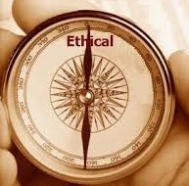

Page 3

**Expanded Ethical Principles of the**

**Belmont Report**

 What are 3 types of Harm?

MODULE 03

*Types of harm*:

• Psychological, physical distress

• Social disrespect or damage to reputation

• Putting people in the way of legal harm (for example if you are researching about someone’s illegal activities)

**3. Justice:**

• Fairness in distribution of risks and benefits**.** Balance the

Three Principles:

***Respect, Kindness, and Justice:*** *Mu st a ll ha ve the same moral force.*

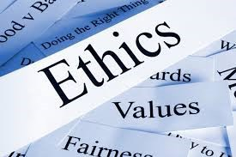

 What are the 3 principles Ethical

Principles?

**Human Subject Research**

**H u m a n Su bject R es ea rch**

•"a living individual about whom a researcher (whether profes- sional or student) conducting research obtains (1) Data or in- formation through intervention or interaction with the individu- al, or (2) private information that can make their identity known."

MODULE 02

**What is Human Subject Research?**

• "a living individual about whom a researcher (whether profes- sional or student) conducting research obtains (1) Data or infor- mation through intervention or interaction with the individual, or (2) private information that can make their identity known."

• “*About whom”* (not what) means

Counts if information is about *someone* or themselves, or

their opinion, characteristics, and behavior

Does not include information about *something*

• “*Interaction*” means

Communication of any form (face to face or even completely electronic or paper interactions)

• “*Intervention*” means

Physical procedures used to collect data (i.e. experiments)

• “*Private information that can make their identity known”* means

Information about behavior that happens in a public place

where a person can expect no one is observing or recording

Information given specific purposes by an individual that a person can expect to be private (e.g. medical, school and work records)

Information that identifies an individual

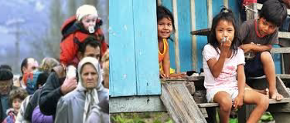

Page 5

**Assessing and Evaluating Risk**

MODULE 05

 What are the 3 General Risks with participation in Social and Behav- ioral Science Research?

 What are the 3 factors in evaluat- ing risk?

**Balancing Risk and Potential Benefits**

• Give clear and all the necessary information

• Confidentiality cannot be promised within a focus group setting

**There are Three General Risks possible with Participation in**

**Social and Behavioral Sciences Research**

1. **Invasion of privacy means**

Personal information is collected without the participant’s

knowledge or agreement to do so

Identity is revealed although it was said that this would not happen

**2. Breach of confidentiality means**

If someone who is not meant to see a person’s private details, for example about their health, but it is revealed, that person could lose their job.

Data collected made public about sexual orientation could result in a loss of social status and in some countries could get them arrested

Workers asked to share their attitudes about their managers, could lose their jobs or not receive a promotions if the infor mation is not protected

Information about illegal activities or immigrant status can have serious legal consequences for subjects

**3. Research procedures**

Review the literature in a given field to consider possible risks of a participant and how they may be protected.

**Evaluating Risk**

**Probability and Amount of Harm:**

How likely is it that harm will occur? How bad is the harm if it happens?

**Situation and Time**: Som e risk is m ore lik ely to happen in certain cultures or places and at certain times

**Different Populations:** There will be diff erent risk s for different kinds of people

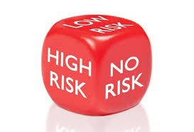

Page 6

**Assessing and Evaluating Risk**

MODULE 05

 What should you do if when the primary source of risk is the con- sent form?

**Evaluating Risk Cautions**

• Researchers usually…

Underestimate risks involved in activities that they are famil iar with.

Overestimate the benefits of things that are important to them.

• Possible Participants usually…

Overestimate the probability of harm when harms are severe Underestimate the probability when harms are less severe Independent evaluation of risk is critical

**Balancing Risk and Potential Benefits**

Give clear and all the necessary information

Confidentiality cannot be promised within a focus group set ting

Tell the entire process and plan to the participants

Design the research to have the least possible risk

**When the Main Risk is the Data**

Remove all identifying factors as soon as possible Give participants codes instead of using their name Keep code lists and data files in separate safe locations

Use computer passwords that only the researchers know

Access and store data on computers without Internet connec tions

**When the Primary Source of Risk Is the Consent Document**

If the only thing that identifies a participant and places him/her at risk for socially damaging or illegal activity is the consent document, it can be removed from the process with permission and substituted for another form (i.e. cover letter, informational sheet or verbal script)

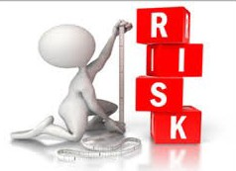

Page 7

**Privacy and Confidentiality**

MODULE 06

Are there are enough provi- sions for protecting the privacy of participants and keeping

the confidentiality of data?

• **Privacy:** related to m eth- ods of gathering infor- mation from research

• **Confidentiality:** creating ways to protect the infor- mation given by the partici- pant

• Are there are enough provisions for protecting the privacy of par- ticipants and keeping the confidentiality of data?

**Privacy:** related to m ethods of gathering inform ation from research

**Confidentiality:** creating ways to protect the inform ation given by the participant

**What Private Information Needs to be Protected**

• Private information

Information about behavior that occurs in a setting that a person can reasonably think that no observation or recording is taking place

Information which has been provided for specific purposes by an individual that he or she can expect will not be made pub lic (for example, medical information)

**Privacy and Research Methods**

• **Participant**- Observational (or Ethnographic) Studies: Research- ers are participants as well as researchers, they have two roles

If participants are observed and private *identifiable* infor mation is gathered about them without their knowledge and consent, there is a clear violation of rights to privacy and this is not allowed

• **Focus Groups** (where a group of people discuss an issue) Researchers cannot control if group members discuss things

outside of the group

Researchers must protect recordings and transcripts them

selves

Researchers cannot ask participants to legally agree to protect the information shared

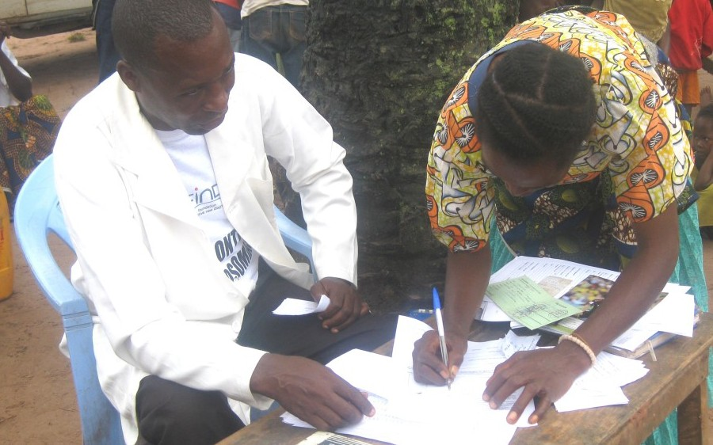

Page 8

**Privacy and Confidentiality**

 What are the 3 Research Methods in this section?

MODULE 06

• **Snowball Sampling**: A technique to fi nd participants by ask - ing participants to assist the researcher by providing names of other persons that may be interested in the study.

*Extra care should be taken if the participant is part of a vul nerable population (e.g. children, pregnant women, prison ers, elderly, abused, etc.)*

**Privacy and Reporting Laws**

• International Privacy Laws

Researchers conducting research abroad should identify pri vacy laws at the research site that may be relevant for the conduct of research with human participants.

**Certificate of Confidentiality**

• Issued to protect identifiable research information from being shared

• May be granted when collecting information that, if shared, could have negative effects for participants or damage their fi- nancial standing, employability, or reputation

• May be secured for any sensitive research, regardless of the fund- ing source

• Allows the researcher and others who have access to research records to refuse to share identifying information on individual research participants

Information that can be protected includes, but is not limi ted to:



Substance abuse or other illegal behaviors

Sexual attitudes, Genetic information

Psychological well-being

Page 9

**International Research**

MODULE 07

 What key areas a Local Researcher should have good knowledge in when doing International Re- search?

**Local Research Context**

• The researcher should have good knowledge of the local context so the rights of participants are protected. Local context knowledge may include:

socioeconomic, political, and cultural factors relationships between parents and their children whether certain questions maybe offensive authority structures

**Securing Local Approval**

• Local approval of proposed research may be required in some countries, Informed Consent in an international context:

Besides participants, who else needs to give consent to re search?

Is the correct language being used so participants can under stand?

Is written or oral consent more appropriate? Use of interpreters?

Is the age of minors different?

Who is the local contact person?



Page 10



**Quiz**

**(Must get 3 out of 4 right or have to reset the test)**

MODULE 08

**What are the three main ethical principles in research?**

*Answer (choose 3):*

A. Respect for Persons

B. Writing the research study well

C. Kindness

D. Justice

E. Finding a good research topic

**What are three main types of risks in participating in research?**

*Answer (Choose three):*

A. Invasion of privacy

B. Breach of confidentiality

C. Becoming famous

D. Research procedures

E. Neighbor's getting jealous

**Describe one type of private information that needs to be pro- tected.** *An sw e r (Ch o o se o n e ) :*

A. Information from what is spoken in public gatherings

B. Information about behavior that occurs in a setting that a person can reasonably think that no observation or recording is taking place

C. Information which has been provided for specific purposes by an individual that he or she can expect will not be made public

**With foreigners studying internationally which of the following do you not need to consider when evaluating ethics in re- search:**

Is the correct language being used so participants can under stand?

Is written or oral consent more appropriate? Who is the local contact person?

Page 11

