## Is the Knowledge of God found in doing a Thesis?

Academic theses have their roots in the work of four Greeks, Pythagoras (6th C BC) who influenced Socrates (d. 399 BC) who mentored Plato (427 -346 BC) whose work Aristotle (384-322) critiques.

Along with others, such as Job and Solomon, or Gautama Buddha of that period, they were passionately interested in wisdom, and particularly epistemology, within which logic and reason were their themes.

Like Buddha or Jesus, Plato was dissatisfied with festivals and myths of religion, seeking purification.

* There was a divine unchanging reality beyond the world of the senses – eternal forms.
* The soul was a fallen divinity, imprisoned in a body, but capable of obtaining its divine status by purification of the reasoning powers of the mind.
* We perceive shadows of eternity (See Ecclesiastes), but gradually we can achieve enlightenment and liberation by accustoming the mind to divine light (Myth of the Cave).
* These divine forms, were not realities out there, but can be found within the self.
* We think of thinking as something we do. He perceived it as something that happens to the mind which contemplates them, a process of recollection, an intuitive grasp of the eternal reality within us. (This has influenced Christian mysticism).
* The universe is essentially rational – which is an imaginary conception.

The forms are a rational version of the ancient myths and archetypes:

* These eternal forms are stable, constant realities that can be apprehended by the reasoning powers of the mind.
* They are fuller, more permament realities than the materials senses, which only echo these forms
* There is an idea corresponding to every conception we have such as Love, Justice, Beauty. The highest is the idea of Good.
* The divine world was static and changeless. Movement and change are signs of inferior reality. This static image would deeply affect Christian theology, even though the scriptures portray a God of revelations, active, innovative, constantly in motion and creative.

Aristotle took this further.

All of this falls in the field of e·pis·te·mol·o·gy iˌpistəˈmäləjē/ *noun* the theory of knowledge, especially with regard to its methods, validity, and scope. Epistemology is the investigation of what distinguishes justified belief from opinion.

Origin: mid 19th century: from Greek *epistēmē* ‘knowledge,’ from *epistasthai* ‘know, know how to do.’

The branch of philosophy concerned with the nature and scope of knowledge it is also referred to as "theory of knowledge". Put concisely, it is the study of knowledge and justified belief. It questions what knowledge is and how it can be acquired, and the extent to which knowledge pertinent to any given subject or entity can be acquired. Much of the debate in this field has focused on the philosophical analysis of the nature of knowledge and how it relates to connected notions such as [truth](https://en.wikipedia.org/wiki/Truth), [belief](https://en.wikipedia.org/wiki/Belief), and justification. The term was probably first introduced in Ferrier's *Institutes of Metaphysic: The Theory of Knowing and Being* (1854), p. 46 (Encyclopaedia Brittanica Online, 2007).

It tends to deal with propositional knowledge = *knowledge that*, vs *knowledge how* or *knowledge of acquaintance*. In French, Portuguese, Spanish these are completely different verbs so the distinction is much clearer. T*o know (a person)* is translated using *connaître,* *conhecer,* and *conocer,* respectively, whereas *to know (how to do something)* is translated using *savoir*, *saber*, and *saber*.

Delineating the boundary between justified belief and opinion.

Epistemology is the study of our method of acquiring knowledge. It answers the question, "How do we know?" It encompasses the nature of concepts, the constructing of concepts, the validity of the senses, [logical](http://www.importanceofphilosophy.com/Epistemology_Logic.html) [reasoning](http://www.importanceofphilosophy.com/Epistemology_Reason.html), as well as thoughts, ideas, memories, emotions, and all things mental. It is concerned with how our minds are related to reality, and whether these relationships are valid or invalid (<http://www.importanceofphilosophy.com/Epistemology_Main.html>).

## 3 approaches to Belief Formation

1. justified belief in a hierarchical system: true belief that has been "given an account of" (meaning explained or defined in some way). According to the theory that knowledge is justified true belief, in order to know that a given proposition is true, one must not only believe the relevant true proposition, but one must also have a good reason for doing so.

Ideas are created by [integrating](http://www.importanceofphilosophy.com/Epistemology_Integration.html) previous ideas and sensory input. Due to this dependency of ideas on previous ideas or sensory input, we know that knowledge is hierarchical. Every higher level [concept](http://www.importanceofphilosophy.com/Epistemology_Concepts.html) is based on a lower level information. At the root of all of this, of course, is [perception](http://www.importanceofphilosophy.com/Epistemology_Perception.html). The very first concepts are derived directly from perceptions, via [reason](http://www.importanceofphilosophy.com/Epistemology_Reason.html). Future concepts can then use the first concepts as part of their base, but the foundation is always there.

1. ripples of influence

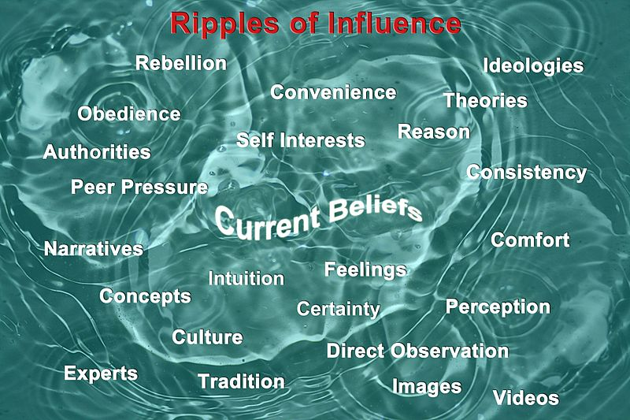

1. Web of Belief

## Approaches to defining knowledge

* [*A priori*](https://en.wikipedia.org/wiki/A_priori_and_a_posteriori) knowledge is knowledge that is known independently of experience (that is, it is non-empirical, or arrived at beforehand, usually by reason). It will henceforth be acquired through anything that is independent from experience.
* [*A posteriori*](https://en.wikipedia.org/wiki/Empirical_evidence) knowledge is knowledge that is known by experience (that is, it is empirical, or arrived at afterward).