|  |
| --- |
|  |

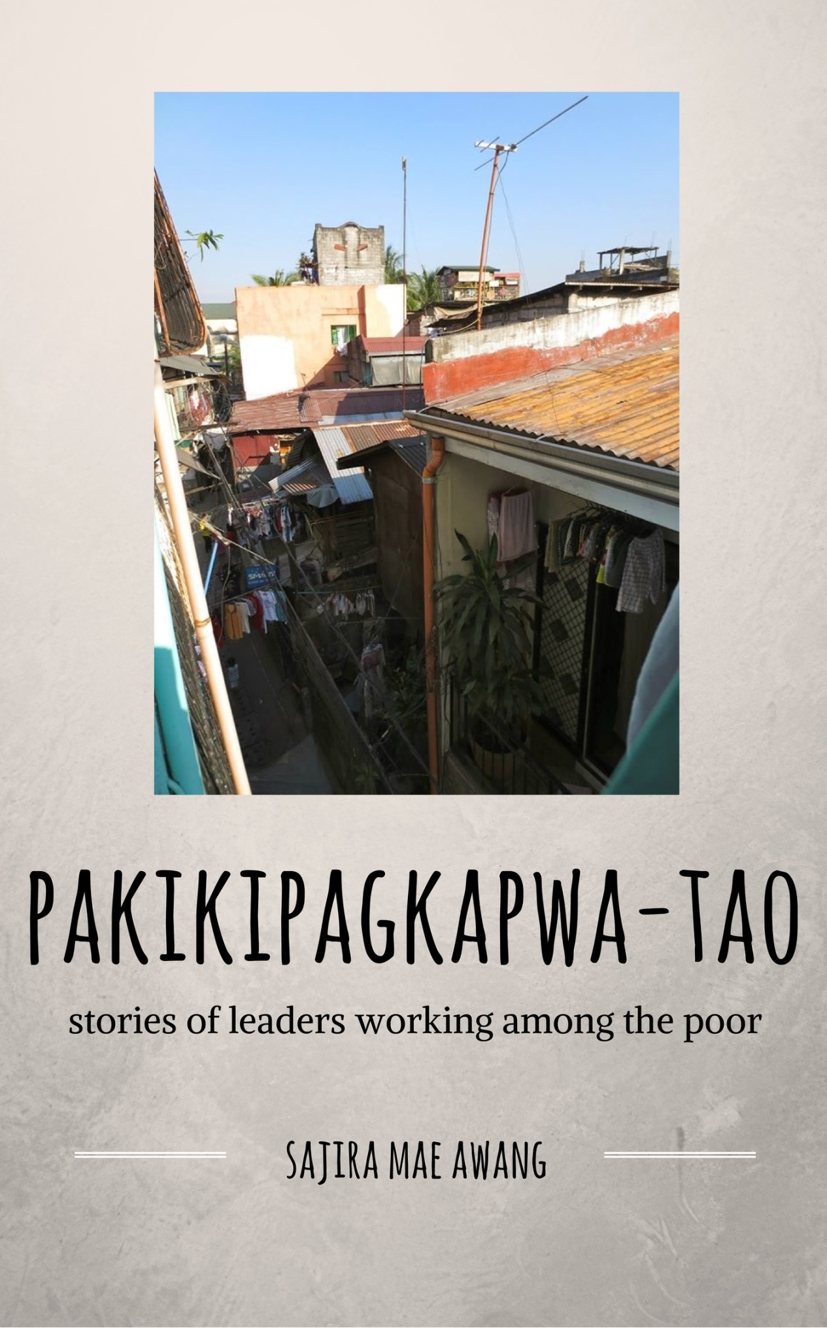

To my family, especially my mother,

for all the support and love you have given me.

To my professors and cohort,

for helping me grow more in the likeness of Christ.

And finally to my Savior,

who found me when I was lost.

# Abstract

The aim of this study is to identify leadership traits of Christ-Following Filipinos who work specifically with the urban poor.

Data for this study was collected through a series of fourteen interviews of leaders working within the vicinity of Metro Manila. Interviews were conducted in a semi-formal manner and recorded on audiotape.

The structure of the thesis begins with an exploration of literature on different leadership models in the Philippines and then explores the issues surrounding the topic. This is followed by fourteen chapters of stories synthesized from the audio interview recordings. Each of these chapters include stories about the organizations, personal histories, and observations of the leaders which are analyzed in the following chapter for motifs. These motifs were linked to Filipino cultural traits in an attempt to explore Filipino leadership styles.

It was concluded that there was no specific correlation of urban poor leadership styles to these motifs. Instead, the results show that that traits exposed by the motifs juxtapose with common cultural values in the Philippines that encourage transformational practices.

# Contents

## Chapter 1, Introduction 1

Servant at Heart, 1

On Leadership in the Philippines, 1

Community Relevance, 2

Theological Framework, 2

Assumptions and Limitations, 3

Populations and Locations, 4

## Chapter 2, Literature Review 5

Literature on Leadership, 5

Issues Surrounding This Study, 7

The Work of Other Researchers, 8

## Chapter 3, Methodology 10

Methodology, 10

Validity, 11

Outcomes, 11

## Chapter 4, Brother Marlon: Friend of the Mangyan 12

## Chapter 5, Brother Louie: Compassion for the Community 16

## Chapter 6, Brother Nelson: Physical and Spiritual Needs 18

## Chapter 7, Doc Jojie: “For I know the plans I have for you” 20

## Chapter 8, Pastor Jun: For the Youth of Tondo 23

## Chapter 9, Pastor Dong: Beloved Worker of the King 26

## Chapter 10, Pastor Dennis: Beginnings in the Slums 28

## Chapter 11, Pastor Arnel: “My calling is still there” 32

## Chapter 12, Sister Rida: Perseverance Through Anxiety 36

## Chapter 13, Pastor Ariel: Romanticizing the Problems of the Poor 39

## Chapter 14, Pastor Glen: Tragedy and Trust in the Lord 42

## Chapter 15, Pastor Obet: Networking in the Community 45

## Chapter 16, Kuya Bryan: “I am willing to die” 48

## Chapter 17, Pastor Nards: Anointed by the Lord 52

## Chapter 18, Analysis 55

Six Motifs, 55

What does this imply about servant leadership?, 58

What did the study say about Filipino Leadership Styles?, 58

## Chapter 19, Conclusion 62

## Appendix A , Interview Questions 64

Chapter 1: Introduction

# Servant at Heart

In front of me sat a pastor. I examined him intently; his face and his frame were gaunt from lung complications I would later find out. His voice was soft and his smile revealed simultaneous excitement and nervousness. Judging from his exterior it would be hard to imagine how much he had done for his community. He was from Krus Na Ligas, an urban poor community in the heart of Quezon City. When we would walk in the streets together people would call to him, and herds of children would run to him to bless his hand. Another pastor pulled me aside and joked that he was known as the “Jesus Christ of Krus Na Ligas”.

When he was younger he had the vision of paved roads, a church filled with his neighbors, and a center for children in his community. In time it became reality. He was a servant at heart and by nature. Although his physical state caused him hardship he pushed through- for his love of the poor and his love of God.

There are countless stories like this one revealing the paradigms of *servant leadership* throughout Metro Manila, eager to be heard. Although I am not able to collect all of those stories this is a small sample of them hoping to inspire a wider study in the future.

Throughout my journey with my master’s degree the importance of *story-telling among the urban poor* has been greatly emphasized. The objective of this project is to tell the stories of urban poor leaders who have been working on behalf of their own communities. There are extensive writings about the leadership models among the upper echelons of society and the well-educated, but there must be an expansion of research of those working with the urban poor of Metro Manila. I hope that in the future there will be another researcher. I have had the honor of partnering with Micah Challenge, Philippines in locating some of these leaders. The following is a collection of stories from 14 leaders throughout Metro Manila working on behalf of the urban poor to see complete and holistic transformation. These are the stories of their lives.

# On Leadership in the Philippines

There are three main variables surrounding the topic of research: Filipino leaders, servant leadership and finally poverty in the Philippines. **Figure 1** is a visualization of how these variables are related. It begins with the Filipino leaders, looks deeper into their style of leadership and then assesses the ways which these traits and practices are revealed in their actions towards transforming poverty within their communities.

Each of these variables as interconnected and as the individual begins to grow deeper into their faith they followed the process pictured above. As a highly communal culture it is important to first look at the Filipino individuals that comprise the group of leaders and then take a step back to see how this individual affected the group as a whole. In this case we begin with leaders, step back to see what similarities they have as a group, and finally look at the picture as a whole and how this group of people affects poverty in the Philippines.

Figure 1. Main variables of this study

# Community Relevance

Church (1986)discusses the issue of identity crisis “as a result of his cultural ‘diversity’ or ‘hybridness’” (p. 2). The Philippines has been colonized multiple times and has hundreds of ethnic groups spread across its islands. This becomes apparent in the way that Filipinos practice their faith as well. Grener (2005) found the following:

“From EE (Evangelism Explosion) to the Prayer of Jabez to G12 to The 21 Irrefutable Laws of Leadership – Filipino evangelicals tend to treat each of these foreign theological packages as indeed irrefutable, biblical universals, as if they bring with them no cultural baggage.” (p. 5)

This research was conducted in the hope that the stories of native Filipinos will indicate cultural commonalities. The theology, models of leadership, and culture of churches in the Philippines have been influenced by and often adopted from other countries. Each of the stories have the potential to help clarify paradigms of Filipino leadership of Christ-followers that live and serve among the poor.

# 

# Theological Framework

One of the closest models of leadership to that of Jesus is servant leadership. A majority of the academic research done on servant-leadership follows that dictated by Robert K. Greenleaf (Greenleaf, 1977). According to his book he first realized the model of servant leadership after reading the novel *Journey to the East.* One integral character in the book, Leo, was a servant in the beginning but in the end it was revealed that he was the individual holding the group together (Greenleaf, 1997). Long before the novel Journey to the East there was Jesus of Nazarene. Jesus had the influence of an exemplary leader but He led the life of a servant until His death on the cross. Although similar to servant leadership, He exemplifies his own style of leadership throughout the scriptures.

He came to Simon Peter, who said to him, “Lord, are you going to wash my feet?”

Jesus replied, “You do not realize now what I am doing, but later you will understand.”

“No,” said Peter, “you shall never wash my feet.”

Jesus answered, “Unless I wash you, you have no part with me.”

When he had finished washing their feet, he put on his clothes and returned to his place. “Do you understand what I have done for you?” he asked them. “You call me ‘Teacher’ and ‘Lord,’ and rightly so, for that is what I am. Now that I, your Lord and Teacher, have washed your feet, you also should wash one another’s feet. I have set you an example that you should do as I have done for you. Very truly I tell you, no servant is greater than his master, nor is a messenger greater than the one who sent him. Now that you know these things, you will be blessed if you do them.” (John 13:6-8, 12-17).

Each of the individuals that I interviewed engage in the process of trying to lead like Christ. Their lives are the experience in the urban poor context at the center of a Pastoral Cycle as discussed by Joe Holland and Peter Henriot in **Figure 2** (Henriot, Holland, Washington, 1983). These stories explore the ways which Filipino leaders wash the feet of those in their communities. Their stories give some degree of social analysis and theological reflection on their own processes of development. In this Pastoral Cycle we are able to use the stories to better understand how these leaders are part of the Biblical conversation on Filipino Leadership.

Figure 2. The Pastoral Cycle

(Henriot, Holland, Washington, 1983)

# Assumptions and Limitations

Both my mother and father were born in the Philippines but I was born in the United States. Throughout my childhood my parents retained a Filipino value system although I grew up in the context of a different country. Because of this, my theological perspectives are highly influenced by my upbringing as a Filipino-American. In contrast, for the past year and a half I have been living in an urban poor settlement in the heart of Quezon City, mastering Tagalog and the culture of urban poverty.

Although I had previous relationships built with some of the pastors I interviewed many of them I was introduced to by means of my supervisor. Many of these leaders are connected to the Micah Challenge, Philippines network. In the Philippines it is well-known that the status of a foreigner may cause intimidation to the individual being interviewed. Because my physical attributes are largely Filipino it has been easy for me to acculturate here and at the same time helped me reach a depth in conversation that might take others more time.

In *Cultureshock! Philippines* Roces (2012) discusses the importance of winning confidence of the individuals that you are trying to research. A story is told in which a foreigner is trying to ask a family to borrow old books that they have in their house. He is persistent in asking and after several months he is able to gain their trust to view them. When one of his Filipina colleagues visited for the first time they had a short conversation and she was instantly allowed access to these books. She explains “‘I did not show too much interest in the books, I did not even look at the books. First I established my identity in their eyes by saying that I am the niece of someone they know, a friend of another they also know, placing myself in a context of mutual acquaintances’” (Roces, 2012, Kindle Location 2072).

This is what I also had to do in a sense, start with small talk and then find the individuals that we had in common. Once a commonality was established it was much easier to move forward with the interviews and the conversation was more fluid. Although that’s not without saying there were interviews which required more effort and ultimately reflected in the openness of their stories and sharing. My language skills served as both an asset as well as a limitation to the study. Most of the interviews were conducted in their native tongue of Tagalog, but others chose to respond in English in order to accommodate me and make me feel more comfortable.

Through this study I hope to set the base for future studies of Filipino models of Christian leadership. I only utilized a story-telling method of research but there are many other approaches that may be utilized to understand this topic in more depth.

# Population and Locations

The group of individuals that I hope to gather information from is through the networks of Mission Ministries Philippines as well as Micah Challenge, Philippines. Each of these individuals are part of an organization working to transform poverty in their communities. They are all located within the vicinity of Metro Manila and address issues within this context. In conjunction with Micah Challenge I was able to establish rapport with each of these individuals. Filipino culture is story-based and often times organizations are unable to financially afford help to dictate their stories. With this in mind, many of the leaders were open to meeting and discussing the stories of their leadership and the stories of their organizations. It created open doors not only for research but for an expanded network.

Chapter 2: Literature Review

In this chapter I will explore the literature written on leadership and Filipino leadership. There were few select writings specifically on Christian Filipino Leadership of those working with the urban poor so I explore the different variables as stated above. These readings provided insight to these topics before I conducted interviews.

# Literature on Leadership

For He was teaching His disciples and telling them, “The Son of Man is to be delivered into the hands of men, and they will kill Him; and when He has been killed, He will rise three days later.” But they did not understand this statement, and they were afraid to ask Him.

They came to Capernaum; and when He was in the house, He began to question them, “What were you discussing on the way?” But they kept silent, for on the way they had discussed with one another which of them was the greatest. Sitting down, He called the twelve and said to them, “If anyone wants to be first, he shall be last of all and servant of all” (Mark 9:30-35).

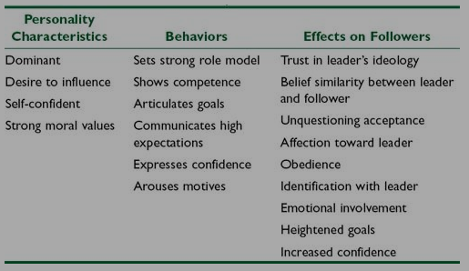In his book titled *The Power of the Leader: Mind and Meaning in Leadership*, Silos (2003) simplifies the different facets of leadership to three main mediations: authority, skills, and values. A combination of these mediations forms different types of leadership. I will be concentrating on the combination of values and authority. According to Silos, authority describes the power of the leader, “One who has authority s more than just a power-wielder. His power is mediated by legitimacy and that makes him already a leader” (Silos, 2003, p. 66). The second mediation, values, concentrates on “the integrity of the leader-follower relation” (p. 126). This combination is often seen in ministries and organizations that are centered in Christ. Many of the leaders that followed this specific type of leadership were listed as pastors according to this reading. “Leadership as a function of values generates collaboration in virtue of shared values. A leader might have neither formal authority nor competence but is a leader nonetheless through the power of values” (p. 59).

Figure 3. An explanation of the different facets of Transformational Leadership

(Northouse, 2004, Kindle Location 3650).

If these three mediations are the basis of leadership then the combination of authority and value in varying degrees creates different types of leadership within the church. Different models of leadership are also defined by the relationship between the leader and the follower. *Leadership: Theory and Practice* is a good resource that discusses several different types of leadership models with in-context examples (Northouse, 2004). Many of the leaders and pastors that I interview actively follow Jesus Christ as a model in their ministry. The leadership of Jesus as seen in the passage above closely relates to the models of servant-leadership and transformational leadership. According to Northouse transformational leadership is centered on the relationship between the leader and the follower in the hopes that the follower will “address higher-level needs” aside from their own (Northouse, 2004, Kindle Locations 3676-3679). The main traits of this model of leadership are listed in **Figure 3**.

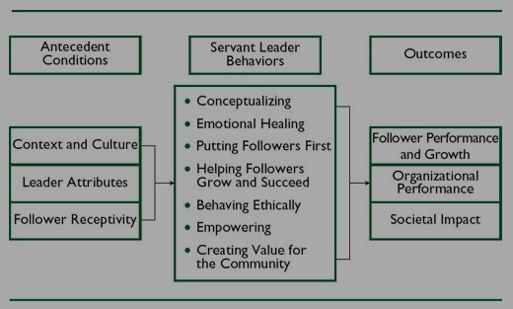Servant leadership, on the other hand, functions in the capacity for the leader to “put followers first, empower them, and help them develop their full personal capacities” (Northouse, 2004, Kindle Locations 4188-4189). One of the most important traits that servant-leaders have is empathy. Greenleaf explains, “the servant always accepts and empathizes, never rejects. The servant as leader always empathizes, always accepts the person but sometimes refuses to accept some of the person's effort or performance as good enough” (Greenleaf, 1977, Kindle Locations 424-425). Both of these leadership models have many similarities, and despite their differences they are able to produce the same outcome, transformation of individuals and communities. The main traits of this model are listed as well in **Figure 4**.

Figure 4. An explanation of the different facets of Servant Leadership (Northouse, 2004, Kindle Location 4295).

These are two models that aren’t tied to biblical frameworks but echo many of the traits of Jesus’s style of leadership. A combination of both of these models creates a holistic picture of leadership in which followers are developed to their fullest. This hybrid model would be based on a system of values that encourages followers to take part in the cycle of growth. More simply stated, the driving force of this model would be to imitate Christ and the result would be multiplication of this type of leadership. This parallels what Viv Grigg describes as a “Jesus-Style Ministry” in his book *Cry of the Urban Poor* (Grigg, 2004).

“The logical starting point for a Christian is to go to his Master, who is truth, manifested truth, and hence probably has the best answer to these issues. How did Jesus respond to the poverty of the city?” (p. 162). He goes on to say that following this type of leadership and ministry involves seeing “spiritual transformation as primary” and that would dictate all of their actions and ministries (p. 162).

Clemente elaborates on these Christian leadership models specifically in the context of the Philippines. According to him Filipino leadership also has similar foundational blocks to this “Jesus-Style Ministry” specifically in the role of *sakop*, or a social unit (Clemente, 1997). Leaders must be a role model of “harmony before God, self, and all *sakop* members”, they must “[champion] the needs and conditions of the religious *sakop*” and lastly they must “enter into a life of sacrifice for the sake of the *sakop*” (p. 22). Filipino leaders must maintain the harmony of the group while addressing needs of others while sacrificing their own. These three aspects are intertwined and vital to leadership in the Philippines.

One of the most important functions within a social unit is *pakikisama*. This is most simply explained as maintaining good relationships within a group. It dictates what the dynamics of the group will be and their ability to push forward with growth. This is cultural trait is also key to understanding leadership within a Christian Filipino context. According to Miranda-Feliciano (1990), Jesus was a role model of this. “The supreme illustration is what the theologians call the Incarnation- the act of God becoming man in the person of Jesus Christ. Jesus, in His earthly life, was seemingly so like the rest of ordinary Jews that the religious among them had trouble believing He was the Messiah.” (p. 25)

These models are examples of the types of leadership that may reveal itself in a Filipino context. Although not explicitly mentioned, Jesus is at the center as the driving force and inspiration for each of these leaders. The readings discussed above build upon each other to provide a more holistic understanding of leadership, from the foundations to the contextual examples of it in a Filipino context. They helped deepen my understanding of different leadership models and how they reveal themselves in the context of ministry.

# Issues Surrounding This Study

In the introduction the article “A Father Motif Leadership: Toward an Understanding of the Role of Sakop in Filipino Evangelical Leadership”, Clemente states an issue that I have come across as well. “Significant literature has been written on Christian leadership as well as Filipino leadership in relation to the Philippine culture. However, very few have dealt with church or religious leadership based on Filipino culture” (Clemente, 1997, p. 3)

I have found a multitude of readings based on both of those topics respectively, but little that combined the two. Because of this, I had to synthesize both topics in my analysis section. In light of that I will be discussing the issues surrounding the two leadership models I discussed above: servant leadership and transformational leadership.

In Northouse’s (2004) chapter on Servant Leadership he lists four main issues surrounding the topic of servant leadership specifically: The paradoxical nature of “servant leadership”, the core dimensions of the process, the tone of what is already published, and the place of “conceptualizing” as one of the main behaviors in this model of leadership. Many of these issues are the same as the gaps in knowledge stated above.

The first issue touches on the tension revealed in the disciples’ reactions to Jesus’s actions. Northouse explains “being a servant leader implies following, and following is viewed as the opposite of leading. Although servant leadership incorporates influence, the mechanism of how influence functions as a part of servant leadership is not fully explicated in the approach” (Kindle Location 4483). This current tension also connects back to the lack of research that explains servant leadership in depth.

This lack of knowledge also leads to the issue of the lack of clarity on the “dimensions” of servant leadership. “Until a larger body of findings is published on servant leadership, the robustness of theoretical formulations about it will remain limited” (Kindle Location 4488). The issue of the inclusion of “conceptualizing” is also linked to this. The main debate is whether this is a “behavior” or cognitive ability. Because of this issue I have also chosen to exclude this aspect of servant leadership from my interviews and my study.

Lastly is the issue of the tone of what is already published. I mentioned this in the previous issue but Northouse elaborates further by noting the “moralistic nature” that is connected to the concept of servant leadership. Articles on the topic reveal a rigid idealism of what servant leadership should look like, and the lack of case studies on this reinforces this issue as well as gap. Many of the issues surrounding servant leadership are similar in the case of transformational leadership

The largest issue with transformational leadership cited by Northouse was that “it is difficult to define exactly the parameters of transformational leadership” (Northouse, Kindle Locations 3888-3889). Until there is more research done on these leadership models specifically in the context of Christian Filipinos working with the urban poor there will be issues of ambiguity and validity.

# The Work of Other Researchers

There are two books that were closest to my own researcher: *Leadership in a Slum* (Johnson, 2009) and *In Search of Filipino Leadership* (Lupdag, 1984). *Leadership in a Slum* in a case study done to better understand leadership in the slums of Bangkok, Thailand (Johnson, 2009). Johnson split his work into three phases, the first was “an investigation into the perceptions and practices of a culturally preferred leader using systematic data collection procedures, the second sought “connections between all the models that were emerging” from the data and the final was understanding the relationship between “the community and the state” (p. 7). Each of these steps were completed using mostly qualitative data collection methods such as participant observation with a reserved amount of quantitative surveying.

In *In Search of Filipino Leadership* Lupdag (1984) did a study in hope of conceptualizing Filipino leadership specifically in the realm of educational circles. He utilized three phases as well. Phase I involved distributing a questionnaire to “college students, faculty, staff members, and administrators from two institutions of higher learning” (p. 11). From there he compiled the data and held sessions of group interviews so he could clarify any questions that he had stemming from the first phase. Phase III involved psychological testing to “measure traits relevant to leadership” (p. 11) Like Johnson, Lupdag used methods that were largely qualitative but interspersed with quantitative surveying towards the end.

Both of these authors touched on two different aspects that I would like to address in my research as well: working among the poor as well as leadership. Many of the methods that they used in their studies would be appropriate to use in mine as well. My research will include qualitative research but quantitative data collection would not be helpful at this time. I hope that in the future this study is continued and a researcher will be able to add statistical data to what I have researched.

Chapter 3: Methodology

The following chapter discusses the methodology that I utilized to complete my research and then proceeds to discuss the validity of my work. The final sections are outcomes of this work, both short-term and long term.

# Methodology

In my research I wanted the voice of the leaders to speak more loudly than that of my own so I chose to utilize a Qualitative Method. This was done in three phases. The first included contacting leaders for interviewing through the Micah Challenge, Philippines network as well as my own. I mentioned earlier that I had the honor to partner with Micah Challenge, Philippines. Their objective is “To deepen Christian engagement with the poor and to influence leaders of rich and poor nations to fulfil their public promise to achieve the UN Millennium Development Goals (MDGs), and so halve absolute global poverty by 2015.” Although this goal still remains unmet Micah Challenge, Philippines has been successful in creating an extensive network of organizations working to affect poverty in their respective communities.

The main method that I utilized to gather information for this research project was informant interviewing as well as participant-observation. Each of the interview questions were a basis for different aspects of leadership, including how they reached their leadership position and often times would enable them to speak to their style of leadership (*See Appendix A*).

Though the questions were basic in nature, informants would willingly elaborate in more depth in response to my questions. They were able to share the stories of what leadership has meant to them. In addition to these questions if I wanted to probe further on a specific story I would ask follow-up questions. I found that in asking for clarification they would explain the background of the story and then elaborate on how the events and their history were intertwined. There were a few interviews in which the informants were more uncomfortable. This was reflected in the manner of which they answered.

Filipino culture is a story-telling culture by nature. Considering what would be most culturally-appropriate, I chose to utilize a semi-structured model of questioning to create an environment in which the individual felt more comfortable and more willing to share stories about their lives. Each of these interviews were conducted in Tagalog mixed with English words.

The second phase of my research included transcribing and translating each of the interviews with an assistant that helped me with three of them. The data was collected from audio recordings, each with the consent of the leaders being interviewed. Many of the questions aimed to ask at the surface in hopes that they would elaborate on a deeper level. Because some of the stories might be sensitive I made sure that they consented to the audio recording as well as the information that I included in my paper. If there were sections that they asked me not to include in the paper then I made sure to honor their requests. None of the stories shared would put these leaders in crisis, and any sections that might breach their *hiya* (or shame, Filipino culture is a largely shame-based culture) were removed as well. These were then shortened to core stories that are presented in chapters 4 through 18. I was able to get feedback from some of these leaders for more details and clarifications of their stories. The final phase included analysis of what this implies for Christian Filipino Leaders working with the urban poor and drawing commonalities that stem from these interviews.

# Validity

There were many factors in this method of research that affected the validity of my research. If I was unable to come across as welcoming and genuinely interested in what the leader had to say then this would reflect in their answers to me. Some of the questions that I choose for my interviews could have led to a simple “yes” or “no”, but there were certain questions that would trigger a response of stories from the leaders. There were also several factors that had the possibility of making my data and data collection methods invalid, but the authenticity and depth of their stories was the chosen focus of this research. Although there were some answers that were short and concise there were many instances in which the leader felt comfortable enough to share a piece of their heart with me. This is what led to the most conclusive and insightful results in my analysis chapter.

# Outcomes

Individuals and churches have expressed interest in a copy of my research to be used for future leadership training events and the formation of leadership training handbook. There have also been other suggestions to me that the individual stories could be used for future publications in Christian magazines. At the same time I have been given the opportunity to present my findings to a church in Quezon City connected to both urban poor communities as well as the rich communities within Metro Manila. It is my hope that the stories of these leaders will be used by the Lord as a source of conviction and desire for change. Perhaps by presenting it to individuals who are in the upper echelons of society the Lord will work in their hearts to move among the poor.

In my presentation I will not present all of my analysis and findings, only the commonalities of the interviews. Although this study concentrated on Christ-following Filipinos working with the urban poor, the main points are also relevant to Filipinos, whether rich or poor, follower or leader. Each of these points are applicable to the life of a Christ-follower and the stories, if synthesized with bible passages, can bring to light some of these paradigms of the leadership of Jesus and how that applies to a Filipino context.

My greatest hope was that this research be a tribute to the voices of those working with the urban poor in the Philippines. Although my findings may not be directly beneficial to the research participants, I at least hope that the stories serve as a source of encouragement, for the leaders and for aspiring leaders. Poverty remains an issue in the country but there are forces working against it with the power and the hope of the Lord.

Chapter 4: Brother Marlon

Friend of the Mangyan

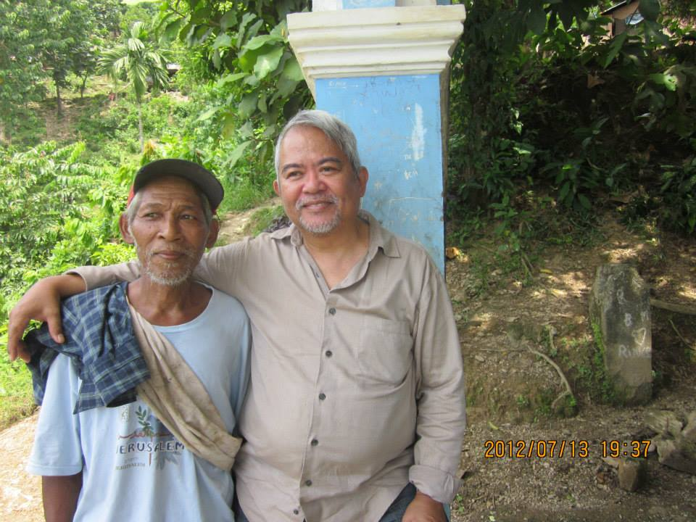In the following fourteen chapters I will tell the stories of Christian Filipino leaders working among the urban poor. This is the data that has been gathered from each of the interviews. From these we will gather the motifs and traits that present themselves throughout the stories in an exploration of the question behind this research: What principles of leadership influence Filipino leaders to transform poverty in their communities? Afterwards I will integrate these discoveries with existent theory and seek to extend it for this specific group of leaders.

I contacted my previous economics professor from Asian Theological Seminary and asked if he knew of any leaders working with the urban poor. Last semester he switched jobs from Asian Theological Seminary (ATS) to International Care Ministries (ICM). He responded fairly quickly and said, “Yes! One is sitting right next to me.” We set a time for the next meeting and I was off to Makati, one of the business capitals of the Philippines.

Brother Marlon with a Mangyan elder to whom he baptized in the beginnings of his ministry in 1976.

The ICM office was in a fairly large building, but when I came into the office everyone shared a common space, separated only by low set cubicles. We sat in a separate air-conditioned room facing another building. Before we started our interview he showed me pictures of his life, from his community when he first started ministry to some of the more recent communities that he is working with.

Brother Marlon, now in his sixties, has been serving the urban poor since the 1970s. In 1972 he met the Lord through a filming by Campus Crusade and then developed his faith through Intervarsity Christian Fellowship. This was around the time that the rule of Ferdinand Marcos sparked the fire of student activism throughout the Philippines.

He confessed to me “If I was not a believer, I would have also joined the activists. But the Lord had a better plan for me.” He watched an evangelistic film that told him the words “I am the Way, the Truth, and the Life”; “What this said to me was that these three things are of utmost value to me and if I give them to the Lord then I will be prepared to follow him.” That was just the beginning. Season by season he chose to follow the Lord more closely.

He originally entered college as a business major but after counseling and career orientation with his university they saw that he was better suited for social work or community development. Luckily, the University of the Philippines had a College of Social Work and Community Development department. There was a requirement in his program called “Rural Urban Community Development Exposure”, so he was sent to Tondo. “That was the first time I went inside a squatter community. I stayed the night there with an organization called Zone One Tondo Organization.”

After this exposure he had training with the Mangyan people in Mindoro and this eventually became his first job. He stayed there for a few years until he decided to expand his studies into the theological realm. After years of training in various countries he was finally ordained in 1989. With extensive studies and training under his belt he returned to missions work in 1995 and that is where he has remained until today.

He is currently Area Head Mentor International Care Ministry’s 10 bases. “I have to mentor people in community development and pastoral skills.” All of this stemmed from his calling from the Lord as a pastor. He realized that this was the path of his life after 10 years of working in community development. Although he held a secular job he was still the head of the youth fellowship as his local church as well as a church elder. This is something that you will observe in a majority of the stories- they began or spent a significant amount of time working with the youth in their communities.

Melba Maggay was one of his closest friends from his college days and she encouraged him to consider going to bible school. During an international conference in Wheaton, Illinois in 1983, someone asked him how he thought the conference was going or how it was affecting him.

Brother Marlon responded “If I am to make a contribution to building up the church and advancing the kingdom of God in the Philippines, I have to be serious in studying and setting my theology straight because I don’t want to be like any other activist, I don’t want to be borrowing tools from the devil’s toolbox in doing development work.’ So I said ‘I better set my theology straight.’”

It took him five years but he followed through with his statement.

I asked him when he first realized he had a heart for the poor and he told me stories from his childhood. “[I got it] from my parents, their heart was close to the poor and I saw the respect that they had, even for the lowly and poor people. If we had someone who would wash our clothes, although we were paying her she would sit with us at the table for meals and we would talk.” His father was a journalist of the Manila Times Publishing Company and also a lawyer, so they were a financially-well off family. Often times Brother Marlon would accompany his father to work and witness how he would treat his co-workers.

His father knew the janitor by name, “Good morning, Mr. Fragata!”, and he knew the security guard by name, “Good Morning, Mr. Agawen!”, and even his personal driver- “Good morning!” He always showed respect to each individual. “I also saw my parents’ compassion for the poor before when we were building our house, sometimes they would feed the carpenters and sometimes once a week they would take them out to eat for free so they would be able to try delicious foods. The things like that, that’s where I developed my being. It was just natural; it’s not a big deal to me.”

*“My heart never left Mindoro.”*

With the compassion of his parents as a model and the love of Jesus influencing his life he spent years working with tribes in Mindoro. Once in January it was raining continuously for two weeks. He got incredibly sick, later to find out that it was bronchitis. “My head hurt so much when I would cough, my neck was hurting and I thought I was going to die. My Mangyan disciples that I trained were joking with me and I told them to watch me to see if I was still breathing. I was just joking with them but the tribe took me seriously.”

Throughout the whole night they didn’t sleep, they would check constantly to make sure that he was still breathing. At this time he was discipling three people and when the rain stopped they were able to leave the community and head back to the town. There were two rivers blocking the path home, but when the rain subsided so did the level of the water. From their trek in the mountains they went directly to a restaurant.

“I don’t know why while I was sick it was like I was dreaming of the food from the outside. When you’re in the mountain, your food is dried fish, cassava and sometimes there’s boiled green bananas with salt. So you’re thinking about all the delicious food on lowlands outside, I felt so deprived.” He continued the story with a huge grin on his face, replaying the events of that day in his mind. When they arrived at the restaurant they ordered a total of 6 courses for the three of them. This was glimpse of the respect and love that his Mangyan companions had for him.

Eventually it was time for him to leave the community in the hands of native leaders. He asked the individual who would take over as program director what the difference was from when he arrived in the community. “He said to me, ‘It’s simple. Before if there was a Mangyan that was sick, we would prepare a grave and start digging. Today if there is a Mangyan that is sick we don’t need to make a grave.” To this day his Mangyan companions remain dear to him.

“My heart never left Mindoro.” After his time working as a Pastor of two churches, he explained to me that he was tired and “burned out” as a pastor. So he said to the Lord, “Please let me return to mission work again. Let me serve the least of our brethren again, and when I cannot climb up mountains anymore then I can go back to climbing the pulpit.” And so it was. Although he still occasionally visits his previous communities he now trains younger generations to do what he did in his younger days.

Throughout all that Brother Marlon experienced he remembers the words of one of his previous mentors. “Remember this because it’s been tried and tested; I was young and I was old but I have never seen the righteous forsaken or their children begging for bread.” Although he experienced hardship during his time as a missionary he was never forsaken by the Lord.

“We want to be the ones to create change at the core of harsh realities in order to become closer [to God]. Everything that we’ve discussed about transformational development, including community development, it is a means to push us nearer to God’s intention, nearer to Christ likeness. The nearer the person moves to becoming more like Jesus Christ. What is our picture of Jesus Christ? He grew in wisdom, in physical health in favor with God and in favor with fellowman, the nearer you go there, then the nearer you are Christ like, the nearer the purpose of God is fulfilled in you. That is the reason for everything that happens in our lives.”

Brother Marlon’s life stories with the Mangyans reveal the importance of incarnational living and building relationships through this. Although he came from a wealthy family he has chosen downward mobility for the sake of the gospel and for his Love of the Lord. The seeds that the Lord planted in his heart as a college student flourished to be deeply rooted trees within his community in Mindoro and now he is training young leaders to do the same.

Chapter 5: Brother Louie

Compassion for the Community

Brother Louie was one of my earliest interviews. I met one of his co-workers through the Micah Challenge network and set out for Cainta, approximately an hour and a half to two hours away from where I lived in Quezon City. After flagging down a taxi and a short ordeal in the taxi when I realized I forgot my wallet [luckily I carry around a money belt with me just in case instances like this happen] I was in front of the Greenhills Christian Fellowship-East (GCF). I was surprised at the enormity of the church and the grandeur of the structure inside. I later found out that this is one of the wealthier churches in Metro Manila.

*“Kuya, you don’t always immerse yourself in their problems.”*

I met his co-worker inside and she introduced us to each other. He was actually surprised because he was expecting a foreigner rather than a Filipino-American. There was a sigh of relief when he realized that I could speak in proficient Tagalog. He was actually on his way out but his co-worker pulled him aside quickly for my interview.

We sat down on a couch in the air-conditioned offices of the pastors at GCF. Brother Louie sat down to my side. He explained to me that he is part of the church planting ministry at the Greenhills Christian Fellowship in Cainta. Like many of the leaders I would interview he was encouraged by a close friend to take part in the church planting ministry of this church. He had retired this year and was looking for things to keep him busy. For twenty years he spent his time working with a private company in the Philippines, so his ministry started much later in life. With a small push he moved forward with taking discipleship training and seminars. Today he’s a church planter in a poor community called Bato-Bato.

“If you asked ‘what are you doing here?’ I would say I’m a church planter. The most difficult thing in the community is sharing the gospel, how will this help them meet their needs? Primarily are the needs of the stomach, not the word of God.” He struggled with this question throughout the initial years of his ministry. He would visit the community on a regular basis with his teammates but they realized that they must approach their ministry in a more holistic manner. They needed to address the spiritual needs as well as the physical needs. An integral part of missions at CGF is transformation; “Actually transformational isn’t just there in the spiritual, you need to transform them from their previous lives spiritual… before they used to be *tambays* [a Filipino adaption of the word “standby” synonymous with unemployed] but they changed.”

It was a challenge, but this is one of his favorite parts of the job.

“Challenge! Being a church planter is very challenging because like when you plant the seeds, the literal plants, then you need to cultivate. In church planting you also cultivate the spiritual life, it’s beautiful when you see them grow in their faith.”

At one point in my interview when he lowered his shoulders in ease and leaned in to tell me a story of his difficulties. Paying attention to non-verbal communication is incredibly important in Filipino culture. This was an indication that he was now more at ease.

Church planting was a challenge that Brother Louie enjoy but he first had to learn the different between compassion and putting the weight of the world on his shoulders. “It is really stressful for me.” There was one family in in community with a child that was suffering from dengue. The mother started texting him multiple times, by the time he read them there were thirty that all said the same thing. “Brother, please help us.” When he was finally able to text back there was no reply. The hours dragged on and he still had no reply, his doubts and anxiety got the better of him.

He thought to himself,

“Why am I by myself?”

“Okay, I am going to resign.”

“Why did they just leave me here?”

He was going to leave the situation alone and try to move on with his day but then he started thinking about the life of the child. When they were finally able to communicate he was moved to accompany the family to the hospital and help them negotiate the expenses of the blood and the hospital care. He moved swiftly to find someone willing to give them a ride from the community to the hospital and his anxiety grew still. “I wasn’t able to sleep in the house.”

When he was discussing everything that happened with one of his good friends she said to him, “Kuya, you don’t always immerse yourself in their problems.” He explained to me “It means you don’t really dive into their problems, you need to let go. And I realized it was true.” The child lived. This happened three years ago and when the child sees Brother Louie in the community he will always run to him and embrace him tightly. This was the moment in which he learned to balance compassion as well as self-care.

He cited 1 John 3:17 as one of his favorite verses: “If anyone has material possessions and sees a brother or sister in need but has no pity on them, how can the love of God be in that person?” His compassion continues to show the love of Christ to this community, but he has learned healthy ways of letting go of the problems he experiences and trusting them in the hands of the Lord. His final words to me were “[The community] needs to see your compassion for them. Like the community, they need this. Not just in the spiritual aspects but also in the physical. It’s important.”

Chapter 6: Brother Nelson

Physical and Spiritual Needs

After my interview with Brother Louie we said our goodbyes and he headed out the door quickly. Betsy led me back into the room where they held ALS classes and we were able to share a lunch together from McDonalds. There’s something about the grease and the French fries that always brings me home, a taste from childhood memories that have long passed. Brother Nelson sat diagonally from me at the table.

*“The poor want everything free, but the word of God still doesn’t sink in.”*

When he found out that I was a Filipino-American the room was filled with laughter of how his “nose would bleed” if we had a conversation. It is often a source of laughter here when Filipinos try to speak in English, there is a common joke that when foreigners come to the Philippines and speak with locals their “nose bleeds”. He was delighted to find out that I learned Tagalog.

Facial expressions and the ability to laugh with each other is important when interviewing Filipinos. The tone of your non-verbal actions carries into conversations. Our conversation began with laughter and that tone carried into the beginning of the interview. We sat down on the same couch of the air-conditioned room. He tried to speak in English but as the interview progressed he grew more comfortable and started in straight Tagalog.

His story began similarly to his co-workers. They were both encouraged by the same person to use their time doing ministry for the Lord. He and his wife have been members at GFC since 2000. On some Sundays he will lead musical worship while his wife does counseling with the members. Throughout the years he has worn different hats of ministry. He worked with children for the past four years. For the past two years he has been a community leader with 8 team members under him. Before we were able to talk he was teaching kids from the community in their Alternative Learning Systems program. Many of the leaders that were interviewed are involved in learning systems that encourage children to continue or finish their studies.

Each of the ministries he is involved in are specified to the youth and now that branched further to their parents as well. He recalled what it was like to start ministry in his community, “On Sunday the parents drink on the street and I take that path on the way to church, it’s difficult. The environment is really hard. They ask me to drink but I always have to say ‘Sorry, I have a ministry but you should come if you have time.’” He also observed children becoming dependent on substances to distract them from their lives. No matter what mental state they are in, he never hesitates to invite others to church. Today he witnesses to the children and their families and tries to show them that there is a better way.

His job is very similar to that of a pastor but still he didn’t refer to himself directly as a one. He explained to me that twice a month he has meetings with the associate pastor of the church. In a group they will learn different methods of teaching, mainly exegesis.

“That’s where I learned the basic study about how to make an outline. I was able to be blessed because he helps us and at the same time we are learning. When you look at a verse you can make an outline and share exactly what the word says. That’s my favorite, because I really like preaching.”

Even when he preaches he made many similar observations that Brother Louie made as well. “The word of God sometimes doesn’t sink in. They can’t focus if they’re hungry.”

The church proceeded to provide free services for the members of the community. This included optical, medical, dental, essentially whatever the needed. Brother Louie made a poignant observation about these services. “The poor want everything free, but the word of God still doesn’t sink in.” Even his wife notices how the word doesn’t “sink in”, but he smiled and continued the conversation after a short chuckle. “For me, it’s okay really. Until today I still enjoy. I still enjoy the ministry- it is coming from the Lord.”

When I first arrived in the Philippines one of my language teachers explained to me that Filipinos will rarely reveal their distress lest they embarrass themselves or the ones they are with. In painful situations they will often continue speaking with a smile, and this is usually an indicator that the pain is deep but they continue to persevere. These are the non-verbal cues that Brother Nelson indicated. He was optimistic in attitude and humble in words.

“Well, if the problem is there, then it’s there. Because there are ups and downs. But you cannot separate yourself from the Lord. Sometimes there are problems in your life. Financial problems or fights in your marriage, but if you fall you can still get up. If you make a mistake then the Lord will be there to give you forgiveness. I have a lot of experience because I am married and I have made many mistakes in my marriage. There are many heavy problems, but God is there. Just ask for forgiveness and come close to him. Your problems will not go away but you should always stay focused on God.”

Chapter 7: Doc Jojie

“For I know the plans I have for you”

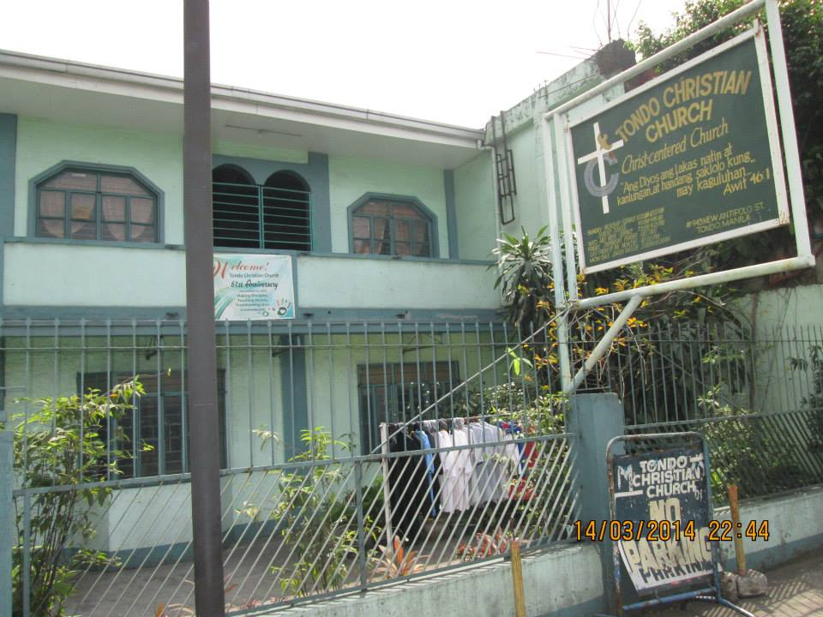My supervisor gave me the contact information of Pastor Cesar who coordinated with Micah Challenge in the past to produce one of their literature pieces. After I messaged him I got a response from someone who identified themselves as “Doc Jojie”. She explained to me that she was not the lead pastor of the church but she was one of the elders in the church. We set a date and decided to meet at the University of the Philippines campus in one of the restaurants.

When she walked through the door and I immediately noticed that she was well dressed, it crossed my mind that she might actually be a professor at the university. There was bustle of groups enjoying each other’s company which seemed to put her at ease. We began the interview and she was eager to tell me the story of Tondo Blessed Hope Bible Baptist Church. She expressed gratefulness that I was willing to share their story.

The front of the Tondo Christian Church building.

Fourteen years ago Doc Jojie was invited by a pastor to “come and see” their community in Estero. She responded, “Okay! I didn’t even know what I would see or what to expect It was just like, okay, I’ll give time to this but I didn’t have anything set in my mind like what’s in this for me? Not like that.” As she walked in between the tall buildings and condominiums with her friend she was surprised at what she saw.

“[The people there] live on several floors, makeshift ply boards, whatever materials they had. And it’s several stories high!” Her heart was broken over the depth of poverty that she witnessed, “it’s something that you really just can’t turn your back on.” This was the beginning of her time with the church. Over time she became more involved with the church and today she is an elder.

I was amazed when she started describing to me all of the organizations and activities that their church of twenty people are involved in. They have a partnership with De La Salle University yearly in which they invite students completing community service to do tutorials for the children. Through other partnerships the church was able to find scholarships for the children, for disaster risk reduction management, for children’s safety as well as trauma intervention.

Doc Jojie is incredibly busy with her church but at the same time she juggles a job at the University of the Philippines, her job as a doctor, as well as her masters in Community Development. She is an example that although there is a lot going on at once there is still time for ministry. This is what encourages to the youth of the church with, “try and make time for ministry also”. She has been there long enough to see generations pass by and watch children grow to be leaders of the church and of their partner organizations. Although the church is small in number it mighty in service.

*The Lord finished everything for them even before they started to move.*

When I interviewed her the church was undergoing great change. Many of the members are relocating from Estero to Laguna, which are approximately four hours apart. They are transferring from the urbanized city of Metro Manila to the rural provinces of Laguna. The land that many church members live on is going to be reclaimed so the community was questioned as to whether or not they wanted to move. Doc Jojie and the leaders of the church were trying to advocate for the children because they didn’t have a choice in the matter, but ultimately it was the choice of the parents.

The leadership believes that the conditions in Laguna would be much better for the children- a healthier environment and a lot that the parents can own. The leadership of the church started helping those that were interested in saving money. They encouraged these members to save as much as they could by cutting back on snacks and other small unnecessary payments. Each of the members were granted sixty square meters for thirty-three thousand pesos (roughly $825 USD). Some members of the church are already paying off the lot by terms that they set for themselves.

There are many great things happening in this church and Doc Jojie believes that it is all by the grace of the Lord. Many members have started paying lots and there are a few that have already moved to their new homes in Laguna. Although there are instances of transformation happening Doc Jojie explained that there I also backlash. “I am worried sometimes, there are so many heart aches because there are members that get so mad, and people bully us. It’s not so easy but you just have to continue on and try to reach and hang in there and continue the work of the Lord.

Jeremiah 29:11 is one of her favorite verses, “For I know the plans I have for you,” declares the Lord, “plans to prosper you and not to harm you, plans to give you hope and a future.” She believes this for her own life and for the lives of those at her church. There are issues that she has to deal with because of her ministry and because of the business of her life but she clings to this truth- that there is “a hope and a future.” This is the sentiment that many of the leaders express in the face of trial and hardship, there is always a plan.

There was a time when she became sick with a respiratory problem but she recognized that getting sick was part of the job. “That’s [my] decision, [I] was sick because [I] was always working and always moving around; medical missions, and busy weekends. But that’s okay! Because that’s my life and that’s already something I embraced in my remaining years.” She was coming from her office when we met at the University of Philippines campus. In the last minutes of the interview she confessed to me “I’m always getting so tired. Oh Sajira, I sometimes feel tired and I know because when I sleep I still see my work.” But still she has great hope for her congregation.

“Even before they have transferred [to Laguna] everything is finished for them, everything is set. The Lord finished everything for them even before they started to move.”

Chapter 8: Pastor Jun

For the Youth of Tondo

Pastor Jun and I met after my morning interview with Doc Jojie. I was also referred to him through my supervisor because he is connected to the Micah Challenge, Philippines network. We set the meeting place as a Jolibee [a common Filipino fast-food restaurant] close to his church by the intersection of a busy street on border of Manila and Quezon City. He had come from his office. There was a dull roar of people and at first he spoke quickly but after small talk he was more at ease as we began the interview.

*The Lord finished everything for them even before they started to move.*

“Work is my hobby and ministry is my passion. Before the Lord called me to become a pastor, I really worked because I have my own family.” Pastor Jun wears multiple hats within his context. He has been a pastor in Tondo for around eight years now and is involved in multiple community based organizations and NGOs that are interested in the welfare of children. He is a board member of the Norwegian Mission Alliance Philippines, the same organization that sponsored him when he was a child. The community he is from, Tondo, is notorious for being one of the most highly-populated and under-developed parts of the Philippines.

When Pastor Jun was a child this was the context that he grew up in. From elementary school on he was sponsored for his studies. He was able to attend camps and training seminars expense free. This was the beginning of his journey with the church. There was a pastor at his church who was mentoring him throughout this time. “We were his Sunday school students, we were five then and he was really mentoring and discipling us. His influence was very big on who I am today.” He began as a youth leader and then followed in his mentor’s footsteps and became pastor. “It’s not too hard for me to take the leadership in the church because I was trained when I was a student during my college years.”

He graduated with a degree in accounting so during the weekdays he works at a bank. He had many opportunities to choose a life apart from working with the poor but realized it only led to emptiness.

“Of course when you graduate from college you are able to work at one of the top five banks here in the Philippines, it became number one, Metro Bank, during the height of my career. I gained so much, it wasn’t really lavish wealth but for me there’s always an emptiness. You know that saying of Grace Pascal, that there is a ‘God shaped gap in the heart of every man that only Jesus can satisfy.’ It’s really not wealth. There’s nothing there, there’s no satisfaction and there’s none in wealth or a beautiful house or a beautiful car you will not find satisfaction there like that.”

He admits that there are still problems within his ministries but in these moments he recalls the story of Jesus and Paul. He tries to imagine what it must’ve been like for God to come down in the form of a human and sacrifice his life for others. Then he recalls when Paul met Jesus in Damascus, the projection of his life and all proceeding actions were dictated by his love for the Lord. Both of these stories of humility and sacrifice inspire him to carry on. And so his work continues.

It took him time to ease into the interview, especially with the background noise of a fast food restaurant. About half an hour later we were able to share laughter and stories about his life. I caught a glimpse of his life through a story about one of the students that he adopted into his family. Often times in the community, mothers will not have money to financially support their children so this is an issue that Pastor Jun’s church tries to address.

There was one student that came to Pastor Jun crying because he wanted to finish his studies, “He was so bright”, but his family did not have enough money to support him. Pastor Jun explained to me how he excelled throughout elementary school and secondary school. By the time this student reached high school he moved into Pastor Jun’s home with the consent of his parents.

Most of his costs were covered by Pastor Jun, the only issue was the cost of transportation every day because he would have to travel from Tondo to Quezon City (about a 2 hours trip). Pastor Jun was able to find foreigners for the student to tutor. Over time he was able to save money to transport himself to school every day, as well as pay for a dorm close to school. “Until he graduated he was able to sustain himself because of his own ability. Then he was able to graduated college cum laude [first in his class] and in the multimedia media was his course, he got a job at *GMA 7* [one of the most popular channels in the Philippines] and today he’s been there for around ten years.”

He has noticed the overcrowding in public schools, which seeps into the church. “In public schools there are so many children, there’s around three-thousand, sometimes five-thousand. Even the church can’t support all of them.” This is one of the reasons that children are unable to continue their schooling. “So what will happen to the out of school youth? They will be taken as child laborers. We need to help them stay students. So I hope that there are more individuals and organizations that respond to the call of helping the children to bring them back into the main stream of education. I hope they want to see children become new in their lives- that’s one of ways to lessen poverty and one way to address poverty, in all aspects of poverty.”

He shared with me the stories of youth that were victorious within his church. While he was telling these stories his face lit up and he couldn’t stop smiling.

“It’s beautiful. It’s a very cinematic, like a movie. Their faith through God becomes developed when they’re with us. There are ups and downs, mostly downs, but their faith in God becomes stronger and I know that the Lord will do something in their lives. It’s hard to take care of the out-of-school youth because they have their own head, sometimes it’s a hopeless case but as the days, months, years go by then you really see the transformation in their lives.”

Many of the children that he has helped grew up to be leaders themselves. “That’s my favorite part. That is the reward of leadership, and that’s what I enjoy the most to see.”

Since his realization that wealth only brings emptiness he challenged himself and his church to live a life of generosity. He recalls the story of the Rich Young Ruler in the gospel of Mark. The Philippines is a Catholic Nation, the roots of Catholicism run deep in the culture. Very much like the rich young ruler there is a higher standard of morality that runs on a shame system of culture. Jesus’s challenge is more than obedience, “Looking at him, Jesus felt a love for him and said to him, ‘One thing you lack: go and sell all you possess and give to the poor, and you will have treasure in heaven; and come, follow Me.’ But at these words he was saddened, and he went away grieving, for he was one who owned much property.” This is Pastor Jun’s challenge, give everything that you are and will be to the Lord.

He visualizes change for the larger issues within the Philippines but he emphasizes the importance of each individual as well.

“When you see a child I hope you don’t just see them as a person that is hungry. I hope that you have a vision to see them one day become a pastor or professional, not just helping them because they’re hungry. When you see a hungry child the instinct is to help them with their hunger but I hope that’s not all, I hope when you see the children you will have the vision that someday this child will grow up to become a leader of this nation.”

His heart for the children is evident in all that he does and all the stories that he has shared with me. When he envisions the future of the Philippines he doesn’t see a country that has fallen further into corruption but a country that is radically changed by the upcoming generations. He charges his church members to be part of the shaping and molding of their futures for the sake of the entire country.

“Life continues on and on even when we’re gone, so what’s the legacy you will leave to the next generation?”

Chapter 9: Pastor Dong

Beloved Worker of the King

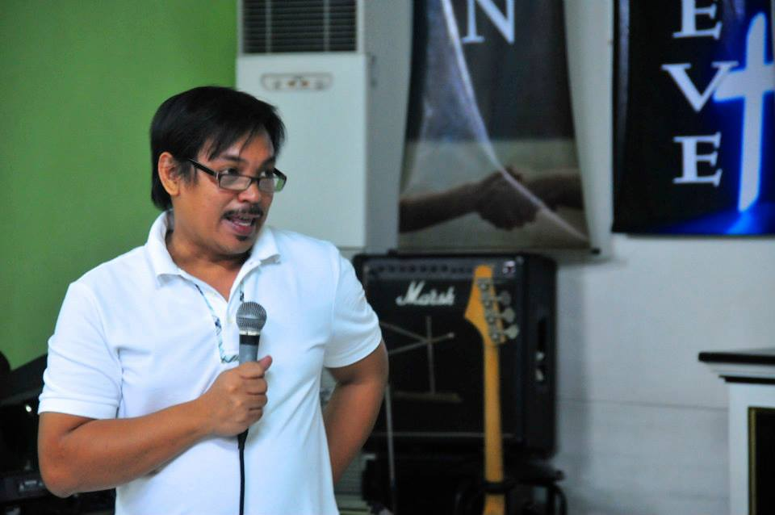The first time I met Pastor Dong was via Skype with my teammates and Dr. Grigg during our time in Los Angeles. I remember looking at the off white wall paper and the bulky machine of air conditioning behind him. My mind was racing about the season of life that I was able to enter; the challenges and the hardships, the beauties and the growth. Two months later we met in his office for the initial orientation of our time in field, and now over one year later we were in his office once again for my research.

He has a warm smile and infectious laughter, the kind that re-sparks hilarity in a humorous moment that had passed several minutes earlier. Throughout my time here he shared with me stories of his childhood in Tondo. Today he is the Executive Director of Mission Ministries Philippines. From the amount of time that I’ve known him I was surprised at the humility of all of his answers.

Pastor Dong speaking at a Mission Ministries Philippines event

He involvement in MMP is much deeper than he made it out to be, and his sweat, tears, and blood have all been given for the love of the poor, his answers reflect deep humility. I do not believe that this section does justice to the true amount of love and work that Pastor Dong has given to the poor but perhaps reflects more of his own thoughts about leadership.

Amado Labrador Reyes Junior means beloved worker of the king, a fitting name for this worker of the Lord that I have come to know this past year and a half. He was part of MMP when it was still part of International Teams Philippines and has remained part of the core leadership of the organization. From missionary to executive director Pastor Dong has given all of his time and energy toward the work of this organization and it is reflective in the annual election of leaders.

New leaders are elected every year by the entire community and after all this time he has remained the executive director. He is welcoming and warm to those that he meets, almost always sharing a joke and a laugh. I remember days when I would just sit with him and my fellow teammates listening to stories about his day or about his life.

His first year as director he had to dive into resolving the financial problems of the staff and the missionaries. “My first year was really, very stressful with many butterflies in my stomach.” But as time passed he grew more confident in his role and his ability with the support of Attorney Chu and Pastor Leo. Mission Ministries Philippines struggles together as a community and moves forward as a community, there is rarely anyone that is left behind. They are a community of many individuals that came from the urban poor, including Pastor Dong.

*‘Let those voice of the margins be heard in the corridors of power.’”*

When I asked him why he chose to continue working with the poor despite his background he said to me “There’s a saying in Filipino: ‘*Ang hindi lumingon sa pinanggalingan ay hindi makakarating sa paroroonan*.’” It’s a quote by Jose Rizal that translates to “He who does not know how to look back at where he came from will never get to his destination.” Like many of the other leaders I interviewed he believed that the Lord prepared him for the work that he is doing today with the place where he grew up.

When he was a child he told me that he dreamed of becoming a soldier. But as he grew older Marcos came into reign and he witnessed the corruption of the government and he “hated the soldiers, so I said ‘Forget about becoming a soldier.’” Then he dreamed of becoming a lawyer but he realized “lawyers lie” and he chuckled to himself, “I thought of going to hell, so I forgot about becoming a lawyer.”

Throughout these times of determining the trajectory of his life he recalled Proverbs 16:9, “In his heart a man plans his course, but the LORD determines his steps.” As much as he wanted his path to lead him out of the community where he came from the Lord brought him back to where he thought Pastor Dong’s shoes would function best.

“I think that loving God and loving the poor are very important virtues of a person. And our existence is meant for God and also for the marginalized. Those who cannot fight for themselves, who have no voice. Now I know I remember a thought, this is a very powerful thought that I remember.

‘Let those voice of the margins be heard in the corridors of power.’”

Chapter 10: Pastor Dennis

Beginnings in the Slums

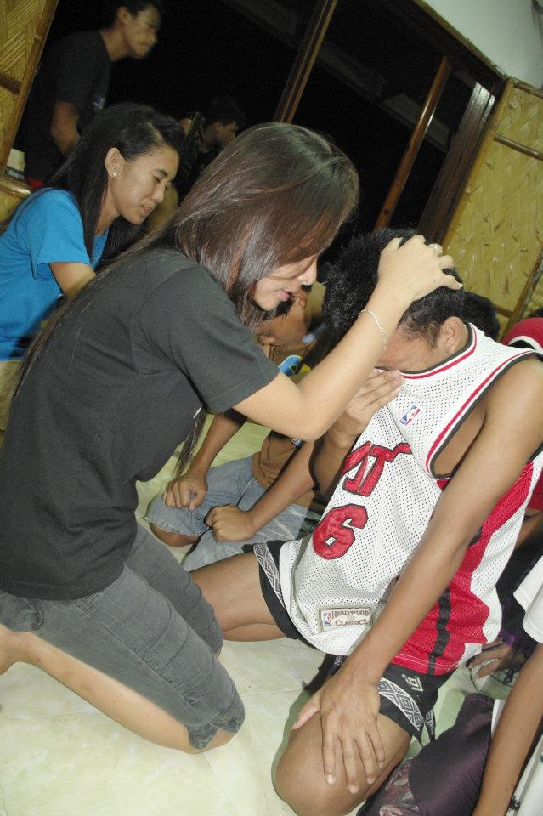Onesimo is located in an area that I am very unfamiliar with so I opted to take a taxi. It was an early morning so my mind began to wander to other places and I failed to notice that we drove right past the building. Realizing it quickly, we made a u-turn on the road and I got out of the taxi. The sign was on the second floor so I walked up to people sitting in front of an eating establishment to the right and asked them how to get to Onesimo.

The man joked with me saying “Are you lost? Why did your taxi make a u-turn?” I explained to him that I was looking for Pastor Dennis to conduct an interview for my thesis, he laughed with a colleague he was sitting with and said to her “Oh, you do the interview instead of me”. It dawned on me that this was the man I was looking for. He finished his meal and then we walked upstairs, passing by dozens of teenagers walking through the halls and sitting on the stairs.

We found a quiet place in his office and talked about how I came to find out about him and Onesimo. This is another connection that my supervisor gave me, he is currently connected to the current executive director, but Pastor Dennis was suggested instead. He was the original executive director for fourteen years, and so he shared the depth of his experience with me.

Onesimo youth at a camp outreach.

Pastor Dennis has been working with the Onesimo Foundation for the past nine years. They have two separate programs that reaches out to the youth at risk ages 14 and above. He found out about the organization through a friend that was working there. They would share stories about the children and Pastor Dennis was fascinated.

“Actually I was really fascinated. I said “Wow, this organization is beautiful. It’s probably wonderful to minster to the youth like this because I used to be one. I was also *pasaway* [naughty] I was a *tambay* [standby, doing nothing] on the street when I was a child.” It first began by visits to the organization and then his friend eventually asked him “Why don’t you join us?” He thought about it for one week and decided to give a try. “My heart changed because of the children. They are very, very close to my heart. We don’t just minister to them, we are also their family.”

At the same time he worked as a pastor of an urban poor church. In 2005 his schedule cleared at the same time Onesimo was looking for someone to coordinate their program- the timing was perfect. “Since then I’ve really been in love with this ministry because I was poor too. I was born poor, then I grew up poor and I’m still living in the land up until now. It’s our choice because this is our ministry.”

As a child Pastor Dennis experienced many of the same hardships that the children in Onesimo experience as well. He grew up in a broken family. His father was “super good looking” so he had many wives. Although he doesn’t consider himself abandoned he still grew up with his mom in the slum because that’s all that they could afford. The environment was filled with drug addicts, dirty roads and noises streets. His eyes started searching back and forth for a few seconds and he said to me “I have one beautiful thing that I would like to tell you about.”

“When I was a teenager, because we were just poor right? We couldn’t even buy one small hamburger. Before, I was asking the Lord, ‘Lord, why is it like this? Why am I alive? Why am I alive or why was I born poor? Why am I poor?’ I was really asking God that when I was still a child. Every time I would pass by fast food chains like Jolibee I would ask again ‘Why are they eating and I can’t buy that?’ All I could afford was pandesal [bread], the small ones. That’s all I can buy. It doesn’t have anything on the inside, I just dipped it in my coffee. Then when I grew up I became a pastor. I was able to work at Onesimo. When I started working I would visit people and I went inside the houses of the children. I wanted to get to know these kids and their families. I went to Navotas, Malabon, and Bagong Silang, Payatas, Tondo, Pasay, all of the depressed areas of Metro Manila; I have been to almost all of them. I realized there are those that are really hungry, there are so many that are incredibly poor. Only then did I see that there are so many families that are hungry- it’s true. The truth is just that there are so many families that are only eating two times in one day. The families that are new to Onesimo usually eat just two times in one day and they need to work first. They have to rummage in the trash in order to eat. Then I realized when I got to know all these families- when I was exposed to their place- I realized ‘Lord, I am so blessed. I am more fortunate.’ I just realized then that kaya pala [this is why] I grew up poor. So I could easily minister to them, to the poorest of the poor.”

This is often his challenge to the churches that he speaks at. During service he will ask the congregation “Who of you have five sets of clothes?” and people will raise their hands. Then he will ask them “Who of you is able to eat three times a day? Sometimes even with a light snack?” and people will raise their hands again. Then he will tell them “You are so blessed. In other communities they are only able to eat one time a day. And they only have three sets of clothes, it’s like wash and wear.” Pastor Dennis strongly believes that everything he has experienced in life is part of the plan of the Lord. He has been given a heart of compassion and empathy for those that he currently works with through Onesimo and at his home church.

This is one of his main observations about the youth that he works with “they take for granted the things that they have.” Even youth in the slums will complain if they don’t have more than one type of dish to eat with their rice and then they’ll want Coke on top of that. When he meets children that think like this he will tell them a story of his experience with a family in Tondo that east *pag-pag* on a daily basis. In Tagalog *pag-pag* is food that has been taken out of the garbage and then recooked.

*“I just realized then that* kaya pala*, I grew up poor. So I could easily minister to them, to the poorest of the poor.”*

People will go to major fast food restaurants such as Jolibee, McDonalds, and Chow King to rummage through the garbage for each of their meals. They will find chicken bones and left over rice then take it home to their families. They eat the left overs of others. One day he visited a family in Tondo and he was accompanied by one his friends. His friend told him that he would stay the night in the community and Pastor Dennis recommended a house for him.

They realized that it was the birthday of two of the people living and Pastor Dennis said to his friend “Take them to Jolibee, would that be alright with you?” His friend nodded in agreement but the father of the family was resistant because the family had never been to Jolibee, “not once”. The couple had already aged and seen their children grow up but they had never had the experience of going inside a Jolibee.

Pastor Denis was saddened. After the meal the father was crying because it was his families first time to taste food that was freshly cooked at the restaurant. The mother said to him, “Pas [his nickname], do you know that this is the first time my family was able to try that? My children always knock at the window” but no one would ever give them fresh food.

As the head of the Church Based Ministry (CBM) department he still works with the teenagers of Onesimo. The children are in CBM are older than the ones residential program. He was also the brain behind the development of the program so the organization found it best that he switch from his position as Executive Director to the head of Church Based Ministry. They partner with churches in the Quezon City area to give the children a place to learn and a place to live.

Before the program started they had around one-hundred children and now they have around three-hundred with over twenty church partnerships. The children stay in the churches and learn how to clean, shop at the market, cook, clean dishes as well as wash their clothes. “They have authority there.” At the same time they undergo rehabilitation with an added spiritual aspect. “Because no matter what you do to change the child, if their heart doesn’t change then they won’t change.”

While recuperating on a relational and physical level their hope is that the child will receive holistic healing in the entirety of their lives. The program also addresses educational issues by teaching them basic literacy and for those that struggle with academics there are skills training classes available also.

When I asked Pastor Dennis what his favorite story from the bible was he said “Of course! The story of Onesimo.” When he tells the children this story he tells it in a way which the children can relate to.

“Onesimo is a young man and his master is Philemon, and one time he stole something from Philemon then he ran away. But later on he was caught by the authorities and put into jail. In jail he came to know Paul and Paul introduced Jesus to him. And then he accepted the Lord Jesus as his personal Lord and Savior just as Paul did during the acts. And then he had a transformation in his life and he became like one of Paul’s assistants. Paul had so many assistants but Onesimo was one of them. And when he was about to be released in prison he came to Paul and said “Paul I was able to be released, I can go outside but I don’t want to because I want to be your assistant, I want to be your companion.” Paul said, ‘No, you have to tell them what happened to you and who is Jesus in your life.’ Onesimo said, ‘I have no place to go home.’ Then Paul said, ‘No, I know your master, Philemon, he’s a good friend of mine. Let me write a letter to him.’ He said, ‘Philemon accept Onesimo, this is my child.’ He used to be useless but now he is both useful to you and me.” And Onesimo used to be pasaway [naughty]; he was wild. That’s what the children on the streets are like also. It’s like when they’re just knocking on our cars, people just get so angry at these children. If people could, they would probably kill the children because they don’t do good things. When you take the children, put them in the church or in the center, and put them through the process of rehabilitation you will see that they will change. When they change they used to be useless but after knowing Jesus they will become useful, this is what happens in Onesimo.”

Chapter 11: Pastor Arnel

“My calling is still there”

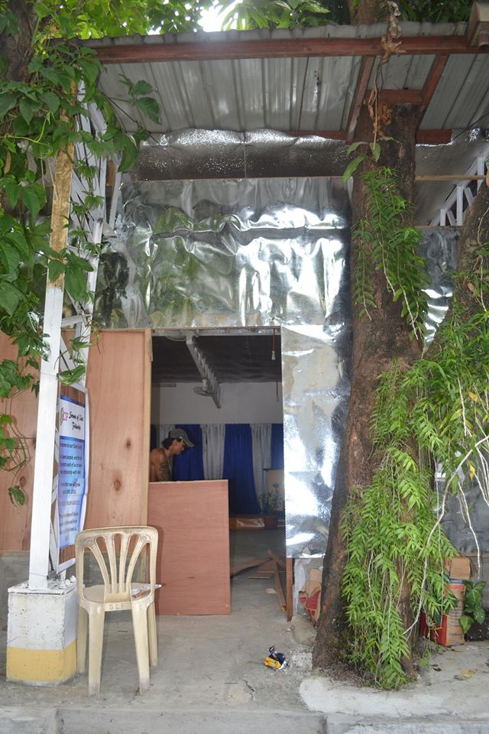Pastor Arnel and I were first introduced through my Community Economics class. As I was thinking of additional people to interview for my research I recalled how successful his final project was for our class and that it was based in his own urban poor community. I contacted to him see when he was available and he invited me to his house so I could also meet his wife. The day came quickly and I realized that his house was fairly close to mine. I came to the gate and his wife, Eden, came to answer the door.

He had left a few minutes earlier to buy supplies for lunch, so I had a few minutes to go over my questions again. When he arrived we exchanged greetings and sat down at his dining room table. During our interview his wife would occasionally chime in and share her side of the story as well. He explained to me that his community was close so we went for a walk afterwards and he took me there.

We stopped at various streets and people would shout hello to him. I met individuals who used to be addicted to drugs and had other problems but were now committed to the church. We also walked through several small alley ways wet with laundry water from mothers washing in the streets. Family after family greeted him and nodded to me as well. He showed me the first space where they held their church services, and then the following three buildings, leading up to where their new location for church was, the multipurpose room of a government building.

The garage church where service was held until they moved to the multi-purpose room.

These were physical manifestations of the blessings that the Lord had given his church to go forth and multiply. One of the last areas that we went to he fondly calls “Boracay”. In reality this is one of the most well-known tourist spots to go to the beach, but he calls this area Boracay “because people never sleep here. There are always people on the streets.” He apologized to me and said “I can’t bring you further down one of the streets here because people might think that you are a police agent trying to bust them or someone who is trying to solicit drugs.” We exchanged laughter to together and then made our way back to his house.

I was amazed, and so blessed that he took the time to show me his community and share his hopes and difficulties. When we arrived at his house lunch was already prepared so they urged me to stay and eat with them. It was hard to decline such warm hospitality. I stayed for lunch and we were able to share more about our own lives. The entire afternoon I experienced their love towards others and I can only imagine the extent to which they love their community.

Pastor Arnel was ordained just last year, but he has been working in ministry for quite some time now. Pastor Dennis was one of his mentors while he was growing up. When Pastor Arnel was doing his undergraduate degree he felt the pull of ministry and decided to ask advice about whether or not he should stop he studies.

When he consulted Pastor Dennis the response was “No, don’t do that. You need you finish your studies, your parents have big expectations for you.” He was incredibly disappointed, “I really thought they would support me.” After he finished his degree and took a job. After some time Pastor Dennis approached him again and said “Is your calling still there?” and Pastor Arnel’s response was “Yes, it’s still there.”

This time Pastor Dennis was supportive of his decision, but the joy was short lived. Pastor Arnel thought that when he quit his job he would receive financial support from the church but what happened was “they just challenged me, but didn’t have a plan for me. They didn’t have any clear support. So when I was going to be pastor it was like ‘What?’ They just said ‘Go, God will provide.’” With financial responsibilities still weighing heavily on his shoulders he chose to work as missionary under Students for Christ. He would do bible studies in different universities including Polytechnic University of the Philippines, where he met his wife.

This was not the end of Pastor Arnel’s financial struggle. He grew up in the community that he serves now and his wife mentioned to me how he used to sleep on the sidewalk while his family ran a small barbeque stand. His life has been marked by financial struggle but through them all he has seen and experienced the great provision and grace of the Lord. When he was still in college he didn’t have enough money to pay for an exam period. For each class you are required payment as well as a testing permit signifying that you paid the due.

When he arrived in school he didn’t have a plan or a permit, just a signal from the Lord that said “Just go on. Review, then go to your class.” He sat down in the classroom anticipating whether or not the professor would react. In the first class the professor told each student to pass up their permits. Pastor Arnel’s heart was racing. The teacher didn’t seem to notice and told the entire class, “Alright, let’s start the exam.” In his second class the professor allowed him to take the exam as well. He explained to me that usually other professors would not let this happen.

This happened for all seven subjects that day. Days passed and he got his grades back for the exams, “I had the highest score!” During the next testing period each professor called him to the front and said to him “Mr. Samol! I receive a memo from the administration because I allowed you to take the exam. Sorry, you have to present your testing permit before I allow you to take the exam this time.” When he asked his mother for the payment she had enough to cover the cost this time around. This is the story that he shares with the youth that are discouraged by the financial hardships of education in the Philippines.

*“If you’re going to be a Christian you have to have a progressive life style. It will*

*change you.”*

His financial hardships have continued to the payment of space rental for services as well. Although he has been able to pick up jobs in the past these payments are a source of stress for Pastor Arnel. In the old building that they held their services they had to pay twenty-thousand pesos (roughly $500 USD) a month for rent, in a poor church this cost is incredibly high. Every month he would pray in desperation and every month the Lord would provide.

When I interviewed him they were in the transition of moving to a different space for their services. They only had ten-thousand pesos (roughly $250 USD) allotted for their rent every month and they were able to find a space that was originally much more expensive than this but accepted what they offered. Again and again he has seen the movement of the Lord.

“The miracle of the movement of the Lord for those that are in need, it’s really there. It’s always there, you just need to trust. The only problem with man is that we always try to take action ourselves. We work while the Lord is still moving. That’s the problem. ‘That’s my work’ the Lord will say, ‘that’s my work, but you’re moving. Okay, fine. Try working for me.’ Then while people are working they don’t see any results. People will reach the point where they just cannot do it anymore, then they cry and say ‘Lord, I give up’ because you are powerless. You must allow the power of the God to work in you.”

He has seen the mighty movement of the Lord in the lives of his community members as well. It first began with the youth. In his free time he would go around the community to build relationships with the children and help them on their homework. Slowly relationships were built and they were able to do a bible study together. When Pastor Arnel was given the opportunity to start a church in the V. Luna area he encouraged a father in the neighbor who was *siga siga*, a word to described someone tough and macho in exterior.

He witnessed generation after generation of elementary school drop-outs in this family. “Then when I started teaching the children, they didn’t become tough like that.” Christ was manifested in the changing of their lives. “They were poor, but they shouldn’t stay poor, it will really change, totally. There are some that are shy; they need to not be shy. If Christ is with you, your social life will improve. So from what I see, those who become born again, it’s not more spiritual because I trust that those who become Born Again Christian, it will include all of the aspects of your life.”

There was one teenager in his community, Patrick, that Pastor Arnel was intentional in getting to know. Patrick was a gang leader, “He had so many tattoos and his face was scary. If you bother him he might stab you, but I became his friend.” Pastor Arnel said this all with a smile on his face and chuckles in between sentences. This teen was part of the fraternity Taugama Traskilyo. Despite the reputation and danger of becoming involved with gang members Pastor Arnel was interested and wanted to find out why he had taken this path in life. As he began to spend more time with Patrick he slowly opened up about his life it was revealed that “he was actually soft-hearted when it came to opening up about his problems. He would cry and cry.”

Pastor Arnel found out that his mother was an overseas Filipino worker in Australia and his father abandoned him. He was left alone with his siblings. Patrick saw Pastor Arnel’s genuine interest and was moved to attend some of the services. He eventually accepted Christ when Pastor Arnel told him “You should accept Christ. All you have to do is come close to Him.” After this moment everything in Patrick’s life changed and it began with his hair. “Yes, he got a haircut and then so many people were so surprised. They said, ‘Wow, you’re actually handsome!’”

What happened next was a renewed desire to study. Pastor Arnel helped him study to pass the high school exam so he would be able to go to university. He passed. Around the same time that this was happening his mother arrived from abroad and was shocked to see the state that her children were in. When she saw her children taking part in bad habits and struggling with schooling she decided to move back to the Philippines. His life was transformed from the inside out. Now he has a good job at a call center and is able to provide financially for his family. His siblings are involved in the music ministry and his mother is active in the church as well.

Pastor Arnel, like Pastor Dennis, experienced poverty as a child and is now able to use that in his ministry to his communities. From a student struggling to pay his dues for his exams to a pastor who struggles to pay rent for their church, he remains faithful in the Lord. He continues pushing forward despite the struggles that he has. “If you’re going to be a Christian you have to have a progressive life style. It will change you.”

Chapter 12: Sister Rida

Perseverance through Anxiety

I was introduced to Sister Rida through one of my language school teachers who has been a very good friend to me since I’ve arrived in the Philippines. Sister Rida and her husband Pastor Bobot live very close to the language school I used to attend. Their residence is on top of a Rapide Car Garage so throughout the interview there were the occasional noises of metal grinding. Her daughter came to sit by us, eating her morning snack and chiming in at points to reaffirm what her mother had shared.

*“Bahala ang Panginoon sa amin”*

The roof was like a hidden urban jungle with a cover providing shade and plants throughout the premises. She was incredibly hospitable and welcoming; after the interview we shared a meal together and continued to talk about our lives.

We sat down on a long bench with a pitcher of ice cold water in front of us. It was so hot this day that the precipitation of the water immediately started running down the sides of the pitcher forming a small pool. After we had small talk about shared the excitement of the amount of mutual friends we had she told me her story. Sister Rida and her husband Pastor Bebot have been at Worship God Christian Fellowship International Ministries for quite some time now, but the face and work is different.

In an area that used to hold worship services there were beds for her family and their children to sleep. There were two rooms in the back that were used for Sunday school are now used to house children from the community and also serve as their classroom. Her journey with the children of the poorest of the poor began in 2009. She was approached by someone she called her “prayer warrior”, a loving brother in Christ who prayed for them whenever they would see each other.

One afternoon after service he asked Sister Rida and her husband “Do you know anyone who ministers to street children?” This question changed the projection of their ministry and church entirely. After meetings with individuals who might be willing to help them start this ministry she was eventually asked “Are you willing to start this ministry? And will you help with the food of the children?”

Sister Rida and Pastor Bebot prayed about it for months. They tried starting a ministry with street children in 2005 but the pressure was too much for them to handle, so they stopped. They had a Daily Vacation Bible School with a total of one-hundred and twenty-eight children. At this point I looked around the small space and my jaw might’ve dropped because she laughed.

“It was actually manageable. But when ten street children joined us, grabe [wow]! It was really like a riot, really like a riot. It was so chaotic because of those ten street children. If someone says something that would get on their nerves, then they would start a fist fight. So I was really crying out to the Lord and saying to him ‘Lord, I really can’t do this with these children. I really can’t.’ And how many years did we do daily vacation bible school and it was fine, sometimes we would have up to one-hundred and forty-eight children! We did it there in one basketball court and it was fine. But this time it was really not… so I said ‘Lord, we really can’t work with the street children.’

That is why this suggestion caused her so much anxiety. “I was so scared because I saw the gravity of taking in street children.” She would have flashbacks to those ten children that caused chaos for the entire DVBS program, but still they prayed for whether or not it was the will of the Lord.

One night Sister Rida had a dream. It was a vivid dream in which she felt she had somewhere to go, an unknown location. A voice spoke loudly to her and said “Go up here!” She listened to the command and climbed to where she was told. When she arrived someone handed her 12 large strawberries- she made the gesture with her hands that indicated they were about as big as basketballs.

The voice then spoke again and said “Okay, go back down, and take good care of those twelve strawberries.” She took this as a clear signal from the Lord that she should start ministry with street children again, and so she did. In 2010 they started their ministry with ten children which grew to twelve. Each child received an allowance for food, and a little extra to help pay for electricity, water, and their basic physical needs. Sister Rida and her husband were able to find support from several different mothers as well as outside sources.

Things were going well until debate broke out over their financial supporters. They had acquired help from an NGO that was non-denominational by nature but provided financial assistance to organizations of mixed religions including the Iglesia ni Kristo, Muslims, Catholics, as long as it was an organization of social change. Rumors started within the church that the NGO that was helping them was actually Seventh-Day Adventist.

Although further research was done stating that the NGO was non-denominational church members did not like the association. Rumors began within the church and so there was a division of opinion. This eventually led to the disbanding of the church. During this time Sister Rida’s anxiety became almost unbearable to her.

“In the morning I would tremble, I would really shake. I was so scared because I can’t like a life like this but I really had to trust the Lord and say ‘You are the only one who can make all of this better. You are the one I trust and my life is in your hands.’” Rumors were still circulating, specifically about Sister Rida, but her husband reminded her to stay focused on the truth. “I said *bahala ang Panginoon sa amin* [The Lord will take care of us]*.* She was tempted to avoid the members of the church after hearing these rumors but Pastor Bebot reminded her “You can’t do that, you have to overcome this.” So again she gave her anxieties to the Lord.

Sister Rida admitted to me “the ministry isn’t always happy, it’s more difficult but your discouragement depends on how close you are to the Lord.” After this happened there was a point when had a major health issue. She had to go to the hospital to get one of her kidneys removed and her previous church members were harsh in words, “Sometimes I heard from them ‘It’s because of what they’re doing with the street children, that’s why her health is failing.’”

The hospital bills started to add up but in each of these instances the Lord provided financially for them. The Lord provided for her, and provided for each of the children that have been sick in their ministry. Despite what others said she still smiled and said “The Lord is kind to me.” Today only around ten to fifteen people attend the church, with three remaining elders. Previous members have told them that “Once the children are gone, then we will return.” Although sadden by their choice, Sister Rida and Pastor Bebot continue on.

They teach the children every Monday, Wednesday, and Friday and have been recognized as a certified Alternative Learning System under the Department of Education in the Philippines. They house children from a nearby urban poor community as well and continue to see lives transformed. She has become the mother to the children that she takes care of and teaches. “Today there are children that have been able finished in this batch and there are others that have work now. There are also others that returned to their previous lives which is a little sad, but until today we still follow up with the children.

Her final wish is awareness of how you minister to others. “Your ministry is a way of saying thank you to the Lord, ‘Lord thank you because you saved me. I have a new life now.’ And then when you’re ministering sometimes times will arrive when you’re really drained and you need the Lord. It’s like the ministry is left to the Lord because sometimes there really is a time when you feel like you really can’t do it and you don’t like what the Lord is doing but He listens to you.” Matthew 6:33 is her favorite verse, “But seek first his kingdom and his righteousness, and all these things will be given to you as well.” As she continually seeks him she has experienced deep pain but she has seen powerful glimpses of His provision and grace.

Chapter 13: Pastor Ariel

Romanticizing the Problems of the Poor

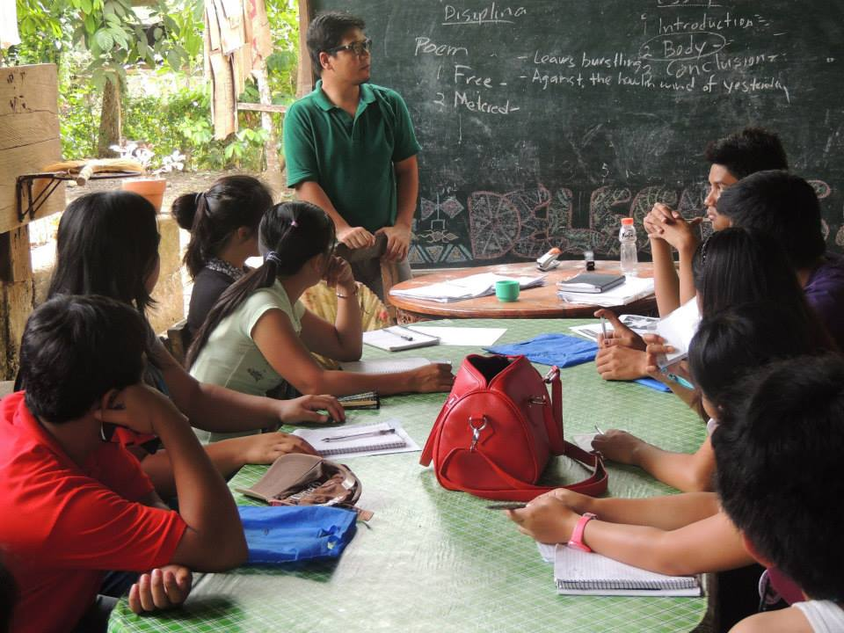Pastor Ariel and I first met through our community economics class at ATS. Neither of us were outspoken although occasionally he would share about his church, The Upper Room. My supervisor suggested that he would be a good candidate for interview because he is also connected to the Micah Challenge, Philippines network. After weeks of clashing schedules we were finally able to correlate a time when we could meet. We met at a McDonalds but we decided to have the conversation elsewhere. It was around 8:30 p.m. and we strolled through the night of Quezon City to a *karenderia* by his office, or a small place where they cook and offer cheap meals. We sat outside and the conversation began amidst the roar of the MTR in the background and motorcycles whizzing by.

Pastor Ariel teaching youth from the community how to write proper essays.

He’s currently the pastor at The Upper Room, the church where he grew up. From the time he was a child he watched the community fall deeper into poverty till it reached its current state. Though his upbringing gave him knowledge for his current ministry he’s only been a pastor for a few months at this point, “You have to apply to the local church then the local church must recommend you to the district and the district will endorse you to the national general assembly. The general assembly has to accept.”

While things were still in the process of approval he set his mind on visiting a *burol* that was being held in his community. Throughout this story he revealed the depth of his heart for the community and his role has a pastor has been marked by his compassion. “I was forced to conduct a service about mourning because someone in our community, one of our members there, had a *burol* for over two weeks.”

A *burol* is the western equivalent of a viewing after someone passes away, but in the Philippines it is a celebration. During *burols* families reunite, there is always an excess of food, and often times there is gambling in hope of raising sufficient funeral funds. Pastor Ariel explained to me that in the Philippines when the *burol* for the dead is already over two weeks it means that they don’t have enough money for the burial- paying for a priest alone was seventeen thousand pesos (roughly $425 USD). “It’s like they’re oppressed by the payment to the priest. When I went there my intention at the time was just to visit but I was forced to do [a service] because they wanted to finally conduct a funeral afterwards.”

*In the bible the Jesus Christ there has risen with a face and it is a face of the people*

*living in poverty.*

He struggled with whether or not it was proper for him to complete the sacraments for the dead but because of the context he believed that it was justified. “I cried because of the situation, they didn’t have a funeral, that was really hard. Can you imagine that your father died and then one week of hosting a *libing* and you’re so tired? How much more if it’s two weeks dealing with the death and the situation still isn’t okay?”

From his upbringing and from his interactions with church members he knew early on that this was his calling. His heart for service and his desire to see transformation for his ran parallel.

“You service to Christ will be acceptable just as long as it is your love for the people, which means how you serve Christ, you cannot just sing songs to them. The best way is to be the face of Christ in the poverty stricken areas of the people. So it’s like that, Christ must change the poverty of the people, when you are listening to the difficulties of the people, Christ is also having difficulty. Change the situation. That is the most concrete service because you cannot serve Christ because Christ is Christ and God. In the bible the Jesus Christ there has risen with a face and it is a face of the people living in poverty. There are even images of God in the old testament of those who are marginalized.”

Many times he explained to me that in order to change the situation people will assume that problems of spirituality may be what leads the poor deeper into poverty. Pastor Ariel emphasized that he believed this was just “romanticizing” of the problems of the poor.

“I don’t have any problem with their spirituality. Actually, you don’t really have a lot of problems with the spirituality of the urban poor. Their problem is really more economic, so that’s me and my wish for you, my hope, that we don’t romanticize their spiritual problems. No, the problem of the urban poor is that they are poor and when you say poor this is not a spiritual problem, this is an economic problem. It’s not because they are sinners, it’s because there is something wrong, there is something terribly wrong with how things are being governed, how we are governed economically.”

Pastor Ariel explained further that he believes this requires economics solutions working in tandem with political solutions as well as cultural solutions. His observation was that the Evangelical church had the tendency to “romanticize” these issues, which often leads to a false frame of conception and false solutions.

He gave an example of this from the issues of education in the Philippines. “At the same time my realization was of what kind of government this is that there are so many politicians that are so rich and they enjoy a beautiful life- they don’t need to search for money for school for their children. The state is responsible for this education. It isn’t necessarily the responsibility of the individual family.

When the situation is like this it’s like you create beggars because they’re running after those who have the money. You create citizens that are rich or are beggars. There’s something wrong with the system.” He explains to me that poverty is not addressed but simply “pacified”. Every year the Philippine government distributes scholarships to students across the country “so that they can cover their eyes to the real and root causes of the problem.” The mindset of the poor is focused on the daily needs, when they are provided enough for one more day it becomes harder for them to look in the perspective of long-term.

This is the standard he has held himself to and the challenge he presents to his friends and church members. “Rise above the popular and dominant interpretation of scriptures. When I say popular and dominant interpretations of scriptures, [I mean] the popular constructions, the Middleclass constructions of scripture- how to overcome so that the poor will be liberated.” Isaiah 65 holds some of his favorite verses. In these words is his hope for transformation of the country from “weeping and crying” to a “new heavens and new earth”.

“See, I will create

new heavens and a new earth.

The former things will not be remembered,

nor will they come to mind.

But be glad and rejoice forever

in what I will create,

for I will create Jerusalem to be a delight

and its people a joy.

I will rejoice over Jerusalem

and take delight in my people;

the sound of weeping and of crying

will be heard in it no more.”

Chapter 14: Pastor Glen

Tragedy and Trust in the Lord

There is a coffee shop called Hillcrest Wellness Café that my classmates and I frequent, especially when our workload becomes particularly heavy. Hillcrest Church was started six years ago by a partnership of pastors. It started with one church in a small building in Sikatuna Village and then they slowly expanded. They were able to open a coffee shop across the street and proceeded to open a second and third church in depressed areas. Every time we would go to their coffee shop there would always be one other American there.

*I was holding her while she was dying. I was looking at her eyes and her pupils became small, then it was as if all the air in her body was gone.*

For many weeks we lived in acknowledgement of each other’s presence without actually having a conversation. One day the staff of the café encouraged him to initiate conversation and so he confronted my classmate and me about our impeccable English accents. From there our friendship developed to the point where I discussed my research with him. I asked the American missionary if he perhaps knew any leaders from his church that were working with the urban poor, he suggested Pastor Glen.

He explained that this pastor’s story was riddled with pain but even in the midst of this, he held fervently to the Lord. I had to meet him. My friend set the meeting for us and one night we sat at the back of the café and he shared his story with me. What I remember most about him is his eyes. There is a way that grief manifests itself on the faces of tragedy’s victims. Yet he still held a depth of trust and resilience that stated “God is still good.”

He sat across a round table from me and began telling me his story. “I am Glen Campus, married with 5 kids.” At this point he pauses for a few moments and takes a deep breath. “But my wife just died.” Her name was Myleen and she was from Quezon City. She had 5 children from previous relationships but she was an active member of Hillcrest Church and so were her children. Both of them had been friends for some time and ended up doing ministry in Montalban together.

“To make the long story short, we developed feelings for each other and became close until we were married.” But their love story was cut short. He relived the moment while he was telling me what happened. “She died inside our house. I was holding her while she was dying. I was looking at her eyes and her pupils became small, then it was as if all the air in her body was gone. Like that… I was shocked.” This was only one week after the wedding. “May 4th we were married”, they were accompanied by their friends from church and everyone as very happy then on May 11th she died. “We didn’t know that the following Saturday she would also be the first person to have a funeral at the church. So… that’s what happened.”

Myleen had heart complications and suffered from an asthma attack. When she was still alive Pastor Glen said “she had a heart for ministry, for the poor. She saw that life in Montalban was not easy, it was difficult.” His wife was the one who initiated church planting in Montalban but the pastor said it would be best to establish a livelihood program before starting a church. Myleen initiated small businesses for families there including selling extra textiles and meat processing. “She was the one that started the ministry there and it would be too bad it we weren’t able to continue it.” So Pastor Glen continued to push forward with livelihood and now in July they will start a worship service once a week.

Adjustment has been difficult for Pastor Glen because she was erased from the picture so suddenly. It was disorienting to him at first. “It’s hard to be by yourself again.” But the Lord provided help for him in ministry. Through this difficulty he learned how to grow from “one who supports the leaders” to being the only leader.

“By God’s grace he continues to move in the leadership there in Montalban. The area is still young, still fresh, so there are things that the Lord is still teaching us in how to lead the ministry, in how to lead the church with 5 children that accompany me.” He perseveres. “When beautiful things are happening in your life there’s nothing to understand really. It’s like all the blessings are yours, you will stay focused on God because He’s just there, He’s providing. But when a season of things that aren’t nice arrive if you’re not focused on the Lord, like Peter when he said to Jesus ‘If it’s really you, tell me to walk on the water to go to you’ then you will sink. The focus on the lord is beautiful, so when he was walking on the water he was okay. But when he saw the problems, the waves and the wind and the storm then he lost his focus on the Lord, but it’s natural for that to happen to each of us. Sometimes we are focused on the Lord but because the problems are arriving we lose our focus. But the Lord is still there, so our focus should be on Him because He’s just there, we must cling to Him. The Bible says beautiful or not beautiful we need to be thankful to the Lord always. So that’s how we handle the beautiful and the not beautiful, stay focused on Him.”

I sat before him humbled. “If there’s no God then I would be mad after everything that has happened in my life.” He laughed after this statement, the infamous Filipino laugh that gets them through the most painful occurrences and statements. “But because I know that there is a God, that He’s always there, it means I always have a purpose in my life. So that’s what I hold onto from the Lord, even if Myleen is gone now her life had a purpose. One of them was probably to teach me to stand on my own two feet, to have a strong personality and to have strong leadership and strength. Because I am the person who needed support from all the leaders, they were always helping me. So the Lord said ‘In this season you will stand on your own two feet and become a leader to support the people that surround you.’”

This year marks an important year in Pastor Glen’s life and his ministry. Myleen’s children received support to finish their time in college and the rest will move to Quezon City with Pastor Glen. Throughout the tragedies and changes in his life he still firmly believes that the Lord is with us throughout all of our problems.

“Jeremiah 33:3 says ‘call onto me and I will answer thee and I will show the way and mighty ways which thou knowest not.’ So he says to us, stay focused on me, call me, call onto me and I will answer you. Call the Lord and pray to the Lord, stay focused on God no matter what problems are here and stay focused on Lord and the great things and the difficulties that you pray. Even if you have problems but stay focused on God then he will show you mighty things that you didn’t think there were solutions for. So when you don’t think you can do it anymore on your own, praise the Lord for what he is doing.”

“Our problems always have a solution even before they arrive.”

Chapter 15: Pastor Obet

Networking in the Community

I was introduced to Pastor Obet through one of my language teachers. He is currently transitioning his life to Malaysia so I caught him in between his final meetings and goodbyes. We met at Mister Donut in Trinoma, one of the more frequented malls in Quezon City. He was texting throughout the interview, extremely busy because he was actually ending his time in the Philippines and moving with his family to a different country for missions.

*“What are you doing? Nothing?*

*Come with me.”*

Like many of the other individuals, he held positions in several different organizations. He’s part of the Volunteers of Christ, Rhoda Ministries Network, The Coordinators Unlimited Program, as well as the Philippine Children’s Ministry Network. He grew up as part of the poor in the Philippines so serving the underserved came naturally to him. His initial experiences in ministry were working with the rural poor in Rizal “where there’s no electricity, it’s underdeveloped, and you don’t know where the air is coming from. When it comes from the north it smells like chicken and when it comes from the south it smells like pig. The two smells mix and in the morning your nose will be so angry.”

We shared a laugh. Each of the organizations he is involved in work with marginalized populations of the country, many of them focusing on children. Through each of these organizations he hopes to be a channel of the grace and forgiveness of the Lord. “It should be an integral part, as a Christian, as an individual.”

Before his work as a pastor he worked in businesses related to architecture and engineering. Although he was involved in the church at this time, his main work was with computer design, “I had a baby so you needed security, of course.” Around 1996 and 1997 his pastor-friends started challenging him to come back to ministry. He would come back to preach for special occasions within the church but remained at his work with computers. “We kept on ignoring the suggestions that people were giving.”

But the Lord spoke clearly to him despite his resistance to their suggestions. “My Missus and I were doing a devotion around 4 a.m., and my child, around 2 years old at the time, woke up and said ‘Papa! Pastor ka! [Dad! You will be a Pastor!]’ and I didn’t even teach her how to say that! And she made a gesture like this [pointing at me]. And then she fell back asleep. And I said to my wife, ‘Who said that?’ No one, no one taught her that. And then she woke up again. It happened three times that she said that to me.”

After this event he returned to his life in ministry. Timing went well with his job because he was allowed more flexibility as a freelance architect. Throughout my time studying my undergraduate degree as well as my time in my masters I have heard many variations of the proverb about a fish pond. Pastor Obet provided another variation unique to any that I have heard in the past.

“I always hear from Duvor ‘Make a fish pond.’ So the Chinese proverb, what was that Chinese proverb? Don’t give man a fish, teach them how to fish. That is already obsolete. Create a fish pond. *Di ba* [right]? Because what if it’s raining, what if the cost goes up? If you have a fish pond then at least you have something constant.” Pastor Obet and his team proceeded to address many of the issues in the community which the government failed to, issues of public schooling, issues of health, as well as issues of the marginalization of children.

The day before our interview his church held a celebration of their 4th anniversary. People came to the stage and explained to them how the gospel had changed their lives. Before they had an actual church building their services were held in a house. People would sleep there together and hold weekly bible studies. His community was closely knit. They would spend days together walking around, building relationships with people in hopes that they would eventually come to Christ. And they did.

“It’s normal for me to say ‘What are you doing? Nothing? Come with me.’ And then we go around, and we expose them to different places. We don’t teach them that they must minister; we just involve them in ministry. It’s not guilt trip because sometimes it’s more based on emotions, but why not involve them so they can enjoy rather than feeling guilty? Can it be like that? So that’s mostly what we do with the leaders. It’s not because they’re informal settlers, they don’t have formal training, so they learn through conversations and stories, what they watch on TV. They become involved right from the very start, they’re not treated as a baby, they have people that they take care of also. So it’s like that.”

He is preparing to leave for Malaysia but he leaves behind him a second generation of leaders to take his place. He walked in faith to the point that he developed problems with his leg. He mentioned it briefly during the interview but I didn’t fully notice until I saw him limping away. His commitment and love for the people manifested in his limp, years of walking around asking people to “Come and see. Come and see what the Lord can offer you.”

Throughout his time working with the marginalized the Lord was always present in each of his hardships. When he was having financial struggles with faith checks would show up from his employers in the CADD business. Because of his awareness of financial struggles he encouraged the second generation of leaders that they should work. Three of them were able to find job and they support the one individual that wasn’t able to.

One of his most difficult times was when his oldest child became sick with dengue. He went to the ER with no idea how he would pay for the hospital bill in the future. Upon arriving he realized that the doctor helping them was the same doctor that helped them with their medical missions in their community on Commonwealth.

“She recognized me, took care of our case and gave us a doctor that was a pastor’s wife. We needed blood for my daughter. This was the time that there were a lot of people in the church that wanted to help so we got so much that we were able to give to the people who were to our side. And then yes, and we still got more. God provided abundantly.”

Dependence on the generosity of the Lord has gotten him through many of his trials. “What you need to know is that God has put you there and all you need is to trust Him.”

With this trust he has been able to serve multiple communities and multiple families throughout his time in the Philippines. It was almost always through mutual cooperation and generosity on one part or another. During his time working in Commonwealth he noticed that many of affluent subdivisions would come to his community to hire *kasambahays* [or house helpers] and men for manual labor.

Commonwealth is one of the largest streets in Quezon City with informal settlements lined along the road and affluent subdivisions hidden behind. In recognizing the needs of the community he started to notice the partnerships taking place as well. “Actually, they were always partners. It was complimentary for the rich to hire people to work from there.”

These observations of the rich helping the poor and the poor helping the rich in a reciprocal relationship eventually influenced his view of how churches should network. Throughout his time as a leader working with marginalized populations he has noticed the division of the church.

He notes that many times churches will not network because of their different sects.

“Calvinist? Or Armenian? Which are you? There are so many reasons why you don’t see them working together but we have one reason that we should work together because we’re all in love with Christ, and that love should withstand be our glue.”

This is his challenge and his burden, and he will bring it into his work in Malaysia as well. He trusts that the Lord has given him certain strengths that he will be able to utilize in his time abroad. “All I have to do is walk daily, by faith.”

Chapter 16: Kuya Bryan

“I am willing to die”

We met a couple times prior to this interview through various ATS events as well as in the office of my supervisor. He’s one of the main staff of Micah Challenge, Philippines so it was easy to set up the interview with him and establish rapport because of our mutual connections. I messaged him through Facebook and we set up a meeting at one particular establishment called Café de Lipa by the Market Market area.

He didn’t give me specific directions and so I became lost and wandered around the area asking security guards where I could find this café. I texted him apologizing that I would be late because I couldn’t find the location and he texted back something to the likes of “good… sorry I didn’t give you specific directions. I will explain why when you get here, I’m actually teaching you a lesson about community development.”

A painting of native Filipino drums on the outside of the Balay Tuklasan Likhaan building.

About twenty minutes later I walked into Café de Lipa with sweat running down my face. He laughed and we exchanged greetings. He is a jolly man, wearing a wrist full of tribal jewelry with some interspersed on his heck and on his ankles. As I sat down he explained to me “This is one of the most important lessons of community development- asking questions of people on the ground.” I laughed and he continued on, it became clear that community organizing was his passion.

Showing respect in Filipino culture is incredibly important so I referred to him as “Pastor Bryan” in the beginning of the interview but he stopped me immediately. As a Christian Anarchist one of his desires is to see the decentralization of power because of the amount of government officials monopolizing this.

He explained to me “Call me Kuya or plain Bryan. It’s okay with me.” In his eyes the word pastor is associated with monopolizing the ability to interpret the bible, so he prefers the term *kuya* or older brother, a more relational approach to respect. He is the current facilitator of Balay Tuklasan Likhaan, which translates to “A House of Discovery and Creativity”. Balay is an alternative space and library in his community in Taguig where people can gather. They have times to learn about culture, about health issues, about music, and anything that will enrich the lives of the children.

He has lived in that community since he was three years old. As a child he played with other children from the community, as he grew older he continued to share meals with him, and now as someone respected in the community they have learned to struggle together in a peaceful manner. He admits to me that there are times that tension arises between neighbors.

One recent incident included one of his neighbors who chopped down a banana tree and uprooted other vegetables by his house. “So we reacted. I told them, ‘You should not cut those old trees because it’s not your property, and second it’s not on your life. Whatever is in your lot you can do. But you don’t have rights to cut all those trees because it was planted by the community.” Many of the community members were upset but Kuya Bryan was able to resolve it with the barangay as mediators to the situation.

His community is tightly-knit, a testament of how heavily he values “shared power”. It is a community that compliments each other with their gifts. “The poor have gifts that I don’t have. For example, I’m not a cook. I don’t know how to cook, only rice, and ahh… fried egg”, we share a laugh, “But if you will look, you will find it in the community. Ask them maybe we can join together, I will organize the community and you can cook for me.” Kuya Bryan explained to me how the agenda in Balay is to create a place of *shalom*, “the Kingdom of the Lord.”

He continually encourages people to eat together as they can. It has become a place of peace for the children of his community that suffer his abuse. This is his burden. As he started describing the situation to me his voice began to tremble and he had to pause. Tears began gently falling from his eyes as he said “There’s a lot of children who have problems in the community. The violence they see… Their mom was punched by their dad, you know? And they will run in Balay and say “Kuya Bryan, can I stay here?”

And so Balay became a place of refuge for the children as well. People will often criticize him for allowing inebriated children inside the church but he repeats to them “Let them be.” In Tagalog *tahan* means peace and *tahanan* is a place of peace and that is what he envisions for Balay: a place of community, a place of healing, and a place of learning.

It took him time to build trust with the community. “You have to tell the community who you are, what you are and where you’re coming from because if you don’t do that then the community will not believe in you and trust in you.” Throughout our conversation he said to me many times “Be firm and bold in who and what you are.” Kuya Bryan urged me, “you need to clarify your calling.” Community organization has taken up his entire life and he recognizes that there is no going back, lest the community fall apart and be deeply hurt.

Many times when no one will step up for an activity he had to take initiative. Through this dedication and persistence the community will understand that you are willing to sacrifice all for them. “The love of the community will overcome poverty. Other organizations, other churches, other people see that money is the answer to community- no. For me, in my experience, no. It’s the love that will change the community. It’s not the money.”

In the beginning of his journey as a community organizer this love was one-sided. There were many instances in which he had to wait for the community to move forward at its own pace. “You have to wait for them and then walk with them step by step, step by step. You know, don’t walk very fast because eventually in the end you will be all alone doing those development and transformation.”

*“Be firm and bold in who and what you are*

During times of hardship “it will strengthen your stomach.” He experienced hunger, anger, frustration, a lot of frustration, but he continued to push forward for the love of his community. “If you show the community how to love they will love you also. But this is not something you should expect from them.”

Balay has become a place of peace and love for the children of his community. Every Sunday they are intentional about feeding the children vegetables. We shared a laugh together talking about this difficulty. He will sit at the table with the children and say “You will not leave this table until you finish this food”, that’s his strict policy.

When the children are eating they make fake gagging noises and Kuya Bryan laughs and says “Oh, no, no, no! You drink water and then you swallow it.” He asked a child, Hasmeen, why they choose to come back even if he foods them food that they detest. She replied “Well, because you love us, and you show that you care for us. We stay here because you love us, and you teach us how to dream again, you teach us how to have hope in the midst of poverty.” This is his confirmation and his affirmation that what he is doing with Balay has been blessed by the Lord. “Those stories changed my life.”

He is well-loved by the parents as well. Kuya Bryan and his community are an informal settlement meaning that the land they live on is owned by the government. Recently there has been a homeowners association who are trying to evict the families so they can buy the land and expand their business. The businessmen came up with a drainage plan that would require destructing two houses as well as the Balay structure but instead of making a straight line they made the line crooked, which would require the demolishment of two houses.

He confronted the business and urged them to change the plans to form a straight line and hit the church instead of the houses. From there the construction came to a stand-still but a while later the issue came up again this time the five houses were threatened. Kuya Bryan waited on the decision of the community. The businessman offered twenty-five thousand pesos (roughly $625 USD) for each family along with sixty square-meters divided into six households.

“After lots of meetings they decided. Because I told them when the businessman takes our land the next he will remove the other line of these households because he wants to combine his property on the front and his property in the back. I told them that I will fight for them, but I will not inject violence. So from there they decided we will stay, whatever it takes.”

They have been working together to maintain the state of the community. Mother have set times to patrol at night and clean the streets during the day. Confidence continued to grow in the community to the point where they stood up to a figure of authority to defend Kuya Bryan. When a spokesperson for the business man came to negotiate with Kuya Bryan and his community she grew very angry. She told them, “You should leave this place.” But other leaders from the community stood in front of Kuya Bryan and said “You don’t have the right to say that.” He sat in the back giggling and this happened. Although he doesn’t believe in the word empowerment he has helped raise the voice and confidence of the community.

It is beautiful, but it has come at a great cost for him. He has come to terms that this work for the community may cost him his life but he stated with a smile on his face “I am willing to die.” With that same smile on his face he confided in me that he has received a death threat. I was speechless as he continued to explain to me the situation. When he received a text with the same threat he simply told them “I will not retaliate, I am willing to die, but I will not retaliate. Maybe we can have coffee and I can introduce you to my community. I will give my life but I will not kill someone, that’s my conviction.”

In honesty he admitted to me that if someone were to point a run in his face he would be “rattled”, but rather than trying to defend himself or potentially inflict violence on the attacker he said “Maybe I will hug him [followed by a chuckle]. Because that’s one thing I always remember- ‘You cannot love your enemy by pointing a gun in his face.’ So one thing I can do is love him.”

He believes in the importance of love for all: love for your God, love for your neighbor, as well as love for your enemy. As he continues to be part of the transformation in his communities it becomes apparent that he is a man of his word, a humble leader and a steadfast brother.

Chapter 17: Pastor Nards

Anointed by the Lord

I have been attending PBCC since I moved to Sitio Lambak since February of 2013. For six months I lived with his parents and now I currently live with his sister and her family. I remember the first month that I attended church and prayer meetings at PBCC. I was vulnerable and missing home dearly, but Pastor Nards and the rest of church leadership were a constant source of encouragement to me.

*I was chosen by God according to His knowledge, not by anyone’s knowledge but by God’s knowledge.*

One of my most vivid first memories of him was when we were walking to a *libing* of one of the church members, her husband had just passed away from a disease that he had struggled with for quite some time. As we made our way up the community children would shout “Pastor! Pastor!” and run excitedly up to him. They would take his hand in offering *mano* or a way of respecting and receiving blessing from others in the Philippines. He walked ahead of the group and one of the associate pastors pulled me aside and joked “They call him the Jesus Christ of Krus Na Ligas.”

For the past year and a half I have seen his dedication to the church, the seminars that he holds, and the logistical meetings for the flow of service. I have heard his stories and listened intently to his sermons and so I wanted to include him in this study. He lives at the church with my host mother’s daughter, his niece, so we conducted the interview in their living room. In front of us was the TV which was playing a heated tennis match so occasionally he would get distracted but for the most part retained interest in the interview. His voice was soft but expressive and his eyes would often divert downwards.

He’s been with the leadership of the Philippine Bible Christian Community since 1999. “I met a missionary working in our place of Krus Na Ligas and then we were together working with the youth. That’s how I started with PBCC, and then eventually, I think probably after 2 years PBCC was able to recognize me and they recommended me for leadership, first to lead the youth, then eventually they took me as a missionary for the urban poor.”

In 2005 he became part of the Pastoral Team. “I think they probably have seen my commitment, what I did with the youth. Because at that time I was discipling the youth in Krus Na Ligas, these youth people, they were the youth that really started in 1992 with the missionary I have mentioned before.” Even as a head pastor his passion remains working with the youth, to see them grow and prosper.

As he developed as a leader he realized one of his favorite things to do was share the knowledge. Although he doesn’t consider himself a people-oriented person he deems himself “relationship-centered”. By his definition it’s difficult for him to initiative in starting conversations, “It’s always takes a while for me to relate with them, but that’s my personality.” Once these relationships are built he tries “to influence people, not using power and authority. Trying to influence them with [his] thoughts, by [his] philosophies.”

“I don’t want people to follow me because they have to, I want them to follow me because they want to. Not out of obligation, but out of willing hearts.” But he explained to me that his style of leadership was bringing up conflict in the community.

“Some of them are saying that they don’t like my style. One [other person from the church] told me, ‘I really don’t like you.’ I mean it’s painful but I think that’s probably one of the costs of leadership. So I said, ‘I’m sorry, maybe you don’t like me but I’m not here to play for your expectations.’ I will do my own style of leading. I won’t use power or authority to make them listen to me; instead I will use my influence as a servant leader.”

There are many instances in which he wants to create a policy to address individuals that may be causing problems. “But because you want to build a relationship then you will just let it go. It’s better like that, it’s better to lose just to win them.” Many of his experiences parallel his three favorite stories in the Bible. The first is the story of David and Goliath. The second is the story of Joseph. Every time he has hit a low point in his ministry he reviews this story for encouragement from the Lord.

“There was a time in my life when I was broken, I was in college then, I stopped because I got sick and then I was so frustrated. I was about to finish college and then I stopped. While I was in the hospital they changed the curriculum so when I went back to school I had to extend my time there. During that time the story of Joseph was able to motivate me, the story of how he was sold into slavery, and accused of raping the wife of Potiphar. Then during the lowest point of his life he was noticed to become prime minister of the city and that really inspired me. It seemed that when I was sick it was like the Lord was preparing a table for me in the presence of my enemies.”

When I first arrived at the church last January, Pastor Nards and I were able to share stories about our lives: why I had chosen to come to the Philippines, how he came to minister to the poor, and stories of his childhood. As a child he lived in a community in Markina before moving to the informal settlement of Krus Na Ligas. He struggled with low self-esteem and confided in me that this is still one of his struggles. As he continually strives for a model of servant leadership one of the great tensions he experiences is the “difference between serving God and serving people, between pleasing God and pleasing people.”

He mentioned his issues of self-esteem earlier and how this affects his confidence, especially in confrontational situations. As we continued it became evident that this was one of his greatest struggles of leadership, the line between serving other people and becoming a people pleaser. “Sometimes when you’re in the urban poor community, of course, to be able to win them you need to be relationships and sometimes you cannot avoid pleasing them.” He let out a dry laugh. He continues to question and ask the Lord for wisdom on these matters.

Through these issues he perseveres and finds words of encouragement from the Lord. The following is an expert from a journey entry he wrote of his thoughts and prayers. “I was chosen by God according to His knowledge, not by anyone’s knowledge but by God’s knowledge. He knows my past, my present, and my future. He even knows my tendencies and weakness yet despite of all this he has yet appointed me lead these people at PBCC therefore I should be confident in His calling because I am not here because of the will of the people but by God’s will as he anointed me for this.”

Chapter 18: Analysis

# Six Motifs

This chapter will compile the motifs revealed through each of the stories and further elaborate on the implications for Filipino leadership. Each of the leaders that were interviewed in the previous fourteen chapters work with different sectors of poverty and hold different positions within their churches or organizations. Despite this it became evident through their stories that they had many similarities that seem to occur in the context of service to the marginalized. These similarities give insight to patterns that may manifest in a greater context of Christian Filipino leaders working with the urban poor thus addressing the research issue at hand.

*1. A burden and a challenge*. In everything that the leaders have experienced they have been convicted that the state of poverty in the Philippines is far from what the Lord intended. This became their burden and weighed heavily on their hearts to the point of action. Each of them have been convicted to dedicate their lives working with people who have been marginalized to see the redemption of the Lord in their physical lives as well as their spiritual lives. Kuya Bryan shed tears during the interview expressing how deeply he was burdened by the plight of the children in his community. He would hear stories or see the evidence of abuse in the children’s families and so he was moved to make Balay Toklasan Likhaan a place of peace for them.

Each conviction dually served as a challenge to the rest of society as a way of saying “this is not what the Lord intended for His children, let us be the hands and feet that address these issues.” Pastor Jun attributes much of his success to the sponsorship he attained when he was a child. He has seen the ways in which this powerfully changes the life trajectory of a child and so his challenge to others is “Life continues on and on even when we’re gone, so what’s the legacy you will leave to the next generation?”

*2. “I had a calling from Lord*.” This is a phrase that occurred several times throughout the interviews, particularly from the pastors in the group. It was a source of encouragement for them to push through with their plans in times of opposition and a source of assurance in times of doubt. Also interesting to note, many of the pastors started in what they term “secular” work but felt a calling from the Lord later in their lives.

The way that their callings were confirmed were either through self-realization, the nudging of a close friend or co-worker, or directly from the Lord. In the case of Sister Rida and Pastor Obet, the were actively avoiding their call from the Lord and so He spoke directly to them through family members or through their dreams. On the other hand Pastor Arnel, Brother Nelson and Brother Louie sought advice from a mentor or were encouraged by a close friend to engage with the issues that were laid before them.

*3. The importance of incarnational living*. There were many stories of leaders that grew up in the slums and developed a deep sense of empathy and compassion for those that they minister to now. The experiences they had as children and growing up are integral in their ministry, in earning the trust of the community and understanding what practices are most effective in these contexts. Even those that did not grow up within the context of poverty willingly chose to move into the communities of those that they minister.

Pastor Dennis realized this when questioning the Lord why he had grown up in poverty. As he continued to walk with the poor in Metro Manila he realized what a blessed life he led and said to me “I just realized then that *kaya pala* [that is the reason why], I grew up poor. So I could easily minister to them, to the poorest of the poor.” Although he wanted differently for his children he realized the power of incarnation and chose to remain in the community that he grew up in. This was different for Brother Marlon, he grew up in a financially stable family and was able to attend one of the best universities in the Philippines. During his time with the Mangyan people from Mindoro he realized how important it was to engage in downward mobility and how powerful it was in ministry. Pastor Dong quoted the Filipino national hero, Jose Rizal, on this topic: ““He who does not know how to look back at where he came from will never get to his destination.”

Although only two leaders are mentioned here almost every single has lived or continues to live among those that they serve. Incarnational living touches on a key value in Filipino culture- *pakikisama*. According to Feliciano, this is rooted in *pakikipagkapwa-tao*: “This core value refers to one’s desire to be treated as an equal. *Pakikipagkapwa-tao* is thus translated into acts of helping, sharing and cooperating with others. A Filipino would like to think that he lives and moves with his co-equals. He would also expect that the consideration he shows to others will be reciprocated.” (Feliciano, pp. 21)

That is why incarnational ministry is vital when working with the poor, to show the desire to live with them reveals that the desire to be their equal rather than their superior. Walking with the poor, experiencing their pain together, and sharing their joy together was integral in the development of each of these leaders’ faith as well as the trajectory of their work. This is also emphasized in the writings of Viv Grigg as a means of more effectively working among the marginalized as well as knowing the Lord more intimately (Grigg, 1992).

One noteworthy motif was also the importance of food within incarnational living in the Philippines. Kuya Bryan emphasized the importance of sharing meals to continue to build a sense of community, and in the case of Pastor Dennis and Brother Marlon food served as a vehicle to further cement their relationship with their communities. The table and shared meals becomes a vehicle for incarnational living and building relationships with communities.

*4. Beginnings in youth ministry*. Almost every leader that I interviewed began their time in ministry with the youth. Some began here because this is what they believed was the most pressing issue within their communities. Other leaders felt more drawn to the youth because they had a particularly difficult childhood and could relate more easily to the children. The challenges they issued were also for the youth in hopes to see a community and a country transformed by the love of the Lord. As the continued to journey with the youth it also became a gateway for them to build relationships with parents and the wider community.

Pastor Nards is now the head pastor of the Philippine Bible Christian Community but he began his ministry work with the children of Krus Na Ligas. Pastor Arnel also began his ministry with the youth of his community by offering to help them with their homework. When both of these leaders walk the streets of their communities children will flock to them.

*5. More than one job*. Ministry occupies most of their time but many of the leaders also had what they called “secular jobs”. In the story of Pastor Jun, he explained that his ministry was his passion but his job was his hobby. Many of these leaders have multiple jobs that provide income for them and their churches. Doc Jojie is an elder of her church but is also juggling two other jobs as well as an academic load for her master’s degree. Pastor Ariel and Pastor Arnel both were students while doing ministry as well. Each of their jobs is a means for them to continue or help knowledge about their true passion, ministry.

*6. Bahala na*. Evelyn Miranda-Feliciano wrote a book called Filipino Values and Our Christian Faith evaluating the transformative power of Christianity within the culture of the Philippines. In her chapter on *bahala na* she explains that although this is usually seen as a fatalistic view of life there is a more positive way to view this cultural value.

“In other situations, [bahala na] may mean taking risks as when one plods ahead, doing what needs to be done even when the prospect of success is bleak. It could also mean a simple, childlike faith in declaring: ‘Bahala na ang Diyos. Siya ang nakakaalam.’ (Let God take charge, He is all-knowing and in control.) When seen in this light, bahala na no longer means fatalism or resignation. It has become an active and aggressive motivational factor. And it has taken an optimistic face.” (Miranda-Feliciano, pp. 17)

This is the type of *bahala na* that revealed itself through the interviews. Many of the leaders went through tragedies or physical ailments in which they had to surrender themselves completely to trust in the will of the Lord. They also told of many times of stress, anxiety, or exhaustion in which they had to surrender themselves to Him once again, lest they burn out or give up completely. During Pastor Glen’s interview he described the recent loss of his wife and compared it to the passage when Peter was walking on top of the sea.

“Sometimes we are focused on the lord but because the problems are arriving we lose our focus. But the Lord is still there, so our focus should be on Him because He’s just there, we must cling to Him.

His focus remained on the Lord throughout his grieving because he knew that the Lord had a plan. In each of these instances leaders were comforted with the truth that the Lord had a plan for each of their lives, and that this plan is perfect and good. They would often end their stories with a statement along the lines of “our problems always have a solution, even before they arrive”. This was true for their desire for transformation as well.

Ultimately their definition of *bahala na* was a means of giving themselves and their communities completely to the Lord while actively pushing forward with their calling and what they believed to be His will. In the case of Kuya Bryan, he confessed to me that he was prepared to die for his community and for his Love of the Lord. No matter what opposition he faces he believes that all he is and all he does is for his neighbors and for Jesus.

# What does this imply about servant leadership?

There are characteristics of the culture of poverty that could indicate specific leadership styles work better among the urban poor (Grigg, 1992). These stories were too brief in their encounters with leaders to be able to correlate with the characteristics of leadership mentioned. The following explores general leadership traits that surfaced.

I was unable to identify leadership styles specific to working with the urban poor but there are books and articles that address the variables separately. Clement (1997) touches on this with three specific points: the leader should “model a life of harmony before God, self, and all [group] members”, the leader should “champion the needs and conditions of the people in this [group], and “he or she should enter into a life of sacrifice… [that] must imitate the sufferings of Christ in love, humility, and selflessness” (p. 22).

Perhaps the closest classification this type of leadership is a hybrid between transformational leadership and servant leadership. According to Northouse (2004) “transformational leadership motivates followers to do more than expected by (a) raising followers’ levels of consciousness about the importance and value of specified and idealized goals, (b) getting followers to transcend their own self-interest for the sake of the team or organization, and (c) moving followers to address higher-level needs” (Kindle Locations 3676-3679).

Servant leadership, on the other hand, “emphasizes that leaders be attentive to the concerns of their followers, empathize with them, and nurture them . Servant leaders put followers first, empower them, and help them develop their full personal capacities” (Northouse, 2004, Kindle Locations 4188-4189). The leadership researched in this paper simultaneously transcends their own self-interests because of their convictions and empathy while challenging their followers to do the same.

# What did the study say about Filipino Leadership Styles?

While researching different cultural traits that may affect the model of Filipino leadership I came across a book on the topic of Filipino psychology. Like every culture, the Philippines has negative traits that weight heavily on the shoulders of its citizens. Church (1986) listed the eight most prevalent traits that “predominate in many writings on Filipino Characteristics” (p. 11).

1. *Bahala na*: fatalism/ concept of success and failure
2. *Mañana* habit: procrastination; putting it off till tomorrow what could be done today
3. *Ningas-kugon*: over enthusiasm or fervor at the start of a project followed by rapid loss of interest to the point where little or no work is completed
4. *Non*-interference: a hands-off don’t intrude attitude where people are caught in accidental circumstances leading to embarrassment and momentary helplessness
5. *Inferiority complex:* a self-concept characterized by a low sense of personal worth, a low sense of self-confidence and independence, and high submissiveness and deference for authority
6. Over-dose of *amor propio*: over-sensitiveness, being always on the alter to note slights, fancied or real
7. Extravagance: reflected in a propensity to give grandiose parties and to celebrate frequent fiestas so extravagantly as to risk financial bankruptcy
8. *Comparde* system: an extension of kinship through the performance of religiously accepted rituals as a sponsor stands for a child’s marriage, baptism, or confirmation

(pp. 11-12)

Reflecting on the six motifs revealed in the interviews I realized that none of the leaders exhibited these traits. In the juxtaposition of the motifs and the traits indicated by Church the results surprised me. It became evident that the traits listed above were the antithesis of the motifs revealed in the interviews.

1. *Bahala na* becomes their strength rather than what they fall back on because they believe that the Lord has a good and perfect plan.

Through all of the stress and heartache that Doc Jojie experiences she says, ““It’s not so easy but you just have to continue on and try to reach and hang in there and continue the work of the Lord.”

1. *Mañana* habit becomes *ngayon* [today] attitude because each of them believe that each day is allotted to them from the Lord, and it is a time to give thanks and walk in the footsteps of love and of obedience.

Sister Rida also has her share of anxiety but some of her final words in the interview were, “Your ministry is a way of saying thank you to the Lord, ‘Lord thank you because you saved me. I have a new life now.”

1. Rather than losing interest over time they push forward with their convictions even in the face of doubt and discouragement. Their enthusiasm is more than fervor, it becomes internalized joy to be part of the work of the Lord.

After discussing instances in which Brother Nelson would get discouraged and even consider leaving ministry he said, “For me, it’s okay really. Until today I still enjoy. I still enjoy the ministry- it is coming from the Lord.”

1. *Non­*-interference became active compassion.Rather than standing back and simply observing or ignoring the plight of their brothers they choose to become involved because they believe that even in helpless situations the Lord is there and He is faithful.

Gang members are often left alone in communities in fear of starting conflict that may lead to death. Both Kuya Bryan and Pastor Arnel chose to look past that and minister to gang members in their area. Pastor Arnel chuckled after he told me how he befriended a gang leader in his community, ““He had so many tattoos and his face was scary. If you bother him he might stab you, but I became his friend.”

1. Inferiority is changed to self-confidence and humility because they recognize that their lives are not their own.

Pastor Glen revealed to me that in the past he struggled with confidence and was often the one that pastors had to support in the leadership team. After his wife passed way he received a clear message from the Lord, “In this season you will stand on your own two feet and become a leader to support the people that surround you.”

1. Although they still may be offended by slights or painful words their experience working in their communities and with their ministries has made their skin thick with experience and their mind sound with biblical truth.

In leadership there are many instances of disagreement. Pastor Nards is often confronted about his style of leadership and there have been harsh words said to his face, which is very uncommon in Filipino culture because it’s considered too direct and confrontational. He told me, “I mean it’s painful but I think that’s probably one of the costs of leadership. So [I say to them], ‘I’m sorry, maybe you don’t like me but I’m not here to play for your expectations.’”

1. Extravagance becomes generosity, for those that they love and those that they serve.

Pastor Jun grew up in poverty but makes an effort to assure he doesn’t respond to Jesus like the rich young ruler who walked away disappointed. He takes children into his home and helps them with their costs for college until they are able to finish. His generosity is both with his finances and with his love for others.

1. The *compadre* system is rid of its nepotism and preference and changed to community, where each member shares in the joys, the successes, and the failures of one another.

Each of these leaders are surrounded by communities that love each other deeply. Kuya Bryan sees it in the way that children come back to the house even if he forces them to eat vegetables, Pastor Ariel experienced it during a time of grieving for his community members, and Pastor Obet heard words of thankfulness and tears of happiness for everything that his church has done in the community for the past four years.

In the acceptance of Jesus Christ as their Lord and Savior the brokenness caused by cultural values began to transform radically. The redemption and healing of the Lord infiltrate aspects of Filipino culture that may have hindered leaders in the past. This passage is a visualization of that:

“When Jesus saw him lying there and learned that he had been in this condition for a long time, he asked him, ‘Do you want to get well?’

‘Sir,’ the invalid replied, “I have no one to help me into the pool when the water is stirred. While I am trying to get in, someone else goes down ahead of me.”

Then Jesus said to him, ‘Get up! Pick up your mat and walk.’ At once the man was cured; he picked up his mat and walked.” (John 5: 6-8, NIV)

Jesus said to each of these leaders “Get up! Pick up your mat and walk” and when they obeyed they were healed of their sin, both generational and personal. The brokenness stemming from negative cultural values became traits used to transform the face of poverty in their communities. This happened all while the leaders chose to live sacrificially and lovingly among the poorest of the poor in Metro Manila. The Lord reveals a glimpse of his face in the gospel of Matthew:

“Then the King will say to those on his right, ‘Come, you who are blessed by my Father; take your inheritance, the kingdom prepared for you since the creation of the world. For I was hungry and you gave me something to eat, I was thirsty and you gave me something to drink, I was a stranger and you invited me in, I needed clothes and you clothed me, I was sick and you looked after me, I was in prison and you came to visit me.’

“Then the righteous will answer him, ‘Lord, when did we see you hungry and feed you, or thirsty and give you something to drink? When did we see you a stranger and invite you in, or needing clothes and clothe you? When did we see you sick or in prison and go to visit you?’

“The King will reply, ‘Truly I tell you, whatever you did for one of the least of these brothers and sisters of mine, you did for me.’

“Then he will say to those on his left, ‘Depart from me, you who are cursed, into the eternal fire prepared for the devil and his angels. For I was hungry and you gave me nothing to eat, I was thirsty and you gave me nothing to drink, I was a stranger and you did not invite me in, I needed clothes and you did not clothe me, I was sick and in prison and you did not look after me.’

“They also will answer, ‘Lord, when did we see you hungry or thirsty or a stranger or needing clothes or sick or in prison, and did not help you?’

“He will reply, ‘Truly I tell you, whatever you did not do for one of the least of these, you did not do for me.’ (Matthew 25:34-45)

To work among the poorest of the poorest and the marginalized is to see the face of the Lord. The leaders that were interviewed all confront this on a daily basis. Coming into contact with the face of the Lord in suffering and poverty transforms individuals; things that once hindered become sources of great strength, joy, and peace. They have been healed and will move forward as agents of healing. In their journey they also continue to find disciples who will multiply and eventually transform the nation of the Philippines.

Chapter 19: Conclusion

In hopes of expanding the research on Christian Filipino leadership that work specifically with the urban poor this study has pursued a series of fourteen interviews. We met in various locations throughout Metro Manila so I would hear stories about their lives. Through this research six motifs surfaced:

* A conviction and challenge
* A calling from the Lord
* The importance of incarnational living
* Beginnings in youth ministries
* Holding multiple jobs
* *The bahala na* mindset

Each of these gives insight to the traits of leadership and actions that compliment these traits in this specific realm of Filipino leadership. Expanding further on the *bahala* *na* attitude, I came to realize that many of the traits that each leader displayed a new set of leadership traits that juxtapose common cultural values.

I chose to use a story-telling method to research this question. In the future my desire is to see other researchers address this topic as well in an expansion of Christian Filipino leadership models of those working with the poor, whether it is through additional qualitative research or quantitative research. This issue is intertwined with cultural values of the Philippines, leadership models, sociological, anthropological, as well as psychological facets that may be further elaborated.

The analysis chapter explored the motifs discovered in further depth and what it indicates for Christ-Following Filipinos. These motifs become themes that the global church can implement in their personal lives as well as the lives of their ministries to transform the face of poverty in each respective country. For Filipinos living in and working in the depths of poverty I hope and pray that this is an encouragement. When you engage with the marginalized and the poorest of the poor on a personal level you see the face of the Lord and experience his transformational power.

Poverty is an issue that will continue to paralyze, enrage, and impassion multitudes across the globe. There are few but mighty children of the Lord that have chosen a life of downward mobility for the sake of the gospel. It is a life riddled with sacrifice and pain, but overflowing with joy and beauty. For those of us who have dedicated your entire lives to serving the poor, I hope this serves as an encouragement to continue pushing forward in perseverance and in faith. Your burden is also the burden of the Lord. In times of doubt I pray you remember that you are part of this transformation.

You were chosen by God according to His knowledge, not by anyone’s knowledge but by God’s knowledge. He knows your past, your present, and your future. He even knows your tendencies and weaknesses yet despite all of this He has appointed you as a beloved child of Christ. Therefore, be confident in your calling because you are not here because of the will of the world, but by God’s will as he anointed you for this

(Adaption from Pastor Nards’ journal entry).

# Appendix A: Interview Questions

* What is the organization you work with?
* How long has it been in operation?
* What part do you play in the organization?
* How did you come to reach that position?
* What are some of your favorite parts of being a leader? Hardest Parts?
* Through the good and the bad how do you stay centered in Christ?
* What are some of your favorite verses or stories in the Bible?

# Bibliography

Church, A. T. (1986). *Filipino personality: A review of research and writings.* Manila,

Philippines: De La Salle University Press.

Clemente, D. W. (1997). *A father motif leadership: Toward an understanding of the role of*

sakop *in filipino evangelical leadership.* Philippines: Phronesis, 4, 3-31.

Greenleaf, R. K. (2002). *Servant Leadership: A journey into the nature of legitimate power and*

*greatness*. New York: Paulist Press. (Original work published 1977)

Grener, T. D. (2005). Doing theology in the Philippines. *Every Filipino christian a theologian: A*

*way of advancing local theology for the 21st century*. Quezon City, Philippines: OMF Literature, Inc, 3-23.

Grigg, V. (1992). *Cry of the Urban Poor*. Monrovia, CA: MARC.

Henriot, P. J., Holland, J., & Washington, D. (1983). Social analysis and social change. *Social*

*analysis: Linking faith and justice*. Maryknoll, NY: Dove Communications and Orbis, 7-20.

Johnson, A. R. (2010). *Leadership in a slum: A Bangkok case study*. Eugene, OR: Wipf & Stock

Publishers.

Lupdag, A. D. (1984). *In search of ilipino leadership.* Quezon City, Philippines: New Day

Publishers.

Miranda-Feliciano, E. (1990) *Filipino values and our Christian faith*. Manila, Philippines: OMF

Literature, Inc.

Northouse, P. G. (2004). *Leadership: Theory and practice*. Thousand Oaks, CA: Sage.

Roces, A., & Roces, G. (2008). *CultureShock! Philippines*. Singapore: Marshall Cavendish

International.

Silos, L. R. (2003). *The power of the leader: Mind and meaning in leadership*. Quezon City,

Philippines: Goodwill Trading Co., Inc.